**Department of Computer Engineering**

**2022-2023 Academic Year Fall Term**

**FINAL PROJECT**

**FOR**

**CSE 0408 Programming III**

**Word Guessing Game Project Report**

|  |  |
| --- | --- |
| **Name & Surname** | **Nasibullah Qarizada** |
| **Student Number** | **1900004691** |
| **Submission Date** | **30.12.2022** |

1. **Introduction**

Word guessing game is a project developed to entertain players with making them to guess the randomly selected word by the program over 4 different datasets accordingly to the score of the players. The project is created to provide a human-nearly performance while playing the game. In other words the program is outputting a text or a functionality after each input the player enters. The moment player enters the game, it will request the player’s name. furthermore, it will continue it with welcoming the player and sharing information regarding to game including attempts left, length of the chosen word, and the first letter of the word as hint. While guessing the letters the users have 10 attempts to guess. In case of validity, it will jump to the next word by adding the scores and not decreasing from the attempts, but if the guesses are incorrect the program will be terminated. A new level would be unlocked in each 20 points added on scores. The higher the level reaches, the game would get harder. Such as, the game chooses words with more letters from the uploaded datasets. If the user is in the middle of the game and want to forfeit or close the game and want to save the score, they can basically enter “quit” or if they need for some hint they can enter the word “hint” which makes score -5 and visualize the word. The program will give a warning in case to use numbers, symbols, and several letters in a row. Name, Score and Date played of the player will be out written in a .txt file.

1. **Project Background**

The process of developing this project started on the very beginning of the semester, therefore it might contains some bugs or may cause to face some errors while using the it. Thanks to dear prof. doc. Yusuf Altunel for their contributions. Alongside, it is good to mention that some parts of the program are inspired from some source on stack overflow and medium websites which has been referenced at the end of the document and mentioned in part 5 while explaining the code parts.

1. **Libraries**

* Random: This library is used to choose randomly between words presented to the program.
* Datetime: This library is used to write the time when game is ended at .txt score file.
* OS: used to get the path of datasets from the sub directory.

1. **Flowchart**

The below chart is visualized way of how word guessing game works.

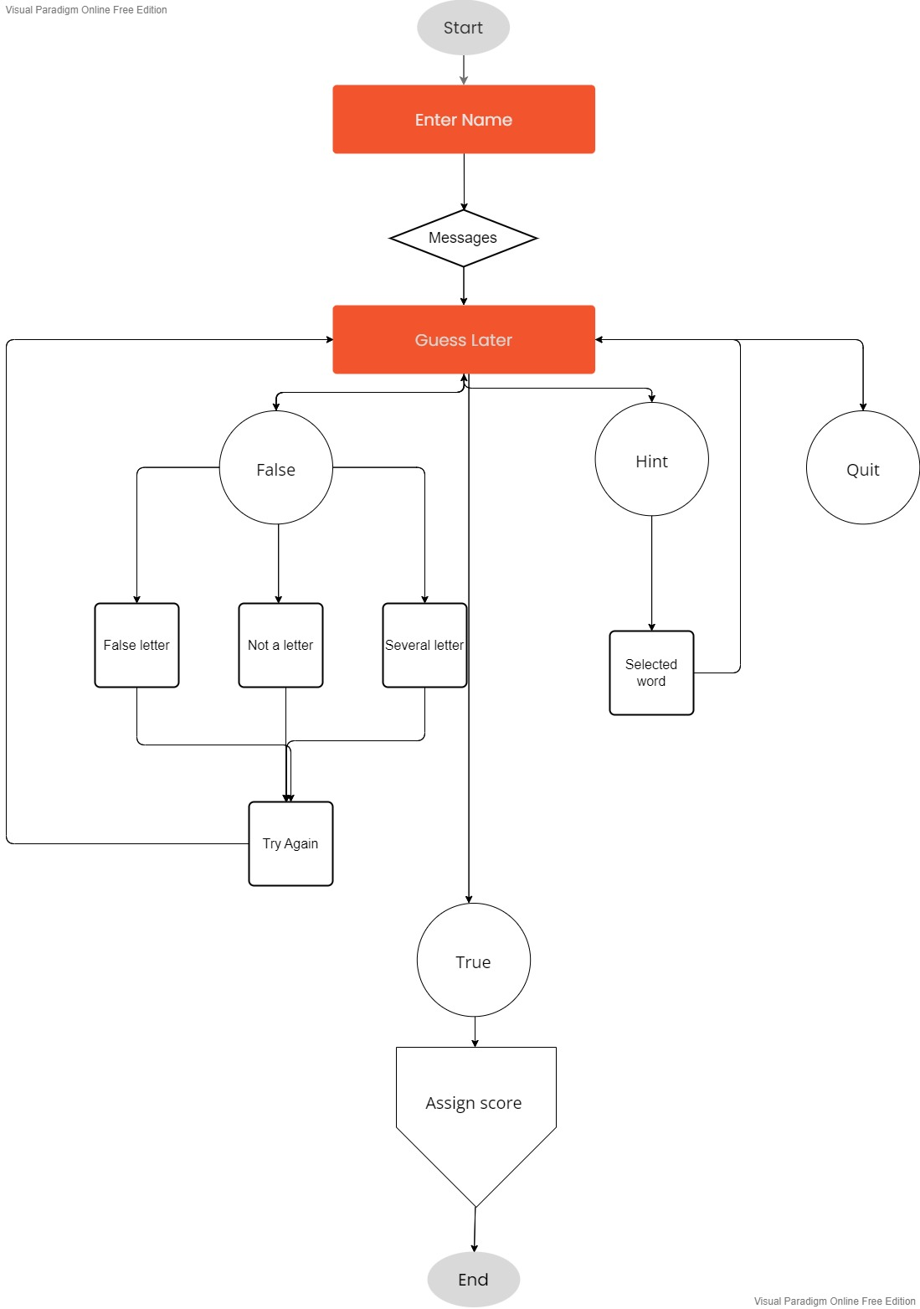

1. **Code Explanations**

As previously mentioned, we are going to use two libraries. Random is for choosing random word and datetime is going to specify the date and time on .txt file which contains player information. And since the game is going to be opened from different pcs. OS library is used to get the path for subdirectory and then call the required datasets.

The below code is receiving the name of the user which it would be calling by that name in the game process and lately we would assign it to score board.

We mentioned that the words are picked from a dataset. Therefore, the below image is the code part of this procedure. By the help of an if else statement it is choosing a dataset according to the score. Furthermore, random.choice functions helps it to pick one word from the chosen dataset randomly. os.getcwd() function automatically receives the path for the specified dataset.

After picking a word from the specified dataset. It is time to visualize it. The below page stand for game start page. As shown, it is presenting us the number of attempts. In second line {len(secilmis)} helps us to take the take the length of chosen word and says the whole line says the length of chosen word. The last line is showing the first letter of chosen word as hint.

The variable ‘secilmis’ is our chosen word, but ‘tahmin_edilen_kelime’ is going the be underscores equal to our chosen word.

The below code starts taking input from the user as it is obvious.

If the input is going to be equal to ‘quit’, it will print a text then assign the name, score, and data to txt file.

As mentioned before, if the player requires hint the below function is responsible. The function firs check if the input is equal to ‘hint’ or not. If it is, it would start an if else statement and check if the score is bigger than 5 it is ok, otherwise it won’t show anything as hint.

It also checks the input whether if it is a letter and consist of only one letter. As shown below, if it is not an alphabet or it is consisting of several letters in word it would print regarding print statements.

If the entered letter matches any of the letters in chosen word one by one and assign all those letters as a new variable called ‘tahmin_edilen_kelime’ then it starts giving messages according to results. By the way if it is true, it would increase the score and attempt variables by one.

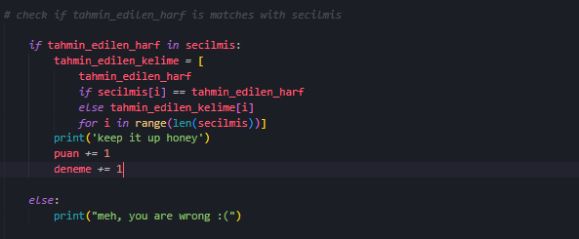

In previous code we assigned entered letters to the variable ‘tahmin_edilen_kelime’. Now this function is assigning value of ‘tahmin_edilen_kelime’ to ‘girilen’. In case of being similar it would print the score and congrats. Furthermore, it restarts the attempt value back to 10.

I have struggled while developing these last two functions, therefore, I tried to search it online and find the following code <https://medium.com/@4k45hr0ck5007/word-guessing-game-in-python-e30f7b176e32> not only in this two function but in overall of the process it helped me with faced problems.

This is part activates when the attempt value gets 0 or in other words the game is over. It will take print the chosen word and closes the game with assigning the last value of score variable, name of the player and the date game has been played.

Below it is shown an example of records saved.

1. **References**

1: <https://medium.com/@4k45hr0ck5007/word-guessing-game-in-python-e30f7b176e32>

2: <https://stackoverflow.com/questions/3591807/how-can-i-stop-python-exe-from-closing-immediately-after-i-get-an-output>

3: <https://stackoverflow.com/questions/311627/how-to-print-a-date-in-a-regular-format>

4: <https://www.tutorialspoint.com/python/os_getcwd.htm>