**Department of Computer Engineering**

**2022-2023 Academic Year Fall Term**

**FINAL PROJECT**

**FOR**

**CSE 0408 Programming III**

**Word Guessing Game Usage Report**

|  |  |
| --- | --- |
| **Name & Surname** | **Nasibullah Qarizada** |
| **Student Number** | **1900004691** |
| **Submission Date** | **30.12.2022** |

As previously mentioned in project report document, word guessing game is a project which let players to estimate the letters selected and hid by computer. In this report we would be having a guide on usage of this application. To begin with let’s start with opening application.

1: Word guessing game can be open from the compiler on terminal and as an executable python file on any windows operating system. Furthermore, we have two ways to open this program, selecting game1.py file or in dist file opening game1.exe. this document is based on game1.exe.

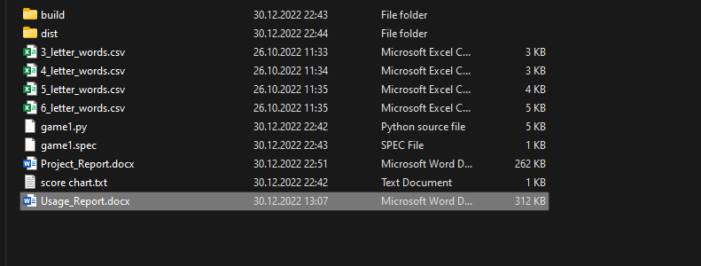

2: The first function would be requesting the name from the user which will be calling the user with that name till the end of the game as shown in figure [2]. There is no limitation while entering the name.

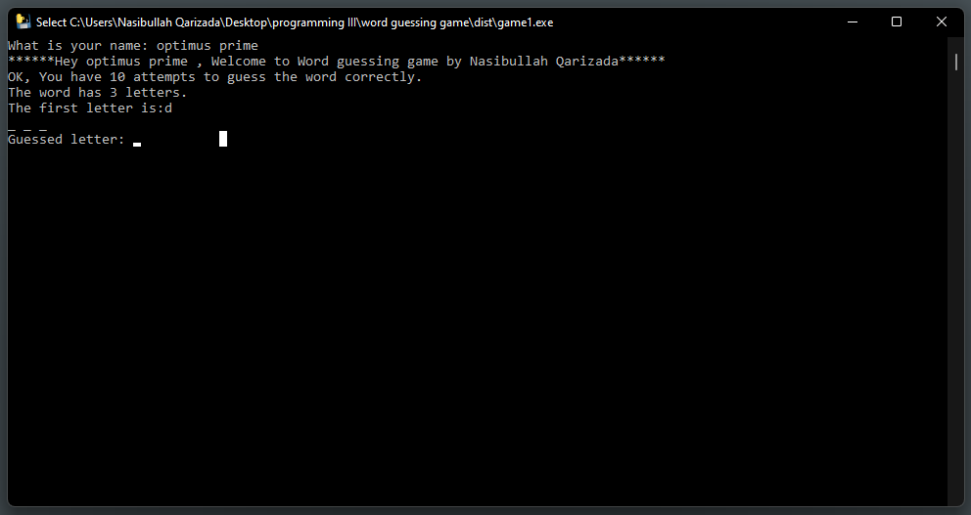3: After entering the name the game would begin, there would be a welcoming page written specified information regarding to game such as maximum attempts available, number of the chosen word and the first letter of the chosen word to help player.

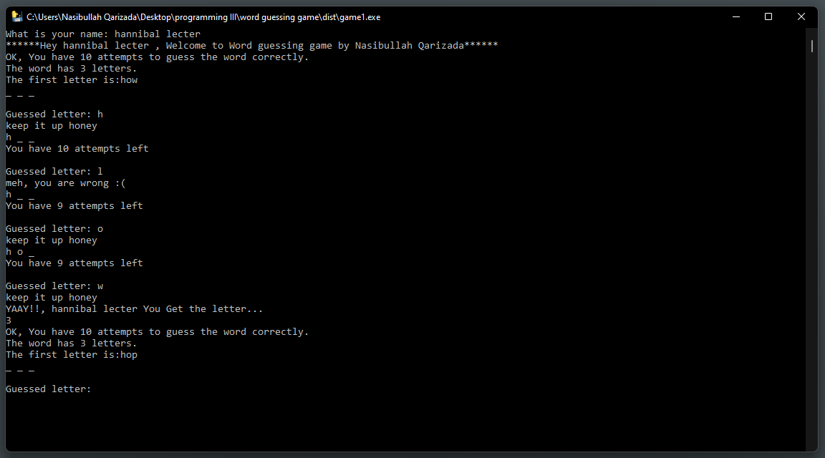4: Once the game is started, the system would generate specific messages in case of being true and false. In each wrong attempt the attempting chance would be decreased by one and if the entered letters are true, it would print a congratulation name containing name of the players.

5: Truly guessing any letter will give you one score, which means if there is a word with three letters and user enters them all right it would be placed as +3 scores. Writing the “hint” word will gives you the word but in would make you score -5 and in case you don’t have enough score it would print that you don’t have enough score

6: as shown in below figure [7], the game only accepts one letter at a time, and it is also supposed to be just letters. If number or symbol has entered it would warn that only enter letters. In case of entering several letters, it would warn that not enter more than one letter at once.

7: In case being tired of game user can basically type “quit” and can close the game with saving records.

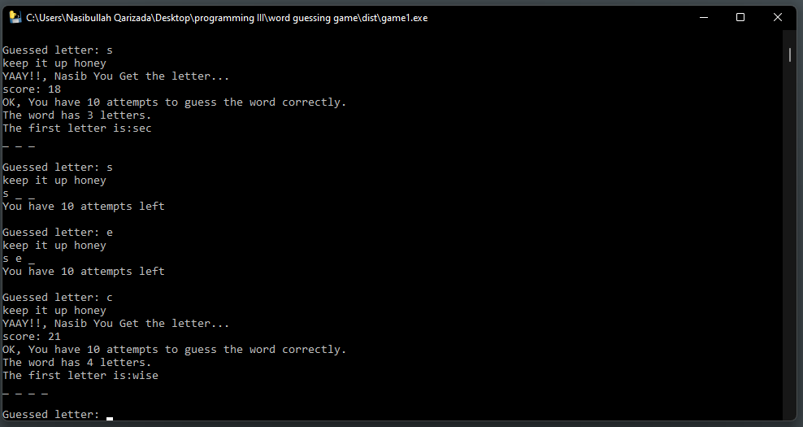8: the game is consist of levels, with increasing the score by 20 it would jump to a new level. The 1st level game would be easy and suggesting 3 letter word but in 2nd level after passing 20 score points it would start suggesting 4 letter words and goes on like this.

9: The game would end after 10 wrong attempts

10: Whatever done so far would recorded to txt file in terms of name, score and date.