MARANDA HIGH SCHOOL

Kenya Certificate of Secondary Education

PRE-MOCK EXAMINATIONS 2023

CODE: 231/1 BIOLOGY – FORM 4

Paper 1

MARCH 2023 – TIME: 2 Hours

Name: ………………………………………………….....Adm No: ……….……

Class: ……………… Date: /04/2023

**INSTRUCTIONS TO CANDIDATES**

* Answer **all** the questions.
* Answers **must** be written in the spaces provided in the question paper.
* Additional pages **must not** be inserted.
* Candidates may be penalized for recording irrelevant information and for incorrect spellings.

**FOR EXAMINER’S USE ONLY**

|  |  |  |
| --- | --- | --- |
| **Questions** | **Maximum Score** | **Candidate’s Score** |
| **1-25** | **80** |  |

© 2022 - 231/1

Biology Paper 1 (THEORY)

=

1 The following apparatus is used in Biological studies.

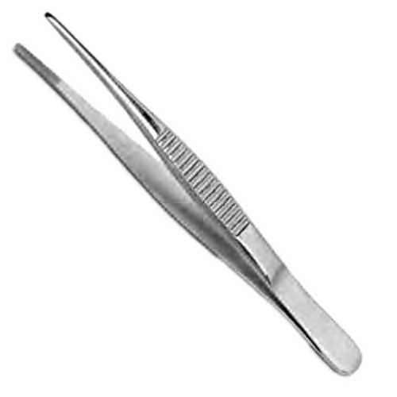

1. Identify the apparatus. (1mk)

………………………………………………………………………………………………………

1. State its function. (1mk)

………………………………………………………………………………………………………

……………………………………………………………………………………………………… 2 Explain why plants do not require an elaborate gaseous exchange system. (2mks)

………………………………………………………………………………………………………

………………………………………………………………………………………………………

……………………………………………………………………………………………………… 3 Name **two** organisms that belong to the Kingdom Protista. (2mks)

………………………………………………………………………………………………………

………………………………………………………………………………………………………

………………………………………………………………………………………………………

1. 60 black and 60 white mice were released in an area inhabited by jackals. After six weeks, it was established that 24 black and 8 white mice had remained.
2. Account for the above observation. (3mks)

………………………………………………………………………………………………………

………………………………………………………………………………………………………

1. Name the evolution theory that supports this observation. (1mk)

………………………………………………………………………………………………………

1. A freshly obtained dandelion stem measuring 5cm long was split lengthwise to obtain two similar pieces. The pieces were placed in solutions of different concentration in petri dishes (L1 and L2) for 20 mins. The appearance after 20 mins is as shown.

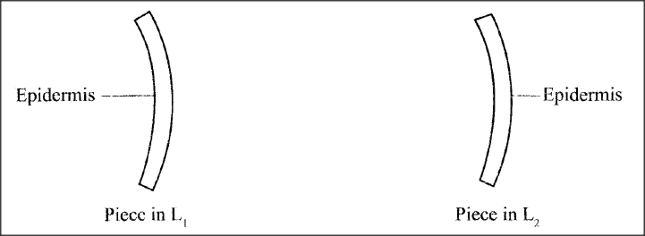

1. Account for the appearance of the piece in solution L2 after 20 minutes. (3mks)

………………………………………………………………………………………………………

………………………………………………………………………………………………………

………………………………………………………………………………………………………

1. State **one** significance of the biological process involved in the experiment. (1mk)

………………………………………………………………………………………………………

1. State **two** environmental conditions that can lead to formation of carboxyhaemoglobin in the human body. (2mks)

………………………………………………………………………………………………………

……………………………………………………………………………………………………… 7 a) Name the part of the ovule that forms each of the following structures after fertilization:

* 1. Zygote (1mk)
  2. Testa (1mk)

1. State **two** structural difference between motor and sensory neurons. (2mks)

|  |  |
| --- | --- |
| **Motor Neuron** | **Sensory Neuron** |
|  |  |
|  |  |

1. Below is a diagram of an organism.

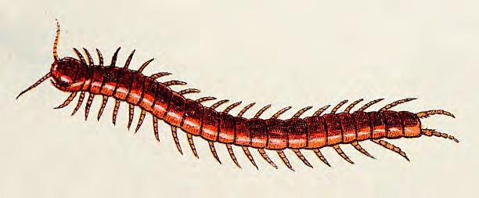

1. Identify the Class to which the organism belongs. (1mk)

………………………………………………………………………………………………………

1. State **two** features shown on the diagram that are characteristics of this Class. (2mk)

………………………………………………………………………………………………………

……………………………………………………………………………………………………… 10a) Diffentiate between **population** and **community** as used in ecology. (1mk)

………………………………………………………………………………………………………

………………………………………………………………………………………………………

* 1. Explain **one** negative effect of the use of herbicide on human health. (1mk)

………………………………………………………………………………………………………

………………………………………………………………………………………………………

* 1. State **two** ways through which energy is lost from one trophic level to the next in a food chain. (2mks)

………………………………………………………………………………………………………

………………………………………………………………………………………………………

11a) Give **two** reasons why anaerobic respiration yields less energy than aerobic respiration. (2mks)

………………………………………………………………………………………………………

b) Explain why fats are not efficient respiratory substrates. (2mks)

………………………………………………………………………………………………………

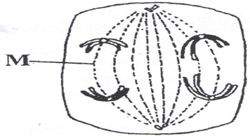……………………………………………………………………………………………………… 12 The diagram below represents a stage in cell division.

1. i)Name the stage of cell division illustrated. (1mk)

………………………………………………………………………………………………………

ii) Give a reason for your answer in 14(a)(i). (1mk)

………………………………………………………………………………………………………

1. In the space provided below, illustrate the next stage of cell division before the one shown above. (1mk)
2. Give **one** disadvantages of inbreeding among living organisms. (1mk)

……………………………………………………………………………………………………… 13 The table below shows the concentration in parts per million of sodium and iodide ions in sea water and cell sap of a plant.

|  |  |  |
| --- | --- | --- |
|  | **Sodium ions concentration** | **Iodide ions concentration** |
| **Sea water** | 326 | 39 |
| **Cell sap** | 162 | 574 |

1. i) Which of the two ions intake will be affected if the plant was sprayed with a chemical that inhibits respiration. (1mk)

………………………………………………………………………………………………………

ii) Explain your answer in 10(a)(i) above. (1mk)

………………………………………………………………………………………………………

………………………………………………………………………………………………………

1. An experiment was set up as shown in the diagram below.

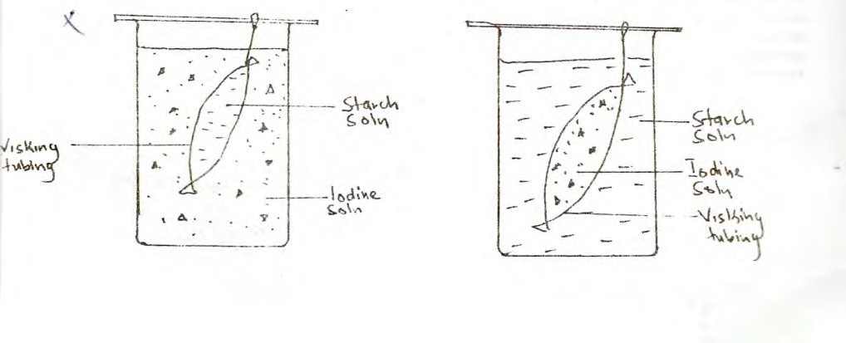

At the end of the experiment, it was observed that the starch turned blue black while the color of iodine solution in the beaker did not change. Account for this observation. (2mks)

………………………………………………………………………………………………………

………………………………………………………………………………………………………

………………………………………………………………………………………………………

1. State the role of the following organelles: (3mks)
   1. Ribosomes

………………………………………………………………………………………………

* 1. Chloroplast

…………………………………………………………………………………………………

* 1. Nucleus

…………………………………………………………………………………………………..

1. A goat and a sheep are both herbivores. Explain why the two can comfortably exist in the same ecosystem. (2mks)

………………………………………………………………………………………………………

………………………………………………………………………………………………………

1. Explain the role of antidiuretic hormone when the human blood water level is below normal. (3mks)

………………………………………………………………………………………………………

………………………………………………………………………………………………………

………………………………………………………………………………………………………

1. Equal amounts of crushed irish potato were placed in equal volumes of hydrogen peroxide solution at various pH values. A gas L was produced, its volume measured and recorded as shown below.

|  |  |  |  |
| --- | --- | --- | --- |
| **pH** | 4.2 | 7.0 | 9.2 |
| **Volume of gas L** | 2.9 | 5.9 | 7.9 |

* 1. Identify gas **L**. (1mk)

………………………………………………………………………………………………

* 1. Account for the difference in the volume of gas L produced at pH values 4.2 and 9.2. (3mks)

………………………………………………………………………………………………

……………………………………………………………………………………………… 18a) State **two** ways in which red blood cells are adapted to their function. (2mks)

………………………………………………………………………………………………………

……………………………………………………………………………………………………… b)In which **two** forms is carbon (iv) oxide transported in the body. (2mks)

………………………………………………………………………………………………………

……………………………………………………………………………………………………… 19 State **three** characteridstics of a respiratory surface. (3mks)

………………………………………………………………………………………………………

………………………………………………………………………………………………………

……………………………………………………………………………………………………… 20 A student set up an experiment as shown in the diagrams below

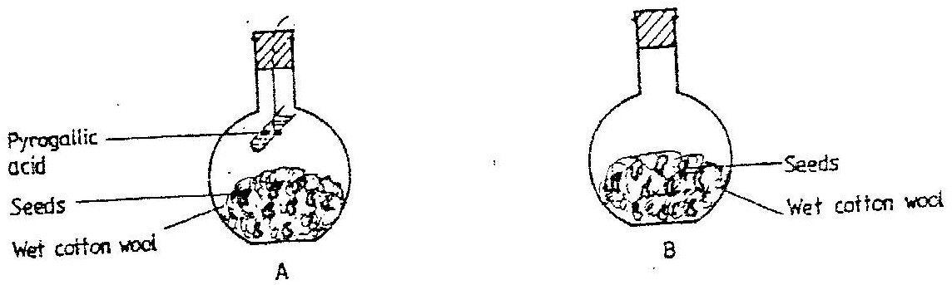

The set up was at room temperature for a week

1. What was the aim of the experiment? (1mks)

………………………………………………………………………………………………………

1. What would be the expected results at the end of the experiment (2mks)

………………………………………………………………………………………………………

21 After four months of pregnancy, the ovaries of a woman can be removed without terminating pregnancy. However, during the first four months of pregnancy, the ovaries must

remain intact if pregnancy is to be maintained. Explain these observations. (2mks)

………………………………………………………………………………………………………

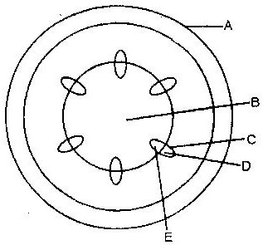……………………………………………………………………………………………………… 22 The diagram below represents a transverse section of a young stem

1. Name the parts labelled A and B (2mks)

A…………………………………………………………………

B…………………………………………………………………

b) State **two** ways in which xylem vessels are adapted to their function. (2mks)

………………………………………………………………………………………………

………………………………………………………………………………………………

………………………………………………………………………………………………

23 A process that occurs in plants is represented by the equation below.

C6H12O6 2C2H5OH + 2CO2 + Energy

(Glucose) (Ethanol) (Carbon dioxide)

1. Name the process. (1mk)

………………………………………………………………………………………………………

1. State **two** economic importance of the process named in (a) above. (2mks)

………………………………………………………………………………………………………

24 Explain why some desert animals excrete uric acid rather than ammonia. (2mks)

………………………………………………………………………………………………………

……………………………………………………………………………………………………… 25 A shoot of seedling exposed to light on one side bends towards the source of light as it grows.

1. Name the response exhibited by the shoot of the seedling. (1mk)

………………………………………………………………………………………………………

1. Explain how the bending towards the source of light occurs. (3mks)

………………………………………………………………………………………………………

………………………………………………………………………………………………………

………………………………………………………………………………………………………