**GITHUMU BOYS’ HIGH SCHOOL**

**CAT 1 TERM 2 EXAMS – 2023**

**BIOLOGY FORM 1**

**NAME: ­­­­­­­­­­­­­­­­­­­­_______________________________ ADM. NO: __________ CLASS: ___________**

***TIME: 1HR (30MKS)***

***INSTRUCTIONS: Answer all the questions in the spaces provided.***

1. Fill in the table below. (3mks)

|  |  |
| --- | --- |
| BRANCH | FIELD OF STUDY |
| Anatomy |  |
|  | Fungi |
| Ichthyology |  |

2. a) Define the following terms as used in microscopy.

(i) Magnification (1mk)

______________________________________________________________________________

______________________________________________________________________________

(ii) Resolution (1mk)

______________________________________________________________________________

______________________________________________________________________________

b) Explain two precautions taken when collecting specimens for study. (2mks)

______________________________________________________________________________

______________________________________________________________________________

3. a) Define the term species. (1mk)

______________________________________________________________________________

______________________________________________________________________________

b) The scientific name for mango is Mangifera Indica.

(i) Which taxonomic unit does the name Mangifera refer to? (1mk)

______________________________________________________________________________

(ii) Identify two mistakes done in the name. (2mks)

______________________________________________________________________________

­­­­­­­­­­­­­­­­­­­­­­­­­­­­­­­­­­______________________________________________________________________________

(iii) Write the name correctly. (1mk)

c) State one reason why classification of organisms is necessary. (1mk)

_____________________________________________________________________________

______________________________________________________________________________

4. (a) In a laboratory exercise a student observing a drop of pond water under a microscope

saw and drew a spirogyra. If the magnification of the eye-piece was x5 and that of the

objective lens was x100, what was the magnification of the spirogyra? (2mks)

(b) If the spirogyra has a length of 5cm at the above magnification, calculate the actual

length in micrometers (2mks)

5. a) State the functions of the following parts of a microscope.

(i) Mirror (1mk)

______________________________________________________________________

(ii) Diaphragm (1mk)

______________________________________________________________________________

b) State the reasons for carrying out the following procedures when preparing microscopic slides.

(i) Using a sharp scarpel/blade when cutting sections (1mk)

____________________________________________________________________________

(ii) Adding a drop of water to the section (1mk)

____________________________________________________________________________

(iii) Cutting very thin sections. (1mk)

____________________________________________________________________________

6. Identify the characteristics of living organisms represented by the following:

i) Removal of urea from the body of human ___________________________________ (1mk)

ii) A rat eating maize grains _________________________________ __________ (1mk)

7. The figure below shows a cell as seen under an electron microscope. Use it to answer the questions that follow.

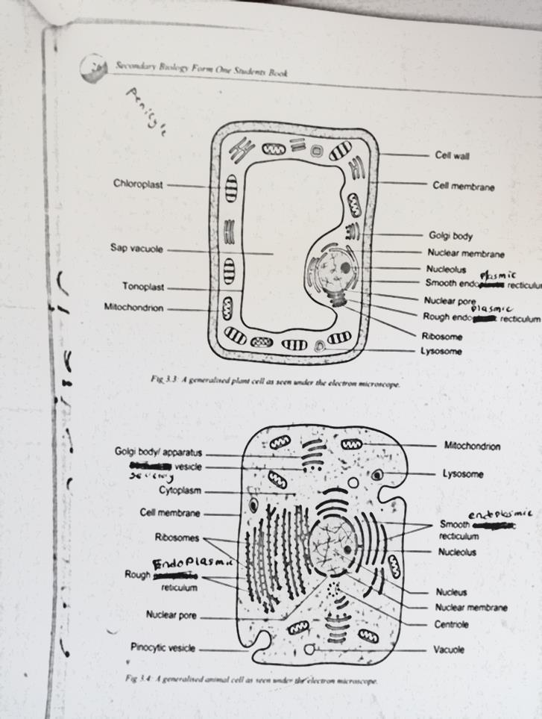

a) Name the part labeled J and K. (2mks)

J ____________________________

K____________________________

b) Identify the type of cell shown in the diagram above and give reason for your answer. (2mks)

Cell: ___________________________________________________

Reason: _________________________________________________

8. The diagram below represents a structure found in cells.

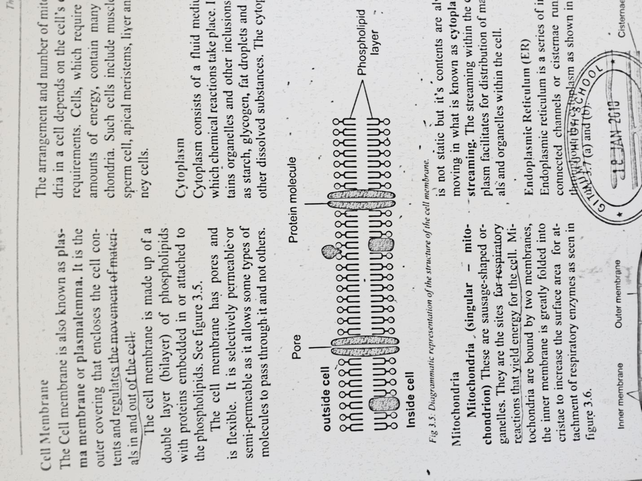

a) Identify the structure _________________________________________ (1mk)

b) Name the parts labeled A and B. (2mks)

A _____________________________________________________________

B ____________________________________________________________