**GITHUMU BOYS’ HIGH SCHOOL**

**BIOLOGY FORM THREE**

**MID TERM 2 EXAM, 2022.**

**NAME: ­­­­­­­­­­­­­­­­­­­­­­­­­­­­­­­­_______________________________________________________-ADM. NO: _________CLASS: _______ DATE: ____________________**

**BIOLOGY**

**FORM 2**

**TIME: 1HR 20 MINUTES.**

INSTRUCTIONS TO CANDIDATES.

* Write your name, admission number and class in the spaces provided above.
* Answer ALL questions in the spaces provided.

FOR OFFICIAL USE ONLY

|  |  |  |
| --- | --- | --- |
| QUESTIONS | MAXIMUM SCORE | CANDIDATE’S  SCORE |
| 1 - 18 | 80 |  |

1. In a certain experiment, the following observation was made:

When red blood cell was placed in a certain solution, the solution exerted more osmotic pressure leading to the cell losing water molecules to become crenated/ shrunk.

1. What type of solution was the cell placed in respect to the cell’s cytoplasm**? (1 mark)**

……………………………………………………………………………………………..

1. By which physiological process did the cell lose water molecules?  **(1 mark)**

**…………………………………………………………………………………………………**

1. Study the flow diagram below.

☼

CO2

CH2O

**U**

Dark stage

2H2O

Light stage

**W**

**V**

Name the substance **U**, **V** and **W**. **(3 marks)**

**U**: …………………………………………………………………………………………

**V**: ……………………………………………………………………………………………

**W**: …………………………………………………………………………………………..

3.a) State the deficiency diseases of each of the following vitamins.  **(3 marks)**

1. B1 ………………………………………………………………………………………….
2. B2 ………………………………………………………………………………………….
3. B6 …………………………………………………………………………………………

b)What is the role of roughage in a diet?  **(1 mark)**

……………………………………………………………………………………………………

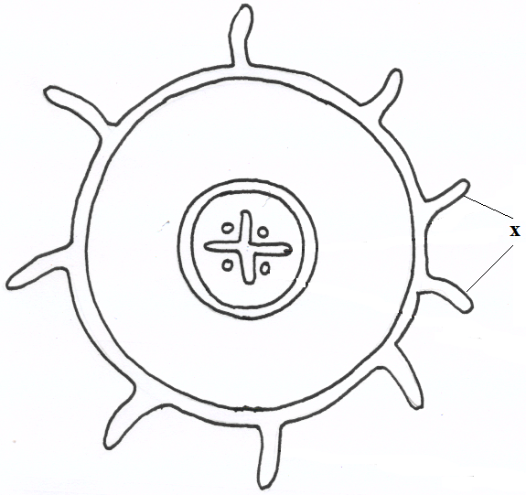**4**. The diagram below represents a transverse section of a plant part. Study it and answer the questions that follow.

1. Name the class in which the plant belongs. **( 1mark)**

…………………………………………………………………………………………………………

1. Give a reason for answer (a) above **( 1mark)**

……………………………………………………………………………………………………………….………………………………………………………………………………………………………………………………………………………………………………

c)State **one** adaptation for the structures labeled X to their functions. **(1mark)**

……………………………………………………………………………………………………………….……………………………………………………………………………………………..………………………………………………………………………………………………………

5**.** Below is a diagram of an organelle.

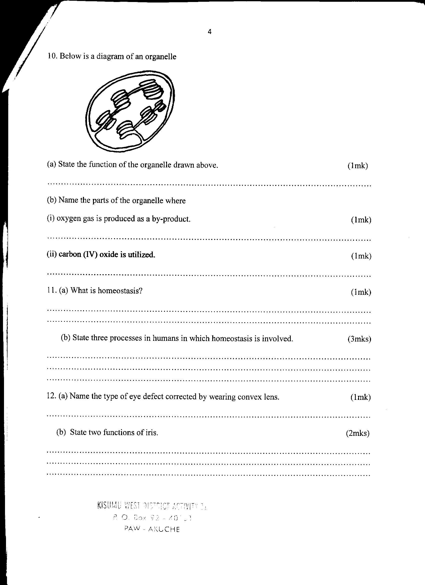

a)State the function of the organelle drawn above.  **(1mark)**

………………………………………………………………………………………………………b) Name the parts of the organelle where :

i)Oxygen gas is produced as a byproduct. **(1mark)**

…………………………..………………………………………………………………………

ii) Carbon (IV) oxide is utilized.  **(1mark)**

…………………………………………………………………………………………………..

**6.** The diagram below represents a set up that was used to investigate a certain process in a plant.

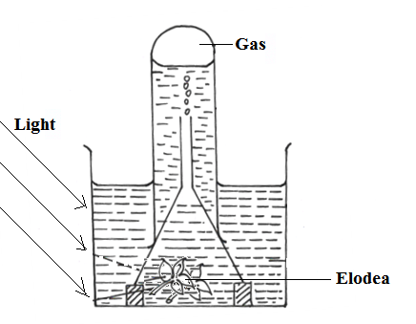

1. State the process that was being investigated. **(1 mark)**

………………………………………………………………………………………………… b) Other than the factors shown, state two factors that would affect the process named in (a) above. **(2 marks)**

……………………………………………………………………………………………………………….……………………………………………………………………………………………..

7. State three factors that cause decrease in the rate of transpiration from leaves. (3mks)

………………………………………………………………………………………………………………………………………………………………………………………………………………………………………………………………………………………………………………………

8. The diagram below represents a plant tissue.

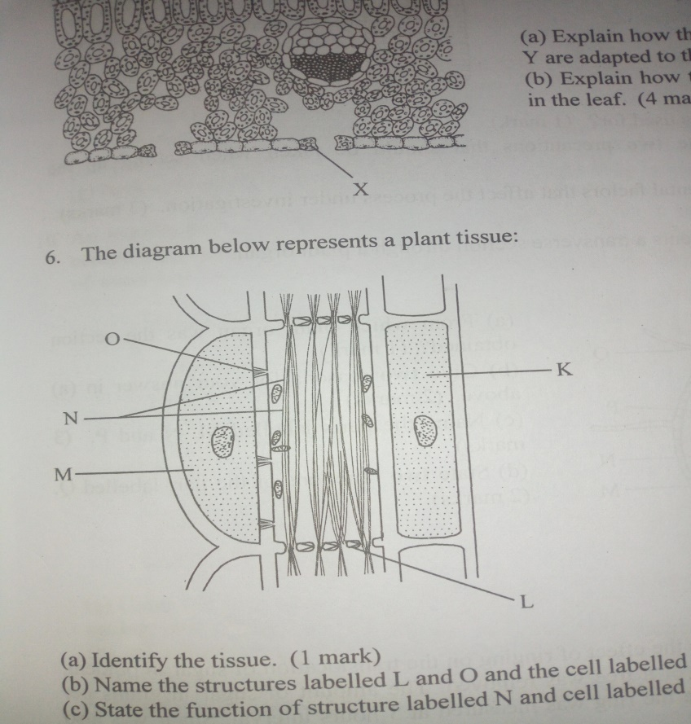

a) Identify the tissue. (1mk)

………………………………………………………………………………………………………

b) Name the structures labeled L and O and the cell labeled K (3mks)

L.........................................................................................................................................................

O ……………………………………………………………………………………………………

Cell K ………………………………………………………………………………………………

c) State the function of the structure labeled N and cell M. (2mks)

N …………………………………………………………………………………………………....

Cell M ……………………………………………………………………………………………...

8. In an experiment to investigate an aspect of digestion, two test tubes labeled A and B were set up as shown in the diagram below.

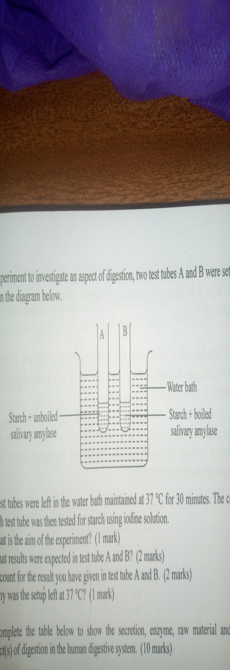

The test tubes were left in the water bath maintained at 370C for 30 minutes. The content of each test tube was then tested for starch using iodine solution.

a) What was the aim of the experiment? (1mk)

………………………………………………………………………………………………………

b) What results were expected in testtube

A (1mk) ………………………………………………………………………………………………………

………………………………………………………………………………………………………

B (1mk)

………………………………………………………………………………………………………

………………………………………………………………………………………………………

c) Account for the results in test tube B. (2mks)

………………………………………………………………………………………………………

………………………………………………………………………………………………………

d) Why was the setup left at 370C. (1mk)

………………………………………………………………………………………………………

………………………………………………………………………………………………………

9. State three factors that affect the energy requirements in humans. (3mks)

………………………………………………………………………………………………………

………………………………………………………………………………………………………

………………………………………………………………………………………………………

10. State three functions of the pericardial membrane of the human heart. (3mks)

………………………………………………………………………………………………………

………………………………………………………………………………………………………

………………………………………………………………………………………………………

………………………………………………………………………………………………………

11.**a)** What type of circulatory system is found in members of class Insecta? **(1 mark)**

………………………………………………………………………………………………………………...…………………………………………………………………………………………………………………………………………………………………………………………………… **b)** Name the blood vessel that transports blood from:

**(i)** Small intestine to liver. **(1 mark)**

………………………………………………………………………………………………………

**ii)** Lungs to heart **(1 mark)**

………………………………………………………………………………………………………

12.a) Name two nutrients that are absorbed without being digested by enzymes in humans (2mks)

………………………………………………………………………………………………………

b) How is a human stomach adapted to:

i) Protein digestion (2mks)

………………………………………………………………………………………………………

………………………………………………………………………………………………………

ii)Churning (2mks)

………………………………………………………………………………………………………

………………………………………………………………………………………………………

13. Name two organisms that possess a single circulatory system. (2mks)

………………………………………………………………………………………………………

………………………………………………………………………………………………………