**Question 4.**

For the SVM that is applied to data, which is linearly separable, we have made the following derivations

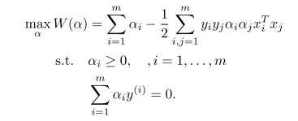

But, for some cases it is not clear to see a hyper plane separating the data, since it is highly susceptible to outliers etc.

Therefore to make the model more robust to deal with these issues we need to re-formulate the regularization.

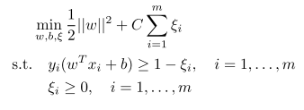

In making the above change, the only affect in our dual problem is that our initial constraint of α >= 0, now becomes 0 <= α <= C. And in this case, the training points are segregated into three types which are described as follows,

• α = 0: non-interesting points

• C > α > 0; β = 0: a support vector on the margin line, no slack variable.

• α = C; β > 0: a support vector, inside the side (or even misclassified)

**Question 5.**

y = wx + b;

w = -1;

b = 1.5

Margin ~ 0.5

