**Tema**

(Un membru staff poate avea mai multe joburi platite. Comanda sql obtine id-ul angajatului dat ca parametru, afla id-ul joburilor pe care le are si calculeaza suma salariilor acestora)

**EX2**

create or replace function ex7_2

(v_nume staff.nume_staff%TYPE DEFAULT 'Benjamin')

return number is v_salariu jobs.salariu_mediu%type;

begin

select sum(salariu_mediu)

into v_salariu

from jobs

where id_job in(select id_job

from ocupa

where id_staff = (select id_staff

from staff

where trim(lower(nume_staff)) = trim(lower(v_nume))));

return v_salariu;

EXCEPTION

WHEN NO_DATA_FOUND THEN

RAISE_APPLICATION_ERROR(-20000,'Nu exista angajati cu numele dat');

WHEN TOO_MANY_ROWS THEN

RAISE_APPLICATION_ERROR(-20001,'Exista mai multi angajati cu numele dat');

WHEN OTHERS THEN

RAISE_APPLICATION_ERROR(-20002,'Alta eroare!');

end ex7_2;

/

select ex7_2('Christopher') from dual;

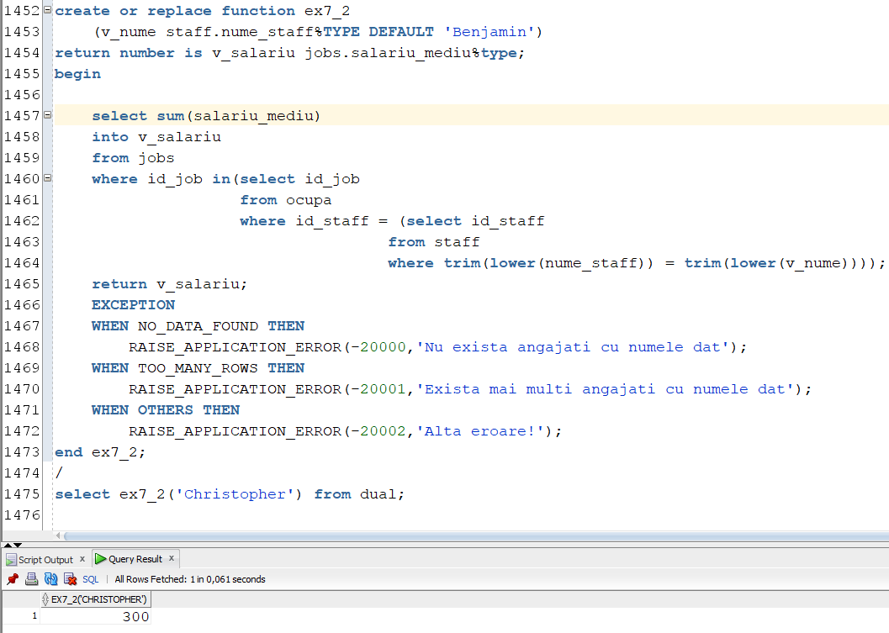

**EX4**

create or replace procedure ex7_4

(v_nume staff.nume_staff%TYPE)

is

v_salariu jobs.salariu_mediu%type;

begin

select sum(salariu_mediu)

into v_salariu

from jobs

where id_job in(select id_job

from ocupa

where id_staff = (select id_staff

from staff

where trim(lower(nume_staff)) = trim(lower(v_nume))));

dbms_output.put_line('Salariul lui ' || v_nume|| ': ' || v_salariu);

EXCEPTION

WHEN NO_DATA_FOUND THEN

RAISE_APPLICATION_ERROR(-20000,'Nu exista angajati cu numele dat');

WHEN TOO_MANY_ROWS THEN

RAISE_APPLICATION_ERROR(-20001,'Exista mai multi angajati cu numele dat');

WHEN OTHERS THEN

RAISE_APPLICATION_ERROR(-20002,'Alta eroare!');

end ex7_4;

/

execute ex7_4('benjamin');

