**TEMA 7**

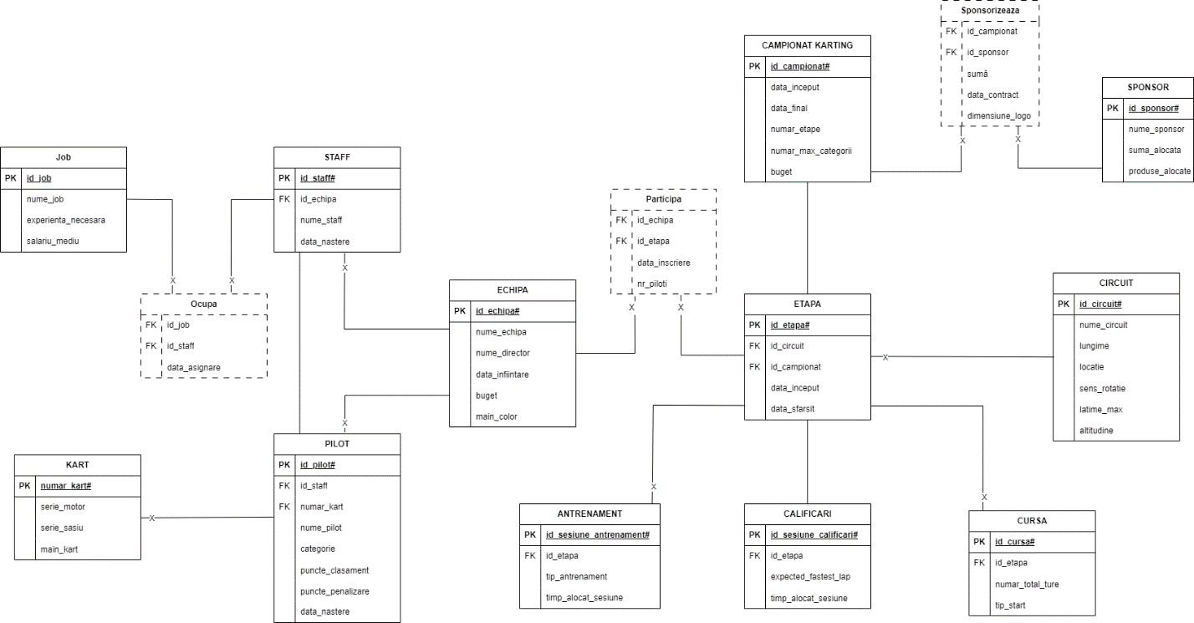

create or replace package tema7_3 as

cursor sal_min(nr number) return staff%rowtype;

function salariu_max(v_echipa echipa.nume_echipa%type) return number;

end tema7_3;

/

create or replace package body tema7_3 as

cursor sal_min(nr number) return staff%rowtype is

select s.id_staff, s.data_nastere,s.id_echipa,s.nume_staff

from staff s,(select s.id_staff, sum(j.salariu_mediu) salmax

from staff s, ocupa o, jobs j

where s.id_staff = o.id_staff

and o.id_job = j.id_job

group by s.id_staff) maxx

where s.id_staff = maxx.id_staff

and maxx.salmax > nr;

function salariu_max(v_echipa echipa.nume_echipa%type) return number is

maxim number;

begin

select max(sum(j.salariu_mediu))

into maxim

from staff s, ocupa o, jobs j, echipa e

where s.id_staff = o.id_staff

and o.id_job = j.id_job

and e.id_echipa = s.id_echipa

and lower(e.nume_echipa) = lower(v_echipa)

group by s.id_staff;

return maxim;

end salariu_max;

end tema7_3;

/

declare

ec echipa.nume_echipa%type := 'BRT';

val_max jobs.salariu_mediu%type;

begin

val_max := tema7_3.salariu_max(ec);

for i in tema7_3.sal_min(val_max) loop

dbms_output.put_line(i.id_staff);

end loop;

end;

/