**TEMA 8**

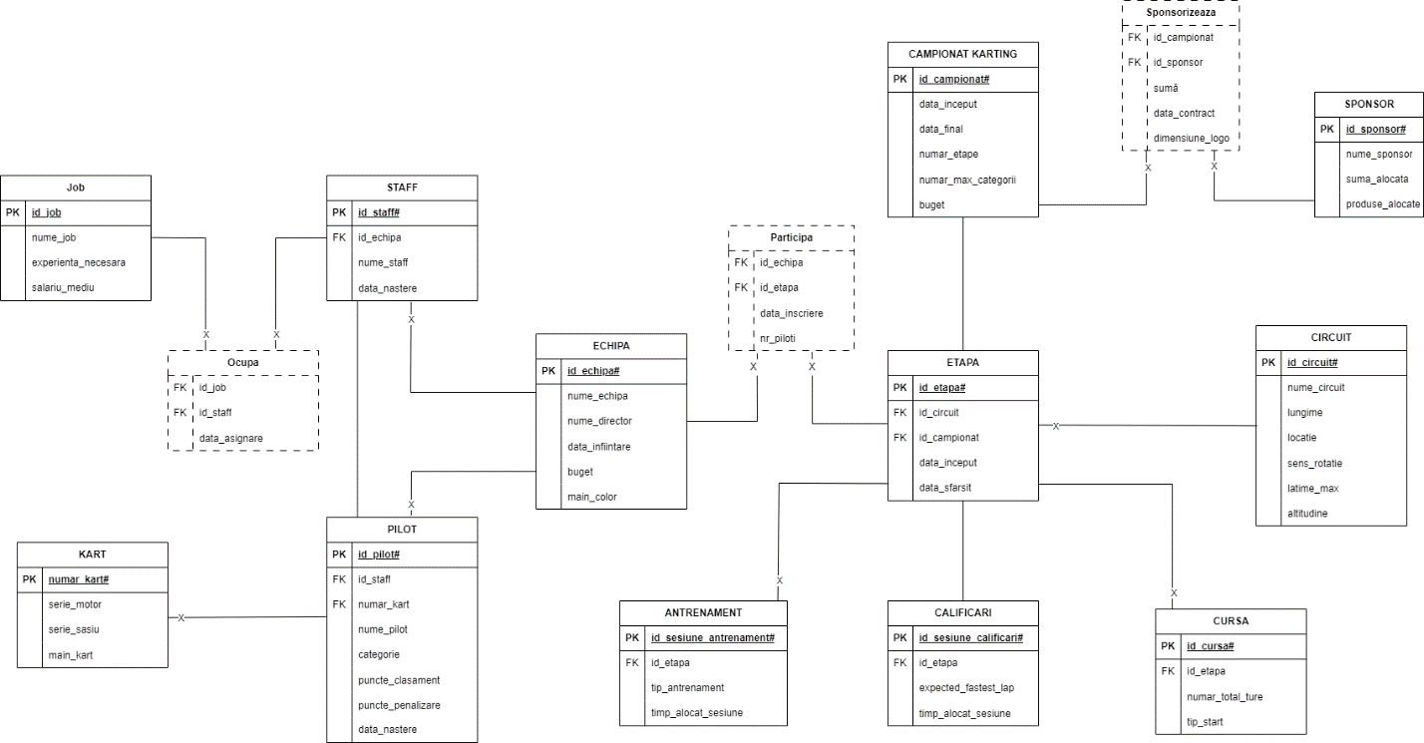create table info_buget_federatie

( id NUMBER,

nume_campionat VARCHAR2(255),

plati NUMBER

);

CREATE OR REPLACE PROCEDURE modific_plati

(v_codd info_buget_federatie.id%TYPE,

v_plati info_buget_federatie.plati%TYPE) AS

BEGIN

UPDATE info_buget_federatie

SET plati = NVL (plati, 0) + v_plati

WHERE id = v_codd;

END;

CREATE OR REPLACE TRIGGER tema8

AFTER DELETE OR UPDATE OR INSERT OF buget ON campionat_karting

FOR EACH ROW

BEGIN

IF DELETING THEN

-- se sterge un campionat

modific_plati (:OLD.id_campionat, -1*:OLD.buget);

ELSIF UPDATING THEN

--se modifica bugetul unui campionat

modific_plati(:OLD.id_campionat,:NEW.buget-:OLD.buget);

ELSE

-- se introduce un nou campionat

modific_plati(:NEW.id_campionat, :NEW.buget);

END IF;

END;

/

alter trigger tema8 enable; 