**TEMA 9**

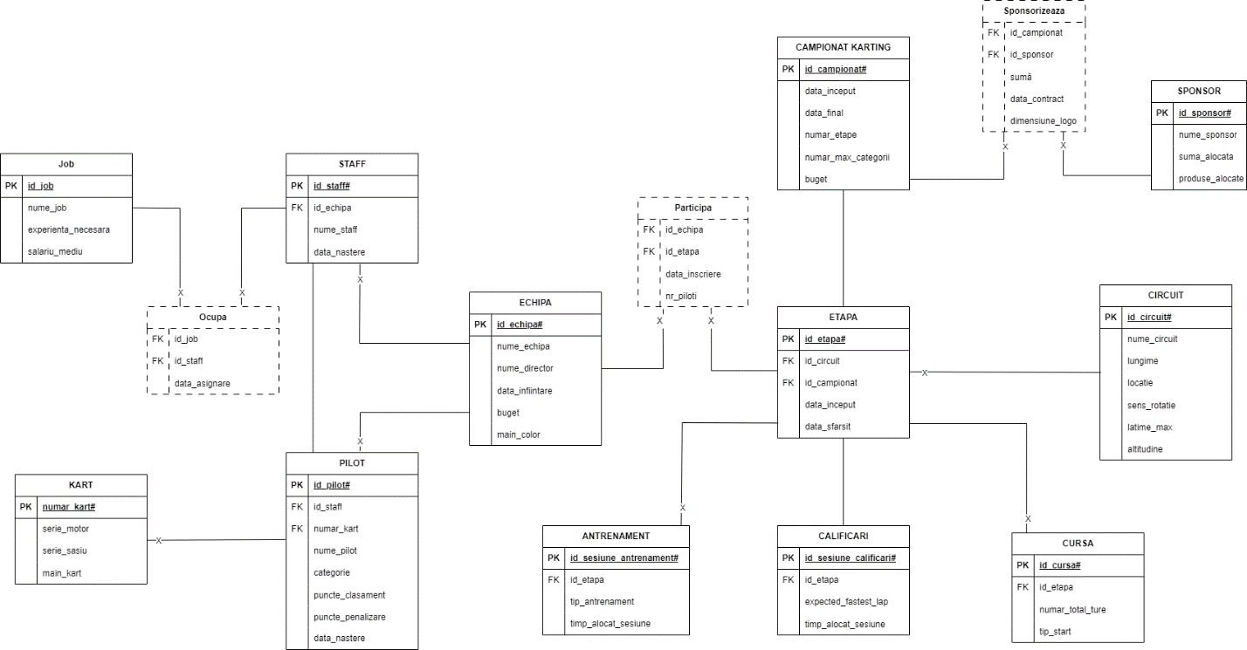

declare

v_val number := &p_val;

nr number;

exceptie exception;

begin

select count(*)

into nr

from( select sum(j.salariu_mediu)

from staff s, ocupa o, jobs j

where s.id_staff = o.id_staff

and o.id_job = j.id_job

group by s.id_staff

having sum(j.salariu_mediu) > v_val);

if nr = 0 then

raise exceptie;

else dbms_output.put_line(nr);

end if;

exception

when exceptie then

dbms_output.put_line('Nu exista staff care sa castige atat');

when others then

dbms_output.put_line('Alta eroare');

end;

/

