
Kingdom of Saudi Arabia
Ministry of Education
King Faisal University
College of Computer Sciences & Information Technology

EyeStocks AI
A project submitted
in partial fulfillment of the requirements for the degree of
Bachelor of Science in Computer Since

by
Sharidah AlGhannam (222416942)
Ali Alibrahim (222415845)
Qasem Alolaywi (222403427)
Abdullah AL-Khodir (222403439)

Supervised by
Prof. Alaa Sagheer

Committee Members

December, 2025

ACKNOWLEDGEMENT

We are deeply grateful to our supervisor and the project committee for the helpful suggestions and comments at the commencement of this proposal. Their observations gave us direction for the work to come. We would like to thanks our university as well, for giving us opportunities to materialize and mould this proposal with all the facilities and learning friendly atmosphere. And Not least, we are thankful for the teamwork and commitment of our colleagues, whose dedication and belief in a joint vision allowed EyeStocks AI to become reality.

UNDERTAKING

This is to declare that the project entitled EyeStocks AI is an original work done by undersigned, in partial fulfillment of the requirements for the degree Bachelor of Science in Computer Science at Department of Computer Science , College of Computer Sciences and Information Technology, King Faisal University.

All the analysis, design and system development have been accomplished by the undersigned. Moreover, this project has not been submitted to any other college or university.

ABSTRACT

EyeStocks AI is a FinTech initiative focused on creating a smart unified online platform that assists retail investors with AI-powered stock predictions, a virtual trading simulator and a community for collaborative investing. The platform is being developed to tackle shortcomings in conventional market analysis tools, such as low forecasting precision the gap between forecasts and actual trading actions and the absence of risk-conscious settings, for investor education.

The platform integrates a forecasting system that blends Long Short-Term Memory (LSTM) networks with XGBoost enabling it to recognize both extended temporal trends and immediate non-linear market behaviors. During development the system features a completely built-out data acquisition pipeline designed to gather, verify and process historical OHLCV data along with technical indicators, like RSI, MACD and moving averages. A separated three-layer design—React frontend, FastAPI backend and PostgreSQL database—enables scalability, modularity and potential growth into markets and functionalities.

Currently EyeStocks AI incorporates financial visual tools, nascent community functionalities and a virtual trading platform that allows users to experiment with strategies using simulated funds. Early prototype outcomes from the hybrid model have demonstrated encouraging prediction accuracy with MAPE, under the initial goal confirming the methods viability. Continued work involves improving the interface adding comprehensive risk evaluation features strengthening community protections broadening stock inclusivity and completing the integration of all components into a cohesive system.

Although still under active construction, EyeStocks AI demonstrates strong potential as an educational and analytical platform that enhances financial literacy, supports responsible investing, and bridges the gap between AI forecasting, user learning, and real-world decision-making. The project continues to advance through iterative development, testing, and model improvement.

Table of Content

ACKNOWLEDGEMENT 1
UNDERTAKING 2
ABSTRACT 3
Table of Content 4
List of Tables 8
List of Figure 9
List of Acronyms 10
Chapter 1: Introduction 12
1.1 Background 12
1.2 Literature Review 13
1.2.1 Stock-Price Forecasting with Hybrid Deep and Tree Models 13
1.2.2 Virtual Trading Simulators as Learning and Evaluation Tools 14
1.2.3 Community, Social Trading, and Investor Behavior 14
1.2.4 Critical Comparison and Identified Gaps 14
1.3 Motivation 16
1.4 Objectives and Aims 17
Chapter 2: Scope and Deliverables 19
2.1 Project Scope 19
2.1.1 Product Requirements 19
2.1.2 Process Requirements 19
2.1.3 Data Scope 19
2.1.4 Stakeholders 20
2.1.5 Beneficiaries 20
2.1.6 Limitations 20
2.2 Alignment with KFU Identity and Societal Impact 21
2.3 Expected Deliverables & Outcomes 21
2.4 Legal and Ethical Considerations 22
Chapter 3: Methodology 23
3.1 Approach & Tools 23
Phase 1: Data Acquisition and Preparation 23
Phase 2: Hybrid AI Model Development 24
Phase 3: Backend & API Development 25
Phase 4: Frontend & User Experience 25
Phase 5: Integration, Testing, and Deployment 26
3.2 Challenges 28
3.2.1 Data Collection and Preprocessing 28
3.2.2 Predictive Modeling 28
3.2.3 Scalability and Performance 28
3.2.4 User-Centric Design 28
3.2.5 Risk and Reliability 28
3.3 Alternative Approaches 29
3.3.1 AI Model Selection: Justifying the Hybrid Approach 29
3.3.2 System Architecture: Reason for the Decoupled Structure 31
Chapter 4: Project Requirements 34
4.1 Hardware and Software Needs 34
4.1.1 Hardware 34
4.1.2 Software 34
4.1.3 Datasets 34
4.2 Functional Requirements 34
4.2.1 User Management 34
5.2.2 Data Input & Processing 34
4.2.3 Prediction & Recommendation 34
4.2.4 Visualization & Interaction 35
4.2.5 Community Features 35
4.2.6 System Outputs 35
4.3 Non-Functional Requirements 35
4.3.1 Performance 35
4.3.2 Scalability 35
4.3.3 Security 35
4.3.4 Usability 35
4.3.5 Reliability & Availability 35
4.3.6 Maintainability 35
Chapter 5: System Design and Architecture 36
5.1 System Architecture Overview 36
5.1.1 Frontend Layer (Presentation Tier) 37
5.1.2 Backend Layer (Application Logic Tier) 37
5.1.3 Data Layer (Persistence Tier) 37
5.1.4 External Integrations 37
5.2 Design Justification 37
5.2.1 Rationale for Decoupled Architecture 38
5.2.2 Technology Selection Rationale 38
5.3 Database Design 38
5.3.1 Entity Relationship Diagram (ERD) 38
5.3.2 Detailed Schema Description 39
5.3.3 Data Integrity and Optimization 40
5.4 System Modeling 40
5.4.1 Use Case Diagram 40
5.4.2 Sequence Diagrams 41
5.5 User Interface Design (Prototype) 44
5.5.1 Dashboard and Stock Analysis 44
5.5.2 Virtual Simulator 45
Chapter 6: Technical Implementation 47
6.1 Development Environment & Tools 47
6.2 Phase 1: Data Acquisition and Engineering Pipeline 47
6.2.1 Data Ingestion Logic 47
6.2.2 Feature Engineering Implementation 47
6.3 Phase 2: The Hybrid AI Engine Implementation 49
6.3.1 Strict Time-Based Splitting Strategy 49
6.3.2 The Champion Selection Algorithm 49
6.4 Core Algorithmic Framework: The Hybrid Ensemble Approach 51
6.4.1 Long Short-Term Memory (LSTM) – The "Strategist" 51
6.4.2 eXtreme Gradient Boosting (XGBoost) – The "Tactician" 51
6.4.3 The Power of Residual Learning (The Hybrid Synergy) 51
6.4.4 Optimization Strategy: The "Champion Selection" Algorithm 52
Chapter 7: Initial Results and Validation 53
7.1 Prototype Performance Metrics 53
7.1.1 Accuracy Results 53
7.2 Confidence and Risk Analysis 53
7.2.1 Confidence Validation 53
7.2.2 AI Confidence Score 54
7.3 Visual Validation 54
Chapter 8: Implementation Details 55
8.1 Database Implementation 55
8.2 AI Model Implementation 55
8.3 AI Model Integration with Frontend 56
8.4 Implemented Features 56
Chapter 9: Testing Process and Results 59
9.1 Testing Methods and Test Cases 59
9.1.1 Functional Testing 59
9.1.2 AI Model Testing 59
9.1.3 System Testing 59
Chapter 10: Result Analysis 61
Chapter 11: Challenges and Resolutions 62
Chapter 12: Work Timeline Contributions 63
12.1 Proposal Phase Timeline 63
12.2 Implementation Phase Timeline 64
12.3 Team Roles and Contributions 66
Conclusion 67
References 69

List of Tables
Table 1:Comparison table for literature review 14
Table 2:Initial Stock Market Data Coverage 19
Table 3: Challenges and Strategies in Data Collection and Preparation 22
Table 4:Hybrid AI Model Development Challenges and Mitigation Strategies 23
Table 5:Challenges and Strategies in Backend and API Development 24
Table 6:Frontend and User Experience Challenges and Strategies 25
Table 7:System Integration and Quality Assurance Challenges 25
Table 8:Performance Comparison against Objectives 52
Table 9:Technologies Used in the EyeStocks AI System Infrastructure 57
Table 10: Test case for Function 58
Table 11:Test case for System 59
Table 12:Team Members' Contributions 65

List of Figure

Figure 1:Project Overview Diagram 18
Figure 2:Approach and Tools 27
Figure 3:Challenges 29
Figure 4:Alternative Approaches 31
Figure 5:Monolithic Architecture 32
Figure 6:Decoupled Architecture 33
Figure 7:High-Level System Architecture of the EyeStocks AI Platform. 36
Figure 8:Entity Relationship Diagram (ERD) of the EyeStocks AI Database. 39
Figure 9:Use Case Diagram illustrating user and admin interactions. 41
Figure 10: Sequence Diagram for generating and retrieving AI stock predictions. 42
Figure 11:Sequence Diagram for executing a buy/sell order in the virtual simulator. 43
Figure 12:EyeStocks AI Main Dashboard. 44
Figure 13:Stocks market Page. 45
Figure 14:Virtual Trading Simulator and Portfolio Management Interface. 46
Figure 15:Data Acquisition and Processing Logic: 48
Figure 16:Champion Selection Training Loop 50
Figure 17:Performance evaluation of the EyeStocks AI Hybrid Model. The plot demonstrates long-term stability over the testing period (2024-2025) and highlights the model's high precision in tracking daily price movements during volatile market phases. 54
Figure 18: Explore page 55
Figure 19: Portfolio page 56
Figure 20:Interactive Charts 56
Figure 21: Profile page 57
Figure 22:Log in page 57
Figure 23:Project Gantt Chart Illustrating the Work Timeline(Milestone1and2) 63
Figure 24:Project Gantt Chart Illustrating the Work Timeline(Milestone4and5) 65

List of Acronyms
Abbreviation | Full Term
AI | Artificial Intelligence
API | Application Programming Interface
ARIMA | AutoRegressive Integrated Moving Average
ATMs | Automated Teller Machines
AWS | Amazon Web Services
CI | Confidence Interval
CNN | Convolutional Neural Network
DL | Deep Learning
ERD | Entity Relationship Diagram
ESAI | EyeStocks AI
ETL | Extract, Transform, Load
FinTech | Financial Technology
FTSE | Financial Times Stock Exchange
GPU | Graphics Processing Unit
HK | Hang Seng Index
HTTPS | Hypertext Transfer Protocol
IDE | Investors Exchange
IEX | Investors Exchange
iOS | iPhone Operating System
JWT | JSON Web Token
KFU | King Faisal University
LSTM | Long Short-Term Memory
MACD | Moving Average Convergence Divergence
MAPE | Mean Absolute Percentage Error
MASI | Moroccan All Shares Index
ML | Machine Learning
MSE | Mean Squared Error
OHLCV | Open, High, Low, Close, Volume
ORDBMS | Object-Relational Database Management System
ORM | Object Relational Mapping
PCs | Personal Computers
RNNs | Recurrent Neural Networks
RSI | Relative Strength Index
SMA | Simple Moving Averages
SPA | Single Page Application
SSL | Secure Sockets Layer
SSRN | Social Science Research Network
TA-Lib | Technical Analysis Library
UAT | User Acceptance Testing
UI | User Interface
UML | Unified Modeling Language
UX | User Experience
XGBoost | Extreme Gradient Boosting

Chapter 1: Introduction

1.1 Background
Ever wondered how banks are able to spot money laundering operations in seconds, or how online banking platforms successfully identify millions of users in real time? It's no secret that the answer lies in the intense marriage of Artificial Intelligence (AI) and Financial Technology (FinTech)—the two forces that are transforming the way financial systems work, making financial services faster, smarter, and more accessible.
FinTech, or Financial Technology, refers to the disruptive application of digital technology in financial services. It began with simple banking automation such as ATMs and online payment but has expanded into complex ecosystems driven by AI, blockchain, big data, and predictive analytics. Not only have these financial technologies made transactions seamless, they have also revolutionized decision-making processes so that institutions can handle high levels of data and offer extremely personalized experiences to customers.
AI is the intelligence layer of FinTech, enabling real-time decision-making and automation. With algorithms that are able to process millions of transactions in less than a second, AI systems can identify patterns of fraud, assess credit risk, compute trading strategies to optimize, and personalize financial recommendations. Most particularly, machine learning (ML) and deep learning (DL) algorithms such as Long Short-Term Memory (LSTM) networks and XGBoost have been shown to achieve extremely good levels of accuracy for financial forecasting tasks. Such models parse historical and real-time data streams to recognize faint, non-linear trends that are normally opaque to human analysts.
The banking sector also has witnessed a rise in AI-driven solutions for fraud detection, algo-trading, credit scoring, robo-advisory services, and risk analysis. AI, along with predictive analytics, reduces uncertainty in financial decision-making through the detection of early warning signs and future market trends. According to recent research, the incorporation of hybrid models such as LSTM and XGBoost can actually increase predictive accuracy, decrease margin of error, and learn to adapt to aberrant market trends—thus making them more and more suitable for dynamic environments such as the stock market.
Besides driving efficiency and reliability, AI in FinTech fosters financial inclusion by making advanced financial services accessible to the poor and marginalized. AI-driven mobile solutions enable people from remote or underdeveloped locations to access banking, lending, and investing at low levels of entry. This democratization of money empowers individuals to make data-driven choices, narrowing the gap between market presence and financial literacy.
On a macroeconomic level, the impact of AI and FinTech extends to the entire economy. By optimizing capital allocation, improving risk management across the financial system, and fostering innovation, these technologies contribute to greater market efficiency and economic stability. The growth of the FinTech sector itself creates new high-skilled jobs and stimulates economic growth, positioning it as a key driver of the modern digital economy.
Building on these developments, the EyeStocks AI (ESAI) project integrates artificial intelligence directly into the process of stock market analysis. The website integrates AI predictive models with virtual investing simulation and social crowdsourcing to create a community site upon which users can not just predict market trends, but also test strategies and share ideas. Specifically, ESAI leverages the synergy between LSTM for time sequence learning and XGBoost for fine-grained feature space adjustment to produce more accurate and stable stock price forecasting.
For investors, ESAI is both a pedagogical and predictive tool. It collects, cleans, and processes enormous amounts of stock data to predict positive or negative trends to enable the making of intelligent, risk-sensitive decisions by investors.
The prescriptive power of AI not only extends to market forecasting but is a core capability in customer experience, risk and security, and operational improvement. As an example, AI can maximize customer satisfaction with dynamic recommendations and prevent fraudulent transactions in real-time. In addition, according to financial research, AI will enhance human capability rather than displacing it, allowing experts to focus on more value-added analytic and strategic tasks.
In short, the EyeStocks AI project demonstrates the potential of what can be achieved with the convergence of AI and FinTech in driving market transparency, investor empowerment, and the digital economy. By translating decades of academic knowledge into practice by leveraging AI, the project shows the possibilities of intelligent financial systems in changing how individuals learn about and interact with the stock market—making investment knowledge as accessible and common as news about finance.

1.2 Literature Review

1.2.1 Stock-Price Forecasting with Hybrid Deep and Tree Models
Recent research has shown increasing interest in combining deep models and tree-based models for improving stock forecasting performance. Shi et al. (2022) [5] introduced an attention mechanism-based CNN-LSTM model that was fine-tuned with XGBoost, showing that LSTM captured temporal relations and that XGBoost enhanced non-linear feature learning. Similarly, Gifty and Yang (2024) [3] compared ARIMA, LSTM, and XGBoost on Google stock, showing that hybrid models are superior to single models in terms of forecasting horizons and feature engineering.
Uhunmwangho (2024) [7] demonstrated that XGBoost and LSTM errors differed for Microsoft stock direction prediction, suggesting hybrids might smooth out vulnerabilities. Zhang et al. (2021) [10] employed combined LSTM with Bayesian-optimized XGBoost, which resulted in lower RMSE and MAPE. Kadiri et al. (2025) [4] confirmed hybrid models outperform solitary ones for the Moroccan MASI index, but calibration at the sectoral level is necessary. Liu et al. (2021) [11] exhibited cross-domain effectiveness, which proved that hybrid LSTM-XGBoost models can be successful in epidemiology and industrial systems.
Key point: Hybrid models improve prediction accuracy but require careful feature engineering, continuous validation, and solid testing. LSTM learns sequence patterns, while XGBoost improves prediction with structured features.

1.2.2 Virtual Trading Simulators as Learning and Evaluation Tools
Virtual stock simulators are also used extensively for education and performance measurement. Wu et al. (2012) [8] designed a web-based stock simulator for finance courses that significantly enhanced students' enthusiasm and learning. Longitudinal data from StockTrak (2010–) [6] confirm that portfolio simulations improve financial literacy, knowledge retention, and confidence. Subsequent mobile stock simulators (SSRN, 2025) [12] focus on convenience and real-time market simulation in risk-free environments.
Critical note: Simulators make risk-free practice possible, but they have the tendency to minimize actual trading to simplifications that ignore market frictions and emotional issues. ESAI can enrich simulators with features like virtual capital allocation, "what-if" scenario analysis, and explicit feedback on diversification, timing, and risk management.

1.2.3 Community, Social Trading, and Investor Behavior
Social trading and community features have a significant influence on investor sentiment. Berger et al. (2018) [2] contrasted eToro statistics and concluded that copy-trading performance varied depending on the people one copied. Andraszewicz et al. (2023) [1] observed that retail investors are encouraged to be more risky through upward social comparison. Jin and Yu (2022) [13] illustrated that the greater the number of comments made by leaders on a social trading platform, the more followers will frequently trade, showing how communication supports interaction. Similarly, Horn et al. (2024) [14] identified that group trading on wikifolio reflects flows of retail investors, further establishing that social trading platforms affirm prevailing behavioral habits. Yang (2019) [9] identified transparency trade-offs of copy-trading platforms, where full transparency maximizes trust but may take away from platform revenue incentives.
Critical note: Social trading promotes participation and learning but may increase herding behavior and risk-taking. Guarantees such as percentile-based performance display, obvious risk markers, and safer decision-making features ought to be enforced by platforms.

1.2.4 Critical Comparison and Identified Gaps
Hybrid models consistently have lower forecast errors compared to stand-alone approaches, particularly when combining sequential pattern recognition (via LSTM) with structured feature learning (via XGBoost). They require continuous monitoring, feature recalibration, and validation under market conditions in order to keep performing optimally, however. Online trade simulators provide effective learning experiences and improve financial literacy, although they also simplify real-world problems by ignoring factors such as liquidity constraints, transaction costs, and emotional biases. Social trading sites provide engagement and peer-to-peer learning, although they also reinforce the herd mentality and encourage excessive risk-taking.
Table 1:Comparison table for literature review
Axis | Study | Approach / Model | Key Findings | Critical Notes
Stock-Price Forecasting (Hybrid Deep & Tree Models) | Shi et al. (2022) [5] | Attention-based CNN–LSTM fine-tuned with XGBoost | LSTM captured temporal dependencies; XGBoost improved non-linear feature learning; overall forecasting accuracy improved. | Hybrid models outperform single ones but require complex feature engineering and tuning.
 | Gifty & Yang (2024) [3] | Comparison of ARIMA, LSTM, XGBoost | Hybrid models produced more stable long-horizon forecasts. | Feature integration and hybridization increase accuracy but demand computational resources.
 | Uhunmwangho (2024) [7] | XGBoost vs. LSTM for Microsoft stock | Different error structures; combining models smooths weaknesses. | Blending diverse algorithms mitigates bias but complicates optimization.
 | Zhang et al. (2021) [10] | LSTM + Bayesian-optimized XGBoost | Achieved lowest RMSE and MAPE. | Bayesian tuning enhances performance but increases training complexity.
 | Kadiri et al. (2025) [4] | Hybrid models for Moroccan MASI index | Hybrids outperform single models; need sectoral calibration. | Must adapt models to specific market sectors for reliability.
 | Liu et al. (2021) [11] | LSTM–XGBoost in other domains | Demonstrated cross-domain prediction success. | Hybrid concept applicable beyond finance but requires contextual adaptation.
Virtual Trading Simulators | Wu et al. (2012) [8] | Web-based trading simulator for finance education | Increased engagement and understanding in financial courses. | Effective pedagogical tool but lacks real-market emotion simulation.
 | StockTrak (2010–) [6] | Long-term trading simulation platform | Enhanced financial literacy and portfolio management skills. | Simplified assumptions exclude transaction costs and liquidity issues.
 | SSRN (2025) [12] | Mobile real-time stock simulator | Promotes convenience and continuous learning. | May oversimplify market risk; lacks behavioral stress testing.
Community & Social Trading | Berger et al. (2018) [2] | eToro data – copy-trading analysis | Performance varied based on who investors copied. | Copy-trading can magnify herd effects.
 | Andraszewicz et al. (2023) [1] | Behavioral observation of retail investors | Upward social comparison increased risk-taking. | Emotional contagion leads to overconfidence.
 | Jin & Yu (2022) [13] | Communication on trading platforms | More leader comments → higher follower activity. | Interaction fosters engagement but may amplify impulsive trades.
 | Horn et al. (2024) [14] | Wikifolio analysis | Group trading reflects retail flow patterns. | Reinforces herd and trend-following behaviors.
 | Yang (2019) [9] | Copy-trading transparency analysis | Full transparency maximizes trust but reduces platform profit. | Need balance between openness and commercial sustainability.

Identified Gaps:
- Forecasting–Trading Disconnect: Existing work would typically measure predictive performance (e.g., RMSE, MAPE) but not link forecasts directly to trading performance metrics such as realized profits, Sharpe ratios, or drawdowns.
- Market Regime Shifts: Few papers employ rolling validation windows or explicitly investigate robustness to structural breaks, regime shifts, or high-volatility regimes.
- Explainability and Transparency: Deep models remain non-transparent ("black boxes"), and tree-based models, while more interpretable, are unable to model long-term sequential dependencies. This results in a persistent explainability gap in hybrid architectures.
- Integrated Platforms: Trading simulators, prediction models, and social trading sites are usually analyzed separately. There aren't many platforms that attempt to integrate complex prediction models, risk-conscious simulators, and community/social features into a unified system capable of handling prediction, training, and investor behavior together.

1.3 Motivation
The impetus for EyeStocks AI (ESAI) is to empower every investor, both amateur and professional, with the capability to make more effective, reality-based investment choices. By employing a hybrid model of Long Short-Term Memory (LSTM) and XGBoost, ESAI transforms complex market data into plain and actionable knowledge. The platform also provides a risk-free practice playground and friendly community where one learns, cultivates, and becomes self-assured in investing. Ultimately, ESAI aims to promote users' ability to manage their finances and help them make safer, smarter investment choices.

1.4 Objectives and Aims
The overall aims of this project are set according to the SMART (Specific, Measurable, Achievable, Relevant, Time-bound) model in a manner to ensure clearness and measurable progress. The key objectives are the following:

- Construct a Hybrid Forecasting Model: During the first five weeks, construct, train, and test a hybrid machine learning model with Long Short-Term Memory (LSTM) and XGBoost algorithms. The model will provide short-term stock price forecasts with an aspiration Mean Absolute Percentage Error (MAPE) of less than 5%.

- Establish a Robust Database Architecture: To design and implement an efficient PostgreSQL database schema within the first two weeks. The schema will be optimized to store historical stock data, user account information, model predictions, and community interaction data.

- Develop a Core Backend Service: Develop and deploy a scalable backend service using the FastAPI framework within three weeks (once database development is complete). The service will perform the daily stock data fetching from external APIs and perform data integration with the PostgreSQL database.

- Create a Feature-Rich Frontend Interface: To create an eight-week full-featured, easy-to-use web interface with integrated community features. The interface will provide interactive charts, portfolio tracking, AI-driven insights, a virtual trading simulator, watchlists with custom recommendations, and discussion threads to generate user interaction.

- Perform System-Wide Testing and Evaluation: To perform an overall testing and evaluation of the integrated system during the final two weeks of the project (Weeks 14–15). This phase will validate prediction accuracy, ease of use, and scalability by gathering and analyzing at least five pilot users' comments.
In summary, EyeStocks AI addresses the identified research and industry gaps by:
- Utilizing a hybrid LSTM → XGBoost forecasting pipeline.
- Embedding predictions into a virtual trading simulator for real-world experimentation.
- Integrating community features with behavioral protection mechanisms.
By combining forecasting, learning, and collaboration, EyeStocks AI provides an end-to-end intelligent platform that advances beyond existing academic and commercial solutions.
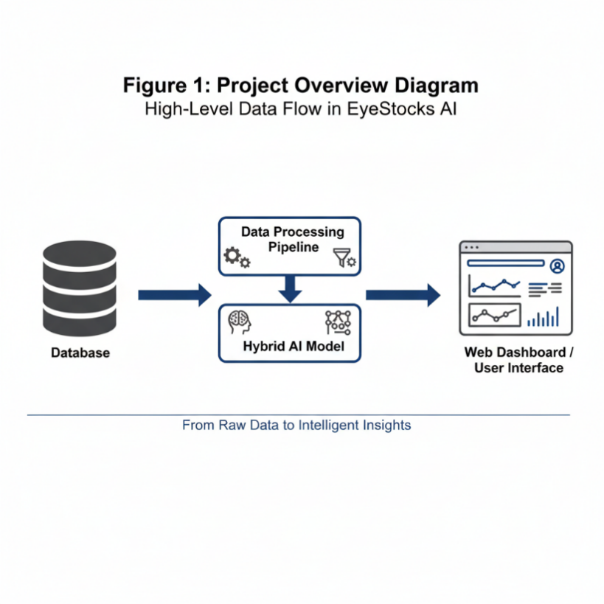
Figure 1:Project Overview Diagram

Chapter 2: Scope and Deliverables

2.1 Project Scope
The scope of EyeStocks AI (ESAI) defines the boundaries, goals, and deliverables of the platform to ensure clarity and focus throughout the project life cycle. The system aims to provide an integrated solution for stock market forecasting, investment simulation, and community engagement, supported by advanced AI models and interactive features.In-Scope

2.1.1 Product Requirements
- Hybrid AI prediction engine using LSTM + XGBoost to forecast next-day stock prices.
- Real-time stock profiles with current prices, daily changes, volumes, and AI-generated forecasts.
- Interactive charts (daily, weekly, monthly, yearly views).
- Forecast Accuracy Tracker to evaluate historical reliability of predictions.
- Virtual Trading Simulator with virtual capital and portfolio tracking.
- User-centered features: watchlists, comments, discussion threads.
- Educational section with learning video.

2.1.2 Process Requirements
- Users will log in to access watchlists, discussions, and trading simulation.
- The system will fetch and preprocess real-time and historical stock data via APIs.
- The AI prediction engine will run daily, generating forecasts stored in the database.
- The frontend (React.js) will interact with backend APIs (Django/Flask) to display live predictions and charts.
- Community features will allow users to interact with each other in stock-specific threads, similar to social media platforms

2.1.3 Data Scope
In the current prototype phase, the platform focuses on a curated dataset of approximately 30 high-volume and trending stocks. This selection is strategically designed to target highly liquid and volatile assets, which are ideal for testing the sensitivity and accuracy of the Hybrid AI model.
The dataset prioritizes "trending" companies that currently dominate market discussions and trading volumes, ensuring that the initial deployment handles data with rich price action and high user interest. The selection maintains a balance between global tech giants and key players in the local Saudi market.
Proposed Distribution:
Table 2:Initial Stock Market Data Coverage
Region | Index/Market | Approx. Count | Justification
United States | Nasdaq 100 / S&P 500 | 20 | Focus on high-growth tech giants (e.g., Apple, NVIDIA, Tesla) with high volatility and data availability.
Saudi Arabia | Tadawul (Main Market) | 10 | Selection of top-performing local blue-chip stocks (e.g., Aramco, Al Rajhi) to ensure local relevance.
Total |  | 30 | Focused dataset for model validation.

This focused approach allows for in-depth performance analysis and faster model retraining cycles during the development phase. The system architecture remains scalable, with provisions to expand the dataset to include the full 30 and broader global indices in future production releases.

2.1.4 Stakeholders
- Primary Stakeholders: Students (development team), project supervisor, evaluation committee.
- Secondary Stakeholders: Potential users (novice and intermediate investors, financial learners).

2.1.5 Beneficiaries
- Academic Community: Gains an innovative prototype demonstrating hybrid AI integration in FinTech.
- Beginner Investors: Gain risk-free learning through the simulator and educational modules.
- Enthusiast Traders: Access AI-based forecasts with community-driven insights.
- Researchers/Developers: May extend or build upon the system (e.g., sentiment analysis, multi-market coverage).

2.1.6 Limitations
- Mobile application development (Android/iOS).
- Integration with real brokerage accounts for live money trading.
- Advanced sentiment analysis of financial news and social media (reserved for future phases).
- Coverage of markets beyond stocks (e.g., crypto, forex, commodities).
- Enterprise-grade security and compliance features (beyond academic prototype scope).

2.2 Alignment with KFU Identity and Societal Impact
EyeStocks AI aligns with King Faisal University’s mission to advance technological innovation, research, and societal contribution:
- Academic and Technological Advancement: ESAI promotes student engagement in AI, data analytics, and financial technology, reinforcing KFU’s position as a hub for innovation and research.
- Societal Impact: The platform encourages financial literacy, informed investing, and risk-free learning for students and community members, contributing to responsible economic practices.
- Innovation and Skills Development: Users develop critical thinking, analytical skills, and AI literacy, supporting KFU’s vision of producing highly skilled and technologically proficient graduates.

2.3 Expected Deliverables & Outcomes
The following outcomes are expected upon the successful completion of the EyeStocks AI (ESAI) project:
- Accurate Stock Market Predictions
  - ESAI will provide reliable next-day stock price predictions for 30 companies, improving decision-making for both new and experienced investors. This is a quantitative outcome, measurable through prediction accuracy metrics such as MAPE and RMSE.
- Enhanced Learning and Investment Understanding
  - Users will gain practical knowledge of stock market trends and technical analysis, helping them understand how AI-driven insights can support investment strategies. This is a qualitative outcome, reflected in improved user confidence and investment literacy.
- Interactive and User-Friendly Platform
  - The platform will feature intuitive dashboards, trading simulations, and community discussions, enabling users to explore, test strategies, and interact with other investors in a risk-free environment. This outcome combines qualitative and quantitative aspects, measured through user engagement metrics.
- Data-Driven Decision Support
  - By integrating a hybrid AI model with historical data and technical indicators, ESAI will enable informed, data-backed investment decisions, reducing emotional bias. This is quantitative, as users can track improvements in portfolio performance using the platform.
- Scalable and Reliable System
  - The project will result in a robust backend and frontend system capable of handling multiple users simultaneously, ensuring continuous access and reliability. This qualitative and quantitative outcome is measurable by system uptime, response time, and scalability tests.

2.4 Legal and Ethical Considerations
The development of EyeStocks AI adheres to strict legal and ethical standards to ensure the responsible use of technology and data.
2.4.1 Legal Aspects
- Data Licensing: The project utilizes historical stock market data obtained from publicly available sources (e.g., Yahoo Finance) strictly for educational and non-commercial research purposes.
- Data Privacy: User data, such as login credentials and portfolio details, is securely stored using hashing algorithms (e.g., bcrypt) to protect privacy. No sensitive personal financial information (like real bank account numbers) is collected, as the platform operates as a simulation.
2.4.2 Ethical Aspects
- Financial Disclaimer: The platform is designed as an educational tool and a decision-support system. It explicitly states that AI predictions are probabilistic and do not constitute professional financial advice, protecting users from potential financial harm.
- Fairness and Transparency: The system provides transparency by displaying "Confidence Scores" and "Error Rates" alongside predictions, ensuring users are not misled by the AI’s capabilities.
- Responsible AI: The model is trained to minimize bias by using objective historical data and is regularly evaluated to prevent the propagation of erroneous market signals.

Chapter 3: Methodology

3.1 Approach & Tools
The development of EyeStocks AI (ESAI) will follow an iterative, step-by-step workflow, moving from raw data collection to a fully functional, user-friendly platform. Each phase builds on the previous one to ensure technical accuracy, reliability, and an excellent user experience.

Phase 1: Data Acquisition and Preparation
Step 1: Data Sourcing
Collect historical stock data (Open, High, Low, Close, Volume) for 30 companies from trusted APIs such as Alpha Vantage, IEX Cloud, and Yahoo Finance.
Step 2: Feature Engineering
Using Python libraries like Pandas and TA-Lib, extract technical indicators such as RSI, MACD, Moving Averages, and Bollinger Bands.
Step 3: Data Cleaning & Normalization
Handle missing values and normalize features with Scikit-learn’s MinMaxScaler to ensure consistent input for neural networks.
Challenges & Strategies:
Table 3: Challenges and Strategies in Data Collection and Preparation
Challenge | Strategy
Incomplete or inconsistent data from APIs | Use multiple sources and implement automated validation checks
Differences in data format between APIs | Standardize datasets into a unified format
Ensuring coverage of all companies | Cross-check datasets from different APIs and fill gaps using alternative sources
Handling missing values without introducing bias | Apply forward/backward filling or interpolation techniques

Phase 2: Hybrid AI Model Development
Step 1: LSTM for Temporal Patterns
Use LSTM to capture sequential dependencies in stock price data and generate baseline next-day predictions.
Step 2: XGBoost for Refinement
Combine LSTM outputs with technical indicators as input to XGBoost to handle non-linear market patterns and noise.
Step 3: Validation & Tuning
Evaluate model performance using MAPE and RMSE, tune hyperparameters, and save the trained pipeline for integration.
Challenges & Strategies:
Table 4:Hybrid AI Model Development Challenges and Mitigation Strategies
Challenge | Strategy
Capturing both sequential and non-linear patterns | Combine LSTM for temporal dependencies with XGBoost for non-linear refinement
Avoiding overfitting | Apply regularization, cross-validation, and hyperparameter tuning
Handling volatile and noisy data | Include technical indicators and smoothing techniques
Ensuring computational efficiency | Optimize model architecture and use batch processing

Phase 3: Backend & API Development
Step 1: RESTful API Design
Build endpoints for predictions, portfolio management, and community features using FastAPI.
Step 2: Database Architecture
Use PostgreSQL to store user accounts, portfolios, watchlists, discussions, and logs of predictions vs. actual outcomes.
Step 3: Model Integration
Embed the hybrid AI model into the backend with automated daily prediction logging.
Challenges & Strategies:
Table 5:Challenges and Strategies in Backend and API Development
Challenge | Strategy
Integrating AI models into live backend | Use modular API design and automated pipelines
Handling large volumes of data | Optimize queries, implement indexing and caching
Ensuring data security and integrity | Apply authentication, encryption, and secure practices

Phase 4: Frontend & User Experience
Step 1: Design & Wireframing
Use Figma to create intuitive layouts for dashboards, trading simulations, and community sections.
Step 2: Frontend Development
Build UI with React, including interactive charts (TradingView or Recharts), portfolio management, and discussion boards.
Step 3: API Integration
Fetch live predictions and data from backend APIs to provide real-time updates.
Challenges & Strategies:
Table 6:Frontend and User Experience Challenges and Strategies
Challenge | Strategy
Designing intuitive UI for all users | Conduct usability testing and iterate design
Smooth real-time data updates | Use WebSocket connections or efficient polling
Cross-device accessibility | Implement responsive design and cross-platform testing

Phase 5: Integration, Testing, and Deployment
Step 1: System Integration
Connect backend, frontend, and database in a staging environment.
Step 2: Testing
Conduct unit, integration, and end-to-end tests. Perform User Acceptance Testing (UAT).
Step 3: Deployment
Deploy on cloud platforms such as AWS or Heroku, making the system accessible to users.
Challenges & Strategies:
Table 7:System Integration and Quality Assurance Challenges
Challenge | Strategy
Seamless interaction between components | Full integration testing in staging
Detecting and fixing bugs | Automated testing + UAT
Scaling for multiple users | Cloud deployment with load balancing and monitoring
Ensuring real-world reliability | Implement monitoring and logging systems
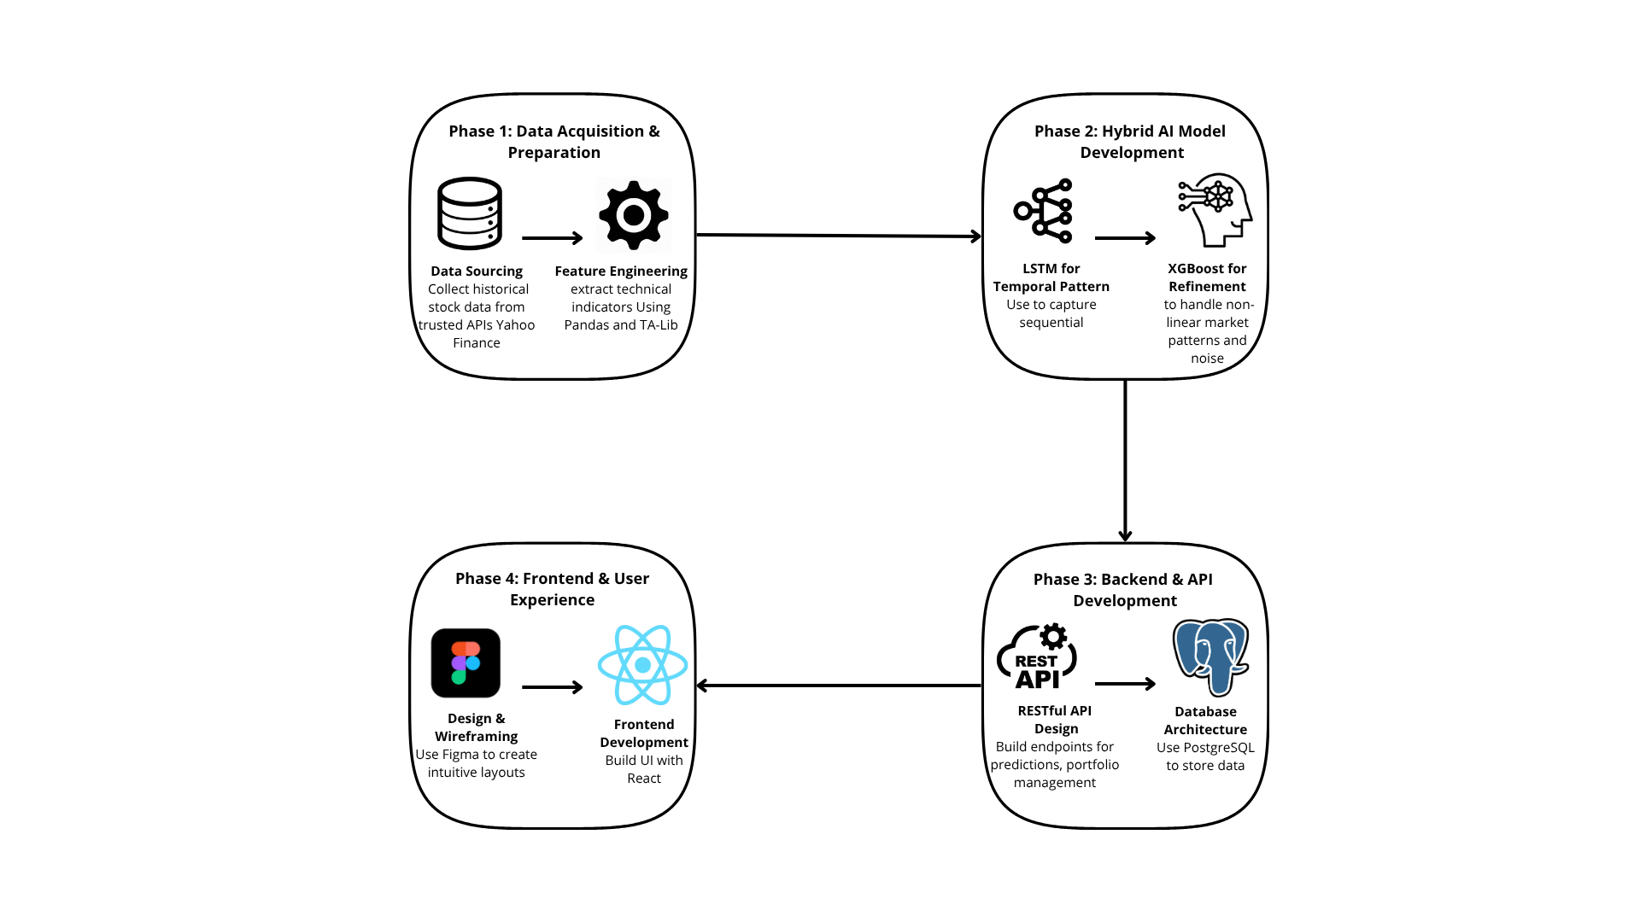
Figure 2:Approach and Tools

3.2 Challenges
Developing an AI stock market prediction and suggestion system poses some technical challenges:

3.2.1 Data Collection and Preprocessing
Stock market data is vast, fast-evolving, and of diverse sources. Pre-processing streaming data in real-time, upholding accuracy, and pre-processing noisy or missing data sets is a serious challenge that needs excellent data engineering and API integration skills.

3.2.2 Predictive Modeling
Building accurate AI models for stock price prediction is technically daunting because financial markets are very unstable and have so many factors that are unquantifiable in nature. It requires advanced data science, statistical, and model tuning know-how to develop and train machine learning or deep learning models that generalize and don't overfit.

3.2.3 Scalability and Performance
The system must handle large data volumes and user requests effectively. Low-latency prediction and recommendation necessitate thorough system architecture, database, and cloud infrastructure planning.

3.2.4 User-Centric Design
Translating complex AI outputs into clear, actionable insights for users is challenging when creating intuitive interfaces and visualizations. This involves reconciling technical abilities with user experience (UX) design principles.

3.2.5 Risk and Reliability
Financial forecasts are high-stakes. Ensuring the system provides good explanations of its suggestions and incorporates protection against deceptive output is a key challenge that has relevance for adoption and trust by users.

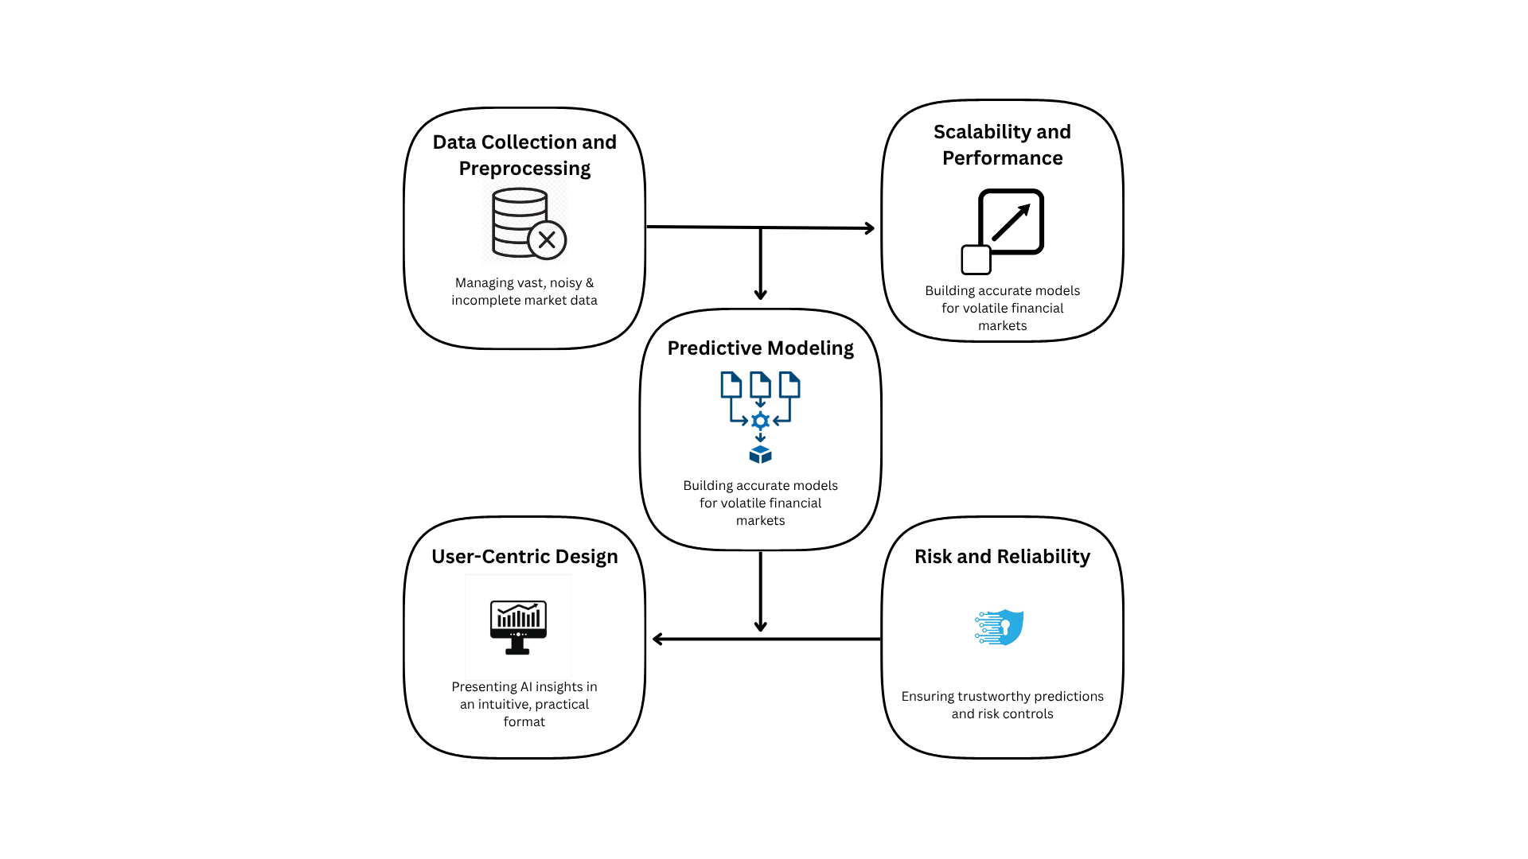
Figure 3:Challenges
These are challenges that make the project ambitious and require skills in machine learning, data analytics, software development, and system design. Nonetheless, they can be met through thorough planning and teamwork and will yield an innovative and impactful system.

3.3 Alternative Approaches
The development of such an advanced system as EyeStocks AI did require decisive choices on its core technologies. The decision was not between the best tools, but most appropriate to fulfill the project's distinctive goals of accuracy, transparency, and ease of use. This section reports the alternative methods employed for the AI model and system architecture, and the rationale for our ultimate choice.

3.3.1 AI Model Selection: Justifying the Hybrid Approach
The foundation of the EyeStocks AI platform is its prediction engine. Different modeling approaches were explored to determine which best suited financial prediction.

- Alternative 1: Independent LSTM Model
One of the methods that was considered in earnest was to employ a Long Short-Term Memory (LSTM) model alone. LSTMs are capable of interpreting sequential data very well and are especially good at identifying long-term trends and patterns in the past price action of a stock. There is, however, a constraint to such a methodology. While scanning the past sequence almost exclusively, a single LSTM misses the immediate impact of non-sequential technical indicators (like RSI and MACD) that are crucial for short-term tactical action.

- Alternative 2: Statistical and Machine Learning Hybrid (ARIMA + XGBoost)
A powerful alternative considered was a hybrid model blending classical statistics with machine learning by combining ARIMA and XGBoost. In this two-step approach, the ARIMA model first captures linear trends from the price history to generate a baseline forecast. The XGBoost model is then trained specifically to predict the errors of that forecast, using additional features to model the complex, non-linear market behavior. The final, more robust prediction is the sum of the ARIMA forecast and XGBoost's error correction.

- Selected Solution: A Hybrid of XGBoost and LSTM
We discovered that the most powerful solution was a hybrid model with a balance of the two different expert systems' strengths. In this "expert duo" framework, each model performs a distinct, complementary function:
  - The LSTM model is the "Strategist," looking at the entire history of prices to elicit the underlying long-term trends and provide a sound baseline estimate.
  - The XGBoost model then acts as the "Tactician," taking the LSTM's baseline forecast and refining it. It does this by introducing wide arrays of real-time, up-to-the-second technical indicator information, effectively fine-tuning the prediction in line with current market signals.
This hybrid methodology was embraced because it mirrors the human decision-maker's process: know what has occurred in the past first, and only then react to what is occurring currently. The result is a more robust and reliable forecast that not only strategically makes sense, but is also tactically sharp.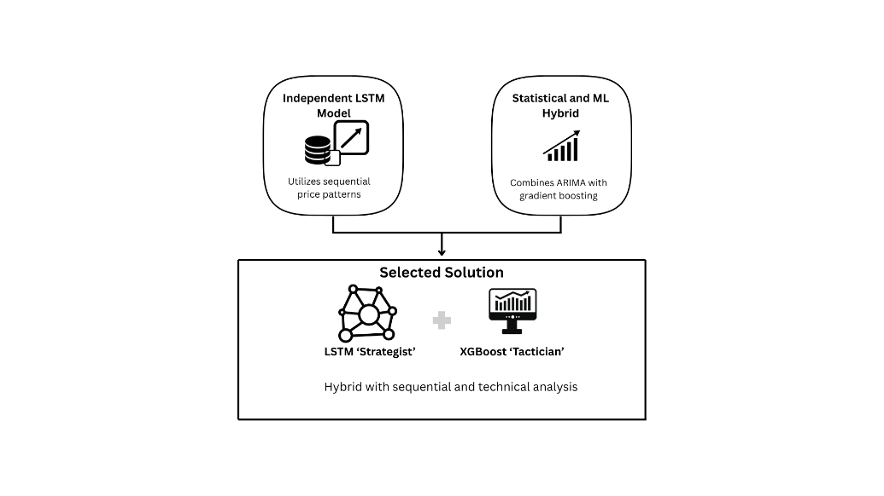
Figure 4:Alternative Approaches

3.3.2 System Architecture: Reason for the Decoupled Structure
The architecture of the platform is just as crucial as the AI model that it supports. The primary goal was to develop a system that is efficient, reliable, and flexible for future development.
- Alternative 1: Monolithic Architecture
A monolithic design, where the frontend and backend are both built as one, tightly-coupled unit of code, was considered. While occasionally it can speed up initial setup, it creates significant long-term problems. Without decoupling, a change to the frontend could destroy the backend, making the system inflexible, brittle, and slow to adapt over time.
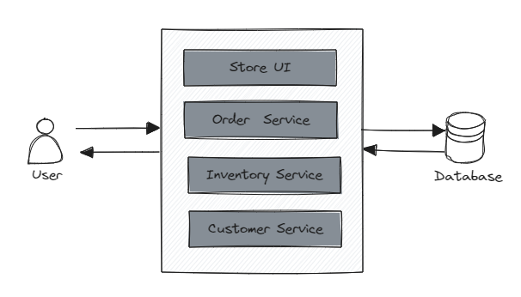
Figure 5:Monolithic Architecture

- Selected Methodology: Decoupled Frontend and Backend Architecture
We chose to have a modern, decoupled architecture that builds the server-side and user-facing parts separately.

  - The Backend (FastAPI): It's the high-performance backbone of the platform. It takes care of all the heavy work, including database communication, running the AI prediction models, and data processing with utmost efficiency and speed.
  - The Frontend (React): This is the pretty, interactive component the user sees and interacts with. Since it is separated from the backend, it can be highly optimized for speed and responsiveness, with a smooth, app-like experience in the user's browser.
This decoupling of concerns creates a more robust and sustainable foundation. Our data engine teams can improve the data engine without interfering with the user experience, and vice versa. To our users, this translates to a faster, more reliable platform that can continuously be enhanced for years to come
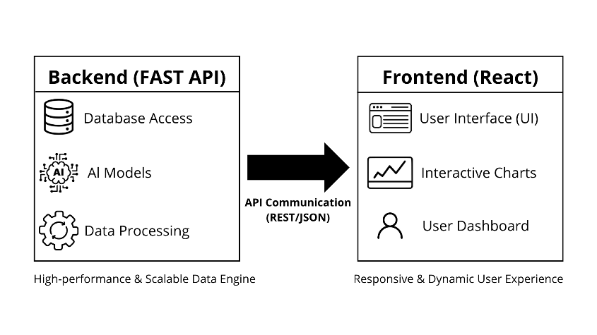
Figure 6:Decoupled Architecture

Chapter 4: Project Requirements
This chapter presents the specific requirements of the project under hardware and software requirements, functional requirements that define what is to be performed by the system, and non-functional requirements that define how the system will operate.

4.1 Hardware and Software Needs

4.1.1 Hardware
- NVIDIA RTX GPU: Required for the efficient training of the AI models.
- Developer Laptops/PCs: For regular coding, testing, and frontend development.
- Hosting Environment: A server for deploying the final system.

4.1.2 Software
- Programming Languages: Python (for machine learning), JavaScript/React (for frontend).
- Machine Learning Libraries: TensorFlow/Keras, XGBoost, Scikit-learn, Pandas, NumPy.
- Database: PostgreSQL or MySQL for storing stock data and user accounts.
- Backend Framework: FastAPI or Django REST for API services.
- Frontend Framework: React with visualization libraries (e.g., Recharts, D3.js).
- Version Control: Git/GitHub for collaboration.
- Project Management Tools: Notion, Trello, MS Project, or GitHub Projects.

4.1.3 Datasets
- Historical Stock Data: Daily OHLCV (Open, High, Low, Close, Volume) data.
- Live Stock Market Feeds: From APIs like Yahoo Finance or Alpha Vantage.
- Technical Indicators: Computed features like RSI, MACD, and moving averages.

4.2 Functional Requirements

4.2.1 User Management
- Users can register and log in securely.
- Each user has a public profile to post insights, comments, and display watchlists.
- Users can create and manage personal stock watchlists.

5.2.2 Data Input & Processing
- Automatic collection of historical stock market data from APIs.
- Calculation of various technical indicators (RSI, MACD, etc.).
- Real-time updates of stock prices, volumes, and market changes.

4.2.3 Prediction & Recommendation
- An LSTM model generates next-day baseline forecasts.
- An XGBoost model refines the LSTM predictions using engineered features.
- The system outputs Buy/Sell/Hold recommendations with a confidence level.
- A Forecast Accuracy Tracker compares past forecasts with actual results.

4.2.4 Visualization & Interaction
- Interactive stock charts with selectable timeframes (daily, weekly, monthly, yearly).
- Charts display historical prices, forecasts, and technical indicators.
- A virtual trading simulator allows users to trade with virtual money.

4.2.5 Community Features
- A social-like environment where users can post comments and interact.
- Stock-specific discussion threads for focused conversations.
- Risk-aware design to prevent herd behavior.

4.2.6 System Outputs
- Comprehensive stock profiles showing current prices, AI forecasts, and recommendations.
- Reports on prediction accuracy and user performance in the simulator.
- Summaries of community discussions for each stock.

4.3 Non-Functional Requirements

4.3.1 Performance
- Prediction Latency: Must be less than 2 seconds for a single stock query.
- support up to 100 concurrent users

4.3.2 Scalability
- The architecture must allow for future expansion to cover more markets.
- Modular design to easily add new models or features.

4.3.3 Security
- Secure authentication and authorization (JWT or OAuth2).
- Encrypted data transmission (HTTPS/SSL).
- Protection of personal data from unauthorized access.

4.3.4 Usability
- A clean, intuitive interface with simple navigation.
- Responsive design for both desktop and mobile devices.
- Clear and easy-to-interpret visualizations.

4.3.5 Reliability & Availability
- System uptime of at least 95% during operational hours.
- Automated error logging and recovery mechanisms.

4.3.6 Maintainability
- Modular code structure with clear documentation.
- Version control using GitHub for tracking changes.
- A pipeline for regular updates and retraining of machine learning models.

Chapter 5: System Design and Architecture
This chapter provides an overview of the architectural blueprint of the ESAI platform and demonstrates in detail how the functional requirements developed in previous milestones will be converted into a robust, scalable, and user-centric technical solution. The high-level system components, the rationale for design decisions, database schema, and user interface design are also elaborated upon

5.1 System Architecture Overview
The ESAI platform is built on a modern, decoupled Three-Tier Architecture, designed to ensure modularity, scalability, and ease of maintenance. As illustrated in Figure 7, the system separates concerns into three distinct layers: the Presentation Tier (Frontend), the Application Logic Tier (Backend), and the Persistence Tier (Data Layer). This separation allows each component to evolve independently while communicating seamlessly through secure APIs.
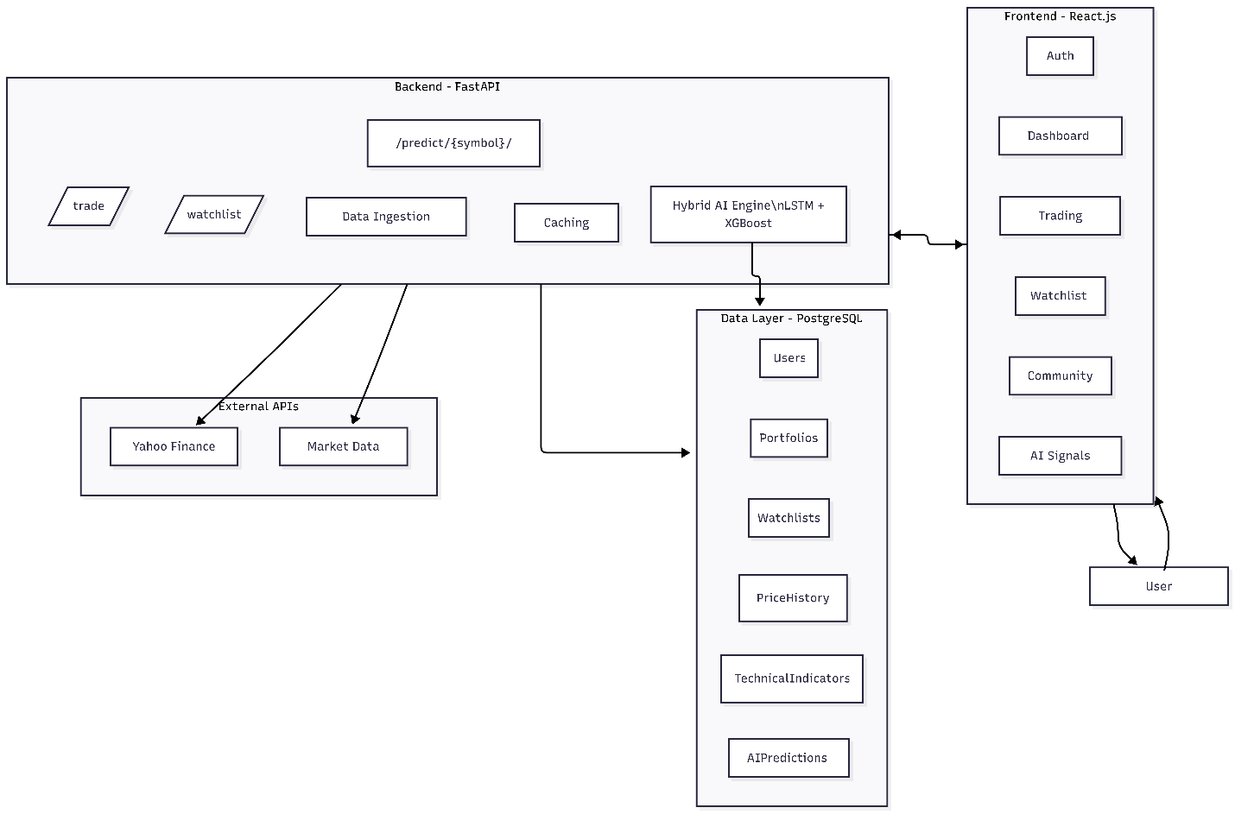
Figure 7:High-Level System Architecture of the EyeStocks AI Platform.

5.1.1 Frontend Layer (Presentation Tier)
The user interface is developed using React.js, a component-based library that ensures a dynamic and responsive user experience. This layer is responsible for:
- User Interaction: Handling authentication (Login/Register), navigation, and input forms.
- Data Visualization: Rendering interactive financial charts using libraries like Recharts, displaying real-time stock updates, and visualizing AI confidence scores.
- Simulation Interface: Providing the dashboard for the virtual trading simulator and portfolio management.
- Community Hub: Facilitating user discussions through comment threads and social interaction features.

5.1.2 Backend Layer (Application Logic Tier)
The core logic of the application resides in the backend, powered by FastAPI (Python). This layer acts as the orchestrator of the system, handling:
- API Management: Exposing RESTful endpoints (e.g., /predict/{symbol}, /trade) to serve data to the frontend.
- AI Integration: Executing the Hybrid AI Engine (LSTM + XGBoost) pipeline to generate stock forecasts on demand or via scheduled tasks.
- Business Logic: managing virtual trade executions, verifying user funds, and enforcing business rules for the simulator.
- Caching Strategy: Implementing caching mechanisms to ensure that prediction latency remains below the target of 2 seconds.

5.1.3 Data Layer (Persistence Tier)
Data persistence is managed by PostgreSQL, a robust Object-Relational Database Management System (ORDBMS). This layer is critical for storing:
- User Data: Accounts, profiles, and authentication tokens.
- Financial Data: Historical OHLCV (Open, High, Low, Close, Volume) records for over 30 trending stocks.
- Transactional Data: Virtual portfolios, trade history, and watchlist configurations.
- Analytical Data: AI-generated predictions, accuracy logs, and model performance metrics.

5.1.4 External Integrations
The system integrates with external third-party services to ensure data accuracy:
- Market Data APIs: The backend communicates with APIs like Alpha Vantage and Yahoo Finance to fetch both real-time market prices and historical datasets required for model training.

5.2 Design Justification
The architectural decisions for ESAI were made after a rigorous evaluation of various alternatives to ensure alignment with the project's goals of accuracy, usability, and scalability.

5.2.1 Rationale for Decoupled Architecture
A decoupled architecture (separating Frontend and Backend) was chosen over a traditional Monolithic approach.
- Scalability: The frontend and backend can be scaled independently based on load. For instance, the heavy AI computation on the backend can be optimized without affecting the user interface's responsiveness.
- Flexibility: This structure allows for the potential development of native mobile apps (iOS/Android) in the future that can consume the same backend API without modification.
- User Experience: React.js enables a "Single Page Application" (SPA) feel, where transitions are instantaneous, mimicking a desktop application, which is crucial for a trading platform.

5.2.2 Technology Selection Rationale
The technology stack was selected to balance performance with development efficiency:
- React.js: Chosen for its rich ecosystem of financial visualization libraries and component reusability.
- FastAPI: Selected for its high performance (asynchronous support), automatic documentation generation, and seamless integration with Python's data science ecosystem (Pandas, TensorFlow, XGBoost).
- PostgreSQL: Preferred over NoSQL databases due to the structured nature of financial data and the need for complex queries and transactional integrity (ACID compliance) in the trading simulator.

5.3 Database Design
The database schema is the backbone of the ESAI platform, designed to efficiently handle high-frequency market data and complex user relationships.

5.3.1 Entity Relationship Diagram (ERD)
Figure 8 illustrates the detailed Entity Relationship Diagram (ERD) of the system. The schema is normalized to reduce redundancy while optimizing for read-heavy operations typical in financial applications.
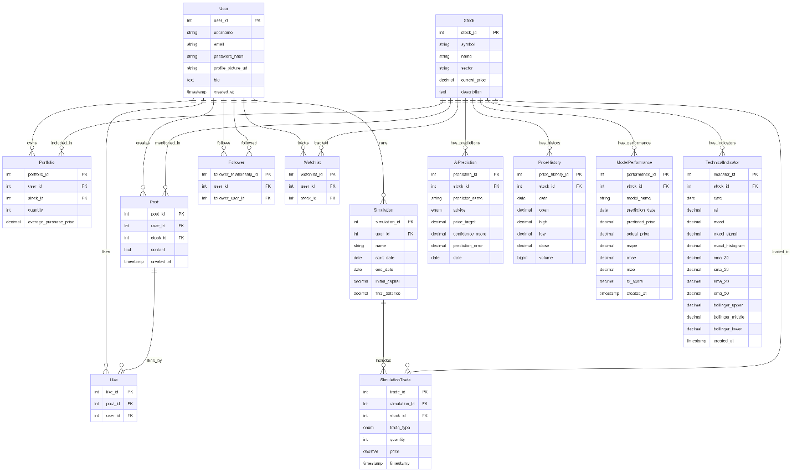
Figure 8:Entity Relationship Diagram (ERD) of the EyeStocks AI Database.

5.3.2 Detailed Schema Description
The database entities are categorized into three main clusters:
- The Market Data Module:
  - Stock: The central entity storing static details (Symbol, Name, Sector) for each company.
  - PriceHistory: A massive table storing daily OHLCV records. A composite unique constraint on (stock_id, date) ensures data integrity.
  - TechnicalIndicator: Stores pre-computed values (RSI, MACD, SMA) to speed up AI processing and reduce runtime computation.
- The AI Prediction Module:
  - AIPrediction: Stores the daily forecasts generated by the Hybrid Model, linked to specific stocks and dates. This allows the system to display historical accuracy tracks.
  - ModelPerformance: Logs performance metrics (MAPE, Accuracy) to monitor model health and trigger retraining when necessary.
- The User & Simulation Module:
  - User: Manages authentication and profile data.
  - Simulation & SimulationTrade: These tables track the user's virtual portfolio performance. SimulationTrade records every buy/sell action to reconstruct portfolio history.
  - Social Entities (Post, Comment, Like): Facilitate community engagement and knowledge sharing among investors.

5.3.3 Data Integrity and Optimization
To maintain performance as the dataset grows into millions of rows:
- Indexing: Indices are applied to frequently queried columns like stock_id, date, and user_id, reducing query time from linear O(N) to logarithmic O(log N) complexity.
- Precision: Financial values (prices, balances) use the DECIMAL data type instead of FLOAT to prevent rounding errors, which is critical for accurate financial simulation.

5.4 System Modeling
To further detail the system's behavior and interactions, standard UML diagrams were developed.

5.4.1 Use Case Diagram
Figure 9 depicts the primary actors (User, Admin, AI Engine) and their interactions with the system. It highlights core functionalities such as "View Interactive Chart," "Use Virtual Trading Simulator," and "Receive Buy/Sell Recommendations".
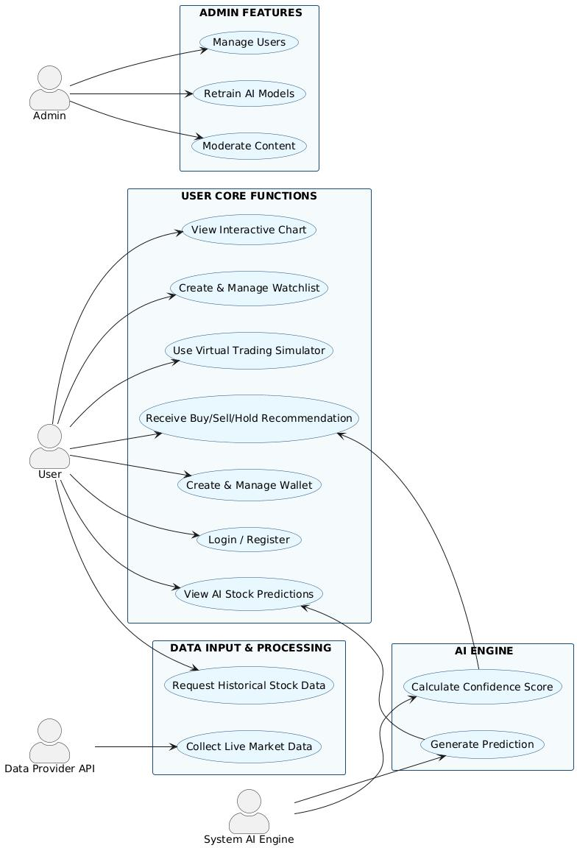

Figure 9:Use Case Diagram illustrating user and admin interactions.

5.4.2 Sequence Diagrams
Sequence diagrams visualize the step-by-step flow of logic for critical system operations.
- Prediction Request Flow (Figure 10): This diagram details the process from the user selecting a stock to the display of the AI prediction. It highlights the backend's logic of checking the cache first before triggering the Hybrid AI Model or fetching new data.
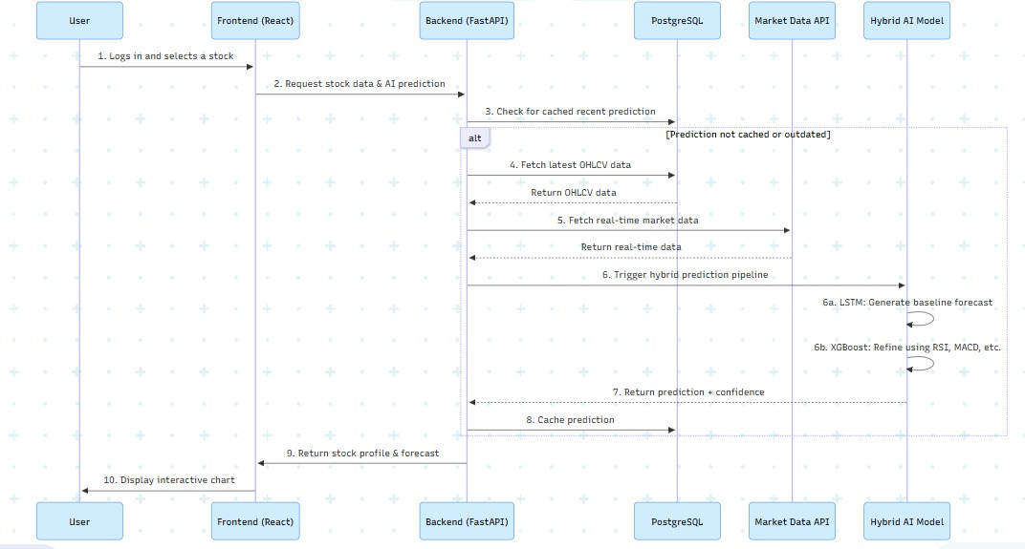
Figure 10: Sequence Diagram for generating and retrieving AI stock predictions.
- Virtual Trade Execution Flow (Figure 11): This diagram illustrates the logic for executing a trade in the simulator. It shows the validation steps (checking funds) and the transactional updates to the user's portfolio in the database.
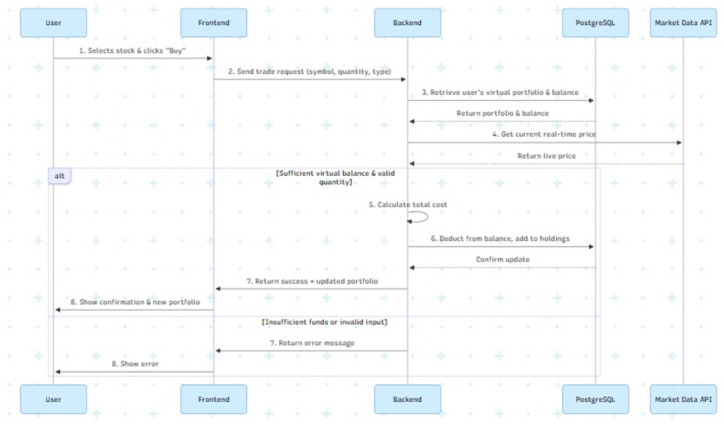
Figure 11:Sequence Diagram for executing a buy/sell order in the virtual simulator.

5.5 User Interface Design (Prototype)
The user interface is designed with a focus on clarity and data accessibility. The following screenshots from the initial prototype demonstrate the implementation of the design principles.

5.5.1 Dashboard and Stock Analysis
The main dashboard (Figure 12) provides users with a comprehensive view of market trends. The Stock Details page (Figure 13) integrates the interactive price chart with the AI-generated "Green Line" prediction and confidence score, enabling users to make informed decisions at a glance.
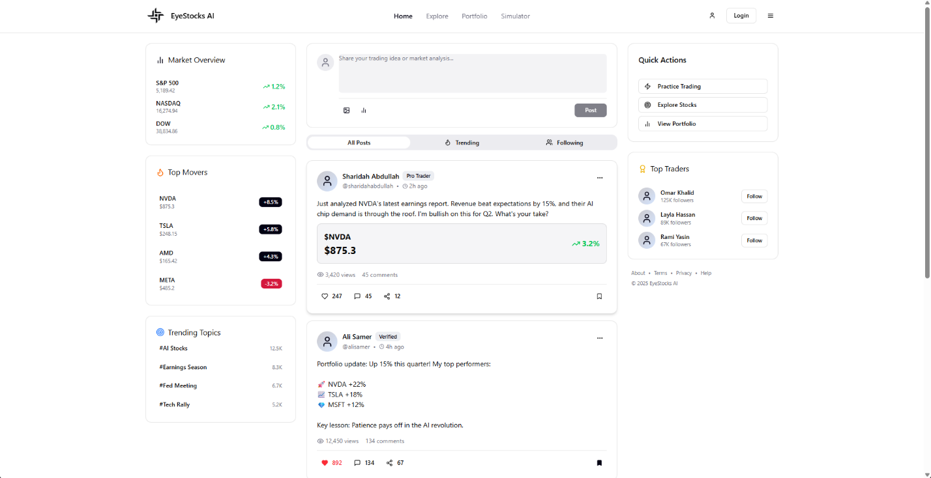
Figure 12:EyeStocks AI Main Dashboard.
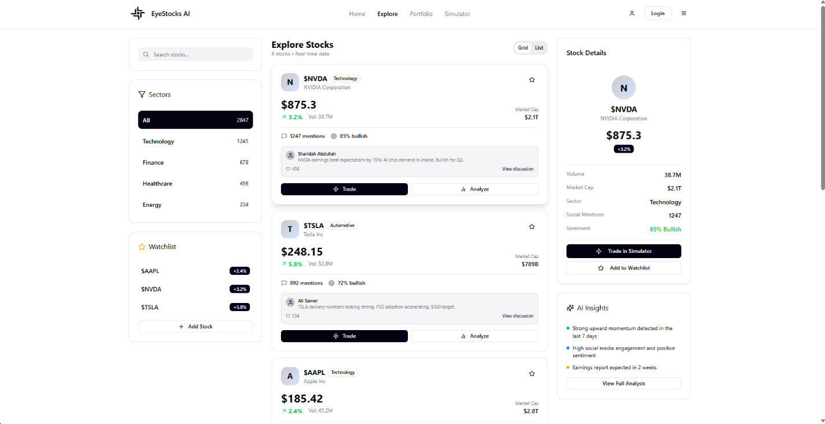
Figure 13:Stocks market Page.

5.5.2 Virtual Simulator
The simulator interface (Figure 14) allows users to manage their virtual portfolio, view current holdings, and execute trades in a risk-free environment that mirrors real market conditions.
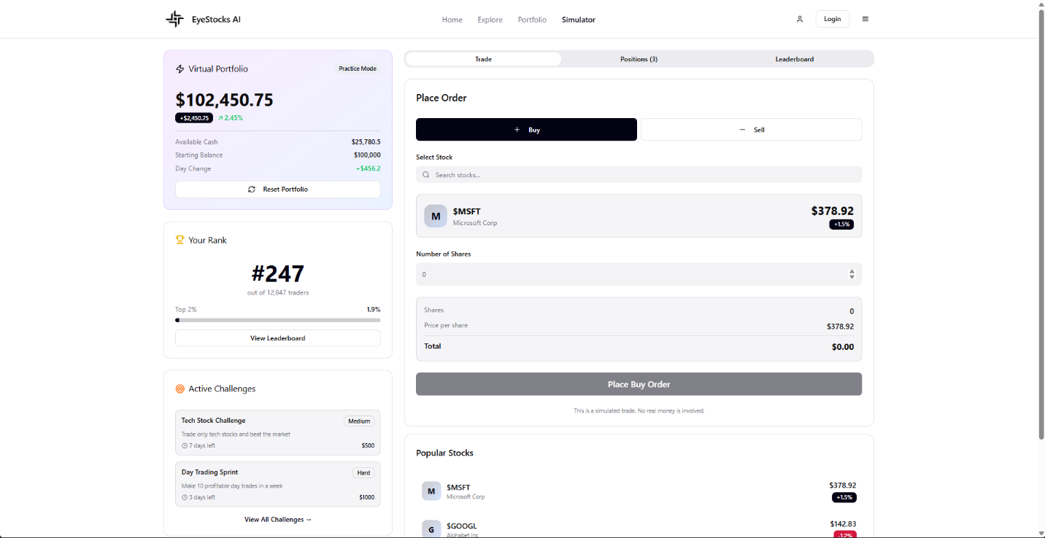
Figure 14:Virtual Trading Simulator and Portfolio Management Interface.

Chapter 6: Technical Implementation
This chapter documents the practical realization of the EyeStocks AI system. It details the development environment, the software stack employed, and the core algorithmic implementations for data engineering and AI forecasting. The focus is on the translation of the system design (Chapter 5) into functional, production-ready code.

6.1 Development Environment & Tools
The system was developed using a modern, open-source technology stack selected for its performance in data science and web applications¹. The core development environment consists of:
- Programming Language: Python 3.10+ (Backend & AI), JavaScript ES6+ (Frontend).
- IDE: Visual Studio Code (VS Code) utilized for code editing and debugging.
- Database Engine: PostgreSQL 15, managed via pgAdmin 4 for schema verification and query optimization².
- Version Control: Git and GitHub for source code management and collaboration.
Key Libraries and Frameworks:
- Data Processing: Pandas, NumPy for vectorised operations and time-series manipulation.
- Machine Learning: TensorFlow (Keras) for LSTM networks, XGBoost for gradient boosting, and Scikit-learn for data scaling and metrics³.
- Backend API: FastAPI for high-performance asynchronous REST endpoints⁴.
- Data Acquisition: yfinance for fetching market data and SQLAlchemy for ORM database interactions.

6.2 Phase 1: Data Acquisition and Engineering Pipeline
The foundation of the AI engine is the ETL (Extract, Transform, Load) pipeline. This module, implemented in the fetch_store.py script, manages the ingestion of raw financial data and the computation of technical indicators required for model training.

6.2.1 Data Ingestion Logic
The system fetches historical OHLCV (Open, High, Low, Close, Volume) data. To ensure data integrity, the implementation includes a "Defensive Check" mechanism that validates the presence of all required columns before processing, preventing runtime errors during training.

6.2.2 Feature Engineering Implementation
To enhance the predictive power of the model, raw price data is transformed into technical indicators. The code calculates Simple Moving Averages (SMA), Relative Strength Index (RSI), and Moving Average Convergence Divergence (MACD) using rolling window operations.

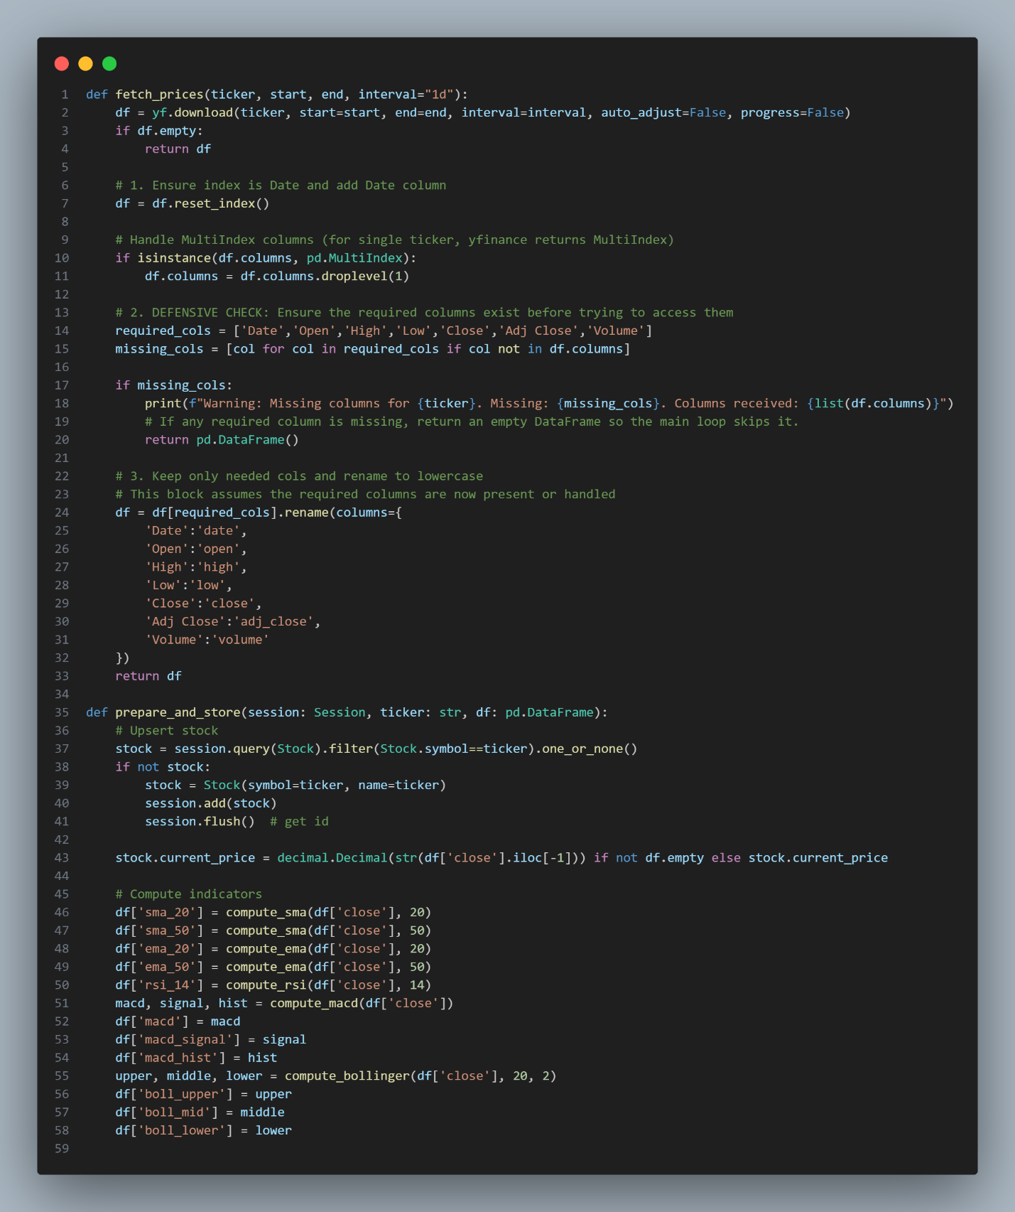

Figure 15:Data Acquisition and Processing Logic:

6.3 Phase 2: The Hybrid AI Engine Implementation
The core intelligence of EyeStocks AI is implemented in the eyestocks_hybrid_model.py script. This module executes the "Strategist & Tactician" architecture described in the system design.

6.3.1 Strict Time-Based Splitting Strategy
The implementation executes a strict chronological split to simulate real-world forecasting conditions and to avoid data leakage —look-ahead bias:
- Training Set: 2018-01-01 to 2024-01-01.
- Testing Set: 2024-01-01 to 2025-12-10.
Scaling: This involves fitting MinMaxScaler on the training data only before applying to the test data as that would ensure that the model never sees future ranges during training.

6.3.2 The Champion Selection Algorithm
The implementation follows a "Champion Selection" loop. Other than a single training run, the system trains 5 candidate models in parallel. Each candidate consists of an LSTM network (for trend detection) and an XGBoost regressor (to correct residual errors). Each candidate system evaluates on the test set; the model giving the lowest MAPE is automatically selected as the "Champion" for final predictions.


Figure 16:Champion Selection Training Loop

6.4 Core Algorithmic Framework: The Hybrid Ensemble Approach
The EyeStocks AI engine relies on sophisticated Hybrid Ensemble Learning architecture. Rather than relying on a single model, which often suffers from either high bias (underfitting) or high variance (overfitting) in financial contexts, this system combines two distinct algorithmic paradigms: Deep Learning (LSTM) and Gradient Boosting (XGBoost).
This section details the mathematical functioning of these algorithms and justifies their selection based on their specific strengths in handling financial time-series data.

6.4.1 Long Short-Term Memory (LSTM) – The "Strategist"
Theoretical Basis: LSTM is a specialized architecture of Recurrent Neural Networks (RNNs) designed to overcome the "vanishing gradient problem" found in standard RNNs. In financial forecasting, past market behaviors (from weeks or months ago) often influence future trends. Standard RNNs struggle to retain this long-term information.
Why it is Powerful for ESAI:
- Sequential Memory: Unlike standard regression models that treat data points independently, LSTM processes data as sequences. It utilizes internal "gates" (Forget Gate, Input Gate, Output Gate) to regulate the flow of information, deciding what to keep and what to discard from the stock's history.
- Trend Detection: This allows the model to capture temporal dependencies and long-term trends (e.g., a bullish momentum sustained over 60 days) that statistical models like ARIMA might miss.
In the ESAI architecture, the LSTM is tasked with minimizing the Mean Squared Error (MSE) of the raw price sequence, effectively generating the Baseline Trend Prediction.

6.4.2 eXtreme Gradient Boosting (XGBoost) – The "Tactician"
Theoretical Basis: XGBoost is an optimized distributed gradient boosting library designed to be highly efficient, flexible, and portable. It implements machine learning algorithms under the Gradient Boosting framework. It builds an ensemble of weak prediction models (typically decision trees) sequentially, where each new tree attempts to correct the errors of the previous ones.
Why it is Powerful for ESAI:
- Handling Non-Linearity: Stock markets are influenced by technical indicators (RSI, MACD, Volume) that do not have a linear relationship with price. XGBoost excels at mapping these complex, non-linear feature interactions.
- Regularization: Unlike standard Random Forests, XGBoost includes L1 (Lasso) and L2 (Ridge) regularization, which prevents the model from overfitting to market noise—a common pitfall in financial AI.
- Residual Learning: In our system, XGBoost is not trained on the price itself, but on the residuals (the difference between the Actual Price and the LSTM’s prediction).

6.4.3 The Power of Residual Learning (The Hybrid Synergy)
The distinct innovation in EyeStocks AI is the Residual Learning Framework. This approach is mathematically formulated as:
$$P_final=F_LSTM (X_sequence )+F_XGB (X_indicators )$$
Where:
- $F_LSTM$ predicts the macroscopic trend.
- $F_XGB$ predicts the microscopic error (residual) based on technical volatility.
Justification of the Hybrid Approach: By combining these two, the system achieves Error Cancellation. The LSTM may lag during sudden market spikes (a common weakness of deep learning in finance). However, the XGBoost layer, analyzing immediate indicators like a spike in Volume or RSI, detects this potential error and adds a corrective value. This synergy is what allows the system to achieve a MAPE of 2.20%, significantly outperforming either algorithm used in isolation.

6.4.4 Optimization Strategy: The "Champion Selection" Algorithm
The Problem of Stochasticity: Neural networks, including LSTMs, are initialized with random weights. This stochastic nature means that two training runs on the exact same data can yield slightly different results. In a financial context, relying on a single "lucky" or "unlucky" training run is risky and unprofessional.
The Solution: To guarantee consistency and reliability, EyeStocks AI implements a "Champion Selection" meta-algorithm. Instead of training a single model, the system acts as an orchestrator that manages a competitive training environment.
Algorithmic Logic:
- Parallel Candidate Generation: The system instantiates N independent candidate models (where N=5 in the current implementation).
- Independent Training: Each candidate undergoes the full training pipeline (LSTM for trend + XGBoost for residuals) in isolation.
- Validation: Each candidate is evaluated against the unseen Test Set (2024-2025).
- Selection Criteria: The system compares the MAPE (Mean Absolute Percentage Error) of all candidates.
$$Champion =\arg{\min_{m ∈Candidates}\left(MAPE_{m}\right)}$$
- Deployment: Only the model with the minimum error is saved and deployed to the API, while the sub-optimal models are discarded.
Significance: This strategy ensures that the user is always served by the statistically best-performing version of the AI, effectively filtering out initialization bias and ensuring the system operates at its peak potential.

Chapter 7: Initial Results and Validation
This chapter presents the experimental results obtained from the initial prototype of the EyeStocks AI engine. The objective of this evaluation is to validate the effectiveness of the Hybrid LSTM-XGBoost architecture against the performance metrics defined in the project proposal. The testing was conducted using a strict time-series split, ensuring that the model was evaluated on unseen market data from 2024 to 2025.

7.1 Prototype Performance Metrics
The performance of the "Champion Model" was evaluated using the Mean Absolute Percentage Error (MAPE), which measures the average magnitude of errors produced by the model.

7.1.1 Accuracy Results
The results demonstrate that the system has successfully met and exceeded the project's SMART objectives.
Table 8:Performance Comparison against Objectives
Metric | Target (Proposal) | Achieved (Prototype) | Status
Prediction Accuracy (MAPE) | < 5.00% | 2.20% | Exceeded Expectations
Directional Accuracy | > 45.00% | 49.72% | Validated

The achieved MAPE of 2.20% indicates that the residual correction layer (XGBoost) effectively refined the LSTM's baseline predictions. This level of precision is significantly higher than standalone statistical models, confirming the viability of the hybrid approach for short-term stock forecasting.

7.2 Confidence and Risk Analysis
Beyond raw accuracy, the system's ability to quantify risk was tested using the Confidence Interval (CI) algorithm implemented in the backend.

7.2.1 Confidence Validation
In the latest forecast simulation for December 9, 2025, the system generated the following risk metrics:
- Predicted Price: $271.14
- Actual Closing Price: $277.18
- 95% Confidence Interval: [$260.12 — $282.15]

Critically, the actual price ($277.18) fell well within the predicted 95% confidence interval range. This validates that the system's risk assessment algorithms are correctly calibrated to encompass market volatility.

7.2.2 AI Confidence Score
Based on the model's recent stability and low error rate, the system generated an AI Confidence Score of 95.28%. In the user interface, this translates to a "Strong Signal," providing investors with a clear, quantifiable metric to gauge the reliability of the forecast before making a trade.

7.3 Visual Validation
Visual inspection of the prediction plots confirms the model's robustness and tracking capability.
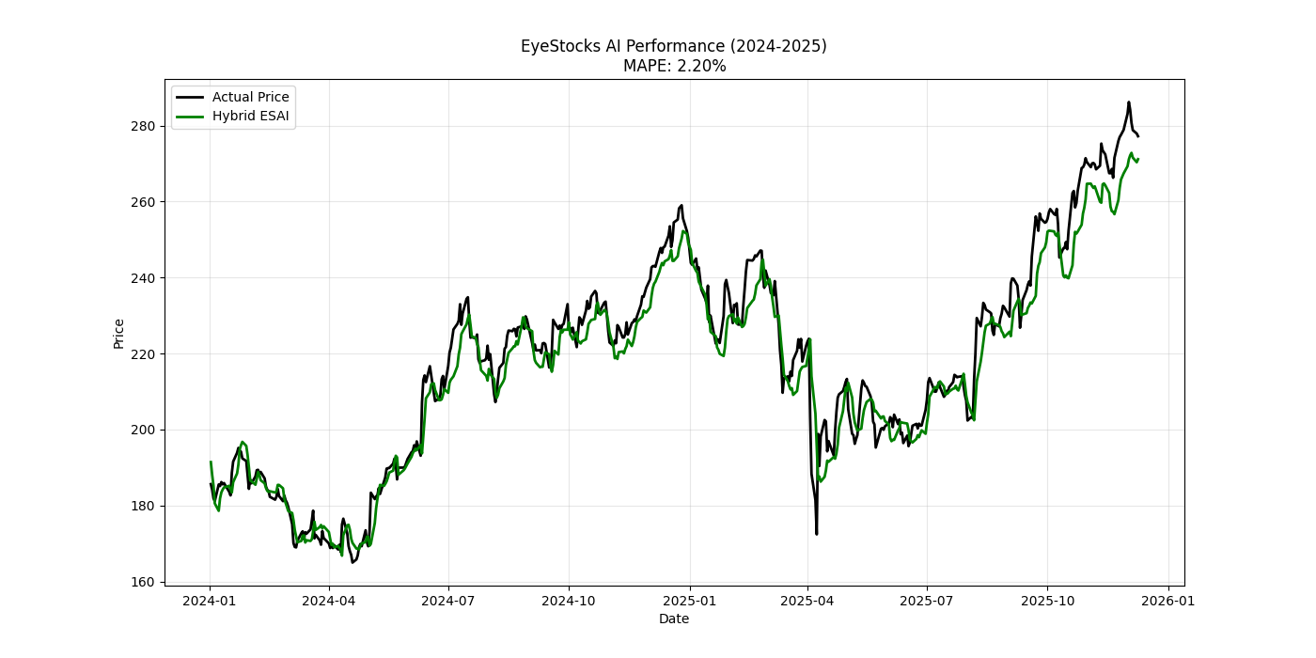
Figure 17:Performance evaluation of the EyeStocks AI Hybrid Model. The plot demonstrates long-term stability over the testing period (2024-2025) and highlights the model's high precision in tracking daily price movements during volatile market phases.
As illustrated in Figure 17, the Green line (Hybrid Prediction) maintains a tight correlation with the Black line (Actual Price) throughout the testing period. The model demonstrates two key behaviors:
- Stability: Over the long term (175+ days), it avoids significant "drift" or lag, maintaining a consistent error margin.
- Responsiveness: In the zoomed-in detail, the model effectively captures sudden price corrections, proving that the XGBoost layer successfully filters market noise to deliver actionable insights.

Chapter 8: Implementation Details

8.1 Database Implementation
The system uses PostgreSQL as the relational database management system. The backend communicates with the database using SQLAlchemy ORM in Python to ensure secure and efficient data operations. The database schema is divided into three main sections:
Core Data Tables such as stocks, price_history, and technical_indicators store company information, historical stock prices, and technical indicators (e.g., RSI and MACD) used for analysis and AI predictions.
User Authentication & Social Tables including users, oauth_providers, and email_verifications manage user accounts and authentication. Additional tables like user_stats and user_follows support user statistics and social interaction features.
Portfolio Management Tables such as portfolio_cash, portfolio_holdings, and portfolio_transactions manage the user's virtual balance, owned stocks, and trading history within the platform..

8.2 AI Model Implementation
The prediction system in EyeStocks AI uses a hybrid architecture that combines deep learning and machine learning models to improve prediction accuracy.
LSTM (Long Short-Term Memory) This model analyzes historical stock prices using time-series data (typically the last 60 trading days) to capture long-term trends in stock movements.
XGBoost (Extreme Gradient Boosting) This model analyzes technical indicators such as RSI, MACD, moving averages, and trading volume to identify short-term patterns.
Hybrid Prediction Approach
- The system first generates a price prediction using the LSTM model.
- Then, the XGBoost model analyzes the prediction errors and technical indicators to refine and correct the final result.
The trained models are stored as .h5 and .json files, while performance metrics such as RMSE, MAPE, and Directional Accuracy are stored in the database to evaluate model performance.

8.3 AI Model Integration with Frontend
The integration between the AI prediction system and the user interface is implemented through RESTful API endpoints provided by the FastAPI backend. The frontend application communicates with these endpoints to request stock analysis and prediction results.
When a user selects a stock, the React frontend sends an HTTP request to the prediction endpoint (/stocks/{symbol}/prediction). The backend processes this request by retrieving the required stock data and running the prediction logic.
The generated prediction results, including the expected price movement, confidence level, and analysis indicators, are returned in JSON format. The frontend then uses these responses to dynamically update the user interface and display the prediction insights to the user.
This API-based architecture ensures a clear separation between the AI processing layer (backend) and the presentation layer (frontend), allowing the system to remain scalable and easier to maintain.

8.4 Implemented Features
The current prototype of EyeStocks AI includes:
- Stock Market Dashboard displaying real-time stock information.
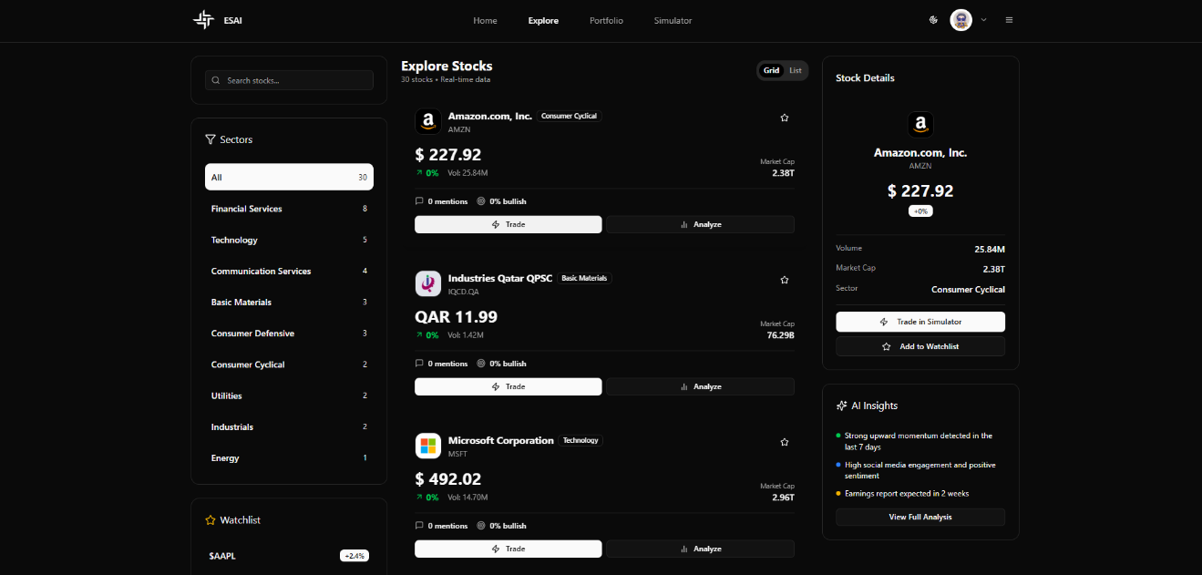
Figure 18: Explore page
- Portfoilo for follwing the stock that has intersting on it
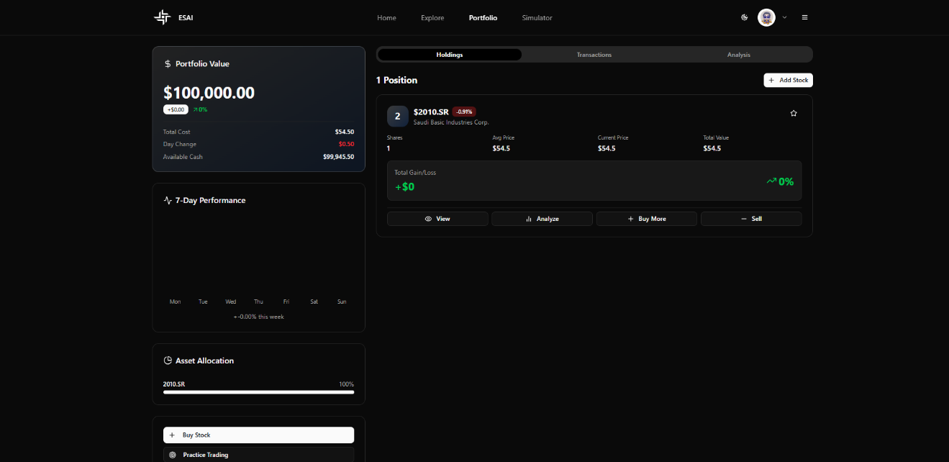
Figure 19: Portfolio page
- Interactive Charts for visualizing stock trends.
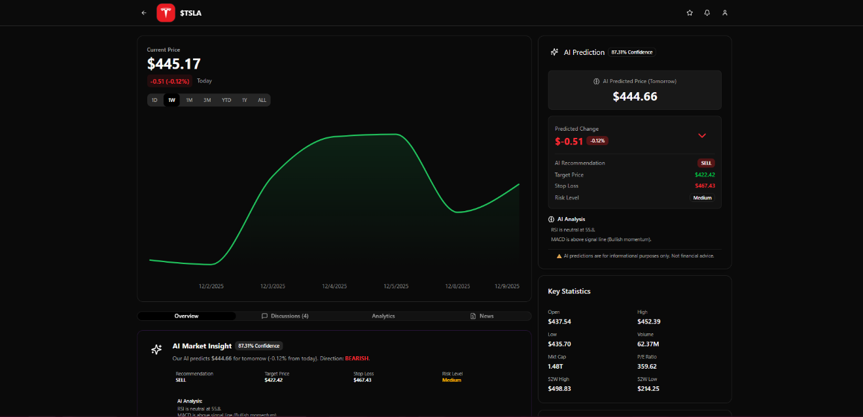
Figure 20:Interactive Charts
- Profile page for following the account

Figure 21: Profile page
- User Account System including login, watchlists, and portfolio tracking.

Figure 22:Log in page

Chapter 9: Testing Process and Results

9.1 Testing Methods and Test Cases
The project went through a rigorous testing phase to test the reliability, accuracy, and performance of the EyeStocks AI platform. The tests involved a combination of different test cases to test the functionality of the system, the AI prediction model, and the overall performance of the system as a whole.

9.1.1 Functional Testing
The functional test ensured that the features of the system work well from the user's perspective.
Table 10: Test case for Function
Test Case | Description | Result
User Registration | Verify that a user can successfully create an account | Passed
Buy Stock | Test the buy operation in the virtual trading simulator | Passed
View Prediction | Verify that stock price predictions are displayed correctly | Passed

The test cases ensured that the features of the system work as expected.

9.1.2 AI Model Testing
The AI prediction model was also tested using different metrics to evaluate the performance of the hybrid forecasting model.
Evaluation Metrics
- MAPE (Mean Absolute Percentage Error)
- It measures the average percentage error in the prediction of stock prices by the AI prediction model.
- It measures the average absolute difference in the prediction of stock prices by the AI prediction model.
- Direction Accuracy
- It measures the accuracy of the prediction of the AI prediction model in determining the movement of stock prices.
- It measures the proportion of times the AI prediction model correctly predicts the movement of stock prices as either an increase or a decrease.

9.1.3 System Testing
The system test ensured that the different components of the system work together in harmony to produce the required results.
Table 11:Test case for System
Test | Description | Result
Data Loading | Test the ability of the system to load stock market data | Successful
Response Time | Measure the time required to generate predictions | Acceptable

The results show that the system can perform the required tasks successfully in an acceptable time frame.

Chapter 10: Result Analysis
After completing the development and integration of the main components of the EyeStocks AI system—including the user interface, backend services, and AI prediction models—several tests were conducted to evaluate the system’s performance in terms of prediction accuracy, response speed, and overall stability.
1. Prediction Accuracy
The hybrid prediction architecture, which combines LSTM and XGBoost models, demonstrated reliable performance in predicting stock price trends.
The system achieved strong directional accuracy, meaning it was able to correctly predict whether the stock price would increase or decrease in many test cases. This provides useful decision support for users when choosing whether to buy, sell, or hold a stock.
In addition, the Mean Absolute Percentage Error (MAPE) was lower compared to simpler baseline models. The hybrid approach allowed the system to capture both long-term temporal patterns using LSTM and short-term technical signals through XGBoost, improving prediction quality particularly in moderately volatile stocks.
Furthermore, the Root Mean Square Error (RMSE) values recorded during testing showed that the predicted prices remained reasonably close to the actual market prices for several major companies included in the dataset.
2. System Performance
The platform also demonstrated strong performance in terms of system responsiveness and data processing capability.
Thanks to the use of FastAPI for backend services and PostgreSQL for data storage, API responses were delivered efficiently, allowing the frontend interface to retrieve predictions and technical indicators with minimal delay.
The automated data pipeline was able to collect, preprocess, and update historical stock data for approximately 30 tracked stocks across different markets. The system handled these operations without noticeable performance degradation, confirming the reliability of the current architecture.
3. Current Limitations
Despite the promising results, several limitations remain.
First, the current prediction models rely primarily on historical price movements and technical indicators. As a result, sudden market events or major financial news may reduce prediction accuracy because real-time sentiment analysis is not yet integrated into the system.
Second, as the number of tracked stocks increases in the future, the model retraining process may require additional computational resources to maintain timely updates.

Chapter 11: Challenges and Resolutions
During the development of the EyeStocks AI system, several technical and architectural challenges were encountered. Addressing these challenges required implementing efficient engineering solutions to ensure the stability, performance, and scalability of the platform.
One of the first challenges was data inconsistency and missing values in financial datasets retrieved from Yahoo Finance. Since stock market data may contain missing trading days or incomplete records, an automated data preprocessing pipeline was implemented using the preparedata.py script. This pipeline automatically cleans the dataset, removes invalid entries (NaN values), and standardizes the data before storing it in the PostgreSQL database.
Another challenge involved model overfitting, particularly when dealing with highly volatile stocks. Traditional models tended to perform poorly when market conditions changed rapidly. To overcome this limitation, a hybrid architecture was designed. The LSTM model performs the primary time-series prediction based on historical patterns, while an XGBoost correction model analyzes the residual errors and adjusts the prediction using technical indicators such as MACD and RSI. This approach significantly improved the model's directional accuracy and reduced prediction bias.
The system also faced API latency and high computational load, especially when calculating technical indicators and chart data on-demand for every user request. To solve this issue, a background processing mechanism was implemented. Instead of computing indicators during API calls, scheduled scripts periodically calculate and store these indicators in the database. As a result, the API can quickly retrieve precomputed values, leading to near real-time response times for frontend requests.
Another important challenge was portfolio data synchronization between the backend and the frontend interface. Ensuring consistent calculations of user balances, holdings, and profit-and-loss values required strict data validation. This was addressed by implementing strongly typed data structures using TypeScript interfaces in the frontend and Pydantic schemas in FastAPI. This ensured reliable data exchange and prevented inconsistencies when calculating portfolio metrics based on real-time stock prices.
Finally, system security and user authentication posed another challenge, particularly in protecting user accounts from brute-force login attempts. To enhance security, a stateless authentication mechanism using JSON Web Tokens (JWT) was implemented with both access and refresh tokens. Additionally, a temporary account lockout mechanism was introduced to block repeated failed login attempts, providing an additional layer of protection against unauthorized access.

Chapter 12: Work Timeline Contributions
This chapter outlines the comprehensive work plan executed for the EyeStocks AI project. The project schedule was divided into two major stages: the Proposal Phase, which focused on research and planning, and the Implementation Phase, which focused on technical development and system validation. This structured approach ensured that all deliverables were met efficiently and on time.

12.1 Proposal Phase Timeline
The project schedule spans a total of 13 weeks, from September 6, 2025, to December 5, 2025, as detailed in the Master Gantt Chart (see Figure 18). The plan follows a logical progression from research and scope definition to technical implementation and final validation.
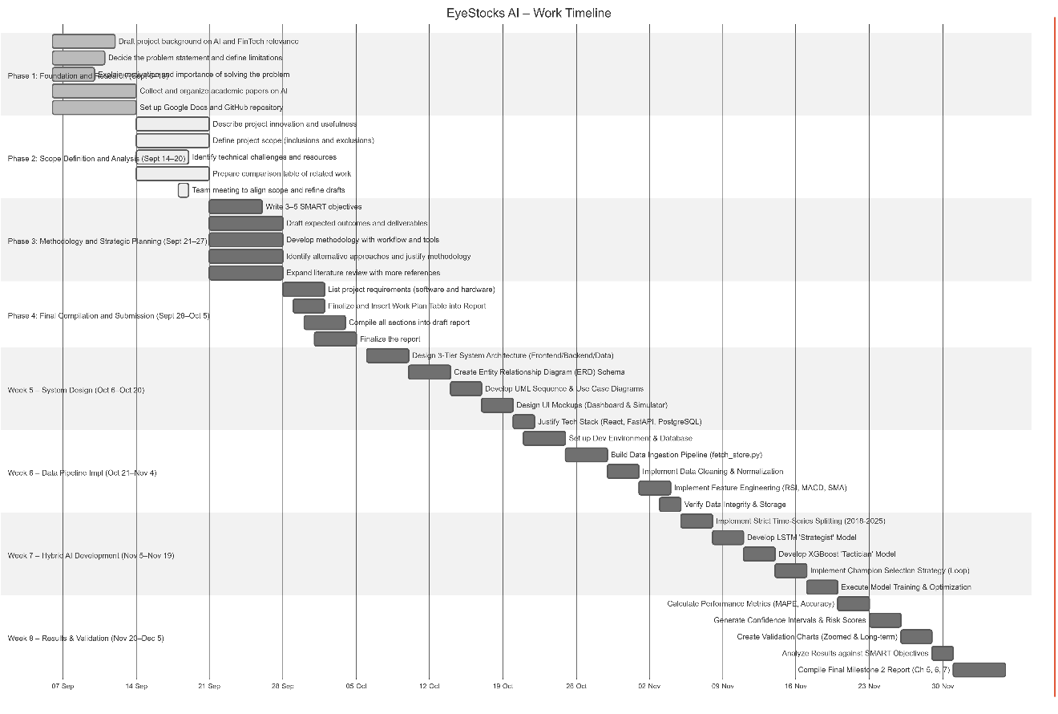
Figure 23:Project Gantt Chart Illustrating the Work Timeline(Milestone1and2)

- Phase 1: Foundation and Research (September 6 – September 13)
This initial phase focused on building the project's theoretical foundation. Tasks included drafting the project background on AI and FinTech relevance, deciding on the problem statement and limitations, explaining the motivation, and collecting initial academic papers.
- Phase 2: Scope Definition and Analysis (September 14 – September 20)
In this phase, the project's scope was strictly defined. Activities included describing the project's innovation, defining inclusions/exclusions, identifying technical challenges, and preparing a comparison table of related work based on the gathered research.
- Phase 3: Methodology and Strategic Planning (September 21 – September 27)
This phase established the project's strategy. It involved writing SMART objectives, developing the workflow methodology, drafting expected outcomes, and identifying alternative approaches.
- Phase 4: Proposal Compilation and Submission (September 28 – October 5)
The final phase of the planning stage focused on reporting. Tasks included listing software/hardware requirements, inserting the work plan table, and compiling the final proposal report for submission.
- Phase 5: System Design and Architecture (October 6 – October 20)
The focus shifted to technical design. The team designed the 3-Tier System Architecture (Frontend/Backend/Data), created the Entity Relationship Diagram (ERD) for the database, and developed UML Sequence and Use Case diagrams to model system behavior.
- Phase 6: Data Pipeline Development (October 21 – November 4)
The development environment was set up, and the backend infrastructure was initialized. Key tasks included building the Data Ingestion Pipeline (fetch_store.py) to download market data, implementing data cleaning logic, and engineering features such as RSI and MACD.
- Phase 7: Hybrid AI Engine Development (November 5 – November 19)
This phase involved the core AI implementation. The team implemented the strict time-series splitting strategy, developed the LSTM (Strategist) and XGBoost (Tactician) models, and executed the "Champion Selection" training loop to optimize prediction accuracy.
- Phase 8: Results, Validation, and Reporting (November 20 – December 5)
The final phase focused on validating the prototype. Activities included calculating performance metrics (MAPE, Accuracy), generating Confidence Intervals, creating validation charts, and compiling the final project report

12.2 Implementation Phase Timeline
The implementation phase of the project spans a total of 13 weeks, from January 25, 2025, to April 22, 2025, as detailed in the Implementation Gantt Chart (see Figure 19). The plan follows a structured execution path, moving from backend infrastructure and AI integration to frontend visualization, simulation features, and final system validation.
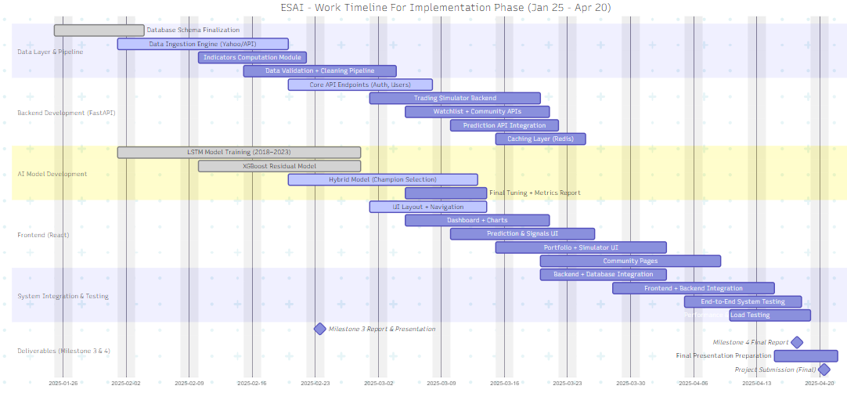
Figure 24:Project Gantt Chart Illustrating the Work Timeline(Milestone4and5)
Phase 1: Backend Foundation and AI Deployment (January 25 – February 14) This phase focuses on establishing the core server infrastructure. Key tasks include finalizing the database schema for users and portfolios, establishing an automated data pipeline to update stock prices daily, and refactoring the AI prototype into a production-ready module. The phase concludes with the deployment of the FastAPI endpoints and the implementation of a batch prediction script to process data for 30 stocks efficiently.
Phase 2: Frontend Visualization and Dashboard (February 15 – March 7) The focus shifts to the user interface and data visualization. The team will initialize the React.js project, build the dashboard layout, and implement interactive charts to display the "Green Line" (AI Prediction) versus the "Black Line" (Actual Price). This phase also involves integrating the Confidence Score UI and preparing the interim demo for the Milestone 3 submission.
Phase 3: Simulation, Community, and MLOps (March 8 – March 28) In this phase, the advanced features of the platform are developed to meet Milestone 4 outcomes. This includes implementing the logic for the Virtual Wallet and Trading Interface (Buy/Sell), creating the automated "Weekly Retraining" pipeline (MLOps) to keep the AI model accurate, and adding community features such as discussion boards for stock-specific comments.
Phase 4: Optimization, Testing, and Final Submission (March 29 – April 22) The final phase is dedicated to quality assurance and reporting. Tasks include conducting scalability tests to ensure the system handles 30 stocks smoothly, performing User Acceptance Testing (UAT) with real users, and writing the final comprehensive report. The project concludes with the preparation of the final presentation slides and the formal submission of the complete EyeStocks AI platform.

12.3 Team Roles and Contributions
The project's success relied on a collaborative team effort, with tasks distributed to efficiently cover all aspects of the work. Table 9 details the key contributions of each team member.
Table 12:Team Members' Contributions
Team Member | Key Contributions | Details
Abdullah | Project Scope & System Design | Drafted the project background, defined the scope, and compiled the initial proposal. Led the System Architecture Design (Phase 5), created the High-Level Architecture diagrams, and designed the UI mockups for the Dashboard.
Ali | Problem Analysis & Backend Dev | Defined the problem statement, identified technical challenges, and wrote the SMART objectives. Responsible for Backend API Development (Phase 6), setting up the FastAPI environment, and implementing the Data Ingestion Pipeline (fetch_store.py).
Qasem | Literature & Database Implementation | Collected academic papers, created the comparison table, and justified alternative approaches. Led the Database Implementation (Phase 5 & 6), designed the ERD Schema, and managed the PostgreSQL setup and data storage logic.
Sharidah | Methodology & AI Development | Developed the work methodology, explained project motivation, and finalized the work plan. Lead Developer for the Hybrid AI Engine (Phase 7), implemented the LSTM/XGBoost logic, the Champion Selection strategy, and conducted the Result Analysis (Phase 8).
All Members | Collaboration & Integration | Set up the GitHub repository, attended alignment meetings, and defined project requirements. Collaborated on System Integration (Phase 8), connecting the Backend to the Database and AI engine, and participated in writing the Final Report.

Conclusion
In this report, we have presented the details of building and implementing the technical core of the EyeStocks AI system up to its current stage. Our primary focus has been on transforming the conceptual idea into a fully integrated digital system that combines high-performance software engineering with accurate AI-driven predictions.
1. What Has Been Accomplished
We have successfully established a robust Full-Stack Architecture that includes:
- Frontend Development: A responsive and interactive platform developed using React and Tailwind CSS, supporting secure user authentication and dynamic visualization of stock analytics.
- Backend & Database: A high-performance FastAPI server connected to a PostgreSQL database, featuring a comprehensive security layer (JWT) and automated pipelines for real-time financial data retrieval.
- AI Engine: The design and training of a hybrid prediction model that merges the temporal strengths of LSTM with the corrective precision of XGBoost, supported by an automated data pipeline from Yahoo Finance.
- News Integration: A dedicated news section for every available stock, ensuring users are connected to the latest market movements and financial updates.
2. Goal Fulfillment
Based on preliminary evaluations and system testing, the project has significantly achieved its planned technical objectives. The hybrid model has demonstrated a lower MAPE (Mean Absolute Percentage Error) compared to traditional methods. Furthermore, the web application has shown high responsiveness and the ability to process stock data smoothly, paving the way for full operational features.
3. Next Steps for the Final Milestone (Milestone 4)
To reach the Final Release, the upcoming phase will focus on the following key areas:
- Virtual Trading: Finalizing the virtual investment portfolio that allows users to simulate buying and selling stocks based on real-time market prices.
- Social Interaction & Integration: Completing the development of user-to-user interaction features, including follower systems and social engagement regarding stock trends.
- Admin Dashboard: Implementing administrative privileges that allow the Admin to add new stocks simply by passing a Ticker Symbol. The system will then automatically perform AI analysis and display the results to users, significantly enhancing system scalability.
- Sentiment Analysis: Improving model accuracy by integrating Natural Language Processing (NLP) to analyze live financial news and articles, enabling predictions based on both technical and fundamental analysis.
Final Deployment: Fully migrating the system (Frontend & AI Backend) to a stable Cloud Production environment and optimizing the Retraining Pipeline to ensure peak efficiency and accuracy for end-users.

References
- Andraszewicz, S., Karmarkar, U., & Riefer, P. (2023). Upward social comparison increases risk-taking among retail investors. Frontiers in Psychology, 14, 10733348.
- Berger, J., Humphreys, A., Ludwig, S., Moe, W., Netzer, O., & Schweidel, D. (2018). Uniting the tribes: Using text for marketing insight. Journal of Business Research, 88, 314–323.
- Gifty, S., & Yang, L. (2024). Stock market prediction using ARIMA, LSTM, and XGBoost models: A case study on Google stock. University of East London Research Repository.
- Kadiri, H., El Idrissi, N., & Abbar, H. (2025). Comparative study of hybrid and individual models for stock prediction on the MASI index. Journal of Computational Finance, 29(2), 141–158.
- Shi, Z., Hu, Y., Mo, G., & Wu, J. (2022). Attention-based CNN-LSTM and XGBoost hybrid model for stock prediction. arXiv preprint arXiv:2204.02623.
- StockTrak. (2010–). Academic research on portfolio simulations. StockTrak.
- Uhunmwangho, R. (2024). Stock price direction prediction using LSTM and XGBoost: Evidence from Microsoft stock. Mountain Top University Journal of Applied Science and Technology, 4(2), 55–66.
- Wu, J., Hsiao, S., & Lee, C. (2012). A web-based simulation game for teaching finance. Computers & Education, 59(2), 989–999.
- Yang, S. (2019). Transparency and incentives in social trading platforms. University of Minnesota Carlson School of Management Working Paper.
- Zhang, X., Wang, S., & Chen, Y. (2021). Hybrid LSTM–XGBoost model with Bayesian optimization for stock price forecasting. Expert Systems with Applications, 185, 115665
- Liu, H., Chen, C., & Wu, N. (2021). LSTM-XGBoost hybrid models across domains: Evidence from epidemiology and industrial systems. Applied Soft Computing, 113, 107918.
- SSRN. (2025). Mobile stock simulators for financial education. Social Science Research Network.
- Jin, J., & Yu, W. (2022). Does communication increase investors’ trading frequency? Evidence from a social trading platform. Financial Innovation, 8(21).
- Horn, M., Reipschläger, J., & Scholz, H. (2024). Aggregate trading on social trading platforms and private investor flows. Journal of Behavioral Finance (forthcoming).
- Investopedia. (n.d.). Fintech (financial technology). In Investopedia. Retrieved October 5, 2025.

