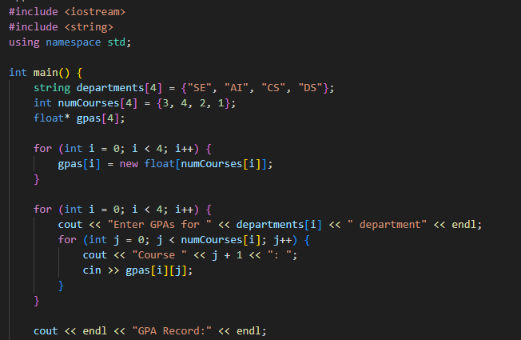

Task6:

