I am continuing my Lab 11 project for Lab 12.
My website theme is Café or Dhaba Menu, and its name is Chai Junction.
My existing website uses:
- HTML
- CSS
- JavaScript
- Cream background
- Dark brown main colour
- Orange accent colour
- Arial font
I want to expand my existing website into a simple multi-page website.
Please keep the same design, colours and fonts on every page. Use only HTML, CSS and JavaScript. Keep the code beginner-friendly and easy to understand because I have to explain it during my instructor's demo.
First, suggest suitable pages for my café website. Do not generate all the code at once. We will build one page at a time.
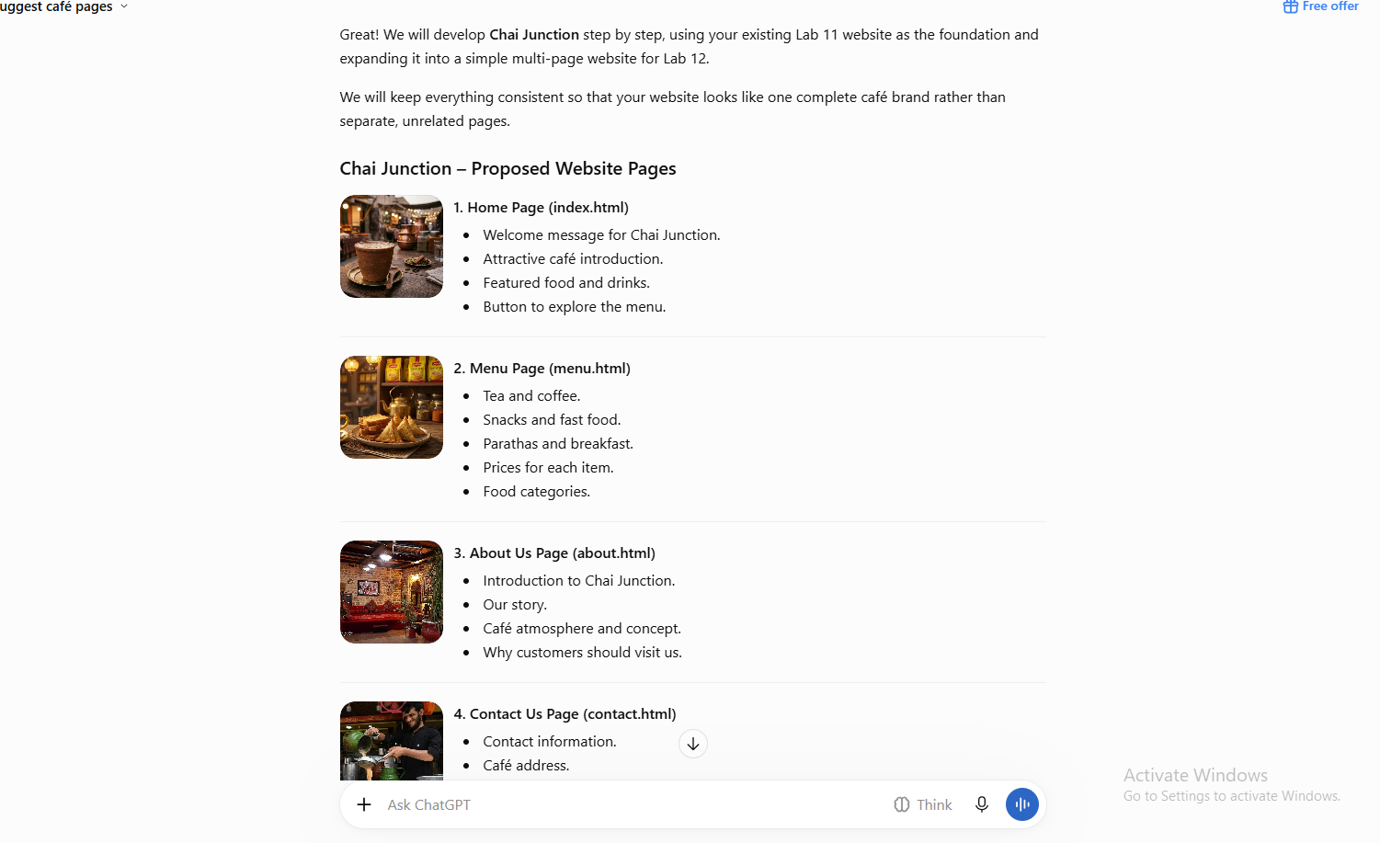
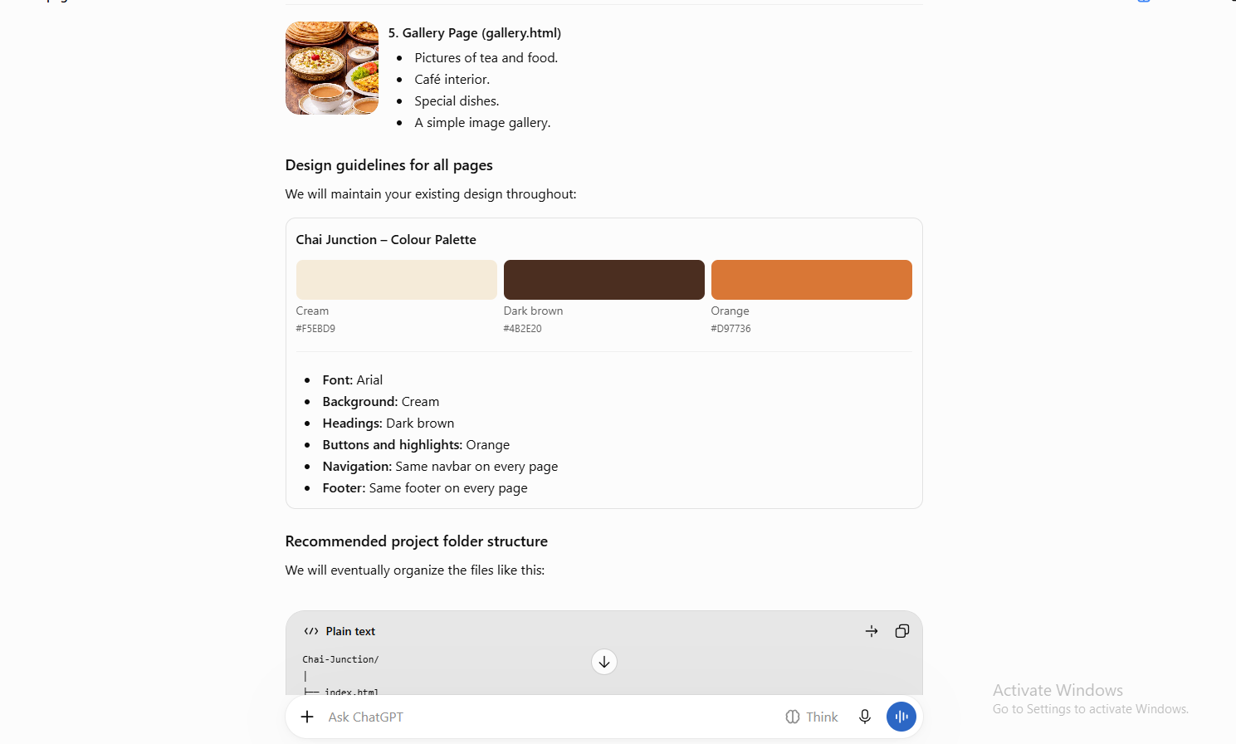
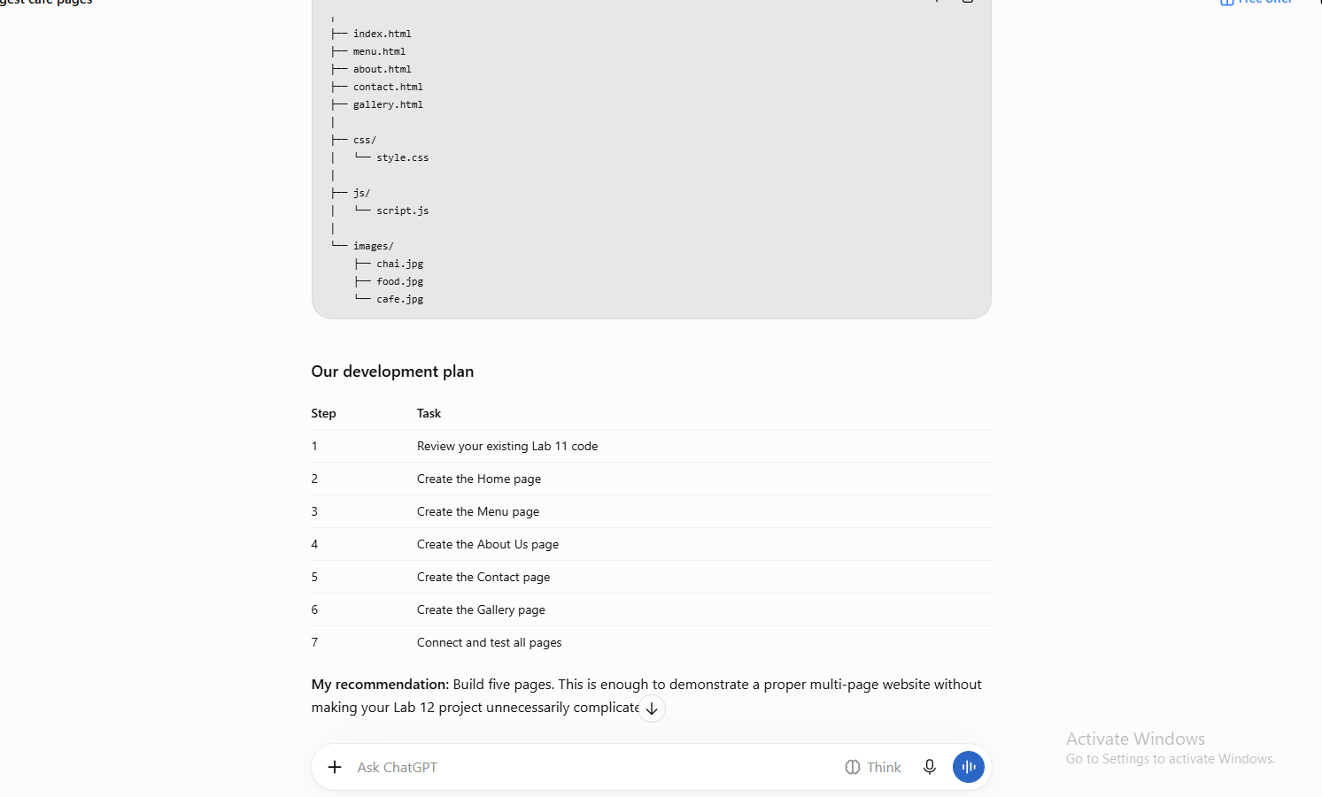
Menu:

Prompt:
Continue my Chai Junction project for Lab 12.
Create a complete menu.html page for my café website.
Requirements:
- Use the same cream, dark brown and orange colour scheme.
- Use Arial font.
- Connect the existing style.css file.
- Include navigation links to index.html, menu.html, gallery.html and contact.html.
- Create a simple menu table with Item, Category and Price.
- Include Doodh Patti, Green Tea, Paratha and Samosa.
- Add an Order Now button using JavaScript window.alert().
- Keep the code simple and beginner-friendly.
- Do not create unnecessary features.
Provide the complete HTML code in one block.
AI output:


