UNIVERITY OF ENGINEERING AND TECHNOLOGY LAHORE



DEPARTMENT OF COMPUTER ENGINEERING
SESSION: 2025-2029

SEMESTER PROJECT:

TOUR AND TRAVEL MANAGEMENT SYSTEM

Submitted To:
Mam Maheen Rao

Submitted By:
Aliza Islam 2025(S)-CYS-79
Qasim 2025(S)-CYS-81

📘 TOUR & TRAVEL MANAGEMENT SYSTEM

Database Project Report

1. Introduction
The Tour & Travel Management System is a database project developed using MySQL.
The main purpose of this system is to computerize the operations of a travel agency including customer management, tour packages, bookings, hotels, transport, and payments.
This system stores data in a structured format and provides efficient ways to retrieve and manage information. It reduces paperwork, saves time, and improves accuracy.

2. Objectives of the Project
The objectives of this project are
:• To design a relational database for a tour and travel company
• To manage customers, staff, tour packages, hotels, and transport
• To automate booking and payment handling
• To use advanced MySQL features such as views, procedures, and triggers
• To ensure data integrity using primary keys and foreign keys
- Tools and Technologies
• Database Management System: MySQL
• Query Language: SQL
• Platform: MySQL Workbench
• Operating System: Window

4. System Overview
The system is based on a centralized database named TourAndTravelDB.
It contains multiple tables connected with foreign key relationships.
The system supports booking management, payment tracking, and automatic seat reduction using triggers

5. Database Design
The database consists of the following main entities:
• Users
• Customers
• Hotels
• Facilities
• Transport
• Tour Guides
• Tour Packages
• Bookings
• Payments

6. Complete SQL Implementation
Below is the complete SQL code used to create and manage the database.
6.1 Database Creation
CREATE DATABASE TourAndTravelDB;
USE TourAndTravelDB;
Explanation:
This code deletes the existing database (if any) and creates a new database named TourAndTravelDB.

6.2 Users Table
CREATE TABLE Users (
UserID INT AUTO_INCREMENT PRIMARY KEY,
FullName VARCHAR(100) NOT NULL,
Username VARCHAR(50) UNIQUE NOT NULL,
Password VARCHAR(100) NOT NULL,
Role ENUM('Admin','Staff') NOT NULL,
CreatedAt TIMESTAMP DEFAULT CURRENT_TIMESTAMP
);
Explanation:
This table stores login and role information of system users such as Admin and Staff.

6.3 Customers Table
CREATE TABLE Customers (
CustomerID INT AUTO_INCREMENT PRIMARY KEY,
FullName VARCHAR(100) NOT NULL,
Phone VARCHAR(15),
Email VARCHAR(100) UNIQUE,
CNIC VARCHAR(15) UNIQUE,
Address VARCHAR(255),
Gender ENUM('Male','Female'),
CreatedAt TIMESTAMP DEFAULT CURRENT_TIMESTAMP
);
Explanation:
This table stores personal and contact information of customers.

6.4 Hotels Table
CREATE TABLE Hotels (
HotelID INT AUTO_INCREMENT PRIMARY KEY,
HotelName VARCHAR(100),
Location VARCHAR(100),
StarRating INT CHECK (StarRating BETWEEN 1 AND 5),
ContactNumber VARCHAR(20),
CostPerNight DECIMAL(10,2)
);
Explanation:
This table stores hotel details and room charges.

6.5 Facilities Table
CREATE TABLE Facilities (
FacilityID INT AUTO_INCREMENT PRIMARY KEY,
FacilityName VARCHAR(50)
);
Explanation:
This table stores different facilities provided in tour packages.

6.6 Transport Table
CREATE TABLE Transport (
TransportID INT AUTO_INCREMENT PRIMARY KEY,
TransportType VARCHAR(50),
Provider VARCHAR(100),
Cost DECIMAL(10,2)
);
Explanation:
This table stores transport service information.

6.7 Tour Guides Table
CREATE TABLE TourGuides (
GuideID INT AUTO_INCREMENT PRIMARY KEY,
FullName VARCHAR(100),
Phone VARCHAR(15),
Language VARCHAR(50)
);
Explanation:
This table stores details of tour guides.

6.8 Tour Packages Table
CREATE TABLE TourPackages (
PackageID INT AUTO_INCREMENT PRIMARY KEY,
PackageName VARCHAR(100),
Destination VARCHAR(100),
DurationDays INT CHECK (DurationDays > 0),
Price DECIMAL(10,2),
AvailableSeats INT,
Description TEXT
);
Explanation:
This table stores tour package information including destination, duration, and price.

6.9 Package Facilities Table
CREATE TABLE PackageFacilities (
PackageID INT,
FacilityID INT,
PRIMARY KEY (PackageID, FacilityID),
FOREIGN KEY (PackageID) REFERENCES TourPackages(PackageID),
FOREIGN KEY (FacilityID) REFERENCES Facilities(FacilityID)
);
Explanation:
This junction table links packages with facilities.

6.10 Package Hotels Table
CREATE TABLE PackageHotels (
PackageHotelID INT AUTO_INCREMENT PRIMARY KEY,
PackageID INT,
HotelID INT,
Nights INT,
FOREIGN KEY (PackageID) REFERENCES TourPackages(PackageID),
FOREIGN KEY (HotelID) REFERENCES Hotels(HotelID)
);
Explanation:
This table assigns hotels and number of nights to each tour package.

6.11 Bookings Table
CREATE TABLE Bookings (
BookingID INT AUTO_INCREMENT PRIMARY KEY,
CustomerID INT,
PackageID INT,
UserID INT,
BookingDate TIMESTAMP DEFAULT CURRENT_TIMESTAMP,
TravelDate DATE,
SeatsBooked INT,
TotalPrice DECIMAL(10,2),
Status ENUM('Confirmed','Cancelled','Pending'),
FOREIGN KEY (CustomerID) REFERENCES Customers(CustomerID),
FOREIGN KEY (PackageID) REFERENCES TourPackages(PackageID),
FOREIGN KEY (UserID) REFERENCES Users(UserID)
);

Explanation:
This table stores booking records and booking status.

6.12 Payments Table
CREATE TABLE Payments (
PaymentID INT AUTO_INCREMENT PRIMARY KEY,
BookingID INT UNIQUE,
AmountPaid DECIMAL(10,2),
PaymentMethod ENUM('Cash','Card','Online'),
PaymentStatus ENUM('Paid','Unpaid'),
PaymentDate TIMESTAMP DEFAULT CURRENT_TIMESTAMP,
FOREIGN KEY (BookingID) REFERENCES Bookings(BookingID)
);
Explanation:
This table stores payment transactions related to bookings.

6.13 Views
CREATE VIEW vw_PendingBookings ASSELECT * FROM Bookings WHERE Status='Pending';
CREATE VIEW vw_TotalPayments ASSELECT SUM(AmountPaid) AS TotalCollection FROM Payments;
Explanation:
Views are created to display pending bookings and total payment collection.

6.14 Stored Procedures
DELIMITER $$CREATE PROCEDURE GetAllCustomers()BEGIN
SELECT * FROM Customers;END$$
CREATE PROCEDURE ConfirmBooking(IN bid INT)BEGIN
UPDATE Bookings SET Status='Confirmed' WHERE BookingID=bid;END$$
DELIMITER ;
Explanation:
These procedures are used to display all customers and confirm a booking.

6.15 Trigger
DELIMITER $$CREATE TRIGGER trg_reduce_seats
AFTER INSERT ON BookingsFOR EACH ROWBEGIN
UPDATE TourPackages
SET AvailableSeats = AvailableSeats - NEW.SeatsBooked
WHERE PackageID = NEW.PackageID;END$$
DELIMITER ;
Explanation:
This trigger automatically reduces available seats after each booking.

7. Results and Outputs
The system successfully:
• Stores customer and booking data
• Updates available seats automatically
• Shows pending bookings using views
• Calculates total payments
• Confirms bookings using procedures

8. Conclusion
The Tour & Travel Management System is a complete relational database project implemented in MySQL.
It demonstrates the use of tables, relationships, views, procedures, and triggers.
This system can be further extended with a front-end application for real-time use.

ENTITY RELATIONAL DIAGRAM

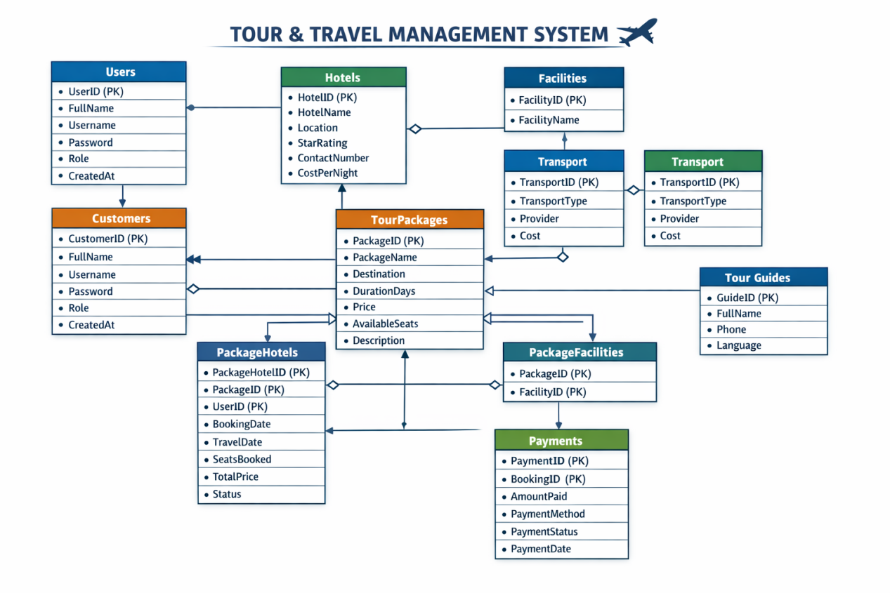

THANK YOU

