COSY AIRCONDITIONERS
Premium Climate Control

USER GUIDE
Complete Guide for Customers & Website Visitors
Version 1.0 | 2026
Supervisor | Miss Maryam Naz
Batch | 2601C1
Group | A
Serial No. | Enrollment Number | Student Name
1. | Student1725134 | ABDUL HAFEEZ AHMED
2. | Student1722646 | GHUFRAN ALI
3. | Student1725155 | MUHAMMAD HASHIR .
4. | Student1722463 | MUHAMMAD QASIM .
5. | Student1722438 | MUHAMMAD WALEED NISAR

ACKNOWLEDGEMENT

First of all, we would like to express our sincere gratitude to our respected teacher, Miss Maryam Naz, for her valuable guidance, encouragement, and continuous support throughout the completion of this project. Her advice and motivation helped us successfully finalize this project within the limited time frame.

Secondly, we are thankful to the eProject team at Aptech Head Office for providing us with the opportunity to work on this wonderful project titled COSY AIRCONDITIONERS. This project allowed us to enhance our practical knowledge and apply the concepts we learned during our course.

We would also like to acknowledge the benefits we gained during the development of this project:

- Reinforcement of technical and practical skills through hands-on experience.
- Continuous guidance and mentoring that kept us focused throughout the project development process.
- Increased confidence in facing interviews and explaining project-related concepts due to real project experience.
- Improved understanding of responsive web design, product management systems, and user interface development.
- Enhanced teamwork, communication, and problem-solving skills while working collaboratively as a group.

Table of Contents
1. | Introduction | 4
2. | Getting Started | 4
3. | Homepage — index.html | 5
3.1 | Navigation Bar | 5
3.2 | Hero Section | 5
3.3 | Brand Showcase | 5
3.4 | Products Section | 6
4. | Browsing by Brand — brand.html | 6
5. | Product Comparison — compare.html | 7
6. | Shopping Cart — cart.html | 8
6.1 | Adding Items | 8
6.2 | Viewing the Cart | 8
6.3 | Removing Items | 8
6.4 | Checkout | 9
7. | Contact Page — Contact.html | 9
8. | Product Detail Pages | 10
9. | All Products at a Glance | 10
10. | Frequently Asked Questions | 11

1. Introduction
Welcome to the COSY AIRCONDITIONERS User Guide. This document will help you navigate and use the COSY AC website with ease — from browsing products to placing an order.
COSY AIRCONDITIONERS is a premium online showroom offering a curated selection of air conditioning units from top global brands including Samsung, LG, Daikin, Whirlpool, Haier, and Gree. Whether you are looking for an energy-efficient inverter unit, a budget-friendly option, or a premium air-purifying AC, COSY AC has you covered.

What You Can Do on This Website:
- Browse 40 premium AC models from 6 major brands
- Filter products by brand for quick discovery
- Compare any two products side-by-side across 10 specification fields
- Add products to your shopping cart and manage quantities
- Proceed to checkout when ready to purchase
- Contact the COSY AC team through the built-in contact form

2. Getting Started
The COSY AC website is a modern web application that runs directly in your browser. No installation, login, or account is required to browse products or use the comparison tool.

2.1 How to Open the Website
- Locate the COSY_AC_Project folder on your computer
- Find the file named index.html inside the folder
- Double-click index.html — it will open in your default web browser
- The website loads instantly and is ready to use
NOTE: Features like Google Fonts and Bootstrap styling require an active internet connection to display correctly.
TIP: Use Google Chrome or Mozilla Firefox for the best visual experience.

2.2 Supported Browsers
- Google Chrome (recommended)
- Mozilla Firefox
- Microsoft Edge
- Safari (macOS / iOS)

2.3 Device Compatibility
The website is fully responsive and works on desktops, laptops, tablets, and smartphones. The layout automatically adjusts to fit any screen size.

3. Homepage — index.html
The Homepage is the main entry point of the COSY AC website. It is the first page you see when you open the site and contains the brand showcase and full product catalog.

3.1 Navigation Bar
The navigation bar appears at the top of every page. It becomes darker as you scroll down the page. Use it to move between all sections of the website:
Nav Item | Destination | Description
Home | index.html | Returns to the main landing page
Brands (Dropdown) | brand.html | Filter by All / Samsung / LG / Daikin / Whirlpool / Haier / Gree
Compare | compare.html | Side-by-side product comparison tool
Contact | Contact.html | Contact form and company information
Cart | cart.html | Shopping cart with item count and running total

TIP: On mobile devices, tap the grid icon (top-right) to open the navigation menu.

3.2 Hero Section
The hero section is the large banner at the top of the homepage. It features:
- The COSY AC brand name and tagline
- An animated temperature display that cycles through values (16°C to 24°C) every 2 seconds — representing precision climate control
- A call-to-action button to explore products

3.3 Brand Showcase
Below the hero, six brand logo cards are displayed — one for each supported brand:
- Samsung
- LG
- Daikin
- Whirlpool
- Haier
- Gree
Clicking any brand logo card will automatically scroll down to the products section and filter it to show only that brand's AC units.

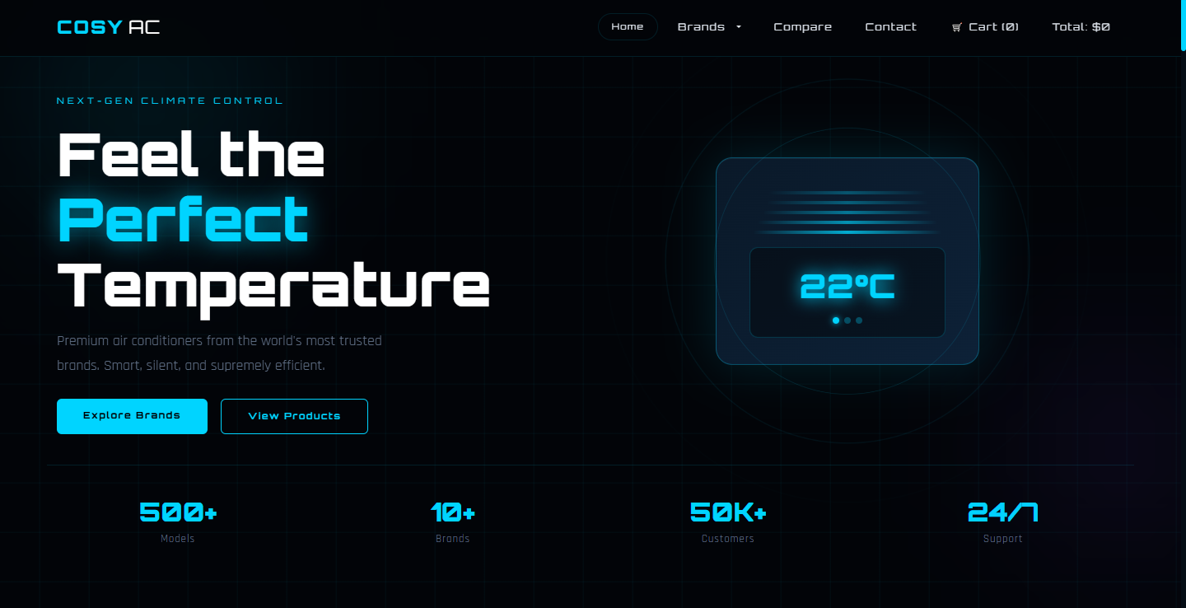

3.4 Products Section
The Products Section displays all available AC units as cards. Each product card includes the following information:
- Brand tag — shown on the top corner of the product image
- Product image
- Product name
- Key specs: Capacity (Ton), Energy Star Rating, and Technology type
- Short product description
- Price in PKR
- Details button — click to open the full product specification page
- Add to Cart button — click to add the product to your shopping cart
TIP: Product cards animate into view as you scroll down the page.
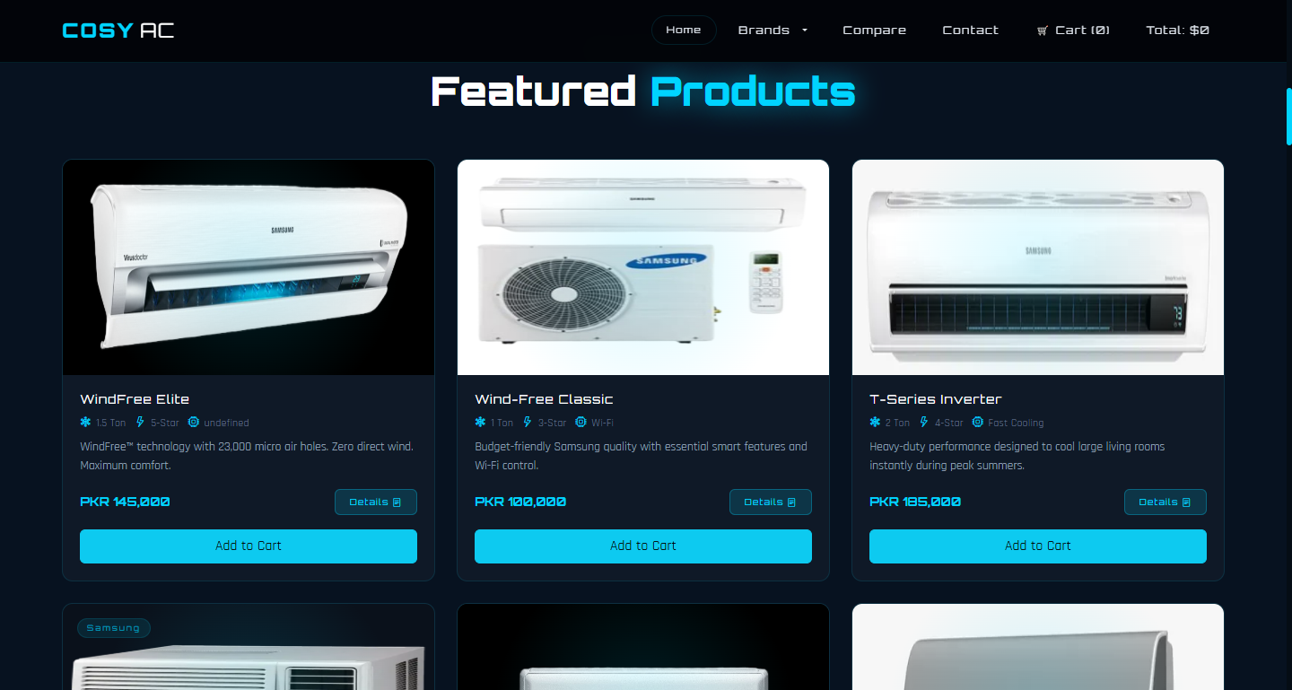

4. Browsing by Brand — brand.html
The Brands page displays the complete product catalog and lets you quickly filter products by manufacturer brand.

4.1 How to Filter Products by Brand
- Click Brands in the navigation bar (or select a specific brand from the dropdown)
- On the Brands page, locate the brand filter buttons near the top
- Click any brand button — All, Samsung, LG, Daikin, Whirlpool, Haier, or Gree
- The product grid immediately updates to show only products from the selected brand
- Click All to display all products again
TIP: You can also click a brand logo card on the Homepage to jump directly to filtered results.
NOTE: Products that do not match the filter are hidden instantly — no page reload needed.

4.2 Available Brands
- Samsung — 2 products: WindFree Elite and Wind-Free Classic
- LG — 1 product: Dual Inverter Pro
- Daikin — 1 product: Streamer X-Series
- Whirlpool — 1 product: Magicool Pro
- Haier — 1 product: CleanCool Ultra
- Gree — 1 product: Fairy Series
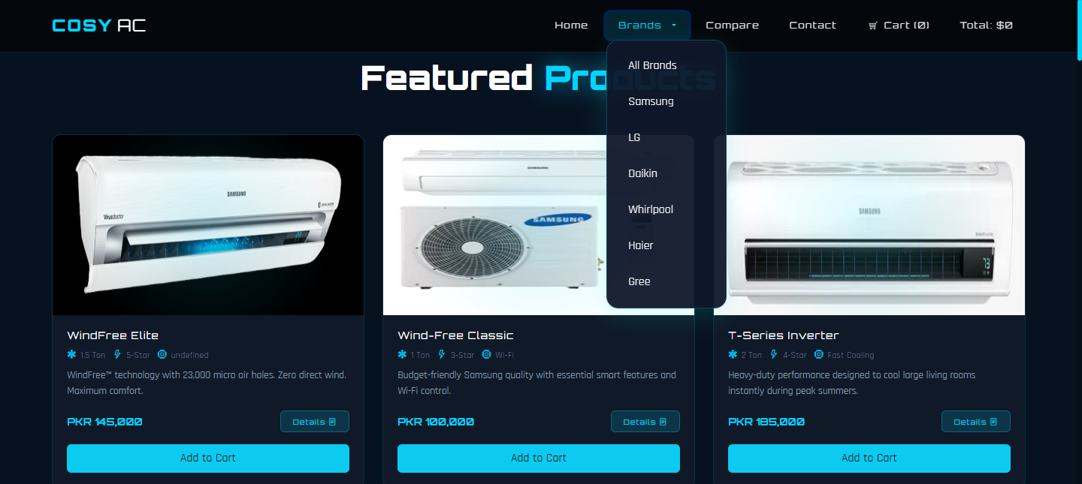

5. Product Comparison — compare.html
The Compare page is one of the most powerful tools on the website. It allows you to pick any two products and view their full specifications side-by-side, making it easier to choose the right AC for your needs.

5.1 How to Compare Two Products
- Click Compare in the navigation bar
- In the Product A dropdown, select your first AC model from the list
- In the Product B dropdown, select a different AC model
- Click the Compare Now button
- A comparison table will appear below, showing specifications for both products
NOTE: You must select two different products. If you choose the same product in both dropdowns, a message will ask you to select different products.

5.2 What the Comparison Table Shows
The comparison table displays the following 10 specification fields side-by-side:
Specification Field | What It Means
Brand | Manufacturer name
Capacity | Cooling capacity in Ton
Energy Rating | Star rating (3-Star / 5-Star)
Technology | Core technology (Smart AI, Dual Inverter, etc.)
Wi-Fi Control | Whether remote app control is available
Air Filter | Filter type for air purification
Cooling Power | Cooling output in Watts
Noise Level | Operating noise in decibels (dB)
Warranty | Manufacturer warranty period
Price | Price in PKR

TIP: Use the comparison tool to evaluate value for money — compare a premium model like the Daikin Streamer X-Series against a mid-range option like the Whirlpool Magicool Pro.

5.3 Tips for Comparing Products
- Compare noise levels (dB) if you need a quiet bedroom AC — lower is better
- Compare warranty periods to understand long-term support — LG offers the longest at 10 years
- Compare cooling power (Watts) for large rooms — higher wattage covers more area
- Check Wi-Fi availability if you want smart phone control
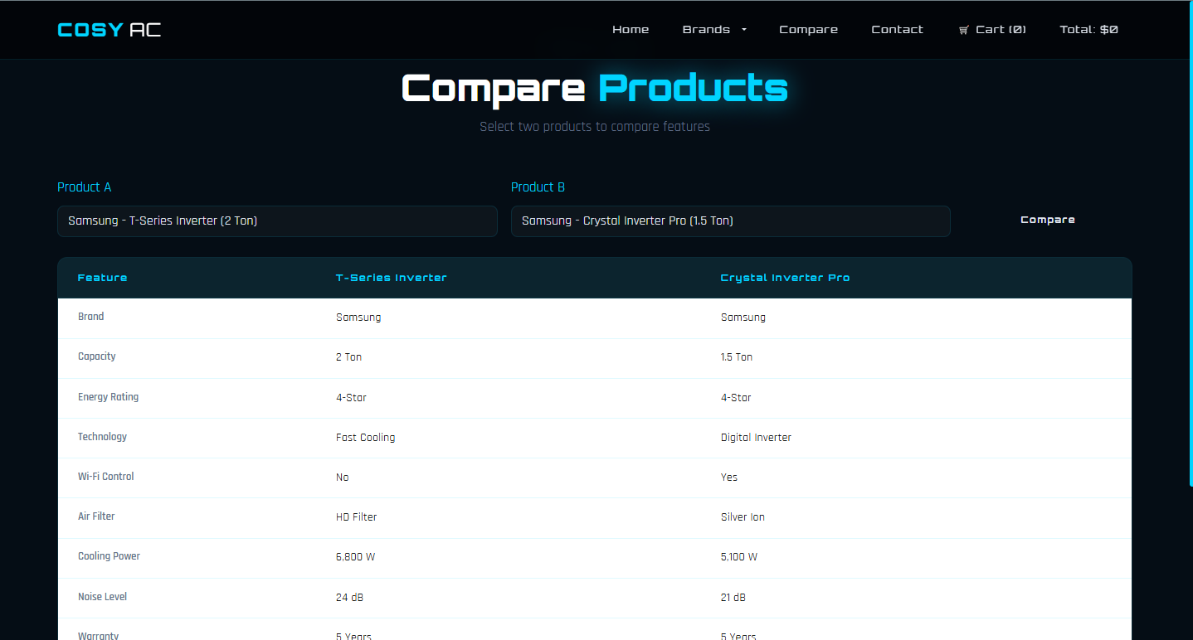

6. Shopping Cart — cart.html
The COSY AC website has a built-in shopping cart that lets you collect the products you want to purchase. Your cart is saved automatically as you browse — items will not disappear if you switch between pages.

6.1 Adding Items to the Cart
- Find a product you like on the Homepage or Brands page
- Click the Add to Cart button below the product description
- The cart counter in the navigation bar (next to the cart icon) will increase by 1
- The running total price in the navbar will also update
TIP: You can add the same product multiple times. Each click increases the quantity by 1.
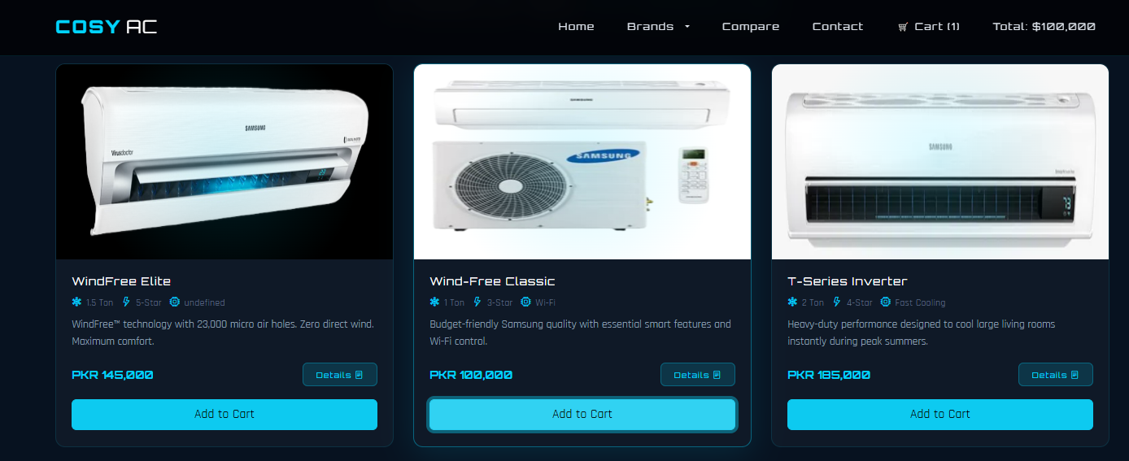

6.2 Viewing Your Cart
- Click Cart in the navigation bar to open cart.html
- Your added products are displayed in a table with the following columns:
- Product Name
- Unit Price (PKR)
- Quantity
- Remove button
- The total amount due is shown below the table

6.3 Removing Items from the Cart
- On the Cart page, locate the product you wish to remove
- Click the Remove button on that product's row
- If the product quantity is 2 or more, the quantity decreases by 1
- If it is the last unit of that product, the entire row is removed from the cart
- The total price updates automatically

6.4 Checkout
- On the Cart page, review your selected items and total
- Click the Checkout Now button when you are ready
- A success confirmation screen appears: 'Order Success! Thank you for choosing COSY AC'
- Click Go Back To Shop to return to the homepage and continue browsing
NOTE: This is a demonstration checkout. No real payment is processed and no order is placed. Contact the COSY AC team directly to complete a real purchase.
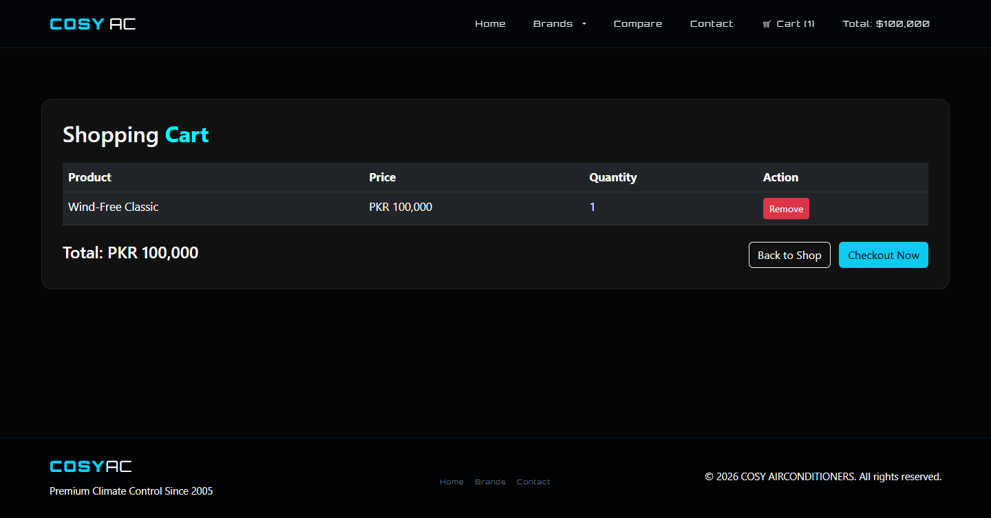

7. Contact Page — Contact.html
The Contact page allows you to reach out to the COSY AIRCONDITIONERS team with questions, queries, or feedback. It also displays the company's contact information.

7.1 Company Information
The left side of the Contact page displays:
- Company name: COSY AIRCONDITIONERS
- Physical address
- Phone number
- Business hours

7.2 How to Send a Message
- Click Contact in the navigation bar
- Fill in your Name in the first input field
- Enter your Email address
- Select the Subject of your enquiry from the dropdown menu
- Type your message in the message text area
- Click the Send Message button
- A green confirmation banner will appear at the top of the form for 5 seconds confirming your submission
NOTE: The contact form is a front-end demonstration. Messages are not actually sent via email. To send a real enquiry, please call or visit the COSY AC office directly.
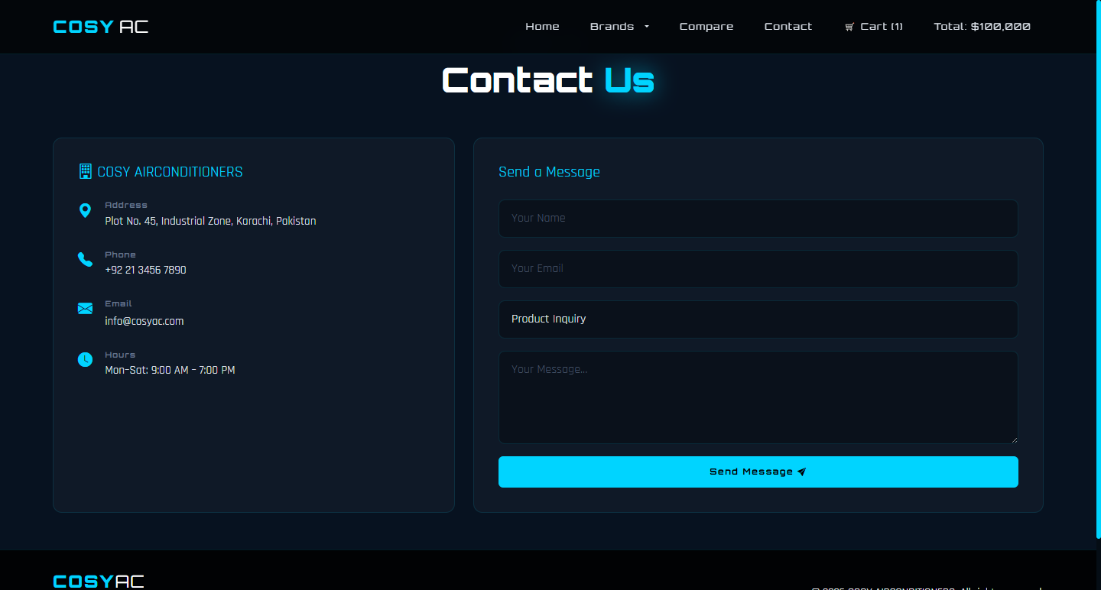

8. Product Detail Pages
Every product in the COSY AC catalog has its own dedicated detail page. These pages provide in-depth technical specifications, features, and highlights for each individual AC unit.

8.1 How to Access a Product Detail Page
- Find any product card on the Homepage or Brands page
- Click the Details button on the product card
- The product's detail page opens (it may open in a new tab)
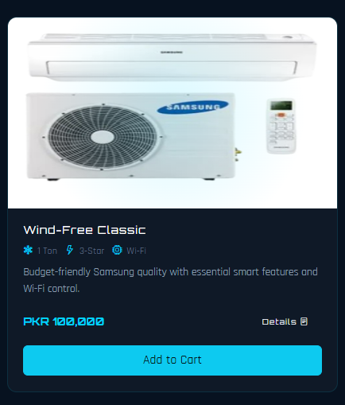

9. All Products at a Glance
The table below provides a quick reference for 7 AC products available on the COSY AC website:

Product | Capacity | Rating | Price | Warranty | Noise
Samsung WindFree Elite | 1.5 Ton | 5-Star | PKR 145,000 | 5 Years | 19 dB
Samsung Wind-Free Classic | 1 Ton | 3-Star | PKR 100,000 | 3 Years | 22 dB
LG Dual Inverter Pro | 2 Ton | 5-Star | PKR 178,000 | 10 Years | 21 dB
Daikin Streamer X-Series | 1.5 Ton | 5-Star | PKR 195,000 | 5 Years | 20 dB
Whirlpool Magicool Pro | 1.5 Ton | 5-Star | PKR 125,000 | 5 Years | 24 dB
Haier CleanCool Ultra | 1 Ton | 3-Star | PKR 75,000 | 3 Years | 26 dB
Gree Fairy Series | 1.5 Ton | 5-Star | PKR 85,000 | 3 Years | 25 dB

9.1 Product Highlights

Best for Quiet Operation
Samsung WindFree Elite — 19 dB, the quietest unit in the catalog. Ideal for bedrooms.

Best for Large Rooms
LG Dual Inverter Pro — 2 Ton capacity with the longest warranty (10 years). Best for large living rooms and office spaces.

Best for Air Quality
Daikin Streamer X-Series — Deactivates 99.9% of viruses and bacteria. Ideal for families and health-conscious users.

Best Value for Money
Whirlpool Magicool Pro — 5-Star rated with smart 6th Sense technology at a mid-range price of PKR 125,000.

Best Budget Option
Haier CleanCool Ultra — Most affordable at PKR 75,000 with self-cleaning filter. Best for small rooms.

Best Year-Round Unit
Gree Fairy Series — The only Heat and Cool unit in the catalog. Perfect for regions with both hot summers and cold winters.

10. Frequently Asked Questions (FAQ)
Question | Answer
Do I need to create an account? | No. You can browse, compare, and add to cart without any account or login.
Will my cart items be saved if I close the browser? | Yes. Cart data is saved in your browser's local storage and will be available when you reopen the website on the same browser.
Can I add the same product more than once? | Yes. Each click of Add to Cart increases the quantity of that product by 1.
What happens after I click Checkout Now? | A success screen is displayed and your cart is cleared. This is a demo — no real payment is taken.
Why are fonts or styles not loading correctly? | The website uses Google Fonts and Bootstrap from the internet (CDN). Connect to the internet for the best visual experience.
Can I compare more than two products at once? | Currently, the Compare tool supports two products at a time. Select and compare different pairs one at a time.
Does the Contact form actually send my message? | No. The form is a front-end demonstration. Contact COSY AC directly by phone or in person for real enquiries.
Which brand has the best warranty? | LG Dual Inverter Pro offers the longest warranty at 10 years.
Which is the most affordable product? | Haier CleanCool Ultra at PKR 75,000 is the lowest-priced product in the catalog.
Which product can both heat and cool? | The Gree Fairy Series is the only heat-and-cool unit available.

Thank You
End of User Guide — COSY AIRCONDITIONERS v1.0 | © 2026

