Errors:
Student Module:
attendance page not working
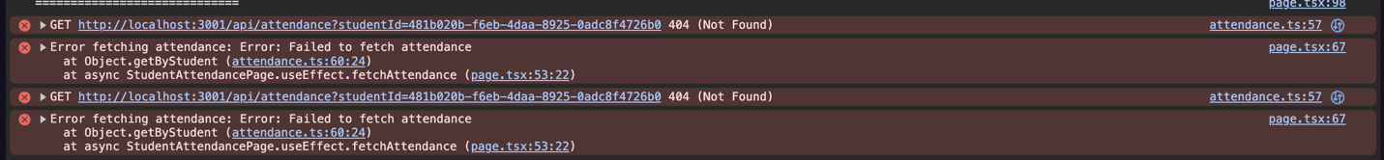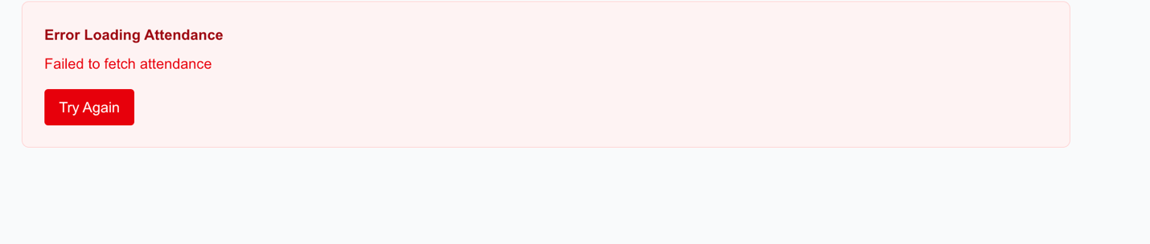
teacher module:
create material has bad font color
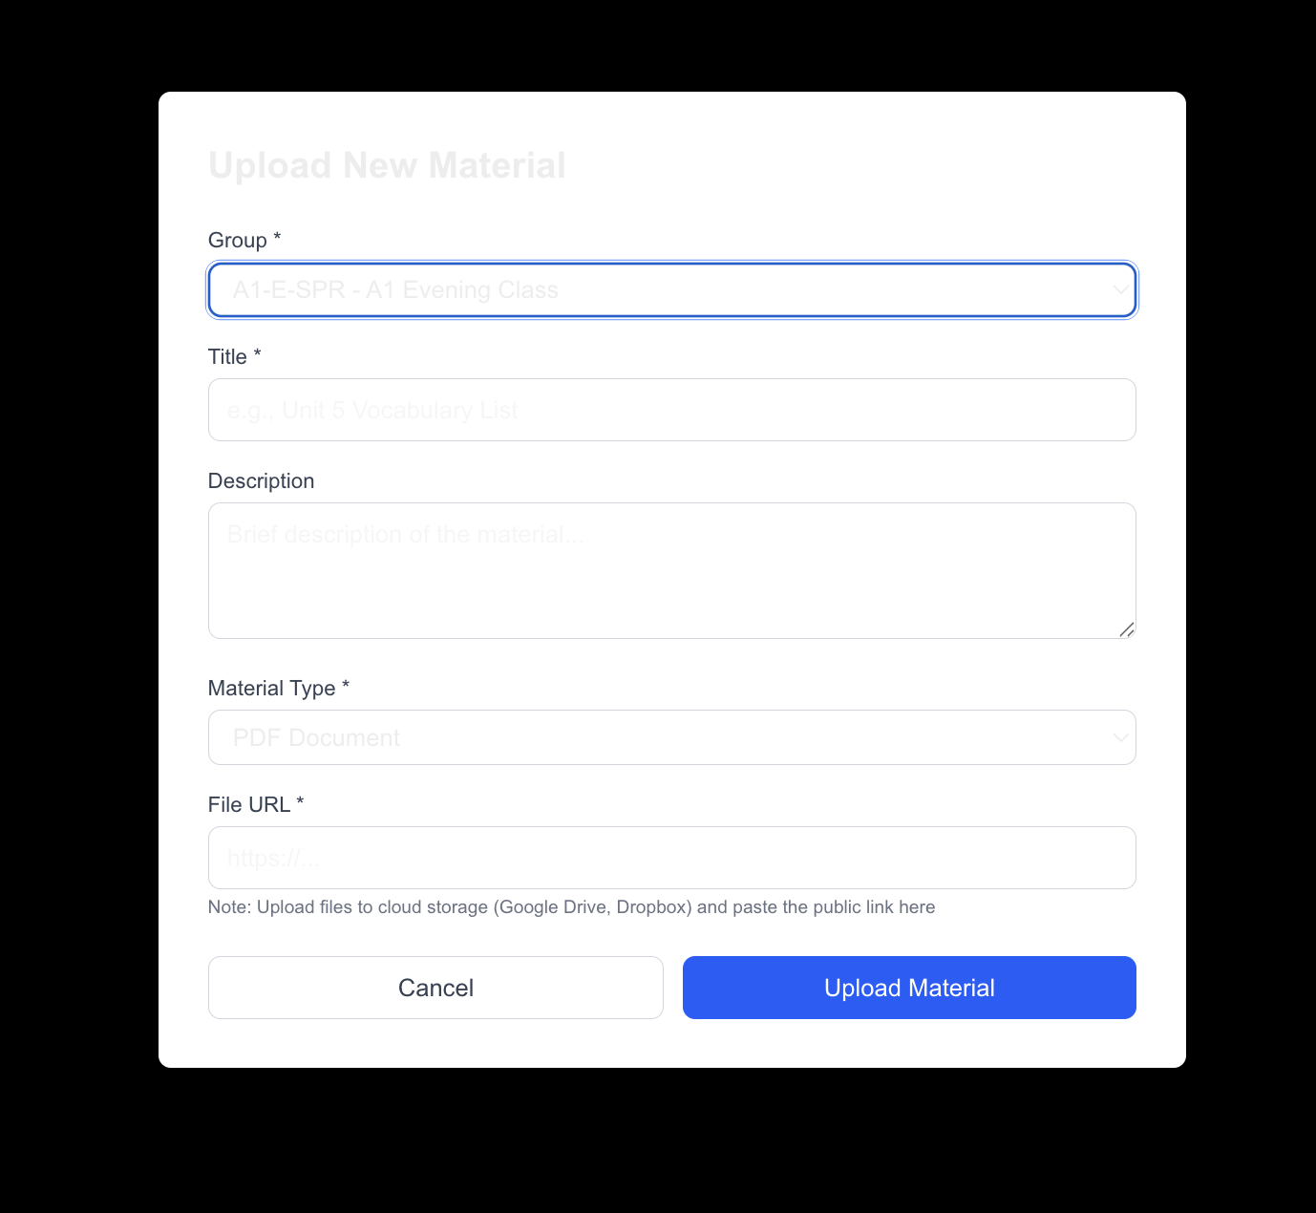
announcements page has an error
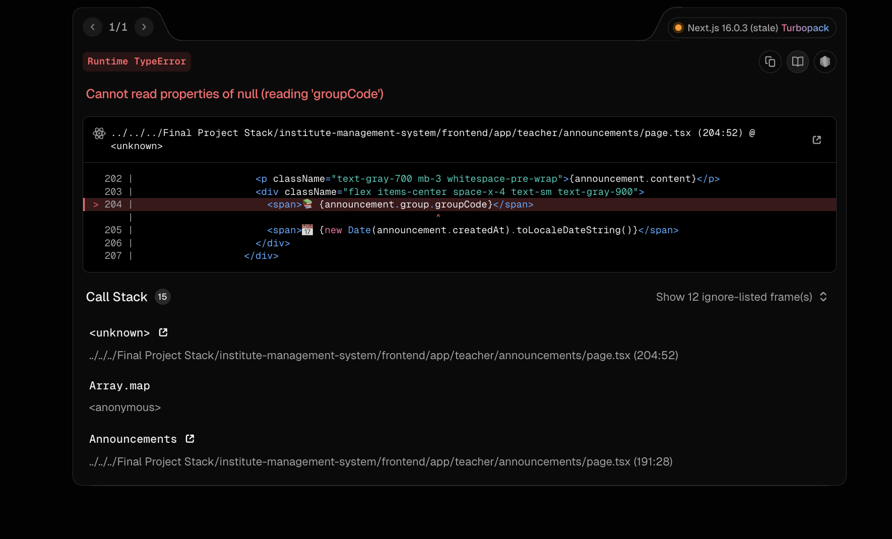

admin module:
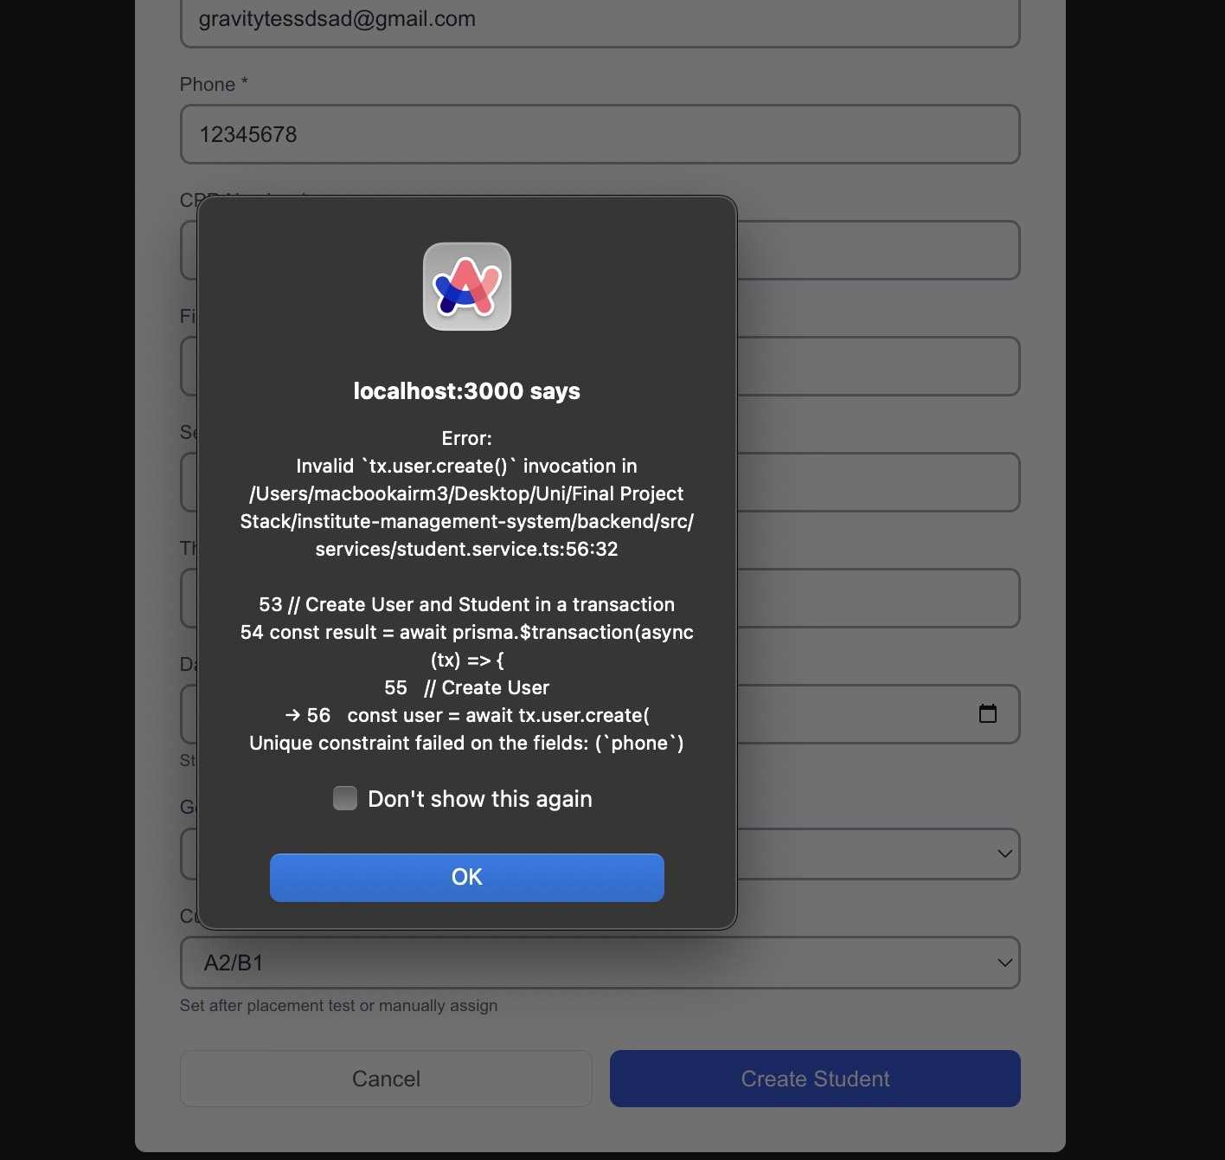
got this error when trying to create a student

cannot edit group still

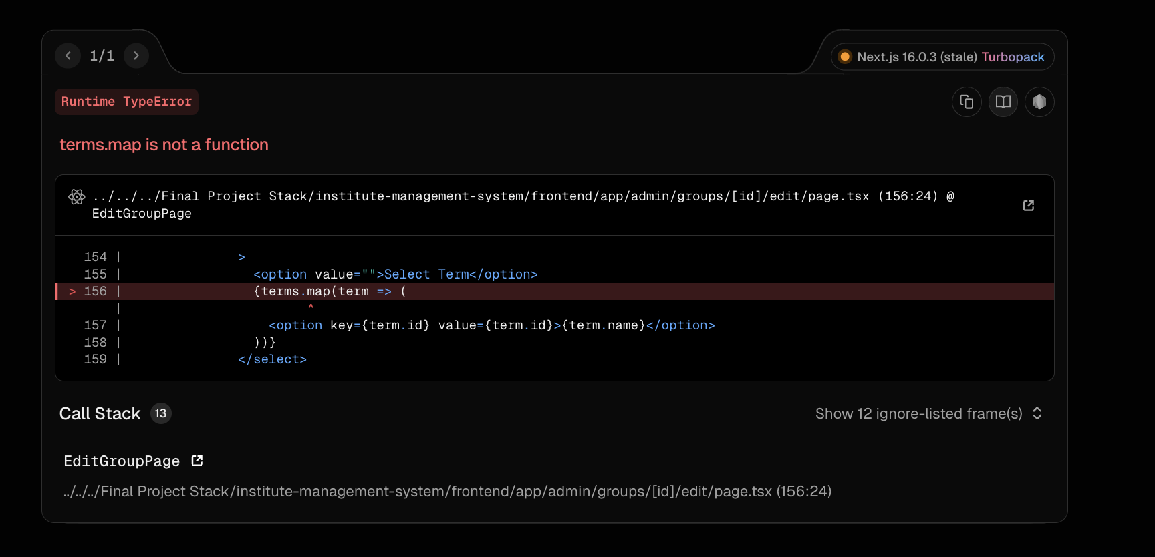
Still cannot delete group, but there is no error, either the group is deleted but still showing, or it is not deletd
still Programs are not seen in the enrollments page
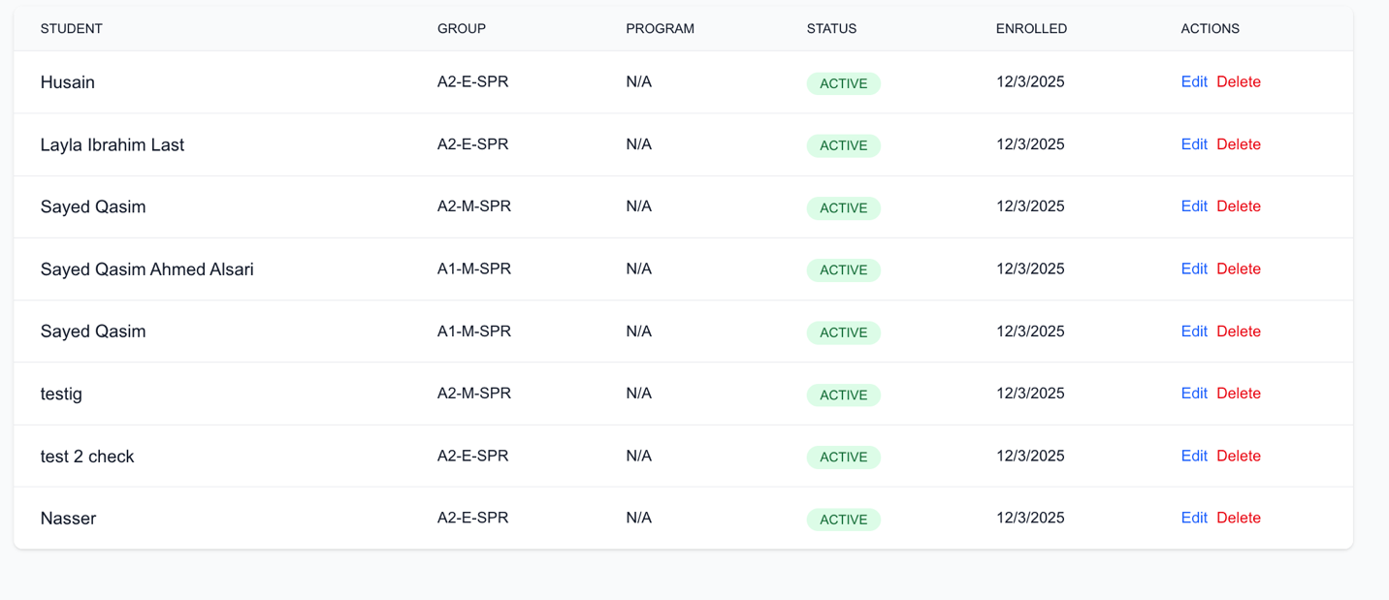
I still cannot update the enrollments
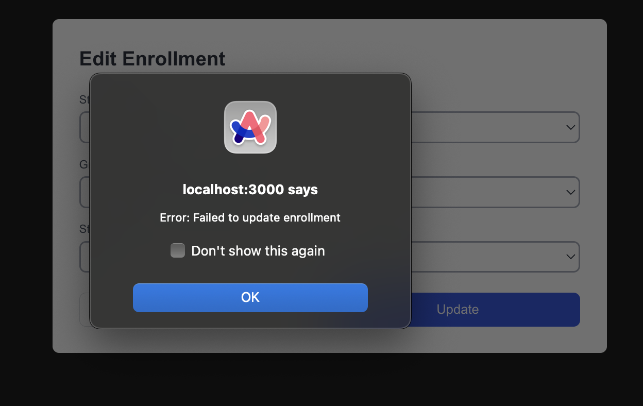

I want to be able to add materials as an admin
Announcements page has an error
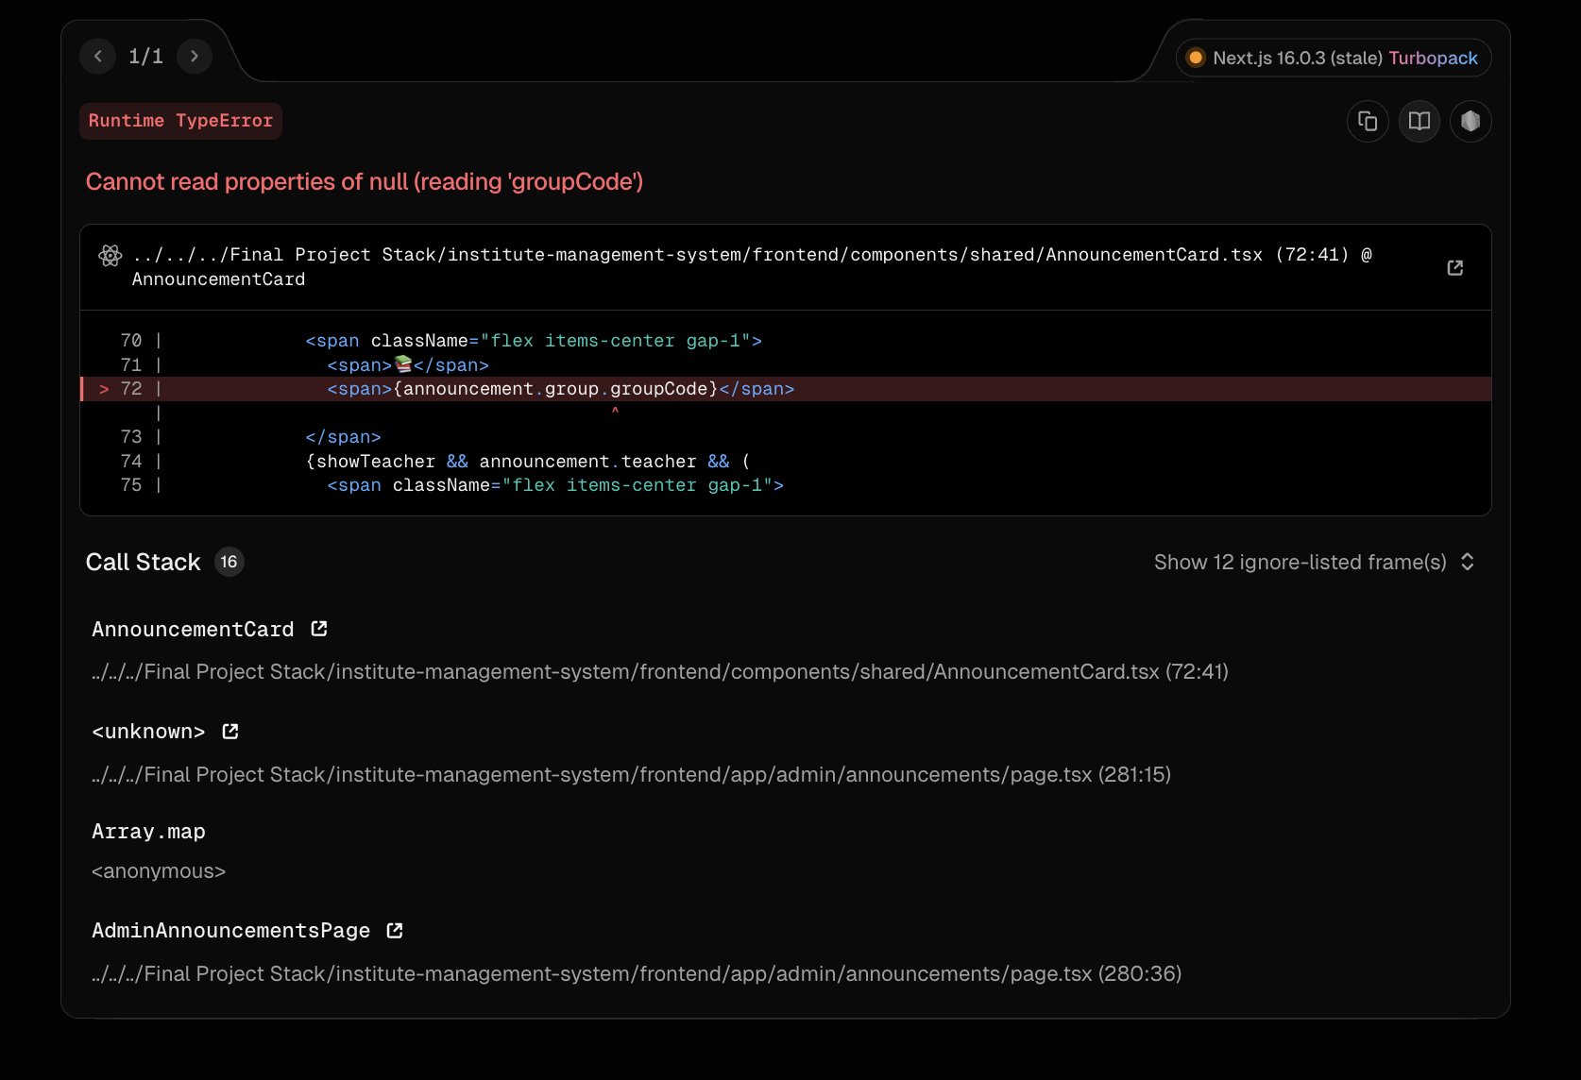

Cannot add a program
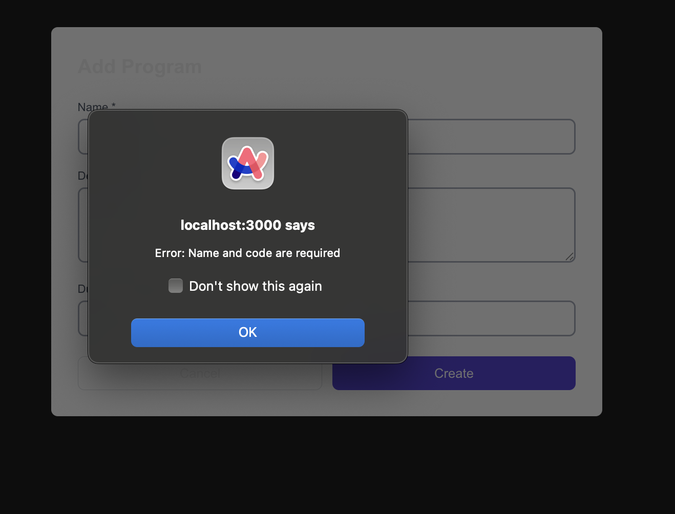

I updated the duration but it still shows na, and also it does not show the groups, cause it needs to show the current term, then the number of groups, so the answer is wrong, cause all groups right now are in the program 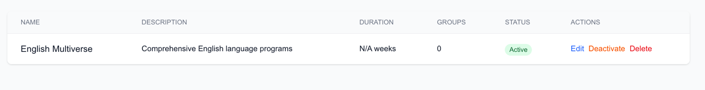

Terms page is not working
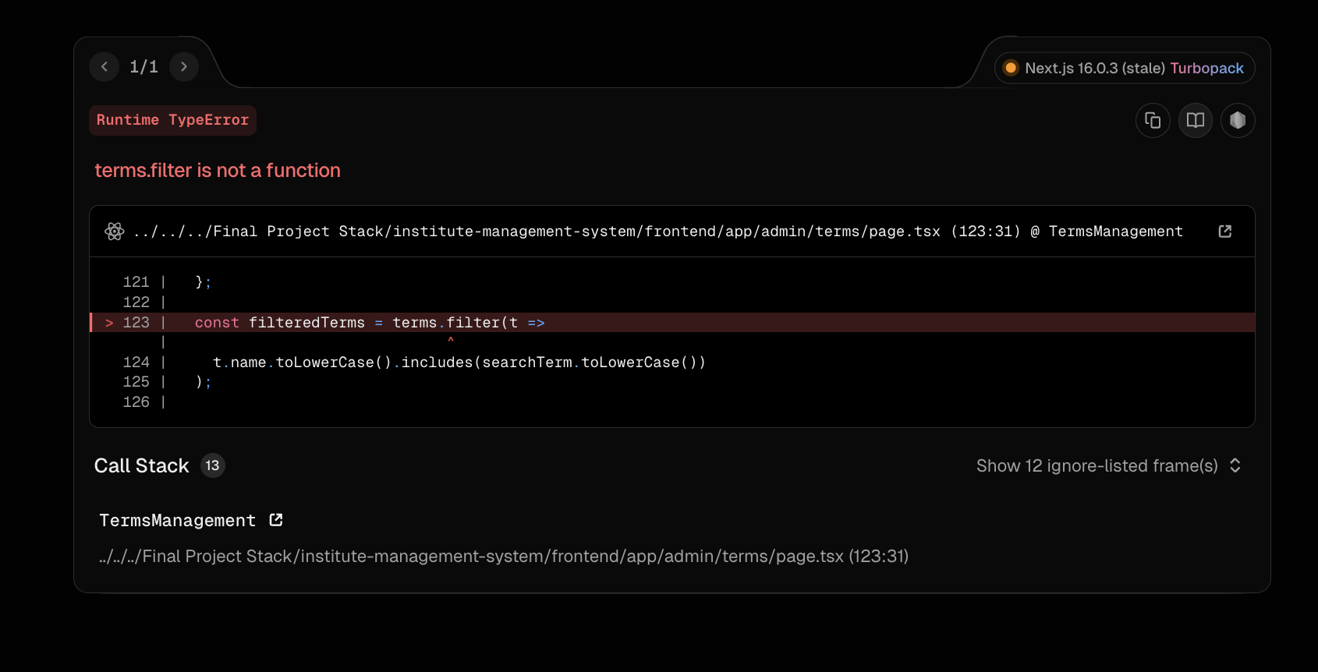

I cannot see the order , cause I created 3 with the same order number 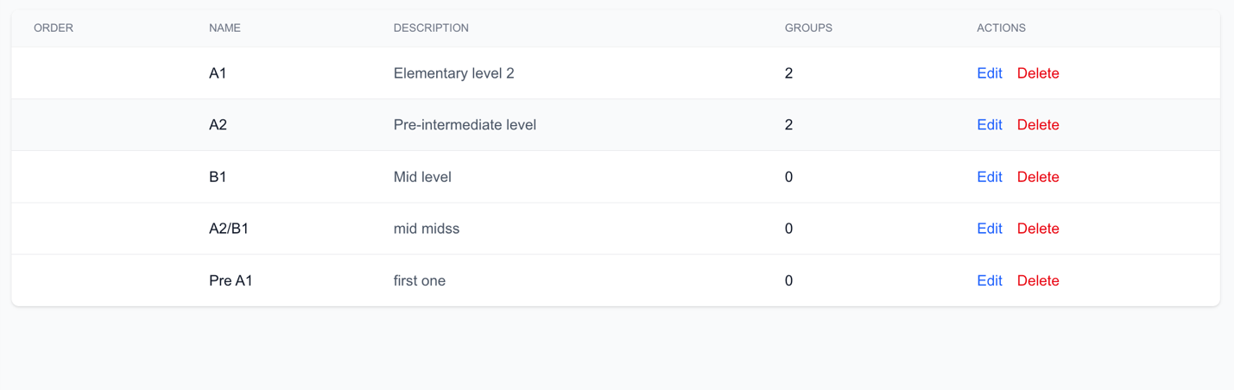

Cannot create a venue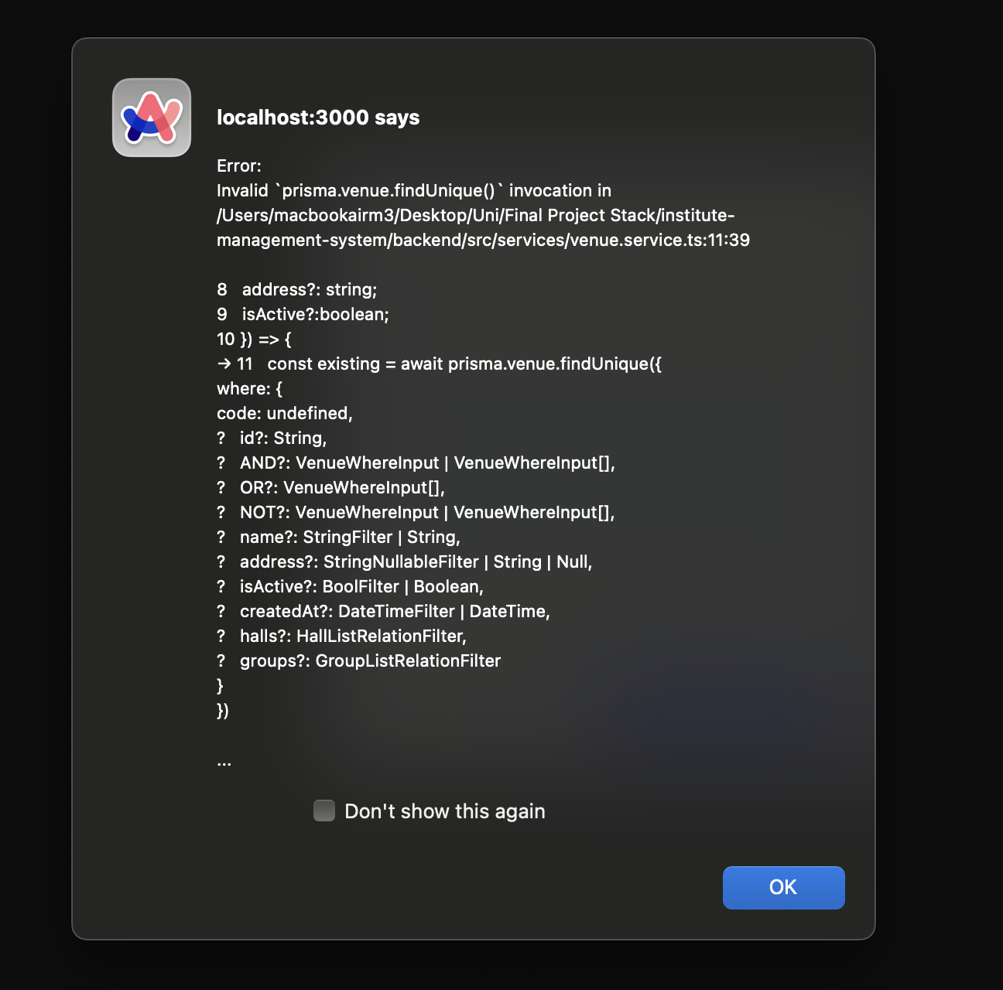
Cannot create a hall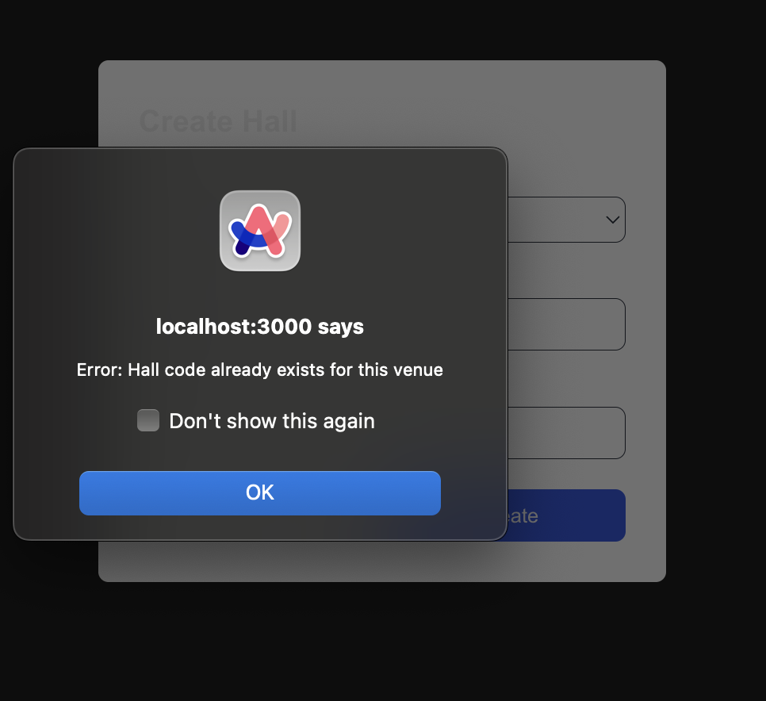

Attendance report page is not found
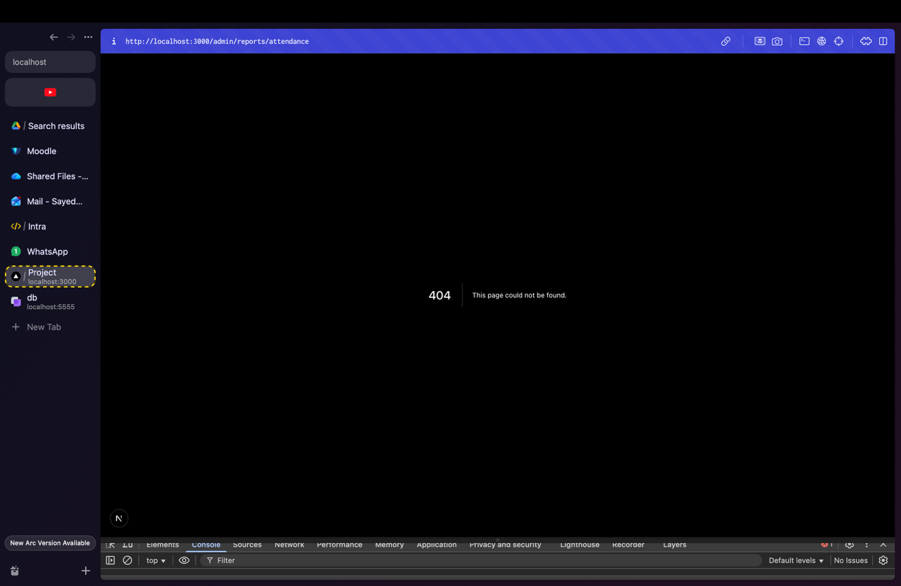
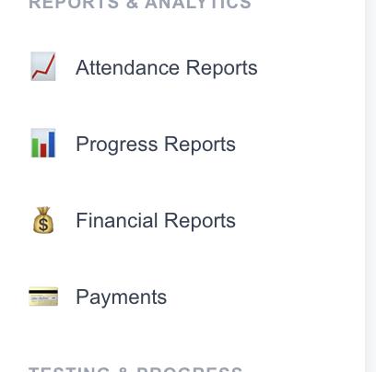
All these are not working 