The Function Institute System
Project Plan

Version 3.0

Date: 4/11/2025

Copyright

Declaration

I hereby declare that this submission is my own work and that, to the best of my knowledge and belief, it contains no material previously published or written by another person nor material which to a substantial extent has been accepted for the award of any other degree or diploma of the university or other institute of higher learning, except where due acknowledgment has been made in the text.

Signature <Sayed Qasim Alsari> Name < Sayed Qasim Alsari> Date: 4/11/2025

Document Control
This section includes the approvals on the document, change control, distribution list and change summary.

Document Change Control

Initial Release: | ^{11th} of October, 2025
Current Release: | 4th of November, 2025
Date of Last Review:
Date of Next Review:
Target Date for Next Update:

Distribution List

This following list of people shall receive a copy of this document every time a new version of this document becomes available:
Sayed Qasim Alsari - Project Manager
Hashem Mohamed - Expert
Tamkeen - Sponsor
The Function – Authentic Learning - Client
Sayed Qasim Alsari - Full stack Developer
Sayed Qasim Alsari – Project Analyst
Sayed Qasim Alsari – Database Designer
Sayed Qasim Alsari – Tester

Change Summary

The following table details changes made between versions of this document
Version | Date | Modifier | Description
1.0 | 11th of October, 2025 | Sayed Qasim Alsari | Added scope management draft, with WBS
2.0 | 25th of October, 2025 | Sayed Qasim Alsari | Added Procurement Management, Closure, Communication, Human Resource, Risk Management, Schedule, Cost and Quality plan drafts
3.0 | 3rd of November, 2025 | Sayed Qasim Alsari | Added Risk and integration management, and finalized the project plan Document

Table of content
Copyright 3
Declaration 4
Document Control 5
Document Change Control 5
Distribution List 5
Change Summary 6
Scope Management Plan 13
RACI table – scope management 14
Scope Management Approach 14
Scope Definition 15
Tools and Techniques Used 16
Supporting Documents Used 16
Scope Statement 16
Product Scope Description 17
Product Acceptance Criteria 17
Project Deliverables 17
Project Exclusions 18
Project Constraints 18
Project Assumptions 18
Work Breakdown Structure (WBS) 18
Time Management Plan 21
Introduction 21
Objectives 22
Processes 22
RACI table – time management 23
Schedule Management Approach 23
Changes 24
Schedule variance and performative index table 25
Reports 25
Project Summary report: 25
Baseline Schedule & Gannt Chart: 25
Network Diagram: 27
Resource Usage Report 28
Work Overview 29
Cost Management Plan 30
Introduction 30
Objectives 30
Processes 30
RACI table – cost management 31
COST Management Approach 31
CHANGES 31
Cost variance and performative index table 31
Reports 32
Cash Flow 32
Cost Overview Report 33
Quality Management Plan 34
Introduction 34
Objectives 34
Processes 34
RACI table – quality management 35
Quality Management Approach 35
Reports 36
Test cases list 36
Test-cases list 42
Quality Requirements 42
Quality requirements list 44
Human Resource Management Plan 45
Introduction 45
Human resource Approach 45
RACI table – human resource management 45
Reports 46
Resource Histogram 46
Resource Work Summary 46
Communication Plan 47
Introduction 47
Objectives 47
Communication Approach 47
Communication Tools and Formats 48
Reports 49
Table 1: Stakeholder communications analysis 49
Table 2: Expectations Management Matrix 49
Table 3: Stakeholders Management Strategy and Influence Matrix 50
Risk Management Plan 53
Introduction 53
Objectives 53
Processes 53
RACI table – risk management 54
Risk Management Approach 54
Reports 56
Risk Register 56
Table 1: Risk and Mitigation Register 56
Procurement Management Plan 60
Introduction 60
Objectives 60
Processes 60
RACI table – procurement management 61
Procurement Approach 61
Reports 62
Integration Management Plan and Closing Plan 64
OBJECTIVES 64
PROCESSES & APPROACHES 65
RACI table – integration management 66
REPORTS 67
LESPI 71
Potential Legal Issues 71
Potential Ethical Issues 71
Potential Social Issues 71
Potential Professional Issues 72
Approval Signatures 73
Appendices 74
Problem Analysis 74
Fishbone (Ishikawa) diagram 75
Appendix 2: Requirements Gathering and Analysis 76
Functional requirements 76
Functional requirement list 79
Non-Functional Requirements 80
Non-functional requirement list 82
Decision Analysis 83
AI-Integrated Institute Management System 83
Executive summary 83
Recommended solution: 83
Reports 84
2. WEIGHTED SCORE ANALYSIS 84
2.1 Scoring Methodology 84
2.2 Weighted Score Summary 85
Table: Weighted Score Summary 85
3. FINANCIAL FEASIBILITY ANALYSIS 85
3.1 Human Resources 86
Development Phase (14 weeks): 86
3.2 Non-Human Resources 86
3.3 Five-Year Cost Summary 86
Five-Year Cost Summary 86
4. COST-BENEFIT ANALYSIS WITH NPV 87
4.1 NPV Screenshot 87
4.2 Key Financial Findings 87
5. CONCLUSION AND RECOMMENDATION 87
5.1 Justification 87
5.2 Risk Mitigation 88
References 88
PROJECT MANAGEMENT STANDARDS 88
TECHNOLOGY DOCUMENTATION 88
Frontend 89
Backend 89
Database 89
CLOUD & INFRASTRUCTURE 89
THIRD-PARTY APIs 89
LEGAL & COMPLIANCE 89
SECURITY & ACCESSIBILITY 90
PROFESSIONAL CODES 90
VERSION CONTROL & TESTING 90
API DESIGN STANDARDS 90

List of tables
RACI table – scope management 11
RACI table – time management 20
Schedule variance and performative index table 22
RACI table – cost management 28
Cost variance and performative index table 28
RACI table – quality management 32
Test-cases list 40
Quality requirements list 41
RACI table – human resource management 42
Table 1: Stakeholder communications analysis 46
Table 2: Expectations Management Matrix 46
Table 3: Stakeholders Management Strategy and Influence Matrix 47
RACI table – risk management 51
Table 1: Risk and Mitigation Register 53
RACI table – procurement management 58
RACI table – integration management 63
Functional requirement list 76
Non-functional requirement list 79

List of figures
Figure 1 WBS - Project Processes 18
Figure 2 WBS - Project Initiation Process 18
Figure 3 WBS – Scope & Requirements 18
Figure 4 WBS – System Design 18
Figure 5 WBS – Backend Development 19
Figure 6 WBS – Frontend Development 19
Figure 7 WBS – AI Chatbot Module 19
Figure 8 WBS – Integration & APIs 19
Figure 8 WBS – Testing 19
Figure 9 WBS – Deployment 20
Figure 9 WBS – Documentation 20
Figure 10 WBS – Project Closure 20
Project summary report 24
Baseline Gantt chart 25
Project network diagram figure 27
Project Resource usage report 27
Project work overview report 28
Project cash flow report 31
Project cost overview report 32
Project resource histogram 45
Project resource work summary 45
Project fishbone (Ishikawa) diagram 74

Scope Management Plan
The purpose of this Scope Management Plan is to define and control what is included and excluded in the AI-Integrated Institute Management and Insight System project. This document ensures that all stakeholders share a clear understanding of the project boundaries, deliverables, and success criteria. It outlines the methods, tools, and responsibilities for defining, validating, and controlling the project scope throughout the development lifecycle.
The main objective is to ensure the project delivers a secure, scalable, and AI-driven management system that automates core institute operations — including registration, attendance, payments, reporting, and chatbot-assisted communication — within the agreed timeline and quality standards.
Scope Management Team and RACI Involvement
The scope management process will involve collaboration between the Project Manager, Development Team, Client Representative (Institute Director), and Academic Advisors. Roles and responsibilities are defined using the RACI framework as follows:
Responsible | Accountable | Consulted | Informed
Project Manager | Defines and maintains the scope plan, ensures scope alignment with objectives. | ✅ | ✅
Full stack Developer | Implements features within the defined scope and reports change requests. | ✅ | -
Client Representative (Institute Admin) | Provides requirements, validates deliverables, and approves scope changes. | - | ✅
Academic Supervisor | Reviews progress and ensures academic alignment with project objectives. | - | ✅
Teachers / End Users | Provide feedback on usability and functional scope. | - | ✅

RACI table – scope management

Scope Management Approach

Scope management will follow a progressive elaboration approach based on the PMBOK (Project Management Body of Knowledge) framework:
Scope Definition: Requirements will be collected through interviews, research, and continuous feedback.
2. Work Breakdown Structure (WBS): The system modules (authentication, attendance, payments, chatbot, reports) will be decomposed into manageable deliverables.
3. Scope Validation: Client and supervisor reviews will be conducted after each milestone to confirm deliverables meet expectations.
4. Scope Control: Any changes to the agreed functionality will follow a formal Change Request procedure, requiring client and supervisor approval.
5. Scope Monitoring: Regular progress reports and sprint reviews will ensure that all project tasks remain within the defined scope.

Scope Definition

The project scope ensures that the system delivers:
• A secure OTP-based login and role management system (Admin, Teacher, Student, Guest).
• Modules for attendance tracking, student registration, and teacher-class assignments.
• Integrated online payment and receipt generation system.
• A built-in AI Chatbot for administrative assistance.
• Comprehensive data reporting and analytics dashboards.

The scope definition ties directly to the requirements documentation:
• Each functional requirement corresponds to a tangible system module (e.g., attendance, payments, chatbot).
• Non-functional requirements define performance, usability, and reliability standards.
• Deliverables are validated at each milestone to ensure alignment with project objectives.

The project scope ensures that the system delivers:
• A secure OTP-based login and role management system (Admin, Teacher, Student, Guest).
• Modules for attendance tracking, student registration, and teacher-class assignments.
• Integrated online payment and receipt generation system.
• A built-in AI Chatbot for administrative assistance and bilingual support (English/Arabic).
• Comprehensive data reporting and analytics dashboards.
• Support for bilingual interface and responsive design across devices.

The scope definition ties directly to the requirements documentation:
• Each functional requirement corresponds to a tangible system module (e.g., attendance, payments, chatbot).
• Non-functional requirements define performance, usability, and reliability standards.
• Deliverables are validated at each milestone to ensure alignment with project objectives.

Tools and Techniques Used

To ensure accuracy and stakeholder alignment, the following tools and techniques were employed in defining the project scope:
1. Expert Judgment:
Consultations were conducted with academic advisors, institute administrators, and IT specialists to define feasible system boundaries.
2. Product Analysis:
The current Google Sheets–based workflow was analyzed to identify pain points, redundancies, and opportunities for automation.
3. Alternatives Identification:
Several design approaches (local server vs. cloud, database types, and chatbot models) were compared to select the most viable combination using AWS cloud hosting and SQLite/MySQL database.
4. Facilitated Workshops:
Stakeholder discussions were held to finalize module priorities (registration, attendance, payments, chatbot, reports) and to avoid feature creep.

Supporting Documents Used
• Project Charter – Defined objectives, stakeholders, and scope boundaries.
• Requirements Documentation – Listed 40 functional and 20 non-functional requirements.
• Problem Analysis (RCA and Ishikawa Diagram) – Identified operational inefficiencies and guided system design priorities.
• Interview Summaries and Client Feedback – Provided insight into user expectations and operational needs.

Scope Statement

Product Scope Description

The AI-Integrated Institute Management and Insight System aims to automate and centralize all major academic and administrative processes within the institute. It replaces manual spreadsheets and paper-based workflows with a digital solution that provides real-time data access, analytics, and AI-powered support.

The system will include modules for student registration, attendance management, payments and receipts, academic performance tracking, and bilingual communication through an integrated chatbot. The platform will be accessible via web browsers on desktop and mobile devices, ensuring scalability, security, and a user-friendly experience.
Product Acceptance Criteria

The project will be considered successful and accepted upon meeting the following measurable criteria:
1. Users can log in securely through OTP authentication and complete system tasks based on their role.
2. Teachers can record attendance, upload learning materials, and view reports without errors.
3. Students can access attendance, grades, and payment details through their dashboard.
4. Administrators can generate accurate reports (financial, attendance, performance) on demand.
5. The chatbot responds accurately to common user queries in both English and Arabic.
6. The system achieves at least 99% functionality uptime and meets data security standards (TLS 1.3, AES encryption).
7. All deliverables are tested, validated, and approved by both the client and academic supervisor.

Project Deliverables

The project will result in the following primary deliverables:
• Functional Institute Management Web Application with user roles (Admin, Teacher, Student, Guest).
• Database schema for student, class, attendance, payment, and report management.
• AI Chatbot integrated using NLP models for bilingual interaction.
• Reporting dashboards with graphical analytics for admin insights.
• Online payment module using Stripe API with automated receipts.
• Responsive bilingual interface supporting English and Arabic.
• System documentation including user guide, technical documentation, and testing reports.
• Deployment and demonstration of the working prototype hosted on AWS or Azure.

Project Exclusions

The following items are outside the current project scope:
• Mobile native app (iOS/Android) development — only responsive web support will be provided.
• Integration with third-party Learning Management Systems (e.g., Moodle, Canvas).
• Multi-branch synchronization (only one institute branch is included in this phase).
• Advanced predictive analytics or AI grading automation (future phase).
• Offline mode or local database synchronization.

Project Constraints
• Time: Development must be completed within the academic term (approximately 14 weeks).
• Budget: Limited to student project resources and free-tier API usage.
• Technical: Restricted by available hosting (AWS/Azure credits provided by university).
• Manpower: Single developer with supervisor and client input.
• Security: Must adhere to institutional data protection policies and privacy standards.

Project Assumptions
• The client (institute admin) will provide accurate operational data for initial testing.
• Internet connectivity will be stable for online features such as OTP and payment processing.
• The AI chatbot will rely on pre-trained language models and not require live training from user data.
• The institute staff will participate in testing and provide timely feedback.
• All stakeholders (developer, supervisor, and client) will maintain active communication and approvals during each development milestone.

Work Breakdown Structure (WBS)
The below figure represents an overview of the duration and the process that the project will go
through to achieve the deliverables.
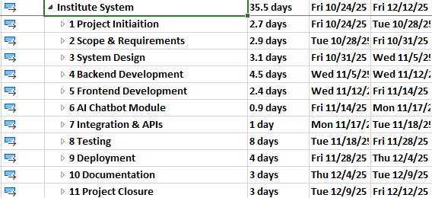
Figure 1 WBS - Project Processes

The below figure displays the work breakdown structure of the initiation process of the project,
with the charter document as the final milestone of this process.

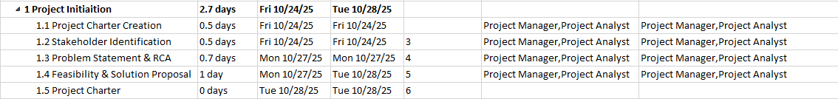
Figure 2 WBS - Project Initiation Process

The below figure presents an overview of the planning process work breakdown structure and
their main tasks in this project, with the project plan document as the final milestone of this
process.
Figure 3 WBS – Scope & Requirements

The below figure shows an overview of the System Design work breakdown structure and
their main tasks in this project, with the completion of System Design as the final milestone of
this process.
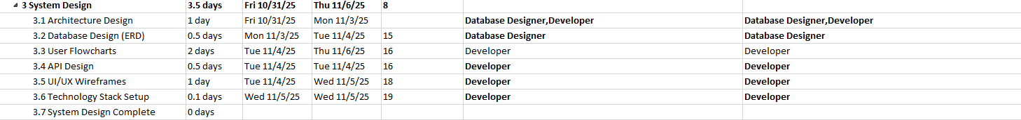
Figure 4 WBS – System Design

The below figure shows an overview of the Backend Development work breakdown structure and
their main tasks in this project, with the Backend completion as the final milestone of this process.
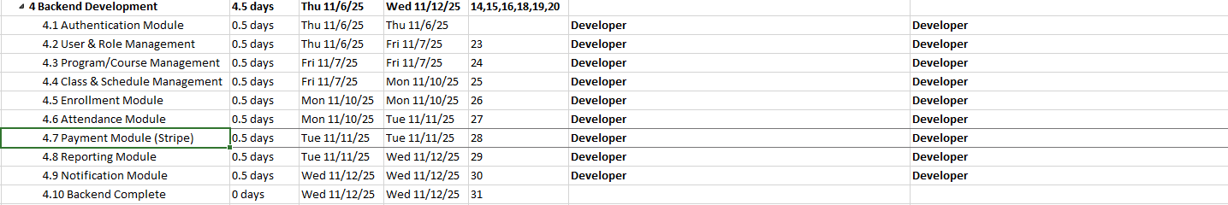
Figure 5 WBS – Backend Development

The below figure shows an overview of the Frontend Development work breakdown structure and
their main tasks in this project, with the Frontend completion as the final milestone of this process.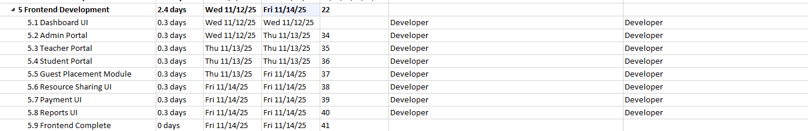
Figure 6 WBS – Frontend Development

The below figure shows an overview of the AI Chatbot Module work breakdown structure and
their main tasks in this project, with the AI Chatbot Module completion as the final milestone of this process
Figure 7 WBS – AI Chatbot Module

The below figure shows an overview of the Integration & APIs work breakdown structure and
their main tasks in this project, with the completion of Integration as the final milestone of this process.
Figure 8 WBS – Integration & APIs

The below figure shows an overview of the Testing work breakdown structure and
their main tasks in this project, with the Ready for Deployment as the final milestone of this process 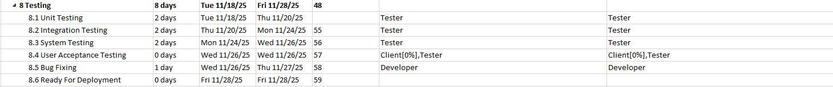
Figure 8 WBS – Testing

The below figure shows an overview of the Deployment work breakdown structure and
their main tasks in this project, with the System Deployed as the final milestone of this process
Figure 9 WBS – Deployment

The below figure shows an overview of the Documentation work breakdown structure and
their main tasks in this project, with the Documentation Complete as the final milestone of this process
Figure 9 WBS – Documentation

The below figure shows an overview of the Project Closure work breakdown structure and
their main tasks in this project, with Project Complete as the final milestone of this process
Figure 10 WBS – Project Closure

Time Management Plan

Introduction
Project Schedule Management is the discipline of planning, organizing, and monitoring project activities to ensure timely delivery. It focuses on defining all tasks, estimating their durations, and arranging them in a logical sequence that aligns with project goals and available resources.
In the Institute Management System project, effective time management was essential to ensure that all development phases—analysis, design, implementation, testing, and deployment were completed within the approved timeframe.

Objectives
The primary objective of schedule management is to deliver the project on time and within scope. This goal was supported by several sub-objectives:
- Estimate the required duration and effort for each project activity.
- Establish a clear and realistic activity sequence based on dependencies.
- Ensure efficient utilization of human and technical resources.
- Identify and monitor the critical path and slack time to avoid bottlenecks.
- Define milestones and ensure they are achieved according to the planned timeline.
- Manage schedule updates and adapt to any project changes.

Processes
To achieve these objectives, the following key processes were implemented throughout the project’s life cycle:

1. Plan Schedule Management
This stage involved defining the tools, methods, and standards to be used for creating, managing, and updating the project schedule. The output of this phase was the Schedule Management Plan, which guided the overall time management process.

2. Define Activities
Project work was broken down into smaller, manageable activities derived from the Work Breakdown Structure (WBS). Each activity included clear deliverables and was assigned to responsible team members.

3. Sequence Activities
Logical relationships among activities were determined using dependency types such as Finish-to-Start (FS) and Start-to-Start (SS). These relationships were then visualized through network diagrams in MS Project.

4. Estimate Activity Durations
Each activity’s time requirement was estimated using previous experience, resource availability, and project constraints. This estimation provided a baseline for the total project duration.

5. Develop Schedule
By integrating duration estimates, dependencies, and resource assignments, a detailed Gantt Chart was generated. Analytical tools such as PERT and Critical Path Analysis were also applied to identify time-sensitive tasks.

6. Control Schedule
This phase focused on tracking project progress and applying corrective actions whenever delays or changes occurred. Schedule updates were communicated with all stakeholders to ensure project alignment and transparency.

Responsibility Assignment Matrix
Responsible | Accountable | Consulted | Informed
Project Manager | Project Manager | Supervisor, Client, PMO | Supervisor, Client, PMO

RACI table – time management

Schedule Management Approach

1. Gantt Chart
The Gantt chart was used to outline all project activities along with their start and finish dates, assigned resources, and task dependencies. It provided a visual timeline of all development phases—such as system analysis, design, implementation, testing, and deployment—and facilitated progress tracking throughout the project lifecycle.

2. Dependencies
Dependencies between tasks were established to maintain logical sequencing and prevent scheduling conflicts. Predecessors and successors were defined to reflect workflow order.
The following dependency types were applied:
- Finish-to-Start (FS): A task starts only after the previous one finishes (e.g., system design after requirements gathering).
- Start-to-Start (SS): Tasks begin simultaneously (e.g., frontend and backend development).
- Finish-to-Finish (FF): Tasks conclude together (e.g., testing and documentation).
- Start-to-Finish (SF): Rarely used, but applicable when an activity’s start determines another’s finish.

3. Schedule Milestones
Milestones were defined at the end of each major project phase to represent key achievements. For example:
- Completion of the Database Design
- Successful System Prototype Presentation
- Testing and Debugging completion
- Final Deployment and Report Submission
Each milestone served as a checkpoint for monitoring project performance and ensuring timely delivery.

4. Lagging
Lag time was introduced when a delay between dependent tasks was necessary—for instance, allowing a review period after system testing before final deployment. This provided flexibility in managing dependencies and addressing unforeseen issues.

5. Leading
Lead time was applied to accelerate the project schedule when possible, allowing overlapping of certain activities (e.g., starting the documentation process before all modules were finalized). This helped recover time lost to minor delays.

6. PERT Analysis
The Program Evaluation and Review Technique (PERT) was used to estimate the total project duration in cases of uncertainty. It incorporated optimistic, pessimistic, and most likely time estimates for key activities, allowing better risk assessment and time prediction.

7. Slack Time and Critical Path
Using Critical Path Method (CPM), the project’s critical path was identified—representing the sequence of tasks with zero slack that determined the minimum project duration. Monitoring this path ensured focus on the most time-sensitive activities. Slack times for non-critical tasks were utilized strategically to manage workload and avoid resource over-allocation.

Changes
To evaluate the project’s performance in terms of schedule management, two main indicators were applied: Schedule Variance (SV) and Schedule Performance Index (SPI). These indicators were measured periodically during project development to track deviations from the planned schedule.

The Schedule Variance (SV) represents the difference between the earned value and the planned value of project work, helping to identify whether the project is ahead or behind schedule.
The Schedule Performance Index (SPI), on the other hand, measures the efficiency of time utilization by comparing the rate of work completed to what was planned.
The following table summarizes how the values of SV and SPI indicate the project’s current progress status:

Schedule Variance (SV) | Schedule Performative Index (SPI) | Progress Status
SV = 0 | SPI = 1 | On schedule
SV > 0 | SPI > 1 | Ahead of schedule
SV < 0 | SPI < 1 | Behind schedule

Schedule variance and performative index table

Reports
Include the Project Summary report, Baseline Schedule, Gantt chart, Network Diagram, and two additional visual reports related to time management explaining why you think they are useful.

Project Summary report:
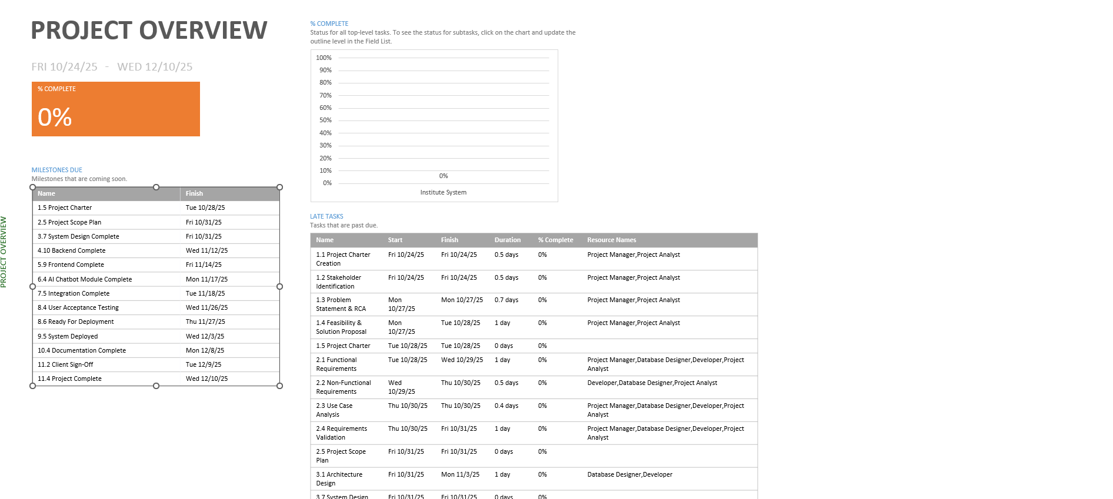
Project summary report
The Project Summary Report provides a high-level overview of the entire project’s status. It helps the project manager and stakeholders quickly understand progress, delays, and workload distribution without diving into detailed task data.

Baseline Schedule & Gannt Chart:
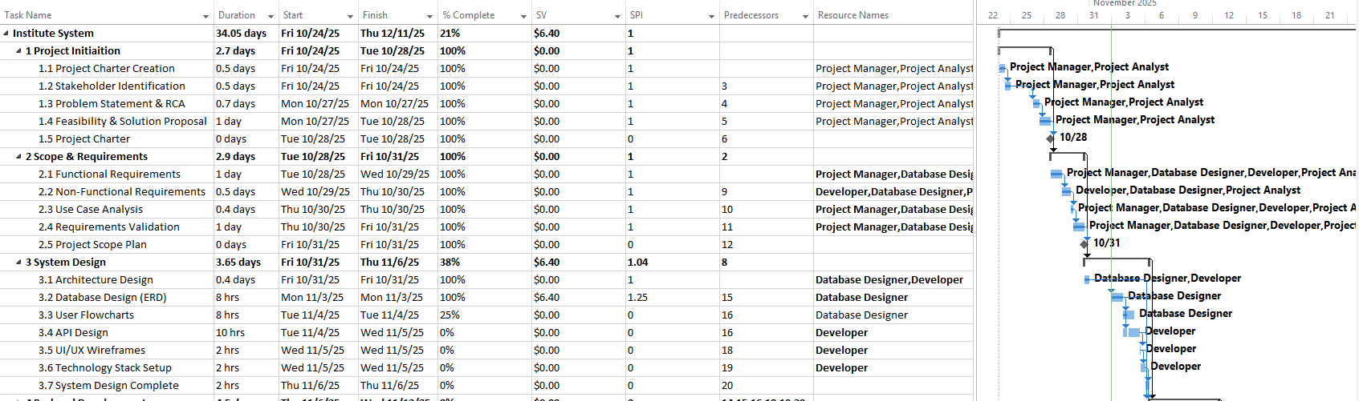
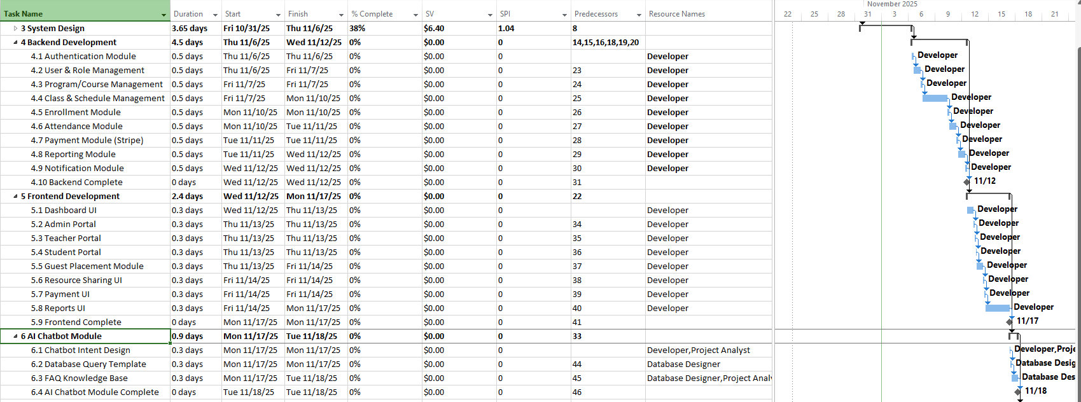
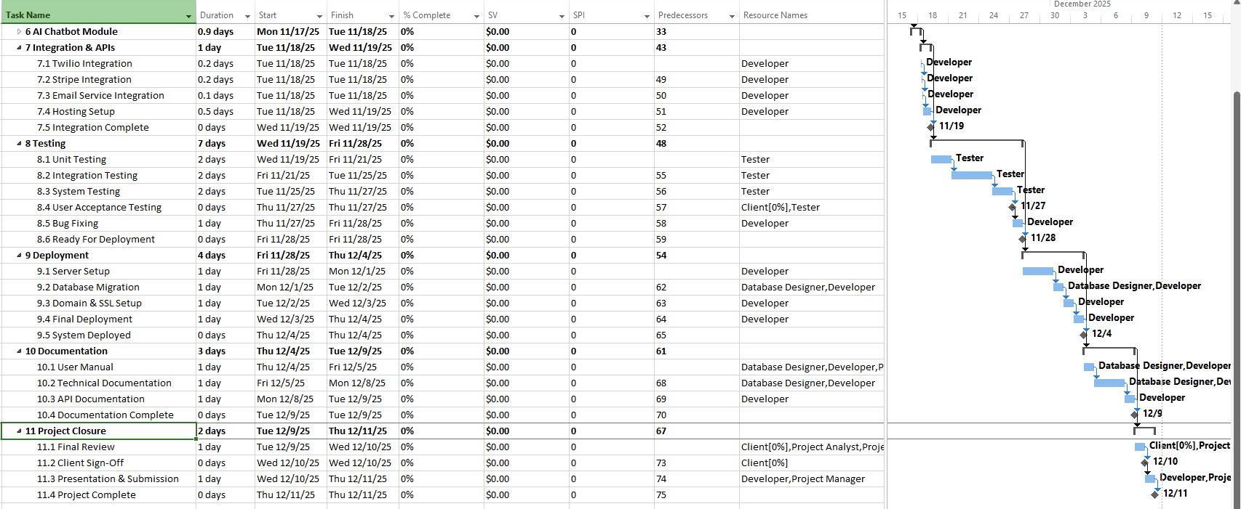
Baseline Gantt chart

The baseline acts as a time-performance benchmark. It allows you to track deviations, measure delays, and evaluate overall project efficiency. This is crucial for calculating Schedule Variance (SV) and Schedule Performance Index (SPI).

The Gantt Chart visually represents the timeline and sequence of all project activities. It helps track progress, identify overlaps, and manage deadlines effectively. It’s one of the most widely used tools in project time management.

Network Diagram:
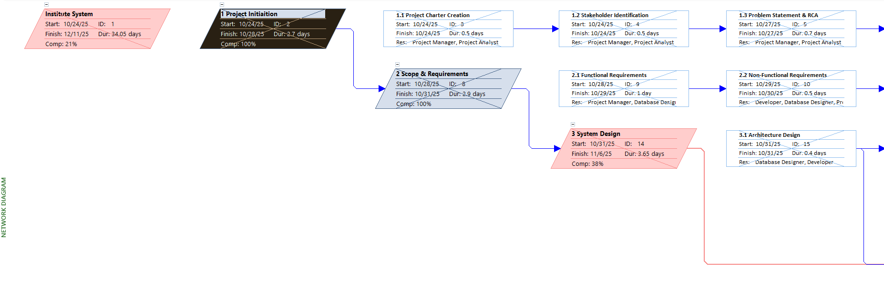
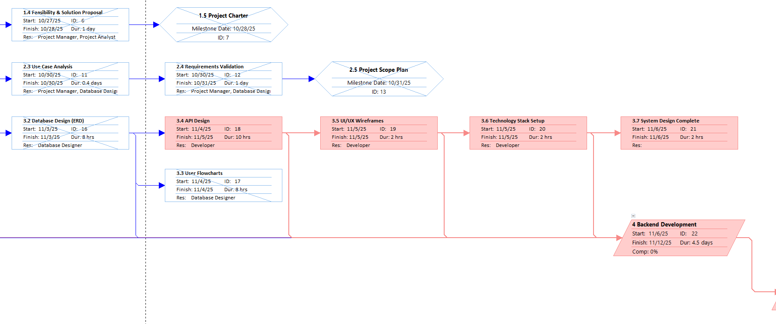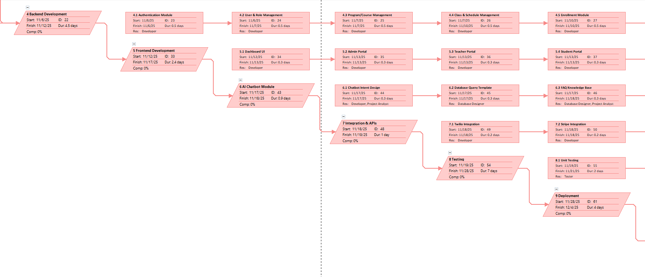
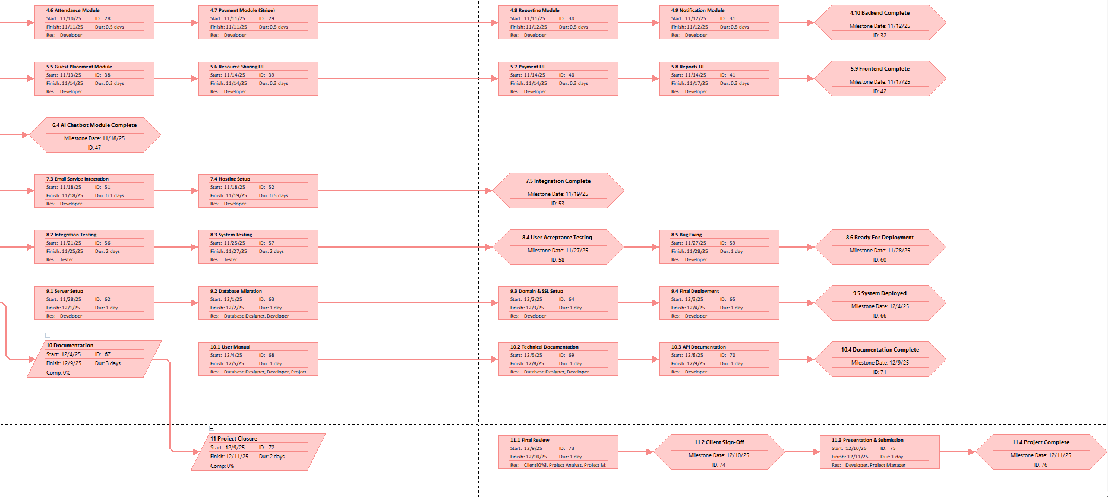
Project network diagram figure
The Network Diagram is essential for identifying critical paths and slack time. It helps visualize logical relationships and evaluate how delays in one activity can affect the overall project timeline.

Resource Usage Report
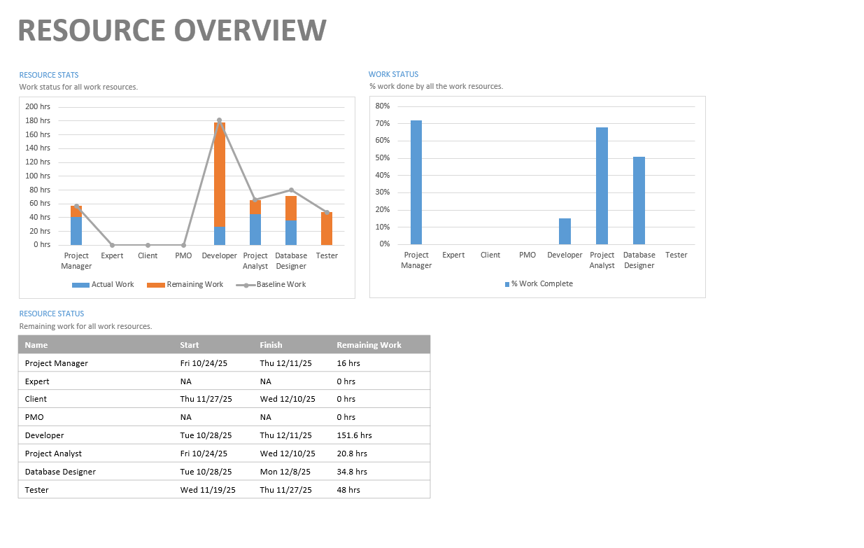
Project Resource usage report
This report ensures that resources are not over-allocated or underutilized. It helps balance workloads and manage productivity efficiently, which directly impacts project timing and schedule reliability.

Work Overview

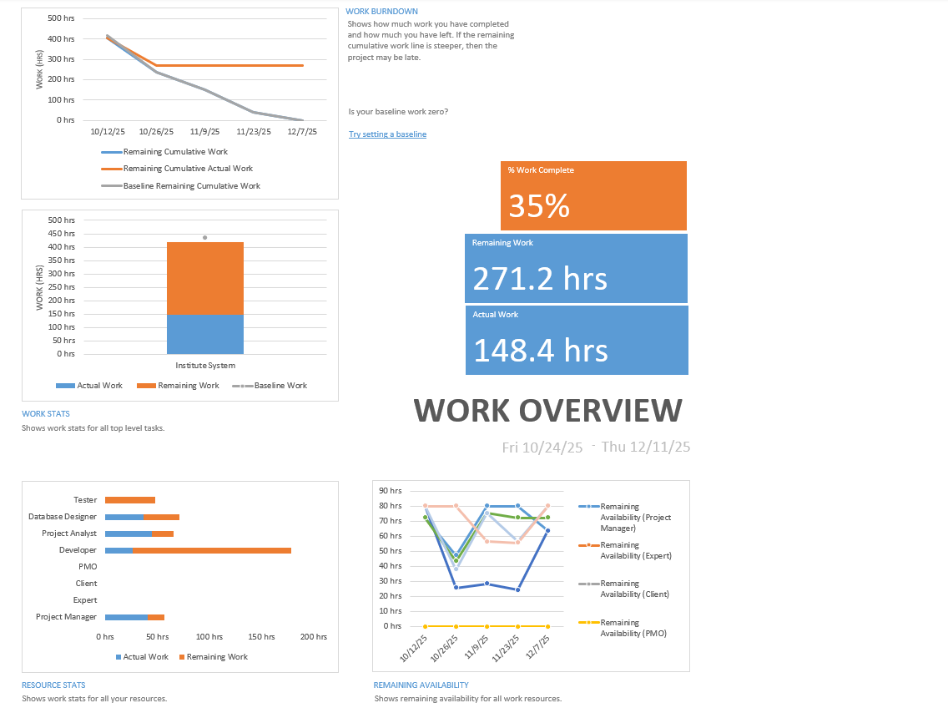
Project work overview report
The Project Overview Report provides a concise visual summary of the project’s overall progress, including completion percentage, milestones, and late tasks. It helps the project manager and stakeholders quickly assess whether the project is on track and identify any schedule issues that require attention.

Cost Management Plan
Introduction
Project Cost Management ensures that all project deliverables are completed within the approved financial limits. It involves defining cost elements, estimating expenses, allocating resources, and controlling spending throughout the project lifecycle. The process aims to establish a realistic budget that aligns with project goals while minimizing unnecessary costs.

Objectives
The main goal of project cost management is to deliver the Institute Management System project within the approved budget. This goal can be achieved through several specific objectives:
- Prepare accurate cost estimates for all project activities.
- Control and monitor financial expenditures across all development stages.
- Utilize project resources efficiently to reduce cost overruns.
- Maintain cost performance in line with planned baselines.
- Ensure milestone completion with optimal cost utilization.

Processes
The implementation of cost management in this project involved the following four key processes:

1. Plan Cost Management
This process defined the policies, guidelines, and documentation methods used to estimate, allocate, and control project costs. It established the approach for managing cost variance and performance during execution. The main outcome of this process was the Cost Management Plan.

2. Estimate Costs
This process involved identifying and calculating the expected costs for each resource and activity, including development, testing, and deployment expenses. Outputs included the Activity Cost Estimates and Resource-Based Cost Summary.

3. Determine Budget
This process aggregated individual cost estimates into a total project budget and allocated costs to each phase according to the Work Breakdown Structure (WBS). The result was the Cost Baseline, used for measuring and controlling project performance.

4. Monitor and Control Costs
This process tracked project spending, analyzed variances, and implemented corrective measures where required. Outcomes included Cost Forecasts, Variance Reports, and Updated Project Documentation to reflect approved financial changes.

Responsibility Assignment Matrix

Responsible | Accountable | Consulted | Informed
Project Manager | Project Manager | Supervisor, Client, PMO | Supervisor, Client, PMO

RACI table – cost management

COST Management Approach

1. Cost–Benefit Analysis
This approach compared the initial project costs (labor, software tools, hardware) against the expected benefits (automation, reduced administrative workload, improved accuracy) to assess the project’s return on investment and payback period.

2. Resource Sheet – Entry View
This view listed all work and material resources used in the project along with their associated cost rates. It provided visibility into the cost contribution of each resource to specific project activities.

3. Resource Sheet – Cost View
This view presented a detailed breakdown of costs per activity and phase. It helped identify the development stages consuming the highest portion of the budget and supported decisions for cost optimization.

CHANGES

Cost Variance (CV) | Cost Performative Index (CPI) | Progress Status
CV = 0 | CPI = 1 | On Budget
CV > 0 | CPI > 1 | Cost-efficient
CV < 0 | CPI < 1 | Cost-inefficient

Cost variance and performative index table

Reports

Cash Flow
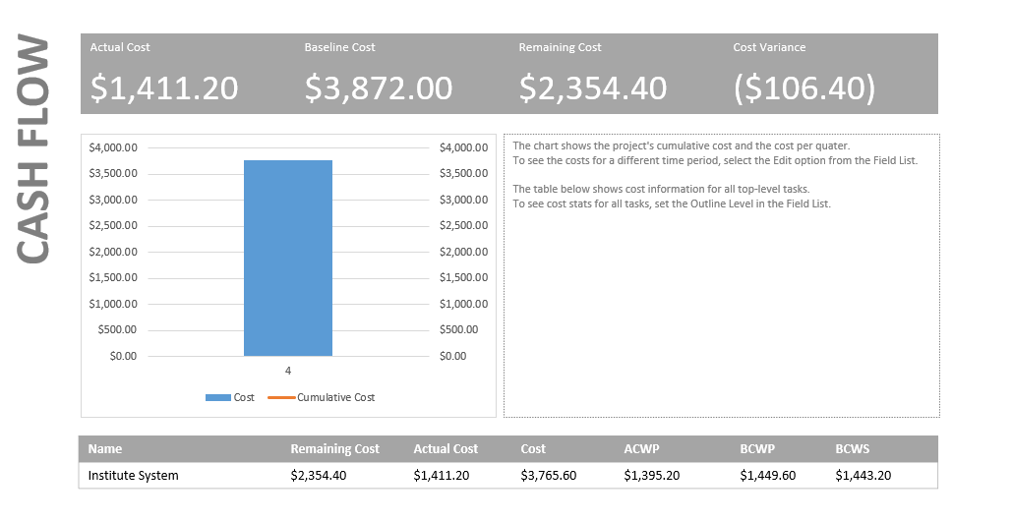
Project cash flow report
The Cash Flow Report displays the cumulative cost distribution of the project over time. It visualizes planned, actual, and remaining costs in graphical form, allowing the project manager to see when and where expenses occur during each project phase.

This report helps forecast future spending and ensures that funds are available when needed. By comparing planned versus actual cash flow, the project manager can detect cost overruns early, adjust resource allocation, and maintain financial control throughout the project lifecycle. It is especially helpful for presenting financial progress to the client or sponsor.

Cost Overview Report
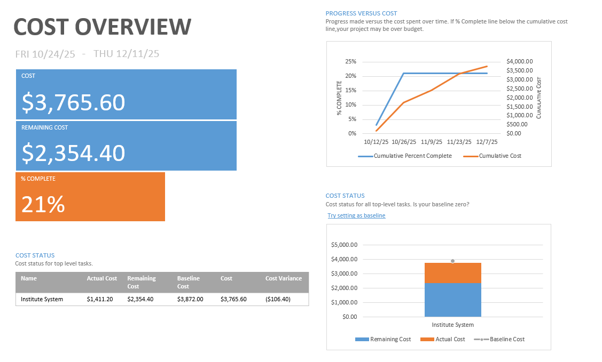
Project cost overview report
The Cost Overview Report provides a summarized view of total, actual, and remaining project costs. It helps track financial performance against the baseline and ensures that all project expenses, such as cloud and API services, remain within the approved budget.

Quality Management Plan
Introduction
Quality Management ensures that the project deliverables meet both the client’s expectations and recognized industry standards. It goes beyond fulfilling written requirements by focusing on understanding and addressing the client’s real needs to achieve overall satisfaction and system reliability.
Objectives
The main goal of project quality management is to deliver a system that meets the defined quality standards and user expectations. This goal can be achieved through the following objectives:
- Ensure that all project deliverables align with the client’s stated requirements.
- Maintain the balance between project scope, cost, and time without compromising quality.
- Apply recognized quality standards and methodologies throughout all project phases.
- Establish continuous communication with the client and supervisor to ensure consistent understanding of quality needs.
- Validate that the final product performs reliably under expected operational conditions.

Processes

Achieving quality objectives involves three key processes implemented during the project lifecycle:

1. Plan Quality Management
This process defined the standards and quality criteria applicable to the Institute Management System project. It established the methodology used to measure, control, and verify quality performance. The main outputs included the Quality Management Plan, Quality Metrics, and Improvement Plan.

2. Perform Quality Assurance
This process ensured that the project adhered to defined standards and procedures. It involved periodic reviews, testing, and validation activities across all development phases to guarantee compliance with performance and reliability expectations. Outputs included review reports, corrective actions, and updated documentation.

3. Control Quality
This process monitored the outcomes and deliverables to ensure they met both the client’s requirements and technical standards. It involved verification of task outputs, detection of defects, and application of corrective measures to enhance overall system quality.

Responsibility Assignment Matrix

Responsible | Accountable | Consulted | Informed
Project Manager | Project Manager | Supervisor, Client, PMO | Supervisor, Client, PMO

RACI table – quality management

Quality Management Approach
Several approaches were implemented to maintain high-quality standards throughout all stages of the Institute Management System project:

- PIECES Framework
The PIECES Framework was applied to classify and evaluate quality requirements effectively. It helped identify both functional and non-functional needs that may otherwise go unnoticed.
- Performance: Ensure smooth system operation and fast response times.
- Information: Maintain data accuracy, clarity, and consistency across modules.
- Economy: Optimize resource usage and minimize operational costs.
- Control: Enforce security measures and data access restrictions.
- Efficiency: Maximize output with minimal resource consumption.
- Service: Deliver a reliable, user-friendly, and flexible platform.

2. Quality Assurance
This approach involved the continuous application of coding standards, documentation guidelines, and system testing to guarantee that the project followed best practices. It focused on preventing errors before they occurred.

3. Quality Control
Quality control focused on inspecting deliverables, executing test cases, and validating module functionality. It ensured that all developed components complied with defined requirements before project closure.

Reports
Test cases list
Case No. |  | Test Case | Objectives | Prerequisite | Input | Expected Output | Actual Output | Status
AUTHENTICATION & ACCESS
1 | Login with OTP via email |  | Verify user can login using OTP sent to email | Valid user account exists in database | Email address: student@example.com | 6-digit OTP sent to email within 30 seconds | - | Not Tested
2 | Verify OTP code |  | Validate correct OTP allows access | OTP sent to user email | Valid OTP code (e.g., 123456) | User successfully logged in and redirected to dashboard | - | Not Tested
3 | Reject invalid OTP |  | Prevent access with wrong OTP | OTP sent to user | Invalid OTP code (e.g., 999999) | Error message: "Invalid OTP code. Please try again." | - | Not Tested
4 | OTP expiration after 5 minutes |  | Ensure security by expiring old OTPs | OTP sent 6 minutes ago | Expired OTP code | Error message: "OTP expired. Please request a new code." | - | Not Tested
5 | Account lockout after 3 failed attempts |  | Prevent brute force attacks | User attempted 3 wrong OTPs | 4th invalid OTP attempt | Account locked for 15 minutes with message displayed | - | Not Tested
STUDENT PORTAL
6 | View student dashboard |  | Display student's key information | Logged in as student | Access dashboard URL | Dashboard shows: attendance %, progress, payment status, upcoming classes | - | Not Tested
7 | View attendance records |  | Student can see their attendance history | Enrolled student with attendance records | Navigate to Attendance page | List of all class sessions with status (P/A/L/E) and attendance % | - | Not Tested
8 | View progress checklist |  | Display criteria completion for current level | Student enrolled in A1 level | Navigate to Progress page | Shows 5 criteria with completion status (e.g., 3/5 completed, 60%) | - | Not Tested
9 | Make online payment |  | Process payment for installment via Stripe | Outstanding balance exists | Select installment, enter card details | Payment processed, receipt generated, balance updated | - | Not Tested
10 | Download class materials |  | Access uploaded materials | Teacher uploaded materials for group | Click download on PDF material | File downloads successfully to device | - | Not Tested
TEACHER PORTAL
11 | Record class attendance |  | Mark attendance for all students in class | Teacher assigned to group with 15 students | Mark 12 as Present, 2 as Absent, 1 as Late | Attendance saved, students' percentages updated, parents notified if below threshold | - | Not Tested
12 | Bulk upload attendance via CSV |  | Upload attendance for multiple sessions | CSV file with correct format | Upload CSV with 15 student records | All 15 attendance records created successfully | - | Not Tested
13 | Update student progress |  | Mark criteria as complete for student | Student enrolled with 3/5 criteria complete | Mark 4th criteria as complete | Progress updated to 4/5 (80%), student notified | - | Not Tested
14 | Promote student to next level |  | Move student to next level when all criteria complete | Student completed all 5 criteria in A1 | Click "Promote to A2" button | Student level changed to A2, new criteria checklist initialized | - | Not Tested
15 | Upload class materials |  | Share resources with students | Teacher logged in, group selected | Upload PDF file (2.5 MB) with title and description | Material uploaded, visible to all students in group | - | Not Tested
ADMIN PORTAL
16 | Register new student |  | Create student account and profile | Admin logged in | CPR: 123456789, Name: John Ahmed, DOB: 2010-05-15 | Student account created, OTP sent to parent email | - | Not Tested
17 | Register duplicate CPR |  | Prevent duplicate student registration | Existing student with CPR 123456789 | Attempt to register with same CPR | Error message: "CPR already exists in system" | - | Not Tested
18 | Create new group |  | Set up class group for term | Term and level exist, teacher available | Group name: "A1-Monday-Evening", Capacity: 15 | Group created with schedule and venue assigned | - | Not Tested
19 | Assign teacher to group |  | Link teacher to class group | Group exists without teacher | Select Teacher ID: 3 for Group ID: 5 | Teacher assigned, visible in group details | - | Not Tested
20 | Enroll student in group |  | Add student to class group | Student account exists, group has capacity (10/15) | Student ID: 1, Group ID: 5 | Enrollment created with status "PENDING_TEST", capacity updated (11/15) | - | Not Tested
21 | Enroll student in full group |  | Prevent over-enrollment | Group at full capacity (15/15) | Attempt to enroll Student ID: 20 | Error message: "Group is at full capacity" | - | Not Tested
22 | Generate attendance report |  | Export attendance data for analysis | Attendance data exists for group | Select Group ID: 5, Date range: Oct 1-31 | PDF report generated showing all students' attendance with percentages | - | Not Tested
23 | Generate financial report |  | View payment collection summary | Payment data exists for term | Select Term: Fall 2025 | Report shows: total due (9000 BHD), collected (5400 BHD), outstanding (3600 BHD) | - | Not Tested
24 | View placement test results |  | Review and approve test outcomes | Student completed MCQ and speaking test | View Test Session ID: 10 | Shows MCQ score (85%), speaking score (80%), recommended level (A2) | - | Not Tested
25 | Approve final level assignment |  | Assign student to level after test | Test results available | Select final level: A2, click "Approve" | Student assigned to A2, enrollment status changed to "ENROLLED" | - | Not Tested
PAYMENT PROCESSING
26 | Create payment plan |  | Set up installment schedule | Student enrolled in group | Total dues: 600 BHD, 4 installments | Payment plan created with 4×150 BHD installments | - | Not Tested
27 | Process Stripe payment |  | Complete online payment transaction | Student selected installment, valid card | Card: 4242 4242 4242 4242, Exp: 12/25 | Payment successful, Stripe confirmation received, installment marked PAID | - | Not Tested
28 | Reject declined card payment |  | Handle payment failure | Invalid/declined card | Card with insufficient funds | Error message: "Payment declined. Please try another card." | - | Not Tested
29 | Record manual payment |  | Admin enters cash/bank transfer payment | Student with unpaid installment | Payment method: CASH, Amount: 150 BHD | Installment marked PAID, receipt generated, balance updated | - | Not Tested
30 | Send payment reminder |  | Automated reminder 3 days before due date | Installment due date: Oct 20, Current: Oct 17 | System automated job runs | Email and SMS sent: "Payment of 150 BHD due on Oct 20" | - | Not Tested
TESTING SYSTEM
31 | Take placement test (MCQ) |  | Guest takes online test to determine level | Guest user (not logged in), Test available | Answer 20 multiple choice questions | Test submitted, score calculated (75%), recommended level displayed (A1) | - | Not Tested
32 | Schedule speaking test |  | Student books time slot with teacher | MCQ test completed, teacher slots available | Select date: Oct 25, time: 2:00 PM | Speaking test scheduled, Zoom link sent to student email | - | Not Tested
33 | Conduct speaking test |  | Teacher evaluates student verbally | Speaking test scheduled, Zoom meeting active | Teacher enters score (80%) and notes | Speaking score saved, final level recommended (A2) | - | Not Tested
ENROLLMENT MANAGEMENT
34 | View enrollment status |  | Track student progress through enrollment stages | Student enrollment exists | View Enrollment ID: 15 | Status shows: "SPEAKING_COMPLETED", next step: "Assign final level" | - | Not Tested
35 | Withdraw student from enrollment |  | Remove student from group | Active enrollment exists | Click "Withdraw" button, enter reason | Enrollment status changed to "WITHDREW", group capacity freed | - | Not Tested
NOTIFICATIONS
36 | Send attendance warning |  | Alert parent when attendance drops below 75% | Student attendance: 70% (below threshold) | Attendance recorded as Absent | Email and SMS sent: "Your child's attendance is 70%. Risk of withdrawal." | - | Not Tested
37 | Send enrollment confirmation |  | Notify parent of successful enrollment | Student enrolled in group | Enrollment approved | Email sent: "John has been enrolled in A1-Monday-Evening class" | - | Not Tested
38 | Send payment confirmation |  | Confirm receipt of payment | Payment processed successfully | Payment of 150 BHD completed | Email with receipt PDF attached sent to parent | - | Not Tested
AI CHATBOT
39 | Query attendance via chatbot |  | Student asks about attendance | Student logged in chatbot | Message: "What is my attendance percentage?" | Bot responds: "Your attendance is 92% (23/25 classes). You're on track!" | - | Not Tested
40 | Query payment via chatbot |  | Student asks about balance | Student logged in chatbot | Message: "How much do I owe?" | Bot responds: "Your outstanding balance is 300 BHD. Next payment due on Nov 17." | - | Not Tested
41 | FAQ query via chatbot |  | User asks common question | Any user (guest or logged in) | Message: "What are your class timings?" | Bot responds: "We offer morning (9 AM-12 PM) and evening (6 PM-9 PM) classes" | - | Not Tested
REPORTS & ANALYTICS
42 | Export attendance report to Excel |  | Download attendance data | Attendance records exist for date range | Select group, date range, format: Excel | Excel file downloads with all attendance records in spreadsheet format | - | Not Tested
43 | View admin dashboard metrics |  | Display KPIs for management | System has operational data | Load admin dashboard | Shows: Total students (250), Teachers (15), Revenue (45,000 BHD), Attendance rate (87%) | - | Not Tested
44 | Generate progress report |  | View student progress across levels | Students enrolled with progress data | Select Term: Fall 2025, click "Generate Report" | PDF shows: student names, current level, criteria completed (e.g., 3/5), progress % | - | Not Tested
SECURITY & SESSION MANAGEMENT
45 | Session timeout after 7 days |  | Expire JWT token for security | User logged in 8 days ago | Attempt to access protected page | Redirected to login: "Session expired. Please login again." | - | Not Tested
46 | Prevent unauthorized access |  | Block non-admin from admin pages | Logged in as Student | Attempt to access /admin/students URL | Error 403: "Access denied. Insufficient permissions." | - | Not Tested
47 | Audit log critical actions |  | Track all important system changes | Admin deletes student account | Delete Student ID: 5 | Audit log entry created: User, Action (DELETE), Table (students), Record ID, Timestamp | - | Not Tested
DATA VALIDATION
48 | Validate CPR format |  | Ensure correct CPR format | Student registration form | Invalid CPR: "ABC123" (contains letters) | Error message: "CPR must contain only numbers (9-11 digits)" | - | Not Tested
49 | Validate email format |  | Check valid email address | User registration | Invalid email: "john@example" (no extension) | Error message: "Please enter a valid email address" | - | Not Tested
50 | Validate phone number |  | Ensure Bahrain phone format | Student registration | Invalid phone: "123" (too short) | Error message: "Phone number must be 8 digits (Bahrain format)" | - | Not Tested

Test-cases list

Quality Requirements

Requirements including Standard and metric(s) | Standard Source | Achieved / Not Achieved
System uptime and availability ≥ 99% | ISO/IEC 25010 - Reliability | Not Achieved
Page load time ≤ 2 seconds for all pages | Web Performance Standards | Not Achieved
API response time ≤ 500ms for 95% of requests | Industry Best Practices | Not Achieved
Support 500+ concurrent users without performance degradation | Performance Requirements - NFR3 | Not Achieved
Database query response time ≤ 200ms | Database Performance Standards | Not Achieved
OTP-based authentication with max 3 attempts and 15-minute lockout | OWASP Security Guidelines | Not Achieved
All data encrypted at rest and in transit (TLS 1.3) | ISO/IEC 27001 - Security | Not Achieved
JWT token expiration: 7 days maximum | Security Best Practices - NFR5 | Not Achieved
Password-free authentication (OTP only) | Functional Requirement FR4 | Not Achieved
All critical actions logged in audit trail | Compliance & Audit - NFR18 | Not Achieved
Stripe payment integration with PCI DSS compliance | PCI DSS Standards | Not Achieved
Unit test coverage ≥ 80% | Software Testing Standards | Not Achieved
All 40 functional requirements implemented and tested | Requirements Document | Not Achieved
User Acceptance Testing (UAT) pass rate ≥ 95% | Quality Assurance - NFR8 | Not Achieved
Mobile responsive design for all pages (tablet and smartphone) | WCAG 2.1 - Responsiveness | Not Achieved
Support for English and Arabic languages | Functional Requirement FR30 | Not Achieved
Automated email and SMS notifications delivery rate ≥ 98% | Notification Requirements - FR14 | Not Achieved
Payment reminder sent 3 days, 1 day, and on due date | Functional Requirement FR33 | Not Achieved
Attendance percentage auto-calculated and updated in real-time | Functional Requirement FR21 | Not Achieved
AI chatbot response time ≤ 3 seconds | Chatbot Requirements - FR12 | Not Achieved
Chatbot accuracy rate ≥ 85% for common queries | AI Performance Metrics | Not Achieved
Database backup frequency: Daily automated backups | Data Protection - NFR17 | Not Achieved
Data retention: Minimum 5 years for student records | Educational Data Standards | Not Achieved
System documentation completeness: 100% | Documentation Standards | Not Achieved
API documentation using Swagger/OpenAPI format | API Documentation Standards | Not Achieved
User manual provided for Admin, Teacher, Student, and Parent roles | User Documentation - NFR39 | Not Achieved
Error messages clear and actionable for users | Usability Standards - ISO 9241 | Not Achieved
System recovery time after failure ≤ 1 hour | Disaster Recovery - NFR16 | Not Achieved
Cross-browser compatibility (Chrome, Firefox, Safari, Edge) | Web Standards - W3C | Not Achieved
Accessibility compliance: WCAG 2.1 Level AA | WCAG 2.1 Standards | Not Achieved

Quality requirements list

Human Resource Management Plan
Introduction
This Human Resource Management Plan defines the processes of acquiring, managing, and controlling the project team for the AI-Integrated Institute Management System. This plan outlines roles, responsibilities, reporting relationships, and resource allocation strategies to ensure successful project delivery within the 14-week timeline (October 2025 - December 2025).

Human resource Approach
Approach Overview:
This project will follow an Agile-Hybrid approach for human resource management, combining:
- Agile/Scrum Framework: Development work organized in 2-week sprints with iterative delivery and continuous feedback. Work will be self-managed with regular progress reviews and priority adjustments based on stakeholder feedback.
- Traditional Hierarchy: Clear reporting structure with Project Manager accountable to Academic Supervisor for thesis requirements and to Institute Owner/Admin for system deliverables and business requirements.
Tools and Formats:
- RACI Matrix: Define Responsible, Accountable, Consulted, Informed roles for all project stakeholders
- Resource Histogram: Visualize resource allocation across project phases over the 14-week timeline
- Gantt Chart/Timeline: Track milestones and deliverables using MS Project or similar tool
- Sprint Planning: Plan work in 2-week iterations with clear goals and deliverables
- Jira/Trello: Track tasks, user stories, and progress throughout development

Responsibility Assignment Matrix

Responsible | Accountable | Consulted | Informed
Project Manager | Project Manager | Supervisor, Client, PMO | Supervisor, Client, PMO

RACI table – human resource management

Reports
Resource Histogram
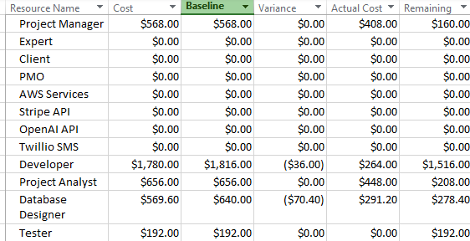
Project resource histogram

Resource Work Summary
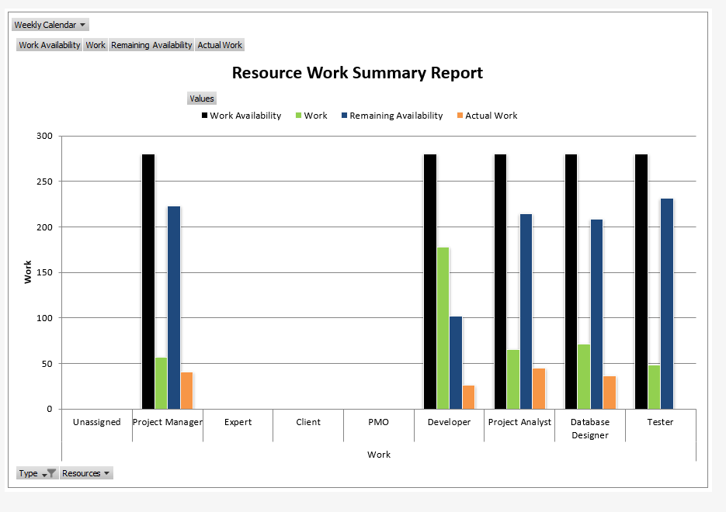
Project resource work summary

Communication Plan
Introduction
1 Purpose
This Communication Management Plan defines the communication requirements for the AI-Integrated Institute Management System project and describes how project information will be gathered, stored, and distributed to stakeholders throughout the 14-week project lifecycle.
The purpose of this plan is to:
- Define stakeholder communication requirements
- Establish communication protocols and standards
- Identify communication channels and tools
- Define roles and responsibilities for project communications
- Establish escalation procedures for issues and decisions
- Ensure timely, accurate, and consistent information flow
2 Scope
This Communication Management Plan covers all project-related communications for:
- Internal stakeholders (Institute Management, Teachers, Administrative Staff, IT Team)
- External stakeholders (Students, Parents, External Vendors)
- Project team members (Developers, QA Engineers, Database Administrators)
- Sponsors and decision-makers (Institute Director, Finance Director)
The plan addresses both formal communications (reports, presentations, documentation) and informal communications (emails, meetings, instant messaging).
Objectives
The key objectives of project communication management are:
- Transparency: Ensure all stakeholders have access to relevant project information
- Alignment: Keep project activities aligned with institute goals and academic calendar
- Collaboration: Facilitate effective teamwork between technical and non-technical stakeholders
- Risk Mitigation: Enable early identification and escalation of issues
- Change Management: Prepare 250+ end users for system transition through clear communication
- Decision Support: Provide timely information to support informed decision-making
- Accountability: Document decisions, changes, and approvals with full audit trail

Communication Approach
Approach Overview
This project will follow a Structured Multi-Channel Communication Strategy that combines:
- Formal Communications: Scheduled reports, presentations, and documentation delivered through official channels with documented approval and sign-off processes.
- Agile Communications: Regular stand-ups, sprint reviews, and real-time collaboration tools for day-to-day coordination among the project team.
- Stakeholder-Centric Communications: Tailored communication formats based on stakeholder needs - technical details for developers, business impact for management, and user-friendly updates for end-users.

Communication Tools and Formats
1. Project Documentation Repository:
- Platform: GitHub / SharePoint
- Content: All project documents (Charter, Plans, Design Docs, Requirements, Meeting Minutes)
- Access: Version-controlled, role-based access
- Update Frequency: Real-time
2. Project Dashboard (Real-time):
- Platform: Jira / Trello / MS Project
- Content: Overall progress %, milestones status, critical tasks, active risks
- Access: All stakeholders
- Update Frequency: Real-time/Daily
3. Status Reports:
- Weekly Status Report (Every Monday)
  - Format: Word/PDF document (2-3 pages)
  - Recipients: Supervisor, PMO, Client
  - Content: Progress summary, completed tasks, upcoming milestones, risks/issues, achievements, next week's priorities
- Sprint Report (Every 2 weeks)
  - Format: Presentation (10-15 slides)
  - Recipients: All stakeholders
  - Content: Sprint goals vs. achievements, completed features, demo screenshots, burndown chart, blockers
4. Meetings:
- Daily Stand-ups (15 min) - Project team only
- Weekly Progress Meetings (1 hour) - Supervisor, PMO
- Bi-weekly Sprint Reviews (2 hours) - All stakeholders
- Monthly Steering Committee (1 hour) - Sponsors, management
5. Communication Channels:
- Email: Formal communications, approvals, weekly reports
- Slack/MS Teams: Real-time chat for quick questions and collaboration
- Zoom/Google Meet: Virtual meetings and demos
- WhatsApp: Urgent escalations only
6. Issue Escalation:
- Low Priority: Email to PM → Response within 24 hours
- Medium Priority: Slack/Teams message → Response within 4 hours
- High Priority: Phone call/WhatsApp → Immediate response
- Critical: Emergency meeting convened within 2 hours

Communication Standards
Meeting Protocols:
- All meetings have agenda sent 24 hours in advance
- Meeting minutes documented and distributed within 24 hours
- Action items tracked with owners and due dates
This approach ensures transparent, timely, and effective communication throughout the 14-week project lifecycle while accommodating both formal thesis requirements and agile development needs.

Reports

Table 1: Stakeholder communications analysis
Stakeholder | What need to be communicated | Format/method | Due
Supervisor | Weekly Meetings | Face-to-face meeting | Every week
Supervisor, PMO | Charter | Word File, PDF | 4/11
Supervisor, PMO | Plan | Word File, PDF | 4/11
Supervisor, PMO | Design Document | Word File, PDF | 28/12
Supervisor, PMO | Thesis Document | Word File, PDF | 28/12
Supervisor, PMO | Product | ZIP File | 28/12
Supervisor, PMO | Demonstration | Presentation | 30/12

Table 2: Expectations Management Matrix
Measure of Success | Priority (1-5) (5 is the highest priority) | Stakeholders Expectations
Time | 5 | Product must be finished on time before demonstration, product show be fully working with all functional requirements
Budget | 1 | Product has no to low budget as it is for small to medium Institutes, however it can easily scalable
Quality | 5 | Product must be intuitive, responsive, and really effective, as it will be used for automating the entire Institute, from marketing to registering and handling payment, to student progress and attendance tracking.
Scope | 4 | The system must include all core functional requirements defined in the project charter: OTP authentication, student/teacher/admin portals, attendance tracking with percentage calculation, criteria-based progress monitoring, multi-installment payment processing with Stripe integration, material upload/download, and AI chatbot assistance. The system should be accessible on both desktop and mobile devices.
Customer Acceptance | 5 | User must be satisfied with the product, and must be capable of using such product without complex interactions, and having all features that were available in the old system.

Table 3: Stakeholders Management Strategy and Influence Matrix
Stakeholder | Role | Internal | Level of Interest  HML | Potential Management Strategy
Sayed Qasim Alsari | Project Manager | internal | High | Maintain weekly progress tracking, communicate regularly with both stakeholders, escalate issues early, ensure quality deliverables
Hashem Mohamed | Supervisor | internal | High | Weekly meetings for progress updates and guidance, involve in major decisions, seek feedback on design and implementation
Cyril Anthoni | PMO | internal | High | Weekly sessions, Emails, private meetings to discuss potential functional requirement, giving insight and solutions and recommendations to Project Manager
Sayed Ahmed Alsari | Client | internal | High | Regular status updates, early involvement in design decisions, comprehensive training before go-live, address concerns immediately
Sayed Qasim Alsari | Data Analyst | internal | High | Weekly coordination meetings, involve in database design, provide clear data requirements, review dashboard and reporting features
Sayed Qasim Alsari | Full-stack Developer | internal | High | Daily standups, clear technical specifications, remove blockers quickly, involve in architecture decisions, recognize contributions

Risk Management Plan
Introduction
The Risk Management process involves identifying, assessing, and responding to potential risks that may arise during the lifecycle of the Institute Management System project. These risks may be negative (threats) or positive (opportunities). Effective risk management ensures that potential threats are minimized while opportunities for improvement are maximized, leading to a more stable and successful project outcome.

Objectives
The main goal of risk management is to proactively anticipate and control possible events that may affect project success. This goal is supported by the following objectives:
- Minimize the likelihood and impact of negative risks.
- Maximize the occurrence and benefit of positive risks.
- Establish mitigation strategies to handle high-impact risks effectively.
- Prevent project scope creep by identifying risks linked to new ideas or changes.
- Ensure the project is delivered with high reliability and quality within approved time and cost constraints.

Processes
The objectives of the risk management plan were achieved through five structured processes applied during the project lifecycle:
1. Plan Risk Management
This process defined the methods, tools, and procedures used to identify, assess, and respond to risks. It set the foundation for how risk management would be conducted throughout all project phases. The key output of this process was the Risk Management Plan.
2. Identify Risks
This process involved identifying potential risks that could impact project objectives. It included both internal risks (such as design errors or technical challenges) and external risks (such as API failures or network interruptions). The main output of this process was the Risk Register, listing all known risks, their causes, and potential effects.
3. Perform Risk Analysis
This process focused on evaluating each identified risk in terms of its probability and impact on project deliverables. Risks were prioritized using qualitative analysis to determine which required immediate attention. The results were used to update the Risk Register and inform mitigation planning.
4. Plan Risk Responses
This process established strategies to mitigate or eliminate threats and enhance opportunities. Response strategies included avoidance, mitigation, transfer, and acceptance, depending on the nature of the risk. Updated risk response plans were documented for monitoring.
5. Monitor and Control Risks
This process ensured that identified risks were tracked, new risks were recorded, and response plans were executed effectively. It also verified whether the implemented risk strategies remained valid throughout the project. The outcomes included risk log updates, mitigation progress tracking, and status reports for stakeholders.

Responsibility Assignment Matrix
Responsible | Accountable | Consulted | Informed
Project Manager | Project Manager | Supervisor, Client, PMO | Supervisor, Client, PMO

RACI table – risk management

Risk Management Approach
1. PESTEL Analysis
The PESTEL Analysis framework was applied to identify external factors that may affect the success or progress of the Institute Management System project. This analysis helped anticipate risks related to the Political, Economic, Social, Technological, Environmental, and Legal aspects of the system’s implementation and operation.

- Political: Changes in institutional or government regulations regarding data storage or privacy could delay deployment.
- Economic: Variations in cloud service costs or payment gateway fees may affect the operating budget.
- Social: Resistance from users adapting to digital systems may slow adoption and require additional training.
- Technological: Integration issues with APIs (such as Stripe or OpenAI) could affect functionality or data flow.
- Environmental: Power outages or network interruptions could disrupt system accessibility.
- Legal: Compliance with data protection laws (such as GDPR-like frameworks or Bahraini privacy laws) must be ensured to avoid violations.
This analysis provided a holistic view of possible external risks and guided preventive measures during project planning.

2. PPMMEE Framework
The PPMMEE Framework was used to categorize and analyze potential risks based on internal project dimensions. It supported the identification of risk sources and helped design specific mitigation strategies to minimize their impact.
- People: Risk of limited technical expertise or over-reliance on a single developer could affect timely delivery.
- Process: Weak documentation or lack of version control might lead to confusion or code redundancy.
- Project Management: Inaccurate scheduling or poor time estimation could delay milestones and reduce efficiency.
- Material: Limited access to testing devices or outdated hardware could affect compatibility and performance testing.
- Environment: Unstable internet connectivity or local system failures might cause deployment interruptions.
- Equipment: Insufficient system resources (e.g., server memory, bandwidth) could cause downtime or slow response times.
This framework helped ensure that risks were identified, categorized, and addressed early, maintaining smooth project progress.

3. Delphi Method
The Delphi Method was used to collect insights from academic supervisors, technical mentors, and peer reviewers regarding potential risks and mitigation strategies. Through structured rounds of feedback, opinions were refined until consensus was achieved.
This method reduced personal bias, encouraged collective judgment, and ensured that all major risks — both technical and operational — were evaluated from multiple expert perspectives. It provided reliable validation for the project’s risk response strategies and enhanced the overall robustness of the risk management plan.

Reports
Risk Register

Table 1: Risk and Mitigation Register
ID/No | Responsible | Risk | Category (Technical Functional and nonfunctional) (Legal, Ethical, Professional, Social) | Probability (HML/ 1-5) | Impact (HML/ 1-5) | Level P*I | Mitigation | Status
1 | Project Manager | Database schema not finalized causing development delays | Technical, Functional | L | H | M | Database schema already completed (41 tables). Review and finalize with team before Week 4. | Closed
2 | Backend Developer | API endpoints incomplete or poorly documented | Technical, Functional | M | H | H | Complete all 50 API endpoint specifications before development starts. Use Swagger for documentation. | Open
3 | Project Manager | 14-week timeline too aggressive for scope | Professional | H | H | H | Prioritize MVP features (authentication, attendance, payments). Push non-critical features to Phase 2. | Open
4 | Security Lead | OTP authentication system vulnerable to brute force attacks | Technical, Security, Legal | M | H | H | Implement account lockout after 3 failed attempts for 15 minutes. Add rate limiting (5 OTP requests/hour). | Open
5 | Backend Developer | Stripe payment integration fails or has security issues | Technical, Legal, Financial | M | H | H | Use Stripe's official SDK. Never store card details. Test with Stripe test environment before production. | Open
6 | DevOps Lead | AWS free tier expires causing unexpected costs | Financial | H | M | M | Monitor AWS usage monthly. Set up billing alerts at 50%, 75%, 90% of free tier limits. Budget $50/month after expiry. | Open
7 | Frontend Developer | UI/UX not user-friendly for non-technical users | Functional, Social | M | H | H | Conduct user testing with teachers and students before Week 12. Iterate based on feedback. | Open
8 | AI Integration Lead | OpenAI API costs exceed budget | Technical, Financial | M | M | M | Set token limits per query (max 500 tokens). Monitor monthly usage. Consider caching common responses. | Open
9 | QA Lead | Insufficient testing time leads to bugs in production | Technical, Professional | H | H | H | Allocate full 2 weeks (Week 12) for testing. Achieve 80% code coverage. Conduct UAT with real users. | Open
10 | Backend Developer | Database performance issues with 500+ concurrent users | Technical, Functional | M | H | H | Implement database indexing on all foreign keys and frequently queried fields. Use connection pooling. | Open
11 | Project Manager | Client (The Function Institute) changes requirements mid-project | Professional, Functional | H | H | H | Freeze requirements after Week 2. Any new requests go to Phase 2. Maintain change request log. | Open
12 | Data Privacy Officer | Student personal data (CPR, phone) not properly protected | Legal, Ethical, Security | M | H | H | Encrypt all PII at rest and in transit. Implement role-based access control. Follow GDPR/local data protection laws. | Open
13 | Backend Developer | SMS delivery via Twilio unreliable in Bahrain | Technical, Functional | M | H | H | Test SMS delivery in Bahrain before production. Have fallback to email if SMS fails. Monitor delivery rates. | Open
14 | AI Integration Lead | AI chatbot provides incorrect information to students/parents | Technical, Ethical, Professional | M | H | H | Limit chatbot to factual queries only. Add disclaimer: "For important matters, contact admin." Log all conversations. | Open
15 | Project Manager | Key team member (developer) leaves project mid-way | Professional | M | H | H | Document all code thoroughly. Use Git with clear commit messages. Cross-train team members on critical modules. | Open
16 | DevOps Lead | Production deployment fails or causes system downtime | Technical, Professional | M | H | H | Deploy to staging first for 1 week. Test all features. Schedule production deployment during off-hours (weekend). | Open
17 | Backend Developer | Third-party API dependencies (Stripe, OpenAI, Twilio) experience outages | Technical, Functional | M | M | M | Implement retry logic with exponential backoff. Show user-friendly error messages. Have manual fallback processes. | Open
18 | QA Lead | Users unable to access system due to browser compatibility issues | Technical, Functional | L | M | L | Test on Chrome, Firefox, Safari, Edge. Use modern web standards. Provide browser compatibility notice on login page. | Open
19 | Project Manager | Inadequate user training leads to low adoption | Professional, Social | M | H | H | Allocate Week 14 for training. Create video tutorials. Provide user manuals. Offer on-site support for first month. | Open
20 | Data Migration Lead | Data migration from Google Sheets fails or lose data | Technical, Functional, Legal | M | H | H | Backup all Google Sheets before migration. Test migration on sample data first. Validate data integrity after migration. | Open

Procurement Management Plan
Introduction
Procurement Management is the process of acquiring the necessary services, tools, and technologies required to implement and maintain the Institute Management System. It involves identifying what needs to be purchased, when it should be procured, and how to obtain it in the most efficient and cost-effective manner. The outcome of this process is the decision to make or buy specific products or services that support the project’s technical and operational needs.

Objectives
The main goal of procurement management is to obtain high-quality services and products that align with project requirements and constraints. This is achieved through the following objectives:
- Ensure that procured services and products meet quality and performance standards.
- Guarantee on-time delivery of all procured items to avoid project delays.
- Ensure cost efficiency in selecting vendors and managing procurement contracts.
- Maintain compliance with institutional and legal procurement policies.
- Establish transparent communication between the project team and vendors.

Processes
The objectives of procurement management were achieved through four structured processes:
1. Plan Procurement Management
This process involved identifying the resources and services that required external acquisition. It included researching available vendors, requesting quotations, and determining evaluation criteria for vendor selection. The main output of this phase was the Procurement Management Plan.
2. Conduct Procurements
This process included issuing requests for quotations (RFQs), evaluating vendor responses, and selecting suppliers based on cost, reliability, and service quality. Upon final selection, the contract documents were prepared and finalized with the chosen vendors.
3. Monitor and Control Procurements
This process ensured proper contract administration and performance monitoring. It included maintaining communication with vendors, tracking delivery schedules, and verifying that the procured services or products met project standards. Outcomes included progress reports, change requests, and updated procurement documentation.
4. Close Procurements
This process involved formally completing and closing all procurement activities, confirming that all contracted items were received, verified, and paid for. It also included documenting vendor performance for future reference.

Responsibility Assignment Matrix

Responsible | Accountable | Consulted | Informed
Project Manager | Project Manager | Supervisor, Client, PMO | Supervisor, Client, PMO

RACI table – procurement management

Procurement Approach
RFI – Request for Information An open enquiry that spans the market seeking broad data and understanding.

RFQ – Request for Quotation An opportunity for potential suppliers to competitively cost the final chosen solution(s).

RFT – Request for Tender An opportunity for potential suppliers to submit an offer to supply goods or services against a detailed tender.

RFP – Request for Proposal Sometimes based on a prior RFI; a business requirements-based request for specific solutions to the sourcing problem.

Two main approaches were used to implement and manage procurement activities for the Institute Management System project:

1. Procurement Management Life Cycle (PMLC)
The PMLC approach was followed to ensure systematic and transparent procurement operations throughout the project. The life cycle consisted of the following steps:
- Determine the procurement budget and prepare required request documents.
- Obtain approval to proceed with proposal documents and identify potential vendors.
- Receive and evaluate quotations from different vendors.
- Issue purchase orders to the selected vendors.
- Track delivery progress to ensure timely arrival of products or services.
- Receive, verify, and record delivered services or products.
- Validate invoices and authorize payment.
- Process payments and record transactions for financial tracking.
This approach helped maintain procurement efficiency and accountability across all phases.
2. Digital Procurement via SpendMap Tool
To streamline and automate procurement activities, the project utilized the SpendMap Tool as a reference framework. SpendMap supports the end-to-end procurement process and simplifies documentation and tracking tasks.
The key stages implemented were:
- Defining and approving the procurement budget.
- Creating requisitions and securing necessary approvals.
- Requesting and comparing supplier quotations.
- Receiving goods or services and verifying delivery details.
- Approving and processing invoices for payment.
This approach ensured transparency, accuracy, and traceability of all procurement transactions while minimizing manual errors.

Reports

Purchase Order Summary Report
Description
This report summarizes all procurement orders related to the Institute Management System project, including service names, vendors, purchase dates, costs, and current delivery/payment status.
It tracks cloud infrastructure, APIs, and external services acquired for the project implementation.
Purchase Order (PO) | Service / Item | Vendor / Supplier | Date Ordered | Cost (BHD) | Status
PO-001 | AWS Cloud Hosting | Amazon Web Services | 10/11/2025 | 25.00 | Active
PO-002 | Payment Gateway API | Stripe | 10/11/2025 | 20.00 | Active
PO-003 | AI Chatbot Integration | OpenAI | 12/11/2025 | 15.00 | Active
PO-004 | SMS Delivery Service | Twilio | 12/11/2025 | 8.00 | Active
Purpose
The Purchase Order Summary Report provides a consolidated overview of all external services procured for the project. It helps monitor procurement progress, verify vendor engagement, and ensure that all acquired services are delivered and functioning as intended. This report supports accountability, vendor management, and cost tracking throughout project implementation.

Budget Utilization Report
Description
This report presents the total budget allocated for all procured services compared with the actual costs incurred to date. It ensures financial control over operational services such as hosting, APIs, and integrations.
Service / Vendor | Budget Allocated (BHD) | Actual Cost (BHD) | Variance (BHD) | Status
AWS Services | 30.00 | 25.00 | +5.00 | Within Budget
Stripe API | 25.00 | 20.00 | +5.00 | Within Budget
OpenAI API | 20.00 | 15.00 | +5.00 | Within Budget
Twilio SMS | 10.00 | 8.00 | +2.00 | Within Budget
Total | 85.00 | 68.00 | +17.00 | Under Budget
Purpose
The Budget Utilization Report ensures that all project procurement activities remain within the approved financial limits. It allows the project manager to identify potential savings, evaluate cost efficiency, and plan future renewals or expansions of the acquired services.

Integration Management Plan and Closing Plan

INTRODUCTION
Integration Management is the process responsible for coordinating and controlling all the implemented project management knowledge areas starting from the initial phase to the closing phase. This strategy helps in gathering all the project elements to ensure the achievement of a successful project.
For the AI-Integrated Institute Management System, Integration Management ensures that all modules (Authentication, Student Management, Attendance, Enrollment, Payments, Testing, Progress Tracking, Materials, Notifications, and AI Chatbot) work seamlessly together as a unified system. It coordinates the technical development with stakeholder requirements, manages dependencies between modules, and ensures alignment with the institute's academic calendar and operational needs.
OBJECTIVES
There are several objectives that Integration Management process intends to ensure:
- Ensure comprehensive control and monitoring of the project using best practices of project management knowledge areas to comply with industry standards for educational technology systems.
- Ensure successful delivery of the project within the 14-week timeline (Oct 2025 - Jan 2026), within budget constraints (AWS free tier), and meeting all defined scope requirements including 40 functional requirements across 11 modules.
- Ensure the system meets stakeholder requirements by solving the current problems of scattered Google Sheets management, manual processes, and lack of automation, while delivering a high-quality, secure, bilingual web application.
- Ensure seamless integration of all system components including Frontend (Next.js), Backend (Node.js + Express), Database (PostgreSQL), Third-party APIs (Stripe, OpenAI, AWS SES, Twilio), and ensure data consistency across all modules.
- Facilitate user adoption by managing the transition for 250+ end-users (students, teachers, parents, admin) from the current Google Sheets system to the new centralized platform.

PROCESSES & APPROACHES
Achieving the objectives of Integration Management involves six main processes. These processes are considered approaches used throughout the project life cycle to follow the execution of an outstanding integration management strategy.
1. Develop Project Charter
This process involves collaboration with all the stakeholders aiming for document creation that approves project initiation. The main output of this process is the project charter document; this document provides guidelines on the objectives and formally acknowledges the existence of the project.
For Institute Management System:
Key Activities:
- Define project purpose: Replace Google Sheets with centralized database system
- Identify stakeholders: Institute Owner/Admin, Supervisor, PMO, Teachers (15), Students (250+), Parents
- Document high-level requirements: OTP authentication, attendance tracking, payment processing, AI chatbot, progress monitoring
- Define success criteria: System operational before next term, all 40 functional requirements met
- Establish project constraints: 14-week timeline, AWS free tier budget, academic calendar dependency
Outputs:
- Project Charter document
- Stakeholder register
- High-level scope definition
- Initial risk register
2. Develop Project Management Plan
This process includes coordinating and integrating all project planning strategies in order to produce a dynamic, consistent, and flexible document that can adapt with project environment changes. The primary output of this process is the project management plan; this document contains all project management knowledge areas. It initiates with stating the scope of the project and finishes with project closing.
3. Direct and Manage Project Work
This process is responsible for managing, directing, and performing the stated activities in the project management plan document. This process counts as the most critical process due to having a higher direct impact on the project execution. The possible outcomes of this process are work performance reports, project change requests, or achieving project deliverables.
4. Monitor and Control Project Work
This process involves controlling and monitoring project activities by gathering and measuring work performance data. These data are then analyzed to determine what can be done to meet the performance scale of the project. The possible outcomes of this process are project updates or project change requests.
5. Perform Integrated Change Control
This process is responsible for coordinating changes by managing and evaluating modifications that impact the project's deliverables. These changes should be identified throughout the project life cycle to ensure successful control of integrated changes. The possible outcomes of this process are project updates or project change requests.
6. Close Project
This process involves concluding the project formally by finalizing all performed tasks and activities throughout the project life cycle. For an official conclusion, all project deliverables are sent to the client/sponsor. The outcome of this process is the final product or service.
RACI
Responsible | Accountable | Consulted | Informed
Project Manager | Project Manager | Supervisor, PMO, Client, Stakeholders | Supervisor, Client, Stakeholders

RACI table – integration management

REPORTS
The below checklist represents the project manager's last process/step in the project life cycle. This step involves professionally closing the project. It uses a checklist as a tool to confirm no loose ends, unfinished business such as contracts, paperwork, or administrative functions prevents the closure of the project
Project Closure Checklist Report
Deliverables & Requirements
- Verify all 40 functional requirements are completely implemented and tested
- Confirm all 41 database tables are created, migrated, and populated with test data
- Ensure all 44+ API endpoints are functional and tested
- Verify all 40 UI pages are complete and responsive (desktop + mobile)
- Confirm all 11 modules are integrated and working seamlessly together
- Validate OTP authentication system is secure and functional
- Test payment processing with Stripe (including test transactions)
- Verify AI chatbot integration with OpenAI API is working
- Confirm email notifications via AWS SES are functional
- Test SMS notifications via Twilio
Testing & Quality Assurance
- Ensure all unit tests pass with 80%+ code coverage
- Complete integration testing for all modules
- Conduct end-to-end testing of critical user flows
- Perform User Acceptance Testing (UAT) with institute staff
- Complete cross-browser testing (Chrome, Firefox, Safari, Edge)
- Verify mobile responsiveness on iOS and Android devices
- Conduct security testing and vulnerability assessment
- Perform load testing for expected 250+ concurrent users
- Test bilingual support (English/Arabic) if implemented
Deployment & Infrastructure
- Deploy backend API to AWS EC2/Elastic Beanstalk
- Deploy frontend application to Vercel/AWS Amplify
- Configure PostgreSQL database on AWS RDS
- Set up AWS S3 bucket for file storage
- Configure AWS SES for email delivery
- Verify Stripe API keys are production-ready
- Configure domain and SSL certificates
- Set up monitoring and logging (AWS CloudWatch)
- Create database backups and recovery procedures
Documentation
- Complete technical documentation (system architecture, database schema, API docs)
- Finalize user manuals for Admin, Teacher, and Student portals
- Create training videos and materials
- Document deployment and maintenance procedures
- Archive all project documents in organized repository
- Complete project thesis document
- Prepare final project presentation slides
Financial & Administrative
- Verify AWS free tier usage and costs
- Settle any vendor invoices (Stripe, Twilio, OpenAI API)
- Close development environment accounts (if separate from production)
- Archive all contracts and agreements
Stakeholder Sign-off
- Obtain formal acceptance from Institute Owner/Admin
- Get Supervisor approval on thesis and deliverables
- Secure PMO sign-off on project completion
- Collect feedback from end-users (teachers, students)
Knowledge Transfer & Training
- Conduct system handover session with institute staff
- Provide training to Admin on system management
- Train teachers on attendance recording and progress updates
- Train students/parents on portal usage
- Deliver system credentials and access information
- Provide ongoing support plan (if applicable)
Project Closure Activities
- Release all AWS resources (if temporary)
- Archive project repository on GitHub
- Transfer ownership of code and database to institute
- Notify all stakeholders of project completion
- Conduct project closing meeting and demonstration (Dec 30, 2025)
- Document lessons learned
- Celebrate project success with team
Final Submission (for Academic Requirements)
- Submit Project Charter
- Submit Project Management Plan
- Submit Design Documents
- Submit Source Code (ZIP file)
- Submit Thesis Document
- Deliver Final Presentation
- Archive all files for submission

LESPI
Legal, Ethical, Social, and Professional Issues
Potential Legal Issues
This project will handle sensitive student data including personal information (CPR numbers, names, dates of birth, contact details, addresses), academic records (attendance, progress, grades), and financial information (payment history, outstanding balances). Therefore, the following legal measures will be implemented:
Data Protection Compliance:
- Bahrain Personal Data Protection Law (PDPL) - 2019 Decree No. 78: Obtain explicit consent for data collection, implement data minimization principles, ensure data accuracy, provide data access rights, implement right to erasure, maintain data processing records
- AWS Customer Agreement - Section 3 Security and Data Privacy: Follow security measures, encrypt data at rest and in transit, implement access controls, conduct regular security audits, maintain data backup and disaster recovery procedures
- PCI DSS Compliance: Use Stripe API (PCI-compliant), never store credit card information, implement secure payment gateway, use tokenization
- Intellectual Property: Respect all open-source licenses, document third-party libraries, ensure institute owns custom code, properly attribute external resources
Potential Ethical Issues
Ethical standards will be maintained by abiding:
- PMI Code of Ethics: Responsibility (protect student data, deliver on time), Respect (privacy, diversity), Fairness (equal access, impartial decisions), Honesty (accurate reports, truthful capabilities)
- ACM Code of Ethics: Contribute to society, avoid harm, be honest and trustworthy, respect privacy and confidentiality
- Specific Commitments: No bias in system design, fair access to resources, transparent criteria, honest communication, protect vulnerable users (minors)
Potential Social Issues
- Student Privacy: Handle data of minors appropriately, implement parental consent, ensure COPPA compliance, provide parents with data visibility and control
- Digital Divide: Ensure system works on low-bandwidth connections, provide mobile-responsive design, consider offline capabilities, ensure accessibility (WCAG 2.1 compliance)
- AI Bias: Ensure chatbot does not discriminate, monitor AI outputs, provide human oversight for critical decisions, be transparent about AI limitations
- Cultural Sensitivity: Respect diverse practices, provide bilingual support (English/Arabic), respect religious holidays, avoid cultural assumptions
- Employment Impact: Provide training to staff, enhance human capabilities, create new opportunities, focus on higher-value tasks
Potential Professional Issues
- ACM Professional Responsibilities: Strive for quality, maintain competence, respect rules and standards, provide professional review, evaluate systems thoroughly
- BCS Code of Conduct: Public interest judgments, professional competence, duty to authority, uphold profession reputation
- Academic Integrity: Properly cite sources, follow thesis guidelines, maintain honesty in reporting, submit original work, adhere to deadlines
- Industry Standards: Follow software engineering best practices, adhere to coding standards, implement security best practices (OWASP Top 10), use version control, conduct code reviews
- Professional Communication: Maintain transparent communication, provide accurate reports, escalate issues promptly, document decisions, respond timely and professionally
- Conflict Resolution: Address conflicts professionally, seek win-win solutions, escalate appropriately, maintain professional relationships

Approval Signatures
The signatures of the people below document acceptance and approval of the formal project charter. The sponsor representative must have the authority to commit the client’s resources to the project. The project manager is empowered by this charter to proceed with the project as outlined in the charter.

Position/Title | Signature | Date
Project Manager | Sayed Qasim Alsari | 4th November 2025
Project Management Office

Appendices

Problem Analysis
1. Purpose and Importance of Root Cause Analysis (RCA)

Root Cause Analysis is a structured method used to identify the fundamental causes behind problems rather than focusing on surface symptoms.
In software projects like the AI-Integrated Institute Management System, RCA ensures that recurring issues such as data inconsistency, delayed workflows, and low user adoption are solved permanently.
By analyzing causes early, the project can prevent future failures, improve reliability, and achieve sustainable digital transformation for the institute.

2. Problem Analysis

The institute currently depends on Google Sheets, manual attendance tracking, and separate payment records.
This fragmentation leads to:
• Data duplication and human error.
• Delays in communication between teachers, students, and admin.
• No unified progress or performance tracking.
• Guests lacking digital access to placement results or program information.

These issues reduce operational efficiency, lower transparency, and increase administrative workload.

3. Conclusion

The RCA reveals that inefficiency is not due to a single failure but a combination of human factors, unclear processes, and technological constraints.
Addressing these systematically—through training, clearer workflows, data validation, and stable hosting—will enhance adoption and ensure the success of the institute’s AI-based management system.

Fishbone (Ishikawa) diagram
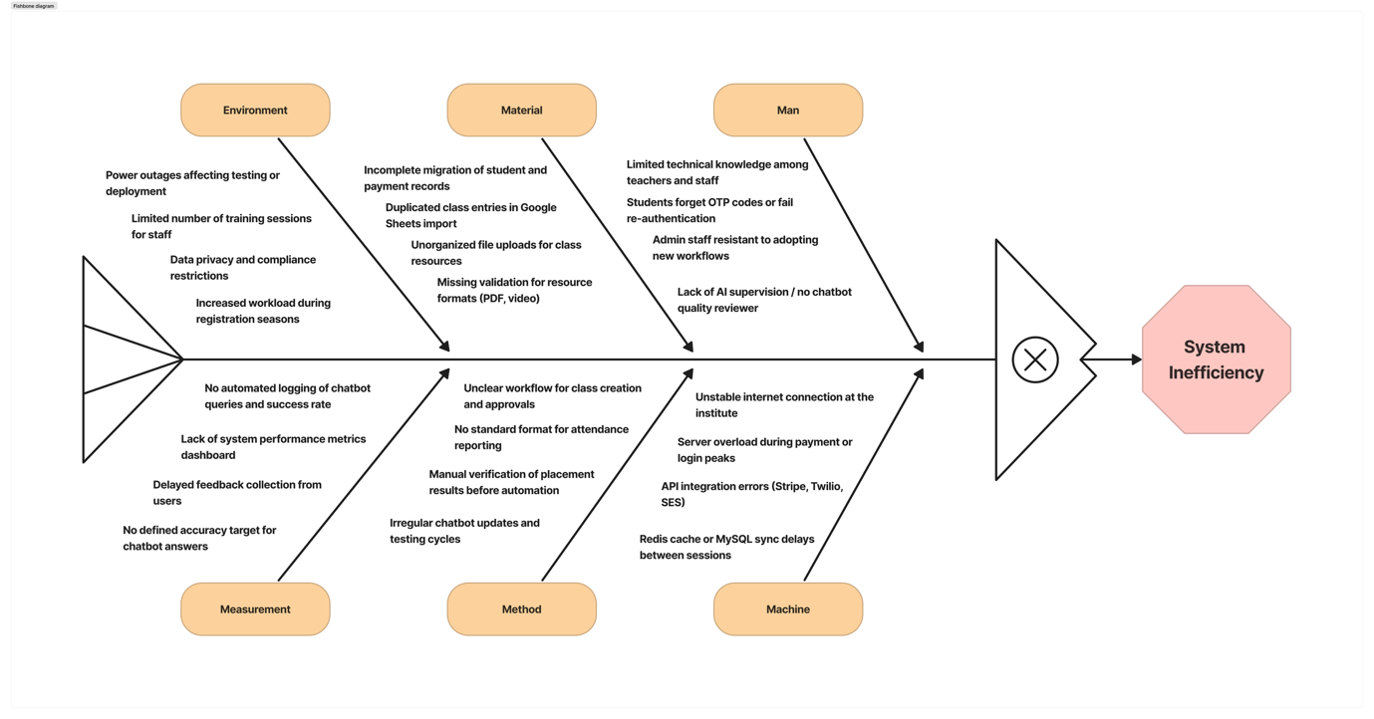
Project fishbone (Ishikawa) diagram

Appendix 2: Requirements Gathering and Analysis
Functional requirements
No. | Source | Requirement Description | Data | Process | Communication | Priority (H/M/L) | Status
Req1 | Client | The system shall allow administrators to register new students and capture details including CPR, name, nationality, DOB, address, contact, and guardian info. | ✓ | - | - | H | -
Req2 | Research | The system shall allow teachers to record attendance including date, time, class ID, and status (present, absent, late, excused). | ✓ | ✓ | - | H | -
Req3 | Client | The system shall allow students to view their attendance records and percentage per course. | ✓ | ✓ | ✓ | H | -
Req4 | Client | The system shall enable OTP-based authentication via email or SMS instead of passwords. | - | ✓ | ✓ | H | -
Req5 | Research | The system shall provide role-based access control to limit module visibility for Admin, Teacher, Student, and Guest users. | - | ✓ | - | H | -
Req6 | Client | The system shall allow admins to create and manage programs, terms, and courses, linking each to teachers and schedules. | ✓ | ✓ | - | H | -
Req7 | Research | The system shall prevent schedule conflicts when assigning teachers or rooms to classes. | - | ✓ | - | M | -
Req8 | Client | The system shall enable online payments using Stripe API and generate digital receipts. // typed below | ✓ | ✓ | ✓ | H | -
Req9 | Research | The system shall allow teachers to upload class resources (PDF, video, link) and categorize them. | ✓ | ✓ | - | H | -
Req10 | Research | The system shall allow students to download/view class materials associated with their enrolled courses. | ✓ | - | ✓ | M | -
Req11 | Client | The system shall provide a guest module where unregistered users can take a placement test and view program details. | ✓ | ✓ | - | M | -
Req12 | Research | The chatbot shall allow admin to ask questions such as attendance summaries, unpaid balances, and policies, and provide accurate answers. | ✓ | ✓ | ✓ | H | -
Req13 | Client | The system shall allow teachers to enter grades and feedback for each student per course. | ✓ | ✓ | - | H | -
Req14 | Research | The system shall automatically notify students via SMS/email for attendance warnings, payment reminders, or new resources. | - | - | ✓ | H | -
Req15 | Client | The system shall generate admin reports summarizing attendance, payments, and enrollments per term. | ✓ | ✓ | - | H | -
Req16 | Research | The chatbot shall summarize key metrics weekly, including total students, payments received, and attendance trends. // add to req 12 | ✓ | ✓ | ✓ | M | -
Req17 | Client | The system shall allow admins to backup and restore data automatically on a scheduled basis. | ✓ | ✓ | - | M | -
Req18 | Research | The system shall maintain audit logs of all critical actions (login, edit, delete, payment). | ✓ | ✓ | - | M | -
Req20 | Research | The system shall provide admin dashboards with visual analytics for quick insights (bar charts, pie charts, trends). | ✓ | ✓ | - | H | -
Req21 | Research | The system shall automatically calculate attendance percentage per student | ✓ | ✓ | ✓ | H | -
Req22 | Client | The system shall allow bulk attendance upload via CSV template for special sessions or make-up classes. | ✓ | ✓ | - | M | -
Req23 | Research | The system shall allow admins to filter attendance reports by program, term, class, or teacher. | ✓ | ✓ | - | H | -
Req24 | Client | The system shall allow online payment tracking, automatically reconciling paid invoices with the student’s balance. | ✓ | ✓ | ✓ | H | -
Req25 | Research | The system shall allow admins to define custom fee structures (tuition, material, registration, transport). | ✓ | ✓ | - | H | -
Req26 | Research | The system shall generate receipts automatically upon successful payment and email a digital copy to the payer. // duplicated | ✓ | ✓ | ✓ | H | -
Req27 | Client | The system shall allow admins to record manual cash payments for walk-in clients. | ✓ | ✓ | - | H | -
Req28 | Research | The system shall generate monthly financial summaries showing payments collected, pending balances, and refunds issued. | ✓ | ✓ | ✓ | M | -
Req29 | Client | The chatbot shall allow admin users to request summaries such as unpaid students this term or total revenue this week. | ✓ | ✓ | ✓ | H | -
Req30 | Research | The chatbot shall be capable of bilingual conversation (English/Arabic) and auto-detect input language. // | - | ✓ | ✓ | H | -
Req31 | Client | The chatbot shall retrieve specific operational data such as students absent today or classes starting now. | ✓ | ✓ | ✓ | H | -
Req32 | Research | The chatbot shall access FAQs and policies via an internal knowledge base. | ✓ | ✓ | ✓ | M | -
Req33 | Research | The system shall send automated reminders for pending payments 3 days before due date. | - | ✓ | ✓ | H | -
Req34 | Client | The system shall send attendance warnings automatically to students/guardians once absence exceeds a defined limit. | - | ✓ | ✓ | H | -
Req35 | Research | The system shall allow teachers to schedule announcements or materials to appear on specific dates. | ✓ | ✓ | ✓ | M | -
Req36 | Client | The system shall maintain class communication threads for teacher-student discussions under each class page. | ✓ | ✓ | ✓ | M | -
Req37 | Research | The system shall generate termly academic reports combining grades, attendance, and teacher comments. | ✓ | ✓ | - | H | -
Req38 | Client | The system shall allow admins to filter dashboard metrics by custom date range, course, and status (active/inactive). | ✓ | ✓ | - | M | -
Req39 | Research | The system shall store system logs for every key event (login, edit, delete, payment, upload). | ✓ | ✓ | - | M | -
Req40 | Client | The system shall enable data backup and restore from admin panel with cloud storage integration. | ✓ | ✓ | - | H | -

Functional requirement list

Non-Functional Requirements
No. | Category | Requirement Description | Measure / Standard | Priority (H/M/L) | Verification Method | Status
NFR1 | Performance | The system shall load all dashboard pages within 3 seconds under normal conditions. | Response time < 3s | H | Performance testing | -
NFR2 | Performance | The chatbot shall respond to queries within 2 seconds on average. | Average latency < 2s | H | Automated load test | -
NFR3 | Reliability | The system shall maintain 99.5% uptime availability per month. | 99.5% uptime | H | Cloud uptime monitoring | -
NFR4 | Reliability | The system shall recover automatically from failures within 60 seconds using cloud failover. | Failover recovery ≤ 60s | H | System monitoring logs | -
NFR5 | Scalability | The system shall support up to 10,000 registered users without degradation. | 10,000 concurrent user test | M | Load testing | -
NFR6 | Scalability | The architecture shall allow horizontal scaling for multiple branches in the future. | Container-based deployment | M | Infrastructure review | -
NFR7 | Security | All communications shall be encrypted using HTTPS (TLS 1.3). | TLS 1.3 | H | Penetration test | -
NFR8 | Security | User data shall be stored in encrypted form in the database. | AES-256 encryption | H | Security audit | -
NFR9 | Security | All user sessions shall expire after 30 minutes of inactivity. | 30 min timeout | M | Session simulation | -
NFR10 | Usability | The interface shall be fully responsive on desktop, tablet, and mobile devices. | Adaptive layout verified | H | UI testing | -
NFR11 | Usability | The bilingual interface shall allow users to switch languages at any time without re-login. | Live language toggle | M | UI inspection | -
NFR12 | Accessibility | The system shall comply with WCAG 2.1 AA accessibility standards. | WCAG 2.1 AA compliance | M | Accessibility audit | -
NFR13 | Maintainability | The system shall be modular, allowing updates without downtime. | Hot deployment | H | Code inspection | -
NFR14 | Maintainability | All code shall follow documented naming and commenting standards. | Code review checklist | M | Peer review | -
NFR15 | Portability | The system shall be deployable on both AWS and Azure environments. | Cross-platform container setup | M | Deployment testing | -
NFR16 | Portability | The database shall be compatible with MySQL and PostgreSQL engines. | Dual DB compatibility | M | Integration testing | -
NFR17 | Auditability | The system shall log every data update and deletion with timestamp and user ID. | 100% log coverage | H | Log verification | -
NFR18 | Backup & Recovery | Automated daily backups shall be performed at 2 AM server time. | Backup verification logs | H | Schedule testing | -
NFR19 | Data Integrity | No transaction shall be committed unless all related data entries are valid. | Transactional integrity check | H | DB audit | -
NFR20 | Legal & Compliance | The system shall comply with GDPR data protection standards for personal information. | GDPR compliance | H | Policy review | -

Non-functional requirement list

Decision Analysis

AI-Integrated Institute Management System
Project Name: AI-Integrated Institute Management System
Project Duration: October 2025 - January 2026 (14 weeks)
Sponsor: The Function Institute
Prepared By: Project Team
Date: November 2025
Executive summary
This decision analysis evaluates three alternative solutions for implementing the Institute Management System. The analysis includes:
1. COTS Matrix - Comparing 3 alternative solutions across 20+ criteria
2. Weighted Score Evaluation - Quantitative scoring with weighted criteria (49 points total)
3. Financial Feasibility Analysis - Complete resource breakdown and 5-year NPV calculation
Recommended solution:
Key Metrics:
Weighted Score: 91.6% (449/490 points)
Net Present Value (NPV): $51284.70(5-year cumulative)
Payback Period: 3.75 months
Total 5-Year Cost: $4000
Total 5-Year Benefits: $20,400

Reports
COMMERCIAL OFF-THE-SHELF (COTS) MATRIX This section compares 3 alternative solutions to achieve the scope of this project. Decision analysis is initiated by constructing an overview of the benefits, hardware infrastructure, software platform, and minimum requirements as follows:

Criteria | Alternative 1: Full Custom Development | Alternative 2: Hybrid (SaaS + Custom) | Alternative 3: Enterprise LMS Platform
Description | Build complete system from scratch using Next.js + Node.js + PostgreSQL | Use existing SaaS for payments (Stripe) and chatbot (OpenAI), build core features custom | Implement enterprise LMS (e.g., Moodle, Canvas) with heavy customization
Development Time | 14 weeks | 10-12 weeks | 16-20 weeks
Initial Cost | $1500-4000 | $10,000-15,000 | $25,000-35,000
Monthly Operating Cost | $1200 | $2000 | $2500
Scalability | Excellent (AWS autoscaling) | Very Good (cloud-based) | Good (limited by platform)
Customization | Full control (100%) | High (80%) | Limited (40%)
Maintenance | In-house team required | Reduced (SaaS handles parts) | Vendor-dependent
Integration Flexibility | Complete flexibility | Good (API-based) | Limited to platform plugins
OTP Authentication | Custom implementation | Custom implementation | Requires plugin/customization
Multi-instalment Payments | Full control via Stripe API | Stripe API + custom tracking | Limited payment options
AI Chatbot (English only) | OpenAI API integration | OpenAI API integration | Plugin-based, limited customization
Attendance Tracking | Custom design (25 sessions/term) | Custom design | Standard LMS tracking (limited)

2. WEIGHTED SCORE ANALYSIS
This section provides a quantitative evaluation of the alternative solutions using weighted criteria. Each criterion is assigned a weight (1-5) based on importance, and each alternative is scored (1-10) based on performance.
2.1 Scoring Methodology
- Score Range: 1-10 (1 = Poor, 10 = Excellent)
- Weight Range: 1-5 (1 = Low importance, 5 = Critical importance)
- Weighted Score: Score × Weight
Total Possible Score: 490 points (across 12 criteria)
2.2 Weighted Score Summary

Table: Weighted Score Summary
Criteria | Alternative 1: Full Custom Development | Alternative 2: Hybrid (SaaS + Custom) | Alternative 3: Enterprise LMS Platform
Cost-Effectiveness (Weight: 5) | 45 | 35 | 20
Customization Capability (Weight: 5) | 50 | 40 | 20
Development Timeline (Weight: 4) | 32 | 36 | 20
Scalability (Weight: 4) | 40 | 36 | 28
Security & Data Ownership (Weight: 5) | 50 | 40 | 30
Other Criteria (7 criteria) | 232 | 200 | 149
TOTAL SCORE | 449(91.6%) | 387(79.0%) | 267 (54.5%)

Result: Alternative 1 (Full Custom Development) scores highest with 91.6%

3. FINANCIAL FEASIBILITY ANALYSIS
This section provides a complete breakdown of all human and non-human resources required for Alternative 1 (Full Custom Development).

3.1 Human Resources

Development Phase (14 weeks):
Role | Quantity | Hourly Rate | Total Hours | Total Cost
Project Manager | 1 | 10 | 56.8 | 568
Full stack Developer | 1 | 10 | 200 | 2000
Project Analyst | 1 | 10 | 65.5 | 655
Database Designer | 1 | 8 | 64 | 512
QA Tester | 1 | 4 | 48 | 192
total |  |  | 434.3 | 3927

3.2 Non-Human Resources
Initial Setup Costs:
- Domain registration, GitHub, tools, AWS setup: $0
Monthly Operating Costs (After Launch):
- AWS Infrastructure (EC2, RDS, S3, CloudFront, ALB): $70
- Third-Party APIs (Stripe, OpenAI, Twilio): $30
- Total Monthly: $100

3.3 Five-Year Cost Summary

Five-Year Cost Summary
Year | Development | Operations | Total
Year 0 | 4000 | 0 | 4000
Year 1 | 0 | 1200 | 1200
Year 2 | 0 | 1200 | 1200
Year 3 | 0 | 1200 | 1200
Year 4 | 0 | 1200 | 1200
Year 5 | 0 | 1200 | 1200
Total | 4000 | 6000

COST-BENEFIT ANALYSIS WITH NPV
4.1 NPV Screenshot
NPV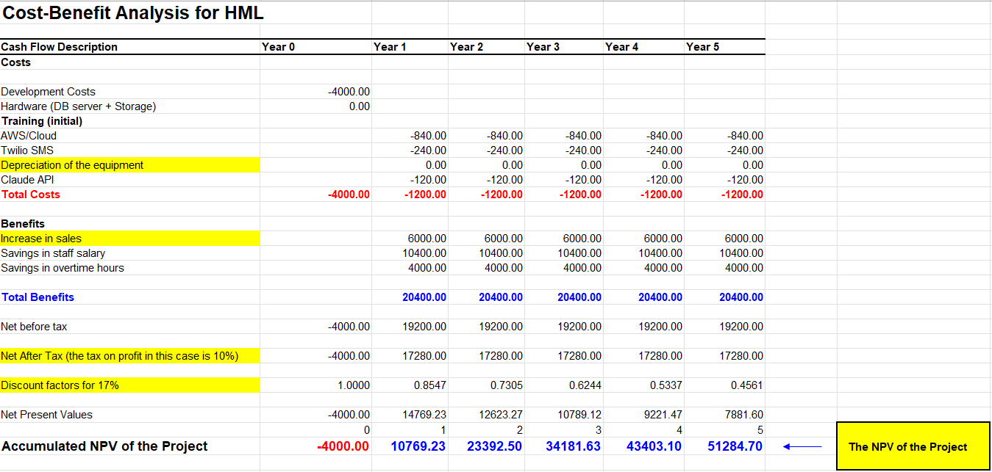
4.2 Key Financial Findings
Development Investment:
- Year 0: $4,000 (Human Resources: $4,000 + Setup: $0)
Annual Operating Costs:
- Year 1-5: $1200 per year
Total 5-Year Cost:
- $9000

CONCLUSION AND RECOMMENDATION
SELECTED SOLUTION: Alternative 1 (Full Custom Development)
5.1 Justification
1. Highest Weighted Score (91.6%)
- Alternative 1 scored 449/490 points (91.6%)
- 12.6 percentage points ahead of Alternative 2 (79.0%)
- 37.1 percentage points ahead of Alternative 3 (54.5%)
2. Perfect Fit for Unique Requirements
- Supports criteria-based progress tracking (not standard in LMS platforms)
- Implements OTP authentication system
- Handles multi-installment payment processing
- 100% customization to meet all 40 functional requirements

3. Best Long-Term Value
- Lowest annual operating costs: $4000 vs $10,000 (Alt 2) or $28,800 (Alt 3)
- No vendor lock-in or escalating license fees
- Complete control over future enhancements
4. Achievable Timeline
- 14-week development timeline aligns with project schedule (Oct 2025 - Jan 2026)
- Proven technology stack (Next.js, Node.js, PostgreSQL, AWS)
5. Strategic Value
- Provides competitive advantage
- Enables future innovations (Arabic support, mobile app, advanced analytics)
- Full control over student data and system evolution
5.2 Risk Mitigation

Risk | Mitigation
Technical complexity | Hire experienced developers, use proven tech stack
Timeline delays | Include 10% buffer, agile methodology with sprints
Maintenance burden | Plan for 0.5 FTE support, comprehensive documentation
Skill dependency | Knowledge transfer, code documentation, training

References

PROJECT MANAGEMENT STANDARDS
1. PMI Code of Ethics and Professional Conduct
https://www.pmi.org/about/ethics/code
2. PMBOK Guide - 7th Edition
https://www.pmi.org/pmbok-guide-standards
3. Scrum Guide
https://scrumguides.org/
TECHNOLOGY DOCUMENTATION
Frontend
4. Next.js Documentation (v14)
https://nextjs.org/docs
5. React Documentation (v18)
https://react.dev/
6. Tailwind CSS Documentation
https://tailwindcss.com/docs
Backend
7. Node.js Documentation
https://nodejs.org/docs/
8. Express.js Documentation
https://expressjs.com/
Database
9. PostgreSQL Documentation (v15)
https://www.postgresql.org/docs/15/
10. Prisma Documentation
https://www.prisma.io/docs
CLOUD & INFRASTRUCTURE
11. Amazon Web Services (AWS) Documentation
https://docs.aws.amazon.com/
12. AWS Customer Agreement
https://aws.amazon.com/agreement/

THIRD-PARTY APIs
14. Stripe API Documentation
https://stripe.com/docs/api
15. OpenAI API Documentation
https://platform.openai.com/docs
16. Twilio Documentation
https://www.twilio.com/docs
LEGAL & COMPLIANCE
17. Bahrain Personal Data Protection Law (PDPL)
https://www.legalaffairs.gov.bh/
18. COPPA - Children's Online Privacy Protection Act
https://www.ftc.gov/legal-library/browse/rules/childrens-online-privacy-protection-rule-coppa
19. PCI DSS - Payment Card Industry Data Security Standard
https://www.pcisecuritystandards.org/
SECURITY & ACCESSIBILITY
20. OWASP Top 10
https://owasp.org/www-project-top-ten/
21. TLS 1.3 Protocol (RFC 8446)
https://datatracker.ietf.org/doc/html/rfc8446
22. WCAG 2.1 - Web Content Accessibility Guidelines
https://www.w3.org/WAI/WCAG21/quickref/
PROFESSIONAL CODES
23. ACM Code of Ethics and Professional Conduct
https://www.acm.org/code-of-ethics
24. BCS Code of Conduct
https://www.bcs.org/membership-and-registrations/become-a-member/bcs-code-of-conduct/
25. IEEE Software Engineering Standards
https://ieeexplore.ieee.org/
VERSION CONTROL & TESTING
26. Git Documentation
https://git-scm.com/doc
27. GitHub Documentation
https://docs.github.com/
28. Jest Testing Framework
https://jestjs.io/docs/getting-started
29. Cypress Testing Framework
https://docs.cypress.io/
API DESIGN STANDARDS
30. RESTful API Design - Roy Fielding's Dissertation
https://www.ics.uci.edu/~fielding/pubs/dissertation/top.htm
31. Open API Specification (v3.1)
https://spec.openapis.org/oas/latest.html

