**Lab#08**

**Q#1:**

private void button1_Click(object sender, EventArgs e)

{

string input = textBox1.Text;

var token = input.Split();

int j = 0;

string dtype = "";

for (int i = 0; i < token.Length; i++)

{

if (token[i] == ",")

{

dataGridView1.Rows.Add(token[i + 1], dtype, "Offset of " + token[i + 1]); }

else if (token[i] == "int" || token[i] == "string" || token[i] == "float" || token[i] == "double" || token[i] == "bool")

{

dtype = token[i].ToString();

dataGridView1.Rows.Add(token[i+1],token[i], "Offset of " + token[i+1]);

}

}

}

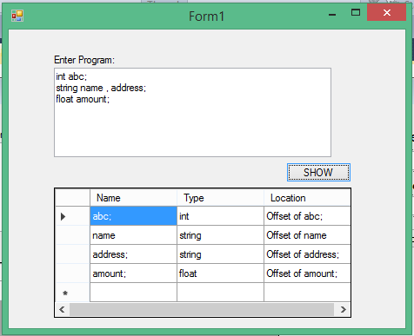

**LabQ#2:**

private void button2_Click(object sender, EventArgs e)

{

bool state1 = false, state2 = false;

for (int i = 0; i < textBox2.Text.Length; i++)

{

if (textBox2.Text[i].ToString() == "[")

{

state1 = true;

}

if (textBox3.Text[i].ToString() == "[")

{

state2 = true;

}

}

if (state1 == true && state2 == false || state1 == false && state2 == true)

{

label4.Text = "Variables have Different Stuctures";

}

if (state1 == true && state2 == true)

{

label4.Text = "Variables have Same Stucture";

}

else

{

label4.Text = "Variables have Same Name";

}

}

