***Face Mask Detection Using Deep Learning***

*Qayyam ud din*

*Ayaz Ahmed*

*Department of Computer Science*

*June 2025*

***Abstract***

* *• Problem: Identifying whether people wear face masks in images or videos.*
* *• Solution: Used CNN-based model (MobileNetV2) to classify masked vs unmasked faces.*
* *• Dataset: 2K balanced images (1K with-mask & 1K without-mask).*
* *• Results: Achieved ~97% validation accuracy with real-time detection.*

**Introduction**

* *• Problem Statement: Manual monitoring of mask usage is inefficient.*
* *• Objective: Automatically detect and classify mask usage using deep learning.*
* *• Relevance: Helps enforce health safety using computer vision.*

***Methodology – Dataset***

* ***• Dataset: Face Mask Detection Dataset from Kaggle.***
* ***• Classes: With Mask, Without Mask.***
* ***• Image Size: Resized to 224x224.***
* ***• Preprocessing: Normalization, label encoding, one-hot encoding.***

***Methodology – Model***

* ***• Model: MobileNetV2 (transfer learning).***
* ***• Layers: Base frozen initially, followed by custom dense layers.***
* ***• Tools: TensorFlow, Keras, OpenCV, NumPy, Google Colab.***

***Experiments***

* ***• Epochs: 10 | Batch Size: 32 | Optimizer: Adam***
* ***• Loss Function: Categorical Crossentropy***
* ***• Training & Validation split: 80% / 20%***
* ***• Accuracy improved from 62% to 97% over 10 epochs.***



***Results***

* ***• Validation Accuracy: ~97.25%***
* ***• Tested on real webcam feed (OpenCV).***
* ***• Correctly detected multiple faces with/without masks.***
* ***• Also tested with single and multiple image uploads.***

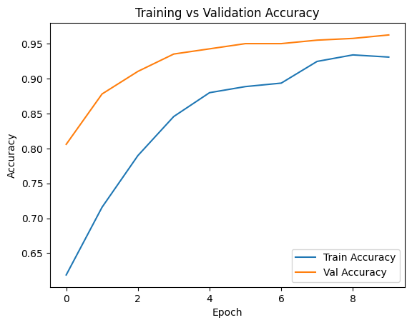

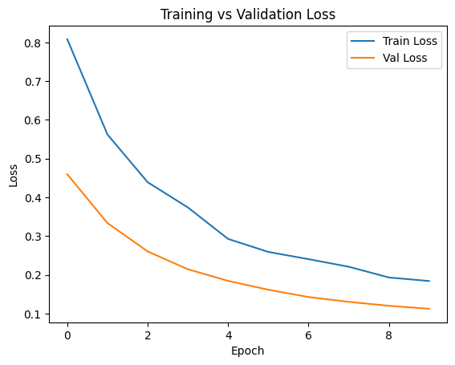

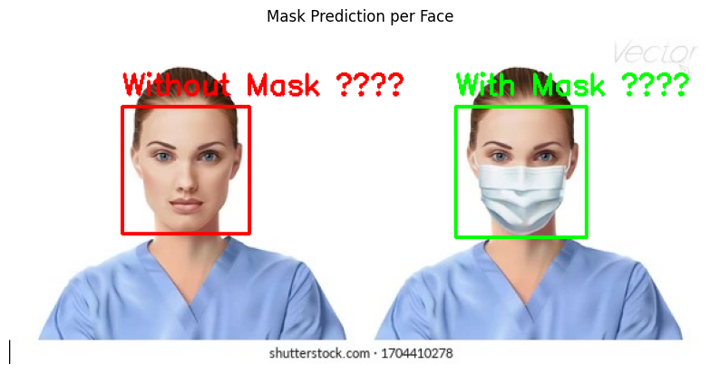

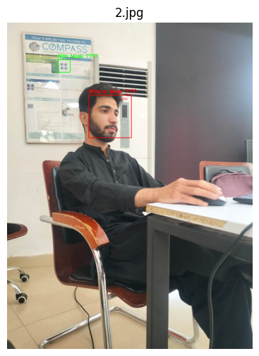

***Discussion***

* ***• Limitations:***
* ***- Errors with occluded/side faces or poor lighting.***
* ***• Future Work:***
* ***- Multi-angle face detection.***
* ***- Mask type classification (cloth, surgical, etc.).***
* ***- Deployment on CCTV or Raspberry Pi.***

***Github link***

***https://github.com/Qayam/facemask.git***