

**Ministry of Education**

**AI Robo Code Club**

***Attendance Students In Class Room Project***

**Preapared by :**

1. **Qais Gafer**
2. **Walaa Mazen Shahrouri**
3. **Fadi Azaar**
4. **Yahya Jabr**

**April 2022**

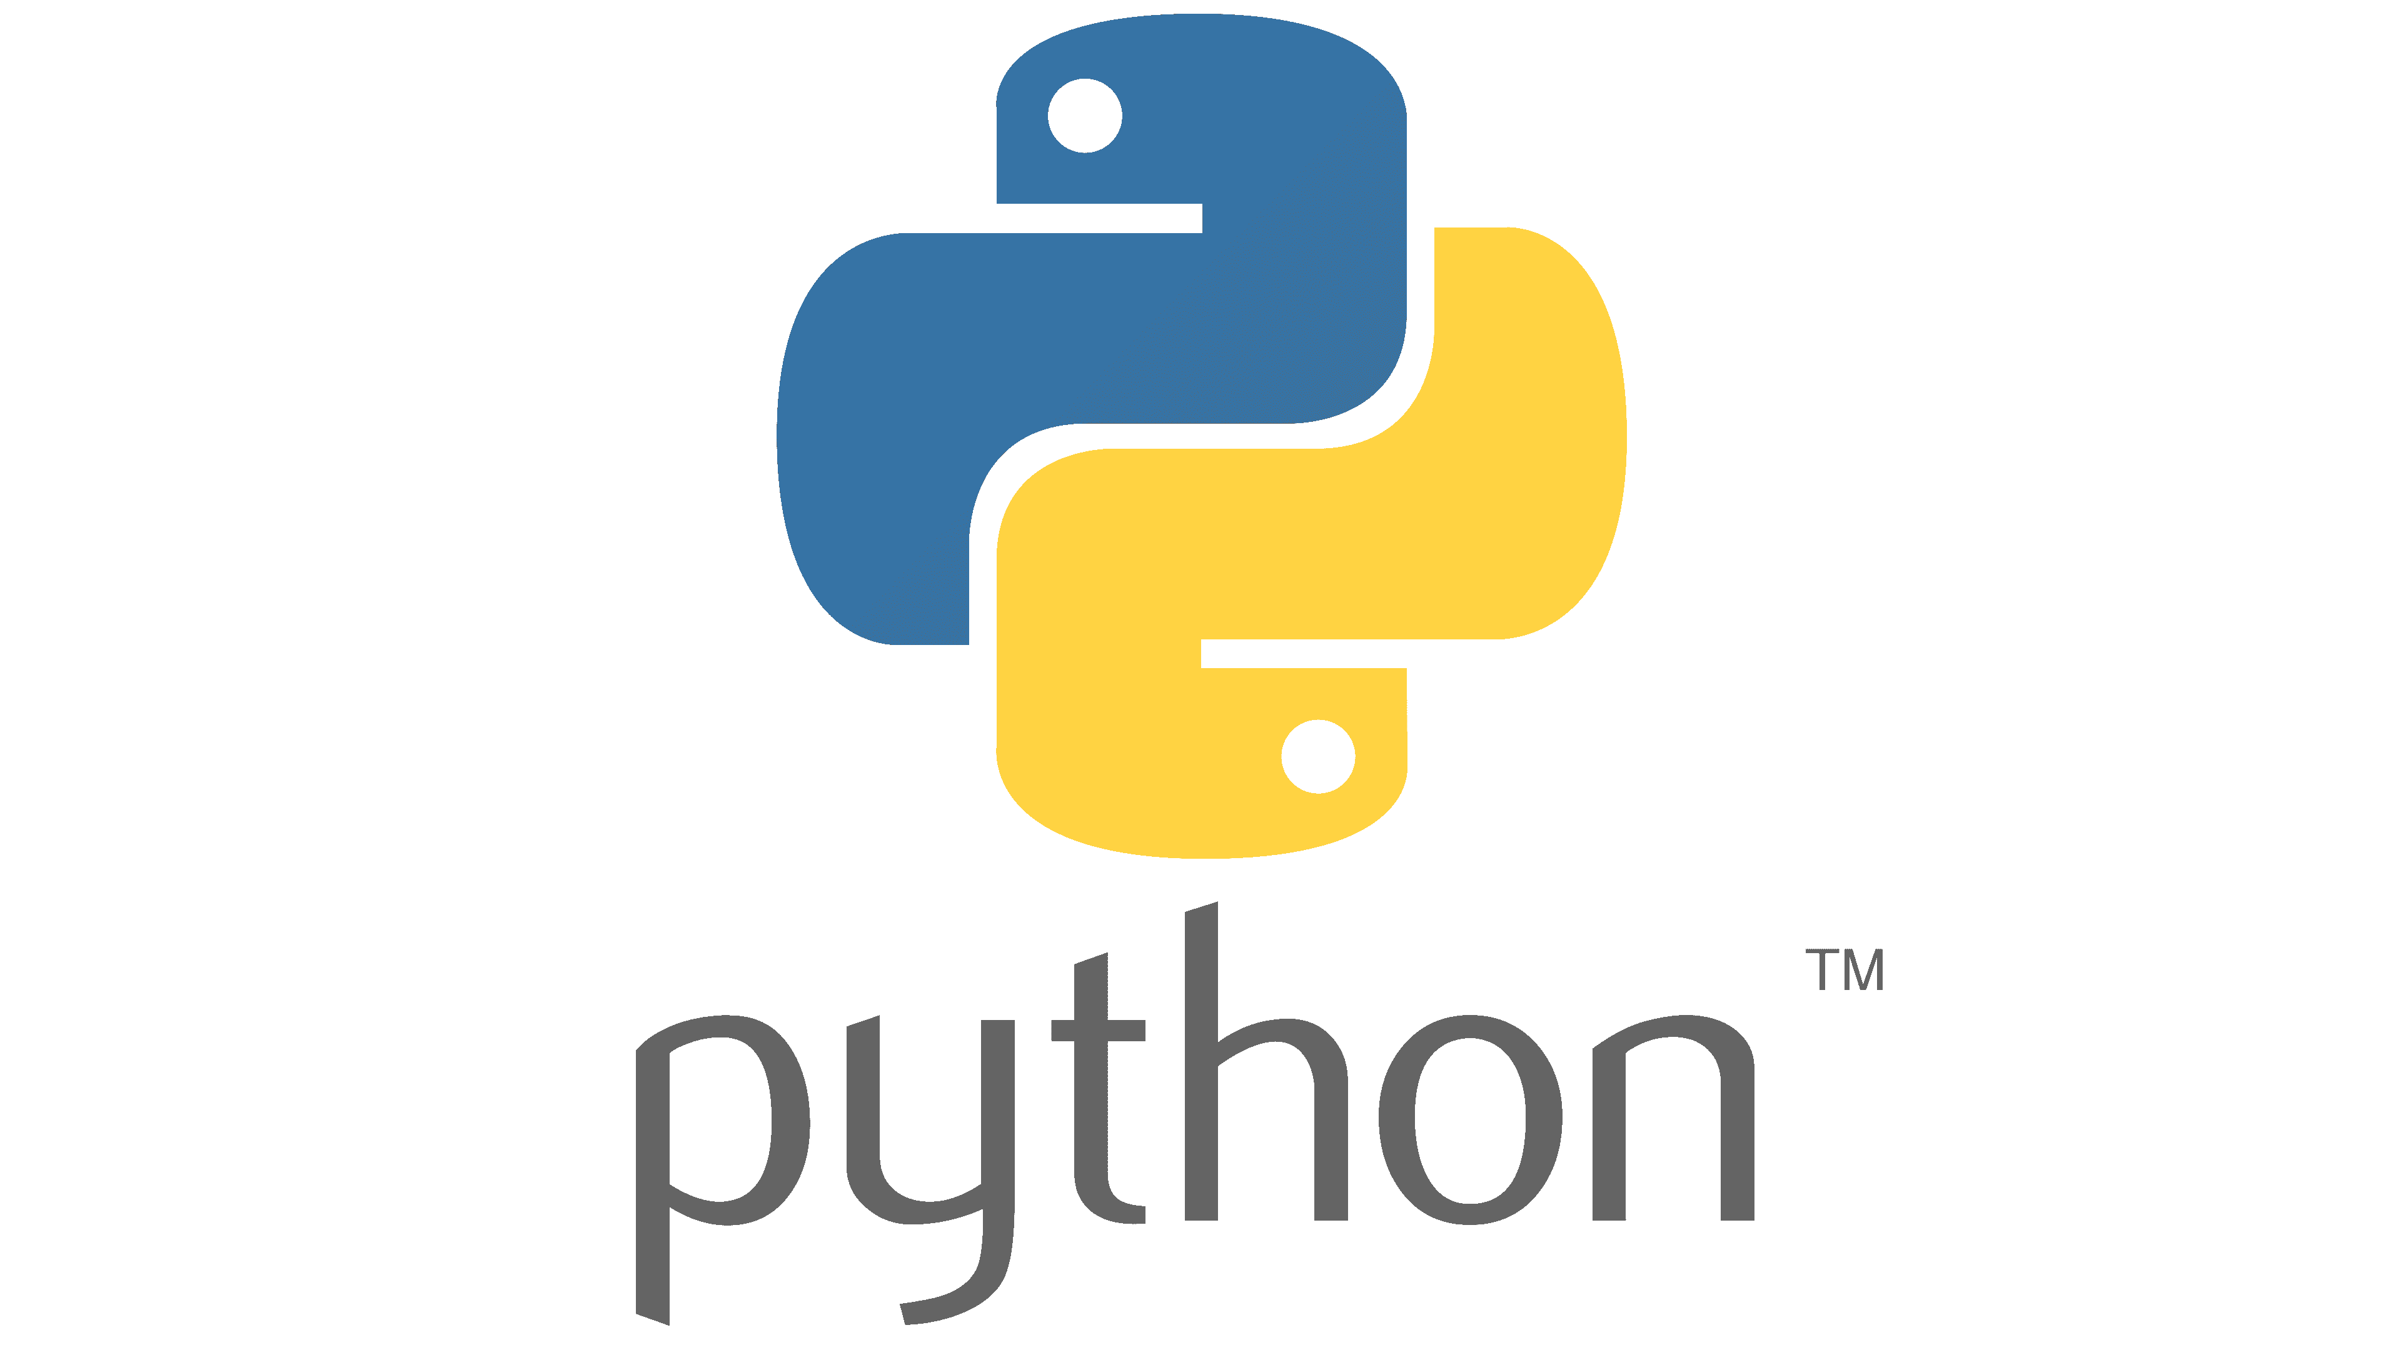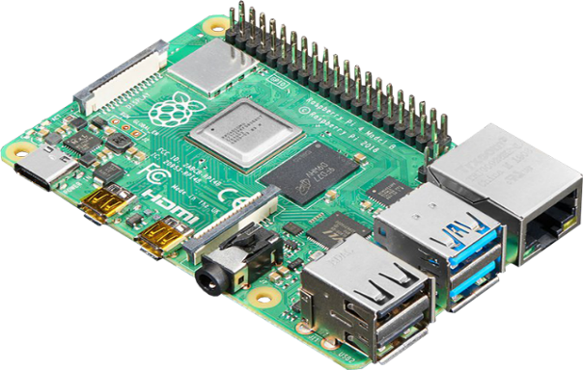

**Table of Index**

|  |  |  |
| --- | --- | --- |
|  | **Subject** | **Page number** |
|  | **Abstract** | **3** |
|  | **Problem** | **4** |
|  | **Materials & Programs** | **4** |
|  | **Methodology** | **5** |
|  | **Description** | **5,6** |
|  | **Redesign & Retest** | **7** |
|  | **Results** | **7** |
|  | **Future Research** | **7** |
|  | **References** | **8** |

**Abstract**

The basic motivation behind the idea of this project is the controlling of students attendance in a class room every day , or every lesson , after that sending report representing the numbers ,names, arrival time ,.. etc to teacher , school principle .

The idea of the project is to design machine to capture the student face when entering the class room after that comparing this picture of student face with face’s pictures are saved in database for students were entering in last time of this day, to prevent iterations of student's attendances in same period.

This project is an opening to transform all attendant students lists and reports to API application, using AI Technology

**Problem**

Follow-up and monitor attendance and absence of students in the classroom, laboratory or engineering operator for each class on a daily basis.

Follow-up and monitor attendance and absence of students in the classroom, laboratory or engineering operator for each class on time to start the class.

Issuing an electronic periodic report with the names of absent and present students in each classroom or laboratory class, arriving simultaneously for the teacher and principle.

Save time and effort that the class teacher will make in monitoring and monitoring the daily attendance and absence of students, and working on the issuance of a handwritten report.

**Materials & Programs**

* Camera .
* Micro controller : “Raspberry pi “ .
* Programmed by “Python language “
* Fast API Platforms.

**Methodology**

The methodology used in this project started with finding the appropriate idea and Setting goals, and working to achieve these desired goals of the implementation of this project.

The next step was Choosing the right algorithm after the work of the software analysis and hardware of the project.

The third step was Choose the right programming language to build the program, Python, because it is suitable for raspberry pi microcontroller, and has a lot of AI libraries.

The fourth step was Run the code through os for the digital controller that was used in this project, Raspberry pi in order for the camera installed on the door of the classroom coupled with the digital control to take pictures of students entering the classroom or laboratory, and record their presence in time, time and date.

**Description**

The idea of the project started when a student enters the classroom or laboratory in the morning, and at the beginning of each class, the camera installed and associated with the digital control type Raspberry pi pick a picture of the student's face, and compares this image with the pictures of the students of the class in the memory of the controller and if this image taken matches with one of them records the presence of this student in time and history through the name of the student stored with his image on the memory of the controller.

After that, if the student leaves the classroom during the time period allocated per serving for some reason such as visiting the school administration or spending his own need, and then returned to class, the camera will take a serious picture of him but through the code will not repeat the student's registration in the attendance list allocated to this class in this time period.

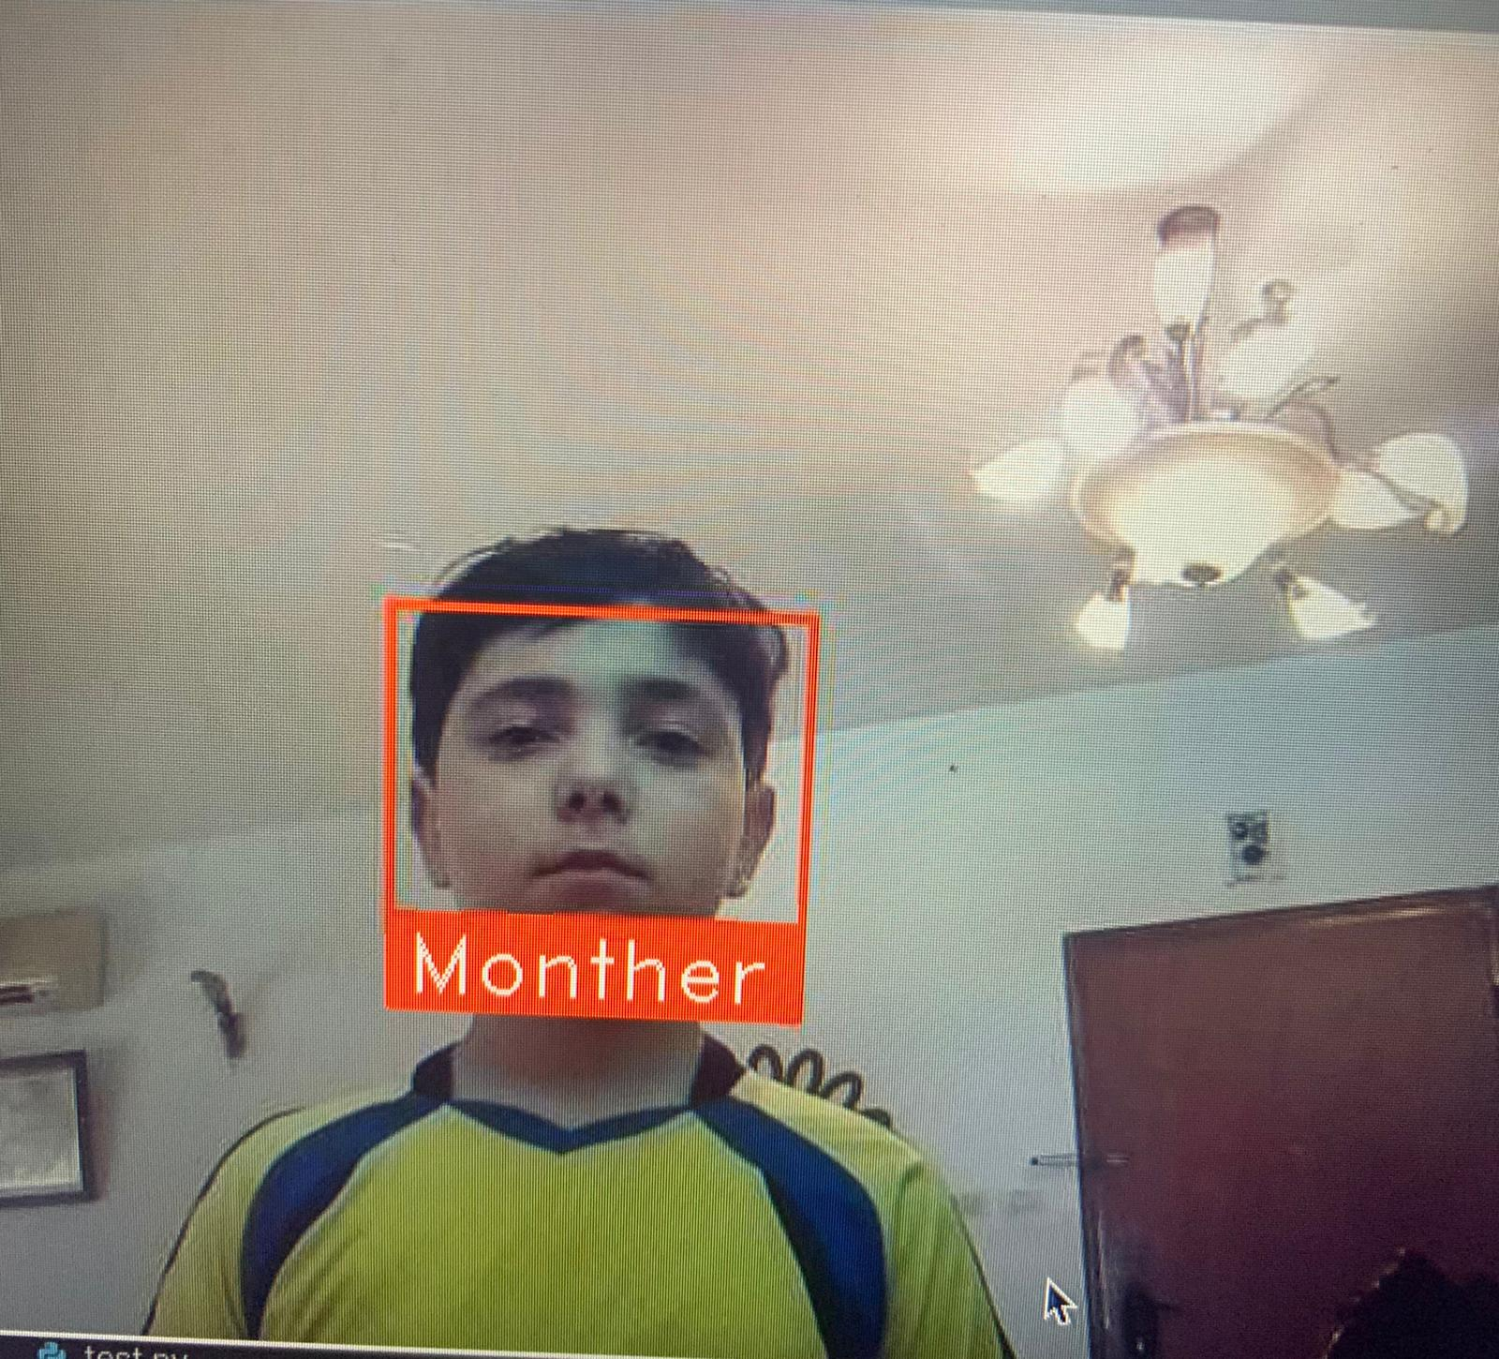

Fig 1

Figure 1 describe how face-recognition algorithm detect the students based on its faces.

A lot of serious thinking was done to choose the appropriate programming language for the project, Python programming was chosen after deep search for several reasons, one important reason is its compatibility with Raspberry Pi microcontroller, we thought that this microcontroller would be the most appropriate for building and testing the primary model, It was proven practically that it was an excellent choice from hardware and software prospective.

We worked steadily for about two weeks to studying the problem and identifying the goals that we will work on in order to achieve the desired benefit of this application, which is "that the program through the camera installed on the digital controller monitors and takes pictures of students in the morning at the start of daily school hours, and at the beginning of each time class or laboratory , after that the program then sends an electronic report to the headmaster and the division's teacher or subject, which contains a list of the names of the students present and a list of names of students absent with today, date and time, similar to the paper report that was previously.

Based on study, analysis, targeting and results, Python programming language was selected and digital controller Raspberry Pi was selected.

**Redesign & Retest**

Building and testing the primary model was not a simple task, a lot of corrections, additions, and extraction both on hardware and software level are required.

Testing was a very lengthy and tedious task, retesting with new data samples was performed to obtain more accurate results.

The end was an excellent intelligent machine according to the initially planned tasks.

**Results**

Using this application and program, the principal and class teacher will receive an electronic report containing two lists of students present at the time allocated to the class, and the second report a list of names of students absent and late depending on the time allocated to attendance per day and date.

**Future Work**

The capabilities of improvement and progress are extremely wide , In the future, this system can be developed by sending a text message on the student's cell phone stating that he or she is absent or delayed after school or both from class.

**References**

• Artificial Intelligence: A modern approach, “Stuart J. Russell and Peter Norvig”, 3 rd ed., Prentice Hall, 2020.

• Artificial intelligence: Structures and strategies for complex problem solving, “George F. Luger”, 6th ed., Pearson education, 2009.

• Artificial Intelligence: Foundations of Computational Agents, “David L. Poole, Alan K. Mackworth”, Cambridge University Press, 2010.

• <https://en.wikipedia.org/wiki/Artificial_intelligence>

• https://en.wikipedia.org/wiki/Machine_learning

• https://en.wikipedia.org/wiki/Object_detection