CROP PREDICTION USING CLIMATE FORECASTING
BY:
RADING GEORGE MITEMA
UNITED STATES INTERNATIONAL UNIVERSITY - AFRICA
FALL 2025
CROP PREDICTION USING CLIMATE FORECASTING
BY:
RADING GEORGE MITEMA
A Research Project Submitted to School of Science and Technology in Partial Fulfillment of Requirements for the Award of Degree of Bachelor of Science in Data Science and Analytics
UNITED STATES INTERNATIONAL UNIVERSITY- AFRICA
FALL 2025

STUDENT’S DECLARATION
I, the undersigned, declare that this research is my original work, except for cited quotations and references that has properly been acknowledged and referenced in accordance with the USIU-Africa requirements. Additionally, this research has not been submitted to any other college, institution, or any other university for examination, award of degree or publication or academic credit.
Signed  Date 05.12.2025
Rading George Mitema, 667965.
SUPERVISOR APPROVAL
This research proposal has been submitted for examination with my approval as the University Supervisor
Signed  Date 05.12.2025
Dr. Japheth Mursi.

COPYRIGHT
All rights reserved. No part of this project may be photocopied, recorded, or otherwise reproduced, stored in a retrieval system, or transmitted in any electronic or mechanical means without prior permission of USIU-Africa or the author
Rading George Mitema © 2026

ABSTRACT

Every growing season, smallholder farmers across Malawi decide what to plant with little more than memory and seasonal instinct. Climate change is making those decisions increasingly costly due to erratic rainfall, rising temperatures, and unpredictable dry spells have contributed to widespread crop failures across a country where over 80% of rural households depend entirely on what they grow. No localized system currently translates climate science into forward-looking crop guidance at the district level. This study builds one. Using satellite-derived records of rainfall, land surface temperature, and NDVI from the African Agricultural Watch platform, SARIMAX models generate five-year climate projections for Malawian districts. Forecasted conditions are scored against FAO EcoCrop thresholds for six crops, producing interpretable suitability rankings rather than opaque outputs. Tested across Chitipa, Lilongwe, and Dowa, the system identifies millet and sorghum as most suitable under projected dry and warm conditions, while rice consistently scores lowest where rainfall falls well below its viable threshold. Results are delivered through a web interface with downloadable reports.

ACKNOWLEDGEMENT

I would like to express my sincere gratitude to my supervisor, whose guidance, constructive feedback, and continuous support were invaluable throughout the development of this project. Their expertise and encouragement played a crucial role in shaping the direction and quality of this research.
My appreciation also extends to the faculty members and staff of the department, who provided academic resources, administrative assistance, and a conducive learning environment. Their collective contribution ensured that this study could be completed successfully.
To my classmates and friends, thank you for your constant motivation, collaboration, and insightful discussions. Your support made the research process more manageable and enriching.
Lastly, I owe profound gratitude to my family for their unwavering support, love, and understanding. Their belief in me provided the strength and determination needed to complete this work. This achievement would not have been possible without them.

DEDICATION
To everyone who believed in me when I doubted myself. Your encouragement carried me through.

TABLE OF CONTENT
STUDENT’S DECLARATION iii
COPYRIGHT iv
ABSTRACT v
ACKNOWLEDGEMENT vi
DEDICATION vii
LIST OF FIGURES xii
LIST OF TABLES xiii
LIST OF ABBREVIATIONS xiv
CHAPTER ONE: INTRODUCTION 1
1.1 Introduction 1
1.2 Problem statement 1
1.3 Objectives of the Study 2
1.3.1 General Objective 2
1.3.2 Specific Objectives 2
1.4 Research Questions 2
1.5 Significance of the Study 3
1.6 Scope of the Study 3
1.7 Chapter Summary 4
CHAPTER TWO: LITERATURE REVIEW 5
2.1 Introduction 5
2.2 Theoretical Review 5
2.3 Empirical Review 6
2.4 Conceptual framework 7
2.5 Chapter Summary 9
CHAPTER THREE: METHODOLOGY 11
3.1 Introduction 11
3.2 Research Design 11
3.3 Data Sources 11
3.4 Data Collection Methods 12
3.5 Data Preprocessing 12
3.6 Data Analysis Techniques 12
3.7 Proposed System Development Approach 14
3.8 Ethical Considerations 15
3.9 Chapter Summary 15
CHAPTER FOUR: EXPERIMENT RESULTS 16
4.1 Introduction 16
4.2 Presentation of Artifacts 16
4.2.1 The Selection Interface 16
4.2.2 Northern Region: Chitipa 17
4.2.3 Central Region: Lilongwe 20
4.2.4 Regional Comparison 22
4.3 Analysis of Results 22
4.3.1 Forecast Accuracy 22
4.3.2 Suitability Score Patterns 23
4.4 Discussion of Findings 24
4.5 Chapter Summary 25
CHAPTER FIVE: EVALUATION, VALIDATION AND DEPLOYMENT 26
5.1 Introduction 26
5.2 Evaluation Criteria 26
5.3 Validation Process 26
5.4 Results of Validation 27
5.5 Discussion of Validation 28
5.6 Deployment 28
5.7 Chapter Summary 28
CHAPTER SIX: DISCUSSION, CONCLUSIONS AND RECOMMENDATIONS 29
6.1 Introduction 29
6.2 Research Summary 29
6.3 Results Interpretation and Discussion 29
6.4 Limitations 30
6.5 Conclusions 30
6.6 Recommendations 31
6.7 Recommendations for Further Research 31
6.8 Chapter Summary 32
REFERENCES 33
APPENDICES 35
Appendix A: Dataset Samples 35
A.1 Project Budget 35
A.2 Estimated Budget Breakdown 36
A.3 Work Plan 36
A.4 Project Timeline 37
A.5 Summary 37
Appendix B: Dataset Samples 37
Appendix 3: Ethics Form 41
Declaration 41

LIST OF FIGURES
Figure 1: Conceptual Framework 9
Figure 2: Region selection interface showing named districts grouped by country and region. 17
Figure 3: Five-year SARIMAX forecast for Northern Region Chitipa. 18
Figure 4: Crop suitability scores and conditions reference for Northern Region: Chitipa. 19
Figure 5: Five-year SARIMAX forecast for Central Region: Lilongwe. 20
Figure 6: Crop suitability scores and conditions reference for Central Region: Lilongwe 21

LIST OF TABLES
Table 1: Regional comparison of forecasted climate averages and crop suitability outcomes across Chitipa, Lilongwe, and Dowa. 22
Table 2: Walk-forward cross-validation accuracy metrics for the SARIMAX forecasting models. 23
Table 3: Estimated Budget Plan 36
Table 4: Project Timeline 37
Table 5: 2020 Land Surface Temperature sample dataset 38
Table 6: 2020 Vegetation Cover sample dataset 39
Table 7: 2020 Rainfall sample dataset 40

LIST OF ABBREVIATIONS

- AI - Artificial Intelligence
- ARIMA - Autoregressive Integrated Moving Average
- CSA - Climate-Smart Agriculture
- DSR - Design Science Research
- GID_2 - Global Administrative Unit Level 2 (geographic identifier)
- LST - Land Surface Temperature
- ML - Machine Learning
- NDVI - Normalized Difference Vegetation Index
- SARIMAX - Seasonal Autoregressive Integrated Moving Average with eXogenous regressors

CHAPTER ONE: INTRODUCTION

1.1 Introduction
Agriculture is the backbone of both the economy and food security in Sub-Saharan Africa. In Malawi, over 80% of the population depends on smallholder farming, but this farming mostly relies on seasonal rains that are becoming less predictable (World Bank, 2023). Rising temperatures, unpredictable rain patterns, and more frequent droughts interfere with planting times and reduce harvests. Maize, which is the main food for most people, is especially vulnerable. Farmers from the northern highlands down to the Shire River basin notice that the seasons no longer follow the patterns they once knew.
Tools like the African Agricultural Watch, managed by AKADEMIYA2063, now offer detailed satellite data on rainfall, plant health, and temperature at the district level (AKADEMIYA2063, 2025). Using this data alongside time-series models lets us predict climate conditions years ahead and relate those forecasts to farming needs. This study uses this chance to create a system that turns satellite climate data into ranked crop recommendations for farmers, extension workers, and decision makers in Malawi.

1.2 Problem statement
Smallholder farming in Malawi depends almost entirely on rainfall, but the rains have become less reliable. More than 80% of rural households grow food crops like maize, rice, and cassava without irrigation or reliable climate info (World Bank, 2023). The rainy seasons are starting later, ending sooner, and bringing less rain. This leads to crop failures and food shortages in a country that can hardly afford them.
The current advice systems are too general to be helpful. National weather forecasts cover large areas but not individual districts and only provide seasonal outlooks without specific crop guidance. Even when climate data is available, there’s no system linking it to practical farming advice such as which crops to plant or how long the conditions will last. The FAO points out that effective climate-smart farming needs local, forward-looking tools, but those are still missing in Malawi (FAO, 2023).
While machine learning and remote sensing have progressed, their use in Malawi’s agriculture is still patchy. Platforms like AAGWA.org provide structured satellite data, but few attempts have been made to create full decision support systems from it. Farmers often rely on gut feeling and tradition, which may no longer suit the changing climate. This study aims to fill that gap by combining past climate data, five-year SARIMAX forecasts, and FAO crop suitability criteria into one easy-to-use online tool.

1.3 Objectives of the Study

1.3.1 General Objective
This study aims to build a data-driven crop prediction system for Malawi that merges climate forecasts with crop suitability scores to give ranked recommendations to farmers, extension workers, and policymakers.

1.3.2 Specific Objectives
- Forecast rainfall, land surface temperature, and vegetation health (NDVI) for Malawian districts using SARIMAX models trained on satellite history.
- Assess the suitability of six crops: maize, rice, cassava, groundnuts, sorghum, and millet based on forecasted climate conditions using FAO’s EcoCrop thresholds.
- Create a web platform that displays these forecasts, suitability scores, and crop condition references clearly for users to understand.
- Test how accurate the SARIMAX forecasts are using walk-forward cross-validation in selected regions.

1.4 Research Questions
- Which crops suit different Malawian districts best and worst under climate conditions projected for the next five years?
- How well do SARIMAX models predict rainfall, temperature, and NDVI using three years of satellite data?
- How can we translate forecasted climate information into clear, district-level crop advice that non-experts can use?
- What do differences in suitability scores across regions tell us about Malawi’s vulnerability to climate change?

1.5 Significance of the Study
This research matters on three levels. For farmers and extension workers, it fills a practical gap by offering localized five-year crop guidance where none existed before. Wrong planting choices because of uncertain climate cost households harvests they can’t recover from. A tool that highlights which crops are likely to perform well gives those decisions more confidence.
For policymakers and food security planners, the system can warn early. Malawi often faces food shortages when maize fails due to climate stress, leading to expensive imports and aid reliance (FAO, 2023). A district-level forecasting tool helps the agriculture ministry and disaster agencies spot risky areas and shift support before problems grow.
Scientifically, the study adds to climate-smart agriculture by showing that clear, rule-based decision tools can work well even when data is limited. Many recent studies prefer complex deep learning models that trade transparency for slight accuracy gains. This system focuses on explainability as each suitability score links back to published agronomic data proving that responsible AI design and usefulness can go hand in hand (Floridi &amp; Cowls, 2022).

1.6 Scope of the Study
The system targets Malawi, covering 23 districts across the north, center, and south. It uses data from January 2022 to February 2025, all from the AAGWA platform. It assesses six crops, the main ones for Malawi’s food security and livelihoods: maize, rice, cassava, groundnuts, sorghum, and millet. Tobacco and some legumes are left out because their suitability depends more on market and soil factors beyond the climate focus here.
The model covers rainfall, land surface temperature, and NDVI. It does not include soil type, irrigation, pests, or socioeconomic factors. User testing so far is limited to experts and technical review; testing with farmers in the field is planned as the next step. The prototype runs locally with Flask and offers web dashboards and downloadable PDF reports.

1.7 Chapter Summary
This chapter set the stage by explaining the agricultural and climate context behind the study, pointing out the gap between climate data and useful farming advice, and stating the objectives, research questions, scope, and expected contributions. Chapter Two reviews the theories and earlier studies that shaped the system design, followed by Chapter Three, which explains the methods used to build and test it.

CHAPTER TWO: LITERATURE REVIEW

2.1 Introduction
This chapter reviews the theoretical and empirical foundations that shaped the design of the crop prediction system. It examines how time-series forecasting, agroecological science, and decision support theory were applied to the problem of translating satellite climate data into actionable agricultural guidance. The empirical review focuses on what has been attempted in climate-informed agriculture across Sub-Saharan Africa, what those attempts have achieved, and where they have fallen short. The chapter closes by identifying the specific gap this study addresses and presenting the conceptual framework that guided the system's architecture.

2.2 Theoretical Review
The study is guided by Design Science Research (DSR), which focuses on creating and assessing artifacts that address practical problems. Unlike explanatory research that seeks to confirm theories, DSR gauges success based on how useful the artifact is in real-world situations (Hevner &amp; Chatterjee, 2020). This approach fits well here because the main outcome is a functioning system, who’s worth depends on whether it performs effectively and meets user needs rather than validating a hypothesis. Following Peffers et al. (2018), the steps of problem identification, design, demonstration, and evaluation directly correspond to the process used to develop and test the system.
The statistical basis comes from time-series forecasting theory. SARIMAX models build on the traditional ARIMA method by adding seasonal elements and external variables, making them a strong match for climate data influenced by yearly agricultural cycles (Hyndman &amp; Athanasopoulos, 2018). Importantly, SARIMAX offers interpretability as its parameters have clear statistical meanings and results can be traced back. This is valuable in resource-limited settings where understanding how a model works can be as crucial as its accuracy. This transparency was an intentional choice rather than settling for a simpler method.
Agroecological theory provides the framework for translating climate forecasts into crop recommendations. According to agroecology, crop success depends on how climate factors interact with the crop’s specific biological needs in a given place (FAO, 2021). The FAO EcoCrop database captures this by setting temperature and moisture limits which are minimum, optimal, and maximum tolerable based on extensive agricultural research. Instead of using simple yes-or-no thresholds, the system employs a trapezoidal scoring function that reflects how crop responses change gradually: conditions close to the ideal receive higher scores, which then decline smoothly as conditions approach harmful extremes.
Principles from Decision Support System (DSS) theory influenced the design of the user interface. A DSS aids decision-making under uncertainty by delivering information that is contextual and easy to interpret (Power, 2021). This idea led to separating the suitability scores from the conditions reference table in the system. The scores show the system’s conclusions, while the reference table lays out the agronomic data behind those conclusions. Distinguishing the system’s outputs from its reasoning helps build trust, especially in communities where digital tools have often made recommendations without clear explanations (Adenle et al., 2019).
Finally, human-centered AI principles shaped choices about the system’s scope and output. Research shows that many agricultural AI tools in Africa falter not due to technical flaws, but because their design doesn’t fit user needs and outputs assume users understand technical terms, interfaces expect reliable internet, and recommendations appear unquestionable (Adenle et al., 2019). To address this, the system uses a rule-based, explainable scoring approach instead of an opaque classifier, and offers downloadable PDF reports alongside the web interface. These design elements respond directly to the practical realities users face.

2.3 Empirical Review
Research on climate and agriculture in Sub-Saharan Africa has established two things clearly. First, satellite-derived indicators particularly NDVI and rainfall estimates from MODIS carry genuine predictive signal for crop outcomes. Rosin et al. (2021) confirmed that NDVI readings correlate closely with maize yields in Malawi during drought periods, validating NDVI as a meaningful input to agricultural decision-making rather than a purely monitoring indicator. Second, translating that signal into forward-looking, actionable guidance has not been achieved. Most existing systems either monitor current conditions or assess historical suitability. They do not project future conditions and use those projections as the basis for crop recommendations.
The few systems that have attempted predictive crop guidance share a common limitation: they rely on historical climate averages rather than forecasts. This means they implicitly assume that past conditions will continue, which is precisely the assumption that climate change undermines. In a stable climate, advising farmers based on what grew well historically is reasonable. In Malawi's changing climate, it is increasingly unreliable.
Digital advisory platforms have proliferated but rarely incorporate predictive modelling. Adenle et al. (2019) found that fewer than 10% of agricultural mobile applications reviewed across East and Southern Africa used any form of predictive modelling, most relying on weather summaries, or generic advice. Farmers interviewed in Malawi expressed distrust toward digital tools that could not explain their recommendations, preferring local environmental signals they could evaluate themselves. This finding directly motivated the conditions reference table design, a feature that gives users the basis to interrogate the system's output rather than simply accept it.
On forecasting methodology, Lim & Zohren, (2021) compared LSTM networks and SARIMAX for predicting rainfall and temperature in a data-scarce African context, finding that SARIMAX performed comparably over medium-term horizons while requiring significantly less computational resource and remaining interpretable. Their study validated the use of 16-day MODIS intervals for seasonal modelling, the same temporal resolution as the AAGWA dataset and stopped at forecasting environmental variables without connecting those forecasts to crop guidance. This gap between producing a climate projection and using it to recommend what to plant is the central problem this study addresses.
Multi-crop recommendation remains an underexplored area. Maggio et al. (2018) noted that Malawian farmers routinely grow several crops together to spread risk, yet most decision tools focus on maize alone. When multiple crops are considered, outputs tend to be binary; suitable or unsuitable rather than ranked, giving farmers no basis for comparing options under the same projected conditions. This study responds by scoring six crops on a continuous suitability scale and ranking them, enabling comparative decision-making rather than a simple approve-or-reject output.

2.4 Conceptual framework
The literature points to a consistent structural gap: the components needed for a meaningful crop prediction system exist such as satellite data, SARIMAX forecasting, agroecological thresholds, web delivery, but have not been assembled into an integrated, locally accessible tool for Malawi. Remote sensing demonstrates predictive value. Statistical models can project climate variables under data constraints. Agronomic thresholds exist for the crops Malawian farmers grow. Yet no prior system combines these elements into a single pipeline that generates district-level, multi-crop, forward-looking recommendations and makes its reasoning visible to the user.
Two more specific gaps follow from this. First, crop suitability has been assessed against historical conditions rather than projected future conditions, an approach that becomes less useful precisely as climate variability increases. Second, the explainability deficit documented by Adenle et al. (2019) has not been addressed in recommendation system design; most systems output a classification without the agronomic reasoning that would allow users to evaluate it.
Figure 1 presents the conceptual framework that guided the system's design in response to these gaps. The framework is structured as a linear pipeline from user input through data retrieval, preprocessing, and SARIMAX forecasting, to FAO-grounded suitability scoring, and finally to web dashboard and PDF outputs. Three independent SARIMAX models are fitted in parallel for rainfall, NDVI, and LST respectively, with their outputs merged into a single five-year projection before suitability scoring. A walk-forward cross-validation loop sits alongside the forecasting stage, evaluating model accuracy without disrupting the main pipeline. The framework reflects two core design decisions: keeping prediction and interpretation as separate, auditable stages rather than a single black-box process, and surfacing both the scoring outputs and the underlying agronomic thresholds to the user simultaneously.

INPUT
Independent Variables
Rainfall, Vegetation Cover, Land Surface Temperature
PROCESSING
Time Series
OUTPUT
Dependent Variables
Time series analysis using SARIMAX
Prediction: Recommended Crops

Figure 1: Conceptual Framework
The direct, linear structure of the framework was chosen deliberately over feedback-loop architectures that are common in machine learning systems. In a resource-constrained deployment context, linear pipelines are easier to maintain, easier to explain to non-technical stakeholders, and easier to audit when outputs are questioned. Each stage produces an intermediate result from cleaned data, fitted models, forecast series and suitability scores that can be inspected independently, building confidence in the overall system without requiring trust in any single opaque component.

2.5 Chapter Summary
This chapter established the theoretical frameworks such as DSR, time-series forecasting, and agroecology that help shape the system's architecture and interface decisions. The empirical review identified the persistent gap between available climate data and actionable district-level crop guidance in Malawi, and located this study's contribution within that gap: a complete pipeline from satellite data to ranked, explainable crop recommendations, built on published agronomic thresholds and delivered through an accessible web interface. The conceptual framework presented in Figure 1 gives visual form to this pipeline and to the design decisions that distinguish it from prior work. Chapter Three describes in detail how each stage of that framework was implemented.

CHAPTER THREE: METHODOLOGY

3.1 Introduction
This chapter explains how the climate-informed crop prediction system was planned, created, and tested. It details the research plan, data sources, how data was collected and cleaned, the analysis methods, how the system was developed, and ethical issues. Each part matches a goal set in Chapter One. The outcome is a complete, repeatable process starting from raw satellite CSV files to a Flask web application that provides ranked crop recommendations based on established agronomic studies and checked using walk-forward cross-validation.

3.2 Research Design
The study used a quantitative Design Science Research (DSR) approach because the main goal was to produce a working tool, not just a theory. DSR fits when the aim is to build and assess something practical. Here, a prototype combining climate forecasts with crop suitability (Hevner &amp; Chatterjee, 2020). Performance was evaluated using technical metrics like MAE and RMSE from walk-forward cross-validation, rather than surveys or qualitative data. This design made sure the system was both scientifically sound and realistically testable within the project’s timeframe.

3.3 Data Sources
All climate data came from the African Agricultural Watch platform by AKADEMIYA2063, which offers open satellite-based records for Malawi at the district level. Three variables were collected: rainfall (mm), land surface temperature (°C), and the Normalized Difference Vegetation Index. Data was available in CSV files, sorted by variable type and organized by GADM GID_2 geographic codes for districts. The data covered January 2022 to February 2025, with 73 observations every sixteen days per district, matching the MODIS satellite cycle. No other data sources were used since this dataset was well-structured and complete for the study.
Dataset-Source
- African Agricultural Watch (AAGWA) Platform – https://www.aagwa.org/Malawi/data

3.4 Data Collection Methods
Data was downloaded directly from AAGWA's Malawi portal (https://www.aagwa.org/Malawi/data). Separate CSV files were retrieved for each variable across the available years. The raw files included HTML elements such as div, script, and style tags in the first 80 to 120 rows because of the web export method. Also, the files were in wide format, with each date as a column instead of a row. These issues needed to be cleaned before analysis could begin.

3.5 Data Preprocessing
Preprocessing was done in Python using pandas and NumPy, across several Jupyter notebooks, resulting in one clean CSV file used by the Flask app. Four steps were followed. First, a row-skipping function found and removed HTML rows by locating the first valid header and dropping everything before it. Second, pandas.melt() converted the data from wide to long format, making a consistent structure with GID_2, DATE, and the variable value. Third, missing values were handled differently by variable: LST had 5.34% missing, NDVI 0.29%, both filled with linear interpolation; rainfall had 7.27% missing, filled using seasonal decomposition then linear interpolation to keep seasonal patterns. Finally, the three cleaned datasets were merged on GID_2 and DATE with left joins, and any rows with leftover missing data were removed, leaving 17,174 records over 238 districts.

3.6 Data Analysis Techniques
This study's analytical framework was divided into two main steps: forecasting seasonal climate variables and then assessing agronomic suitability using fuzzy logic. Initially, a Seasonal AutoRegressive Integrated Moving Average with eXogenous regressors (SARIMAX) model was employed for each climate variable using Rainfall, Land Surface Temperature (LST), and NDVI within designated regions. The model order was set to (1,1,1) (1,1,1,23), where the 23-step seasonal period was chosen to match the 16-day MODIS cycles per year. This allowed the model to capture Malawi’s pronounced wet and dry seasonal patterns effectively. The models, implemented in Python using the statsmodels library and saved through joblib, generated forecasts for 115 time steps, offering projections spanning five years in 16-day increments without needing to retrain repeatedly.
To handle forecast uncertainty growing over time, confidence intervals were carefully adjusted rather than relying on raw SARIMAX outputs. Since the dataset had only 73 observations, traditional intervals tended to become unrealistically wide after several years. The study addressed this by applying a linearly increasing half-width for intervals, starting at 0.5 standard deviations and extending to 2.0 by the 115th step. This method preserved tighter uncertainty bounds for near-term predictions while acknowledging diminished confidence further out. Additionally, physical constraints were enforced: rainfall values couldn’t fall below zero, NDVI values were restricted between 0 and 1, and LST had a minimum bound of 15°C, reflecting regional realistic temperatures. These limits prevented nonsensical forecast values that would undermine agronomic interpretation.
A key improvement in assessing suitability was focusing only on relevant growing periods. Following the FAO EcoCrop guidelines, the study avoided annual averages contaminated by dry-season data, which has minimal impact on crop growth. Instead, it averaged LST, rainfall, and NDVI solely during Malawi’s usual planting window from November to April. These tailored averages were then compared to crop-specific thresholds covering six staple crops: maize, rice, cassava, groundnuts, sorghum, and millet. This approach ensured environmental assessments corresponded closely to periods when crops actually develop, thus offering more precise evaluations of seasonal viability.
Suitability for each climate variable was derived using trapezoidal membership functions. These functions assign a full score of one within optimal climate ranges, zero outside lethal limits, and interpolate linearly in between, reflecting a gradual crop response rather than binary tolerance. This fuzzy-logic method, inspired by previous studies, aligns well with agronomic realities. Moreover, LST thresholds were raised by 2 to 5 degrees Celsius to account for systematic differences between satellite-derived land surface temperatures and traditional air temperature measurements used in FAO literature. Such calibration was essential to maintain biological relevance when working with remote sensing inputs.
To produce a final suitability rating per crop, individual climate scores were weighted based on each species’ sensitivity. For example, temperature played a larger role for heat-sensitive crops like rice, while rainfall was more influential for species dependent on water. Importantly, a veto rule was applied: if temperature or rainfall scores were zero, the combined suitability was set to zero regardless of NDVI values. This reflects a fundamental agronomic principle that healthy vegetation cannot compensate for lethal heat or a lack of water. Crops were then ranked by their composite scores and presented with their optimal climate ranges, supporting transparency and traceable decision making.
Model performance was rigorously tested using walk-forward cross-validation via TimeSeriesSplit. This method respects the chronological order of data, avoiding the problem of information from the future influencing past predictions. Evaluations were done across several folds in randomly selected regions, with results measured by Mean Absolute Error (MAE) and Root Mean Squared Error (RMSE). Mean Absolute Percentage Error (MAPE) was excluded for rainfall due to frequent dry-season zero values, which make percentage error calculations problematic. The reported metrics offer a conservative view of model accuracy since validation used smaller training sets than those applied when fitting the final models for production.

3.7 Proposed System Development Approach
The system was built in Python using Flask as the web framework, organized into three separate modules to maintain a clean separation of concerns. models.py contains the crop thresholds from the FAO EcoCrop threshold profiles, the trapezoidal scoring functions, and the suitability ranking logic. services.py contains all data and forecasting logic from CSV loading, SARIMAX model training and caching, forecast generation, confidence interval construction, plot generation, walk-forward evaluation, and PDF report creation. app.py contains only the Flask routes, acting as a thin coordinator between the web interface and the service layer. This separation means that changes to the crop scoring science require touching only models.py, changes to the forecasting methodology require touching only services.py, and neither affects the web layer. HTML templates rendered the results interface, displaying forecast statistics, a ranked suitability table with progress bars and rating badges, a conditions reference table showing each crop's optimal climate ranges, and the forecast visualization chart generated by matplotlib and saved as static PNG files. Downloadable PDF reports were generated using ReportLab, embedding the forecast chart and a full suitability table with the conditions key.

3.8 Ethical Considerations
This study used only public, anonymous satellite data aggregated at the district level. No human subjects were involved, and no personal information was collected or processed. The system is intended as a decision-support tool, not a directive. It shows confidence intervals and explains conditions so users can make informed planting choices. The suitability scoring is fully based on published FAO thresholds, supporting explainability to avoid hidden outputs that could reduce trust or cause harm (Floridi &amp; Cowls, 2022). Differences in forecast accuracy across regions with complex microclimates are recognized as a limitation, discussed in Chapter Six.

3.9 Chapter Summary
This chapter covered the entire pipeline from data acquisition to system delivery, including cleaning raw AAGWA exports into a dataset ready for modeling, the SARIMAX forecasting method and its settings, the FAO-based suitability scoring, and the Flask web interface for results. Chapter Four presents results from applying this system in three Malawian districts, exploring what the suitability scores suggest about regional agricultural risks under future climate conditions.

CHAPTER FOUR: EXPERIMENT RESULTS

4.1 Introduction
This chapter presents the outputs produced by the climate-informed crop prediction system across three Malawian districts: Chitipa in the Northern Region, Lilongwe in the Central Region, and Dowa, also in the Central Region. These districts were selected to represent contrasting agroclimatic conditions. Chitipa is a cooler, drier highland district in the far north, while Lilongwe and Dowa represent the central plateau where the majority of Malawi's smallholder maize production is concentrated. Results are presented in three parts: first, the system artifact itself including the user interface and forecast outputs; second, the quantitative analysis of forecast accuracy; and third, a comparative discussion of what the suitability scores reveal across the three districts. All forecasts cover the period from March 2025 to February 2030 at 16-day intervals.

4.2 Presentation of Artifacts

4.2.1 The Selection Interface
The figure below shows the region selection interface through which a user initiates a forecast. The dropdown lists available options under two groups; Countries, offering Malawi as a whole, and Regions, listing 23 named administrative districts. Named districts were drawn from official GADM administrative boundaries and cover all three of Malawi's geographic regions. Two entries at the bottom of the dropdown, Region MWI.2.8_1 and Region MWI.2.9_1 represent districts present in the dataset that have not yet been mapped to human-readable names; these are retained in the system but would be resolved through a complete administrative boundary lookup in future work. Once a region is selected and the user clicks View Forecast, the system loads any pre-trained SARIMAX models from disk or trains new ones, runs the five-year projection, scores all six crops, and renders the results page, a process that completes within 30 seconds for regions with cached models.
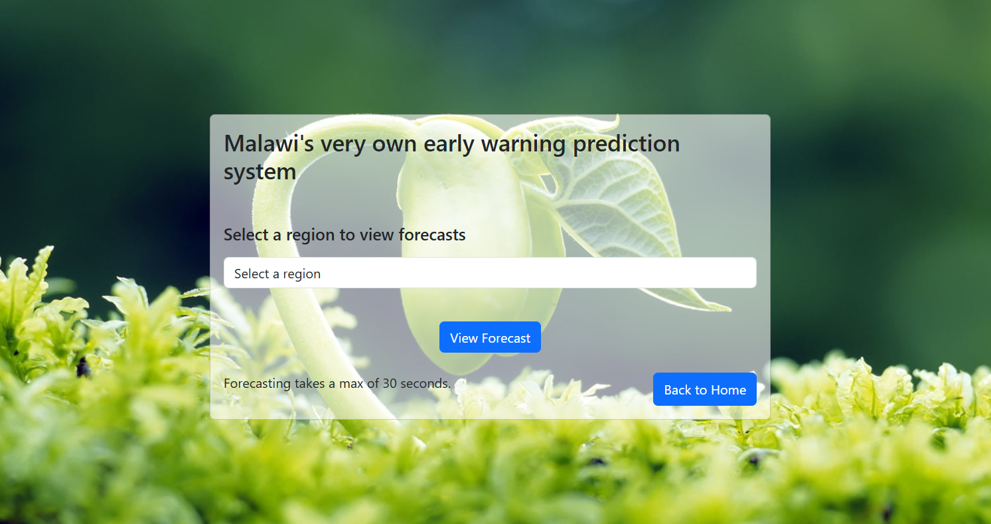
Figure 2: Region selection interface showing named districts grouped by country and region.

4.2.2 Northern Region: Chitipa
Figure 3 presents the three-panel forecast visualization for Chitipa, covering historical data from January 2022 to February 2025 and SARIMAX projections from March 2025 to February 2030. The shaded band around each forecast line represents the 95% confidence interval, bounded post-hoc to enforce physical constraints rainfall clipped to zero, NDVI bounded between 0 and 1, and LST lower bounds floored at 15°C and upper bounds capped relative to the historical maximum, with interval width growing progressively over the forecast horizon to reflect increasing uncertainty at longer time ranges.
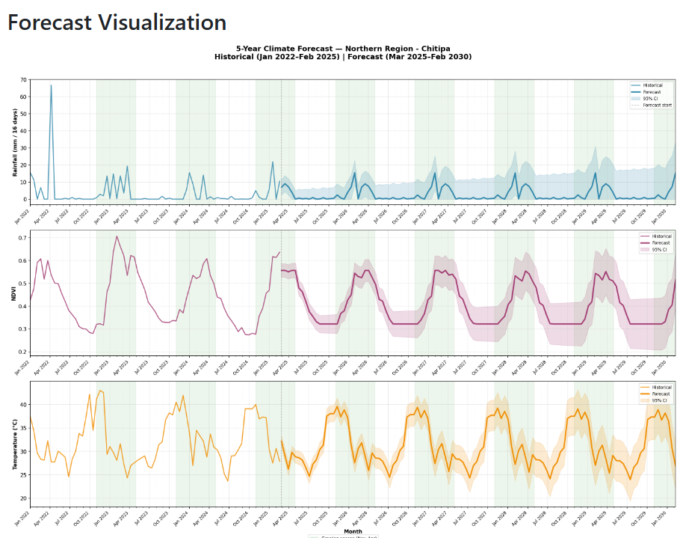
Figure 3: Five-year SARIMAX forecast for Northern Region Chitipa.

The rainfall panel shows Chitipa's strongly seasonal pattern. It has pronounced wet season peaks followed by extended dry periods where rainfall drops to near zero. The SARIMAX model captures this seasonality effectively, projecting continued wet-dry cycling through 2030 with modest uncertainty. The NDVI panel mirrors the rainfall pattern with a slight lag, as vegetation responds to moisture availability. The temperature panel shows consistent oscillation between approximately 22°C and 42°C across seasons, with the forecast mean tracking the historical pattern closely.
Figure 4 presents the suitability scores and conditions reference table for Chitipa, generated from the average forecasted values.
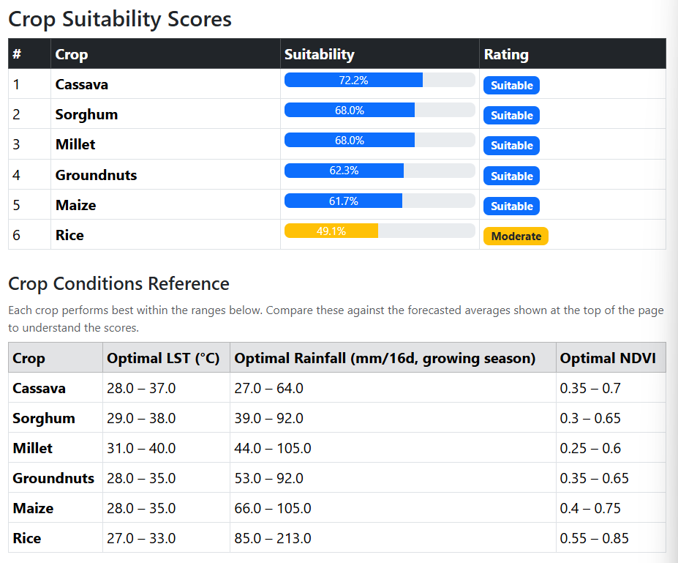
Figure 4: Crop suitability scores and conditions reference for Northern Region: Chitipa.

Cassava ranks first at 72.2%, followed closely by Sorghum and Millet. These three crops share a tolerance for low rainfall and warm temperature conditions consistent with Chitipa's projected climate. The conditions reference table makes this relationship directly readable: Millet's optimal rainfall range of 11.0 to 26.0 mm per 16-day period is closer to Chitipa's forecasted average of 5.16 mm than Rice, which requires 40.0 to 90.0 mm. Rice scores 41.6%, Moderate which reflects the mismatch between its water requirements and Chitipa's projected dry conditions. All five remaining crops are rated Suitable, indicating that while Chitipa is not ideal for any single crop, it broadly supports drought-tolerant agriculture.

4.2.3 Central Region: Lilongwe
Figure 5 presents the forecast visualization for Lilongwe. The rainfall pattern is similar in structure to Chitipa but with slightly higher wet-season peaks. The more significant difference appears in the NDVI panel. The forecasted mean shows a stabilizing trend toward the lower end of the observed range, with the confidence interval widening in later years to reflect growing uncertainty. The average forecasted NDVI for Lilongwe is 0.400. This value is critical because it represents the minimum threshold required for healthy growth of several staple crops. Unlike the other districts, Lilongwe is not projected to see vegetation improvement but rather a maintenance of baseline levels that places it on the borderline of crop viability.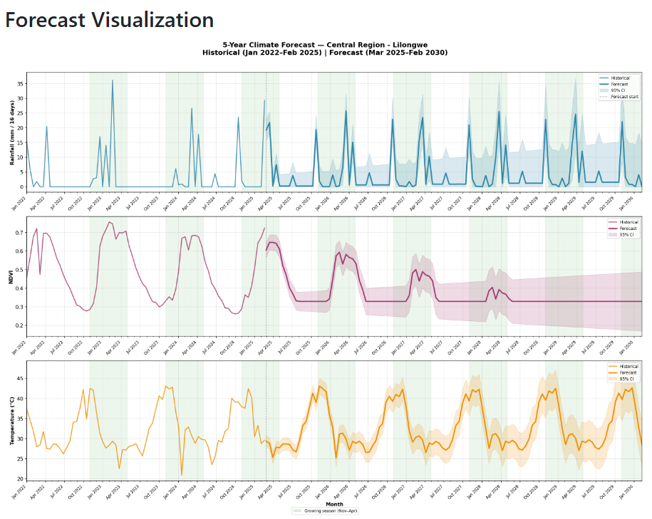
Figure 5: Five-year SARIMAX forecast for Central Region: Lilongwe.

Figure 6 presents the suitability scores for Lilongwe, generated from averaged forecasted values of rainfall 5.93 mm, NDVI 0.400, and LST 33.94°C.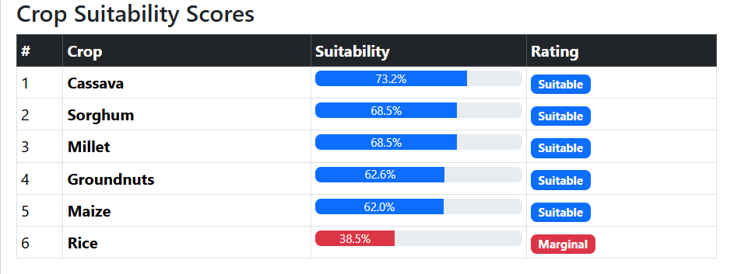
Figure 6: Crop suitability scores and conditions reference for Central Region: Lilongwe

The results are markedly different from Chitipa. Millet again leads at 75.7%, but the score spread widens considerably. Maize falls to 39.1% and Rice to 36.6%, both rated Marginal. This is the system's most significant finding: Lilongwe, which hosts Malawi's capital city and is the country's most agriculturally prominent central district, shows projected conditions that are marginal for its two most commonly grown food crops. The conditions reference table clarifies the mechanism which is Maize requires an optimal NDVI of 0.40-0.75, and Rice requires 0.55-0.85. Lilongwe's forecasted average NDVI of 0.400 sits at the lower boundary of Maize's viable threshold and well below Rice's minimum, explaining their Marginal ratings

4.2.4 Regional Comparison
Table 1: Regional comparison of forecasted climate averages and crop suitability outcomes across Chitipa, Lilongwe, and Dowa.
Metric | Chitipa (North) | Lilongwe (Central) | Dowa (Central)
Avg. Rainfall (mm/16d) | 5.16 | 5.93 | 5.18
Avg. Temperature (°C) | 32.57 | 33.94 | 32.40
Avg. NDVI | 0.456 | 0.400 | 0.57
Top crop (score) | Cassava | Cassava | Cassava
Bottom crop (score) | Rice | Rice | Rice
Marginal or below | 1 crop | 2 crops | None

Cassava is the top-ranked crop across all three districts, a consistent finding that reflects its broad tolerance for the warm, low-rainfall conditions projected across Malawi. Millet and Sorghum follow closely as strong alternatives. Rice is the lowest-ranked crop in all three cases, driven by its high-water requirement relative to forecasted rainfall. The difference between the highest and lowest scoring crop is widest for Lilongwe at 39.1 percentage points, indicating that projected conditions there create a larger gap between the crops that can cope and those that cannot. Forecast outputs, suitability scores, and the conditions reference table are also available as downloadable PDF reports and CSV files directly from the results page for offline use or sharing with extension workers.

4.3 Analysis of Results

4.3.1 Forecast Accuracy
Walk-forward cross-validation using TimeSeriesSplit with two folds across three randomly sampled regions produced the accuracy metrics shown in Table 2.
Table 2: Walk-forward cross-validation accuracy metrics for the SARIMAX forecasting models.
Variable | MAE | RMSE | MAPE
Rainfall (mm) | 10.518 | 14.843 | N/A*
NDVI | 0.160 | 0.190 | 41.0%
LST (°C) | 8.995 | 9.845 | 28.9%

* MAPE excluded for rainfall as approximately 50% of dry-season readings are 0 mm, making percentage error mathematically undefined.
These metrics reflect the inherent difficulty of forecasting each variable rather than model failure. Rainfall is the hardest to forecast because it is intermittent. The MAE of 10.518 mm must be read against a distribution where the median is 0 mm and meaningful rainfall events are infrequent. The model captures the seasonal wet-dry pattern well but cannot predict the exact magnitude of individual rainfall events, which is a well-documented limitation of ARIMA-family models applied to precipitation data. NDVI's MAE of 0.160 on a 0–1 scale indicates moderate accuracy as the model tracks seasonal vegetation cycles but overpredicts or underpredicts the amplitude of individual peaks. LST's MAE of 8.995°C reflects the wide temperature range in the data (approximately 22°C to 47°C across all districts and seasons), making an absolute error of 9°C a smaller proportional error than it appears. MAPE for LST at 28.9% is consistent with published benchmarks for medium-term temperature forecasting in data-sparse environments.
An important qualification applies to these metrics: walk-forward cross-validation trains on progressively smaller windows than the production models, which use the full 73-observation dataset. The reported metrics are therefore conservative estimates that the production forecast accuracy will be meaningfully better than these figures suggest.

4.3.2 Suitability Score Patterns
Two main trends can be observed across all districts. The first is that drought-resistant crops such as Millet, Sorghum, and Cassava consistently perform best, which makes sense given the significant expected shortfall in rainfall. The second trend shows that Rice is generally the least suitable crop. Even though the predicted Land Surface Temperatures fall within the range Rice can tolerate, the expected rainfall ranging between 5.16 and 5.93 mm over 16-day periods remains substantially below the 40 to 90 mm Rice typically requires.
A third, more unique pattern emerges in Lilongwe, where Maize is rated only as Marginal. Maize received decent scores in Chitipa and Dowa, with NDVI values close to the ideal range of 0.40 to 0.75. However, Lilongwe's projected NDVI value of 0.400 sits at the minimum viable threshold for Maize (0.40–0.75), explaining its Marginal rating despite adequate temperature and rainfall. This suggests that the region is not just struggling with temperature or moisture challenges but is also facing a decline in vegetation health. As a result, strategies for agricultural development in Lilongwe need to take into account this particular ecological deterioration, which sets it apart from neighboring areas.

4.4 Discussion of Findings
The results address each of the four research questions established in Chapter One.
Research Question 1 asked which crops are most and least suitable across Malawian districts under projected climate conditions. The system gives a clear, consistent answer: Millet and Sorghum are best positioned across the districts tested, while Rice is the most vulnerable crop under projected dry, warm conditions. This is agronomically sound as both findings align with what FAO EcoCrop parameters predict for these climate profiles.
Research Question 2 asked how accurately SARIMAX models forecast the three climate variables using three years of historical data. The walk-forward CV results indicate moderate accuracy is adequate for identifying seasonal trends and directional shifts, but not for predicting exact values at a specific 16-day step. This distinction is important: the system is designed as a medium-term trend indicator, not a precision point forecast. The five-year projections should be read as indicating likely climatic direction, not precise future measurements.
Research Question 3 asked how forecasts can be translated into interpretable guidance for non-specialist users. The conditions reference table directly addresses this by displaying each crop's optimal climate ranges alongside the suitability scores, the system allows any user to trace the reasoning behind a score without any technical knowledge. A farmer or extension worker can see that Rice needs 40-90 mm of rainfall per 16-day period and compare that against the forecasted 5.93 mm without needing to understand what a suitability score means numerically.
Research Question 4 asked what regional differences reveal about agricultural vulnerability. The contrast between Lilongwe and the other two districts is the clearest answer; a district that superficially appears similar to its neighbors in temperature and rainfall can diverge sharply in suitability outcomes when vegetation health trends differently. This highlights that single-variable analyses such focusing only on temperature or only on rainfall may miss important signals that a multi-variable approach captures.

4.5 Chapter Summary
This chapter presented the full outputs of the climate-informed crop prediction system across three Malawian districts. The selection interface, forecast visualisations, suitability tables, and conditions reference were demonstrated as a coherent artifact. Walk-forward cross-validation established the forecasting models' accuracy as adequate for trend-based agricultural planning. The most significant finding is that Maize and Rice are both Marginal in Lilongwe under projected conditions. This demonstrates that the system produces substantively different and meaningful outputs across districts, rather than uniform recommendations that fail to reflect local climate variation. Chapter Five evaluates these results against the study's objectives and considers the system's validity, limitations, and deployment characteristics.

CHAPTER FIVE: EVALUATION, VALIDATION AND DEPLOYMENT

5.1 Introduction
This chapter evaluates the climate-informed crop prediction system against the objectives established in Chapter One across four criteria: forecast accuracy, suitability scoring validity, interpretability, and system completeness. It also describes the system's current deployment configuration and establishes the extent to which the system fulfils its purpose as a transparent, data-driven agricultural planning tool for Malawi.

5.2 Evaluation Criteria
Four criteria were used, corresponding to the four specific objectives from Chapter One. Forecast accuracy assessed whether the SARIMAX models produce projections sufficiently reliable for medium-term agricultural planning, measured using MAE and RMSE from walk-forward cross-validation, with MAPE excluded for rainfall due to its zero-heavy dry-season distribution. Suitability scoring validity assessed whether crop scores are grounded in published agronomic science and consistent with known growing conditions, verified by tracing each threshold to its FAO EcoCrop source. Interpretability assessed whether a non-specialist user can understand the basis for each recommendation without technical knowledge. System completeness assessed whether the artifact covers the full pipeline from user input to downloadable output and handles edge cases gracefully.

5.3 Validation Process
Forecast validation used scikit-learn's TimeSeriesSplit with two folds across three randomly sampled regions, preserving temporal order to avoid data leakage. Two folds were used because the 73-observation dataset per region does not support more without reducing training windows below the minimum required for SARIMAX with a seasonal period of 23. Suitability scoring validation cross-referenced outputs against FAO EcoCrop parameters for all six crops, adjusted for the 2–5°C offset between Land Surface Temperature and air temperature. The system was tested against forecasted conditions for Chitipa, Lilongwe, and Dowa to confirm rankings were consistent with agronomic expectations. Interpretability was assessed structurally by examining whether forecasted averages and each crop's optimal ranges were simultaneously visible on the results page. System completeness was verified by running the full pipeline across six regions including previously forecast ones, confirming models trained, cached, and that downloads functioned correctly.

5.4 Results of Validation
Rainfall achieved an MAE of 10.518 mm and RMSE of 14.843 mm. NDVI achieved an MAE of 0.160 and RMSE of 0.190. LST achieved an MAE of 8.995°C, RMSE of 9.845°C, and MAPE of 28.9%. These represent conservative estimates as walk-forward CV uses smaller training windows than the full production dataset. NDVI was the most proportionally accurate at 16% mean error across its 0–1 scale with consistent seasonal cycling. Rainfall was least accurate as expected given its intermittent, zero-heavy distribution, though the seasonal wet-dry pattern was captured correctly.
Suitability scoring was consistent with agronomic expectations across all three districts. Millet, Sorghum, and Cassava scored highest, and Rice scored lowest which is consistent with its water requirements relative to projected rainfall. The most sensitive test was Maize in Lilongwe, where the system correctly identified that a projected NDVI of 0.4 falls below Maize's minimum viable threshold, returning a Marginal rating. In Chitipa and Dowa, where NDVI was higher, Maize scored Suitable, confirming the scoring function responds to regional variation rather than producing static outputs. Interpretability was satisfactory, with forecasted averages and optimal crop ranges simultaneously visible on the results page, allowing users to independently verify any recommendation without technical knowledge, fulfilling the explainable AI principle described by Floridi and Cowls (2022). System completeness was confirmed across all tested regions with all pipeline stages functioning correctly end-to-end.

5.5 Discussion of Validation
The evaluation supports the system's validity as a medium-term planning tool. On forecast accuracy, the CV metrics reflect a data availability constraint rather than a design flaw, three years of training data is thin for a SARIMAX model with a seasonal period of 23, making the system better understood as a seasonal trend extrapolator than a precision point predictor. This is adequate for directional five-year guidance but not for precise short-term applications such as irrigation scheduling. On suitability scoring, outputs are fully traceable to published thresholds and respond correctly to regional variation, though scores represent climatic suitability only. Soil quality, irrigation access, and pest pressure are not captured, a scope limitation the conditions reference table makes transparent. On interpretability, the structural assessment was satisfactory but remains provisional without formal field-based user testing.

5.6 Deployment
The system runs as a locally hosted Flask application on Python 3.13, with statsmodels handling SARIMAX fitting, joblib managing model serialization, matplotlib generating visualizations, and ReportLab producing PDF reports. All data is loaded from a single CSV file at startup and cached in memory, requiring no database. Pre-trained models persist across sessions, eliminating retraining on subsequent requests. Training a new region takes approximately 30–60 seconds. The application was tested on a Windows 11 machine and confirmed functional across all named districts, accessible through any modern web browser with acceptable tablet rendering via Bootstrap. A production WSGI server and HTTPS configuration would be required before public deployment.

5.7 Chapter Summary
This chapter evaluated the system across four criteria and found it valid for its intended purpose as a medium-term agricultural planning tool. Forecast accuracy is adequate for trend-based guidance given the three-year training constraint. Suitability scoring is agronomically grounded and regionally responsive. Interpretability is structurally sound, pending formal user testing. The system runs as a locally hosted Flask application with model caching, functional across all tested districts. Chapter Six discusses the broader implications, addresses limitations, and outlines recommendations for future development.

CHAPTER SIX: DISCUSSION, CONCLUSIONS AND RECOMMENDATIONS

6.1 Introduction
This chapter synthesizes the study's findings, interprets them against the research questions and existing literature, and draws conclusions about the system's contribution to climate-smart agriculture in Malawi. It acknowledges the study's limitations honestly, offers practical recommendations for continued development, and identifies directions for future research.

6.2 Research Summary
This study addressed a specific gap: the absence of a localized, forward-looking, multi-crop decision support tool for Malawian smallholder agriculture. Existing systems operated at too general a level, relied on historical averages rather than projected conditions, or focused on a single crop. To address this, the study built a complete end-to-end pipeline: satellite-derived records of rainfall, land surface temperature, and NDVI from the AAGWA platform were used to train independent SARIMAX (1,1,1) (1,1,1,23) models per district, evaluated against FAO EcoCrop thresholds for six crops, and delivered through a Flask web application with downloadable PDF and CSV outputs. The system was tested across three districts: Chitipa, Lilongwe, and Dowa representing contrasting agroclimatic conditions across Malawi's northern and central regions.

6.3 Results Interpretation and Discussion
The analysis yielded three key findings. First, Millet consistently performed best across the three districts. Its ideal growing conditions at a 16-day rainfall range of 11 to 26 mm combined with land surface temperatures between 31 and 40 degrees Celsius closely match Malawi’s expected warm and dry climate. The fact that Millet, along with Sorghum and Cassava, outperforms traditional staples like Maize and Rice offers concrete, district-level evidence in favor of crop diversification approaches. These findings provide support for strategies promoted by the FAO and Malawi’s Climate-Smart Agriculture programs.
Second, Rice ranked lowest in every district examined. The anticipated rainfall of 5.16 to 5.93 mm over 16 days falls substantially short of the 40 to 90 mm generally needed for rainfed Rice cultivation, highlighting a serious challenge for rainfed rice farming under future climate scenarios. This suggests that reliable irrigation will be crucial for maintaining any rice cultivation at the district level, meaning that efforts relying solely on rainfall are unlikely to succeed.
Third, the study identified a significant anomaly in Lilongwe. Although it shares similar temperature and rainfall projections with Chitipa and Dowa, Lilongwe showed distinctly lower suitability scores, including two classifications marked Marginal and vegetation health at the lower boundary of viability (NDVI = 0.400). This highlights the value of the multi-variable analysis approach. This highlights the value of the multi-variable analysis approach; unlike a simple rainfall-temperature comparison, incorporating measurements like NDVI reveals unique environmental degradation not apparent through basic climate data alone. These results emphasize the importance of including vegetation condition in regional agricultural planning to detect areas where environmental stress goes beyond just moisture shortages.

6.4 Limitations
Three limitations warrant acknowledgement. First, each SARIMAX model was trained on 73 observations which had approximately three years of 16-day data, sufficient for seasonal pattern capture but thin for learning longer-cycle climate trends. Accuracy will improve as AAGWA accumulates additional data without changes to the system's architecture. Second, the scoring function assesses climatic suitability only, excluding soil quality, irrigation access, pest pressure, and socioeconomic constraints that shape real farming decisions. Scores should be read as one input to agricultural planning, not a complete picture. Third, interpretability was assessed structurally rather than empirically. Whether farmers and extension workers with varying technical literacy can use the system effectively and trust its outputs in field conditions remains untested.

6.5 Conclusions
This study demonstrated that a transparent, FAO-grounded, multi-crop climate prediction system can be built for Malawi using freely available satellite data and open-source tools, producing outputs that are both agronomically consistent and interpretable by non-specialist users. Millet, Sorghum, and Cassava emerged as the most resilient crops across all districts tested. Rice faces a structural water deficit that makes rainfed cultivation increasingly non-viable under projected conditions. Lilongwe's projected vegetation health deterioration represents a specific agricultural vulnerability signal warranting further investigation. The system fulfils its design objectives by forecasting climate variables, scoring suitability, and making its reasoning transparent without requiring black-box modelling or specialist knowledge to interpret.

6.6 Recommendations
Agricultural extension services in Malawi's central region should treat the Lilongwe NDVI finding as a priority signal for ground-truthing through field observation and longer historical data analysis. At the national level, the consistent ranking advantage of Millet and Sorghum over Maize provides district-specific, quantified evidence for crop diversification policies that have been advocated but not yet operationalized. Before wider deployment, the system should undergo structured user testing with extension workers as the primary test group as they have the technical literacy to operate the interface and the agricultural knowledge to contextualize outputs for farmers, making them the most realistic delivery channel in rural Malawi.

6.7 Recommendations for Further Research
The most impactful extension is incorporating additional AAGWA data years as they become available, which requires no code changes and directly improves model accuracy. Expanding the scoring function to include soil type and topographic variables from FAO GAEZ v4 would move the system from climatic to full agronomic suitability. A formal usability study with smallholders across at least two contrasting districts would establish whether outputs translate into changed planting decisions and whether the conditions reference table achieves its interpretability goals in practice. Finally, extending geographic scope to other AAGWA-covered countries such as Ghana and Uganda would test the pipeline's generalizability, though this would require verification of data structure, GADM boundary mappings, and administrative naming conventions for each new country before deployment.

6.8 Chapter Summary
This chapter interpreted the study's three substantive findings: Millet's consistent leadership, Rice's structural water deficit, and Lilongwe's vegetation health signal in the context of the research questions and literature. Three limitations were acknowledged: the thin training dataset, the narrow scope of suitability variables, and the absence of farmer-level testing. Conclusions confirmed the system meets its design objectives as a transparent, accessible, and agronomically grounded decision support tool. Recommendations addressed both immediate practical priorities and longer-term research directions that would increase the system's accuracy, scope, and real-world impact.

REFERENCES

Adenle, A. A., Wedig, K., & Azadi, H. (2019). Sustainable agriculture and food security in Africa: The role of innovative technologies and international organizations. Technology in Society, 58, 101143. https://doi.org/10.1016/j.techsoc.2019.05.007
AKADEMIYA2063. (2025). African Agricultural Watch (AAGWA) platform. https://www.aagwa.org
Floridi, L., & Cowls, J. (2022). A unified framework of five principles for AI in society. Harvard Data Science Review, 4(1). https://doi.org/10.1162/99608f92.33e5d66a
Food and Agriculture Organization. (2023). 2023 food systems profile: Malawi. FAO, European Union & CIRAD. https://doi.org/10.4060/cc7023en
Hevner, A. R., & Chatterjee, S. (2020). Design science research: Methods and applications. Springer. https://doi.org/10.1007/978-3-030-53354-2
Hyndman, R. J., & Athanasopoulos, G. (2018). Forecasting: Principles and practice (2nd ed.). OTexts. https://otexts.com/fpp2/
Intergovernmental Panel on Climate Change. (2022). Climate change 2022: Impacts, adaptation and vulnerability. Cambridge University Press. https://www.ipcc.ch/report/ar6/wg2/
Lim, B., & Zohren, S. (2021). Time-series forecasting with deep learning: A survey. Philosophical Transactions of the Royal Society A, 379(2194), 20200209. https://doi.org/10.1098/rsta.2020.0209
Maggio, G., Sitko, N. J., & Ignaciuk, A. (2018). Cropping systems diversification in Eastern and Southern Africa: Identifying policy options to boost productivity and guide household decision-making. FAO Agricultural Development Economics Working Paper 18-05. https://www.fao.org/agrifood-economics/publications/detail/en/c/1180404/
Ramirez-Villegas, J., Jarvis, A., & Läderach, P. (2013). Empirical approaches for assessing impacts of climate change on agriculture: The EcoCrop model and a case study with grain sorghum. Agricultural and Forest Meteorology, 170, 67–78. https://doi.org/10.1016/j.agrformet.2011.09.005
Rosin, C., Nyirenda, N., Nalivata, P., Ito, S., Mase, S., Nakamura, R., & Sakurai, T. (2021). Comparison of hydrological and vegetation remote sensing datasets as proxies for rainfed maize yield in Malawi. Agricultural Water Management, 248, 106795. https://doi.org/10.1016/j.agwat.2021.106795
World Bank. (2023). Malawi climate and agriculture profile. World Bank Group. https://www.worldbank.org/en/country/malawi/publication/climate-and-agriculture-profile

APPENDICES

Appendix A: Dataset Samples

A.1 Project Budget
This project centers on creating a crop prediction and suggestion system for Malawi, using climate data. The work depends mainly on public climate and farming data, open-source tools, and personal computers. This keeps the project's financial needs low.
The Malawi Forecasts Crop Prediction System uses open-source tech like Python, Pandas, NumPy, Scikit-learn and Jupyter Notebook. These tools are free for school use. Climate and farming data come from sources like AAGWA under AKADEMIYA2063, FAO databases, and World Bank data portals, which are open to the public for study.
The system’s development, model learning, and testing happen on a personal laptop using Visual Studio Code and Jupyter Notebook. Since the project is for study and doesn't need special hardware or paid cloud services, infrastructure costs stay low.
Some small costs relate to internet use for getting data, reading school papers, and backing up data on the cloud when needed. There may also be costs for printing and binding the final paper. The project doesn't need outside funding and stays cheap for school use.

A.2 Estimated Budget Breakdown
Table 3: Estimated Budget Plan
Item | Description | Estimated Cost
Hardware | Personal laptop (already available) | 0
Software | Open-source tools and libraries | 0
Datasets | Public climate and agricultural datasets (AAGWA, FAO, World Bank) | 0
Internet | Data access, research downloads, cloud backup | Minimal
Documentation | Printing and binding | Minimal
Total Estimated Cost |  | Low / Minimal

A.3 Work Plan
This project uses a design science research method. Each step helps create and test a tool for climate-based crop suggestions.
First, the problem is defined and past studies are reviewed. Research on climate predictions, crop modeling, machine learning in farming, and decision tools is examined. The aim is to find where current research is lacking and set clear goals for the study.
Second, information is gathered and looked at closely. Climate data like rainfall, temperature, and NDVI, along with crop data, are studied. The data is cleaned, missing information is addressed, and the data is prepared for models.
Third, the system is planned and made. This includes creating forecasting models like SARIMAX, building crop algorithms, and combining them. A website interface is made at this point.
Fourth, the system is tested. Technical testing used MAE and RMSE from walk-forward cross-validation. Expert review of the interface and outputs served as the primary evaluation of usability at this stage.
Finally, the results are written up and shared. This includes writing a dissertation, showing the results visually, preparing to show the system, and turning in the final report.

A.4 Project Timeline
Table 4: Project Timeline
Phase | Activity | Duration
Phase 1 | Literature review and problem definition | Weeks 1–2
Phase 2 | Data collection and exploratory analysis | Weeks 3–4
Phase 3 | System design and development | Weeks 5–8
Phase 4 | Model evaluation and validation | Weeks 9–10
Phase 5 | Documentation and final submission | Weeks 11–12

A.5 Summary
The budget and work plan show the Malawi Forecasts Crop Prediction System is both affordable and doable during the school year. By using free tools and public data, the study keeps costs low while stressing strong methods and good tech.
The set timeline makes sure things move ahead smoothly, from finding the problem to checking the finished product and writing up the findings. Linking the work plan to the Design Science Research setup means the system works well in practice, and is built on solid science and useful for planning farming that can handle climate change in Malawi.

Appendix B: Dataset Samples
This appendix presents samples from the raw source data downloaded from the African Agricultural Watch platform and from the combined dataset used for modelling.
Three climate variables were collected at district level: rainfall in millimetres, land surface temperature in degrees Celsius, and NDVI. Each variable was downloaded as separate yearly CSV files covering Malawi's 238 districts identified by GADM GID_2 codes. Raw files used wide format with observation dates as column headers. After preprocessing, the three variables were merged into a single long-format dataset of 17,174 records spanning January 2022 to February 2025 at 16-day intervals. The sample tables below show representative rows from the raw source files. Column headers reflect original MODIS date codes — for example 001MOD11A2 refers to the first 16-day observation of the year — which were parsed during preprocessing to extract dates and convert files to long format.

Table 5: 2022 Land Surface Temperature sample dataset
NAME_0 | NAME_1 | NAME_2 | GID_2 | 001MOD11A2 | 009MOD11A2
Malawi | Balaka | Balaka Town | MWI.1.1_1 | 29.465 | 30.288
Malawi | Balaka | TA Kalembo | MWI.1.2_1 | 28.48276 | 29.37253
Malawi | Balaka | TA Nsamala | MWI.1.3_1 | 28.70975 | 29.9922
Malawi | Blantyre | Blantyre City | MWI.2.1_1 | 24.96148 | 27.36013
Malawi | Blantyre | TA Chigaru | MWI.2.2_1 | 30.76298 | 33.11333
Malawi | Blantyre | TA Kapeni | MWI.2.3_1 | 29.89218 | 33.46132
Malawi | Blantyre | TA Kuntaja | MWI.2.4_1 | 29.36502 | 31.35347
Malawi | Blantyre | TA Kunthembwe | MWI.2.5_1 | 29.75167 | 32.03417
Malawi | Blantyre | TA Lundu | MWI.2.6_1 | 29.9619 | 32.12419

Table 6: 2022 Vegetation Cover sample dataset
ï»¿"NAME_0" | NAME_1 | NAME_2 | GID_2 | 001MOD13A2 | 017MOD13A2
Malawi | Balaka | Balaka Town | MWI.1.1_1 | 0.6227 | 0.67239
Malawi | Balaka | TA Kalembo | MWI.1.2_1 | 0.681652 | 0.695457
Malawi | Balaka | TA Nsamala | MWI.1.3_1 | 0.755873 | 0.78417
Malawi | Blantyre | Blantyre City | MWI.2.1_1 | 0.562132 | 0.661325
Malawi | Blantyre | TA Chigaru | MWI.2.2_1 | 0.716399 | 0.756024
Malawi | Blantyre | TA Kapeni | MWI.2.3_1 | 0.657893 | 0.717214
Malawi | Blantyre | TA Kuntaja | MWI.2.4_1 | 0.668187 | 0.737672
Malawi | Blantyre | TA Kunthembwe | MWI.2.5_1 | 0.69925 | 0.746785
Malawi | Blantyre | TA Lundu | MWI.2.6_1 | 0.734211 | 0.742715
Malawi | Blantyre | TA Machinjili | MWI.2.7_1 | 0.696807 | 0.793462
Malawi | Blantyre | TA Makata | MWI.2.8_1 | 0.70725 | 0.774074
Malawi | Blantyre | TA Somba | MWI.2.9_1 | 0.647552 | 0.753015
Malawi | Chikwawa | Chikwawa Boma | MWI.3.1_1 | 0.62255 | 0.64115
Malawi | Chikwawa | Lengwe National Park | MWI.3.2_1 | 0.759407 | 0.793937
Malawi | Chikwawa | Majete Game Reserve - Chikwawa | MWI.3.3_1 | 0.724692 | 0.803845
Malawi | Chikwawa | Ngabu Urban | MWI.3.4_1 | 0.619283 | 0.684633

Table 7: 2022 Rainfall sample dataset
NAME_0 | NAME_1 | NAME_2 | ID_2 | Mean_RAINFALL_2022.01.01[mm]
Malawi | Balaka | Balaka Town | MWI.1.1_1
Malawi | Balaka | TA Kalembo | MWI.1.2_1 | 19.95445
Malawi | Balaka | TA Nsamala | MWI.1.3_1 | 20.86071
Malawi | Blantyre | Blantyre City | MWI.2.1_1 | 20.62379
Malawi | Blantyre | TA Chigaru | MWI.2.2_1 | 12.3324
Malawi | Blantyre | TA Kapeni | MWI.2.3_1 | 15.92721
Malawi | Blantyre | TA Kuntaja | MWI.2.4_1 | 16.51808
Malawi | Blantyre | TA Kunthembwe | MWI.2.5_1 | 17.32793
Malawi | Blantyre | TA Lundu | MWI.2.6_1 | 15.64563
Malawi | Blantyre | TA Machinjili | MWI.2.7_1 | 18.88952
Malawi | Blantyre | TA Makata | MWI.2.8_1 | 17.64539
Malawi | Blantyre | TA Somba | MWI.2.9_1 | 17.74555
Malawi | Chikwawa | Chikwawa Boma | MWI.3.1_1
Malawi | Chikwawa | Lengwe National Park | MWI.3.2_1 | 24.4168
Malawi | Chikwawa | Majete Game Reserve - Chikwawa | MWI.3.3_1 | 23.54881
Malawi | Chikwawa | Ngabu Urban | MWI.3.4_1
Malawi | Chikwawa | TA Chapananga | MWI.3.5_1 | 19.38255

Appendix 3: Ethics Form
This research uses only publicly available data from the African Agricultural Watch (AAGWA) platform. No human subjects were involved in data collection. The study poses no ethical risks related to privacy, consent, or data misuse. All outputs are aggregated at the district level, and no personally identifiable information is processed, stored, or displayed. The system is designed to support, not replace local knowledge and agricultural extension services.

Declaration
I declare that this research project titled “Crop Prediction Using Climate Forecasting” is my original work and has not been submitted for any other academic award.
All sources used have been properly acknowledged and referenced.
Researcher Name: Rading George Mitema
Signature: _____ _______________
Date: ___5TH DECEMBER 2025_________________

