Chapter 8: Licensing and Legal Responsibilities

Driving as a Privilege
Driving in the United States is a privilege granted by the government and regulated by state law. This privilege can be revoked if rules and responsibilities are not followed. As a driver, you agree to respect traffic laws, ensure the safety of others, and maintain the roadworthiness of your vehicle. According to Florida Statute § 322.03, it is illegal to operate a motor vehicle without a valid driver's license.
Having a driver’s license isn’t just about freedom — it’s a legal contract that says:
"I understand the rules. I accept the responsibility. I will drive safely and lawfully."
If you’re in this course due to a suspended license, traffic conviction, or habitual offenses, it’s time to ask:
Am I treating my license like a privilege… or like something I’m entitled to?

Obtaining and Maintaining a Driver's License in Florida

To Obtain a License

Learner’s Driver’s License
A learner's license allows new drivers to gain experience while under supervision. Florida Statute § 322.05 outlines the requirements and restrictions for obtaining and using a learner's license.
Supervision Requirements:
- Drivers with a learner's license must be accompanied by a licensed adult aged 21 or older seated in the front passenger seat.
- For the first three months, driving is permitted only during daylight hours.
- After three months, driving is allowed from 6 a.m. to 10 p.m., as long as the licensed adult supervisor is present.

Requirements at a Glance
To qualify for a learner’s license, applicants must:
- Be at least 15 years old.
- Complete a Traffic Law and Substance Abuse Education (TLSAE) course.
- Pass the written knowledge test on traffic laws and road signs.
- Pass a vision test.
- Have a parent or guardian sign the parental consent form if under 18.
- Provide two forms of identification (e.g., birth certificate and Social Security card).
- Provide proof of Florida residency.
- Pay the required licensing fee.

Learner’s Permit Restrictions
Florida Statute § 322.16 details the restrictions for learner’s permit holders:
- Under 17: Cannot drive between 11 p.m. and 6 a.m. unless accompanied by a licensed adult aged 21 or older or driving to/from work.
- Age 17: Cannot drive between 1 a.m. and 5 a.m. under the same conditions.
- Drivers with a learner's permit are not eligible for a motorcycle endorsement.

To Obtain a Regular Driver’s License
To upgrade from a learner’s license to a regular Class E driver’s license, applicants must meet these requirements:
- Hold the learner’s license for 12 months or until reaching age 18 (16 is the minimum age for obtaining a regular driver’s license).
- Have no moving traffic violation convictions during the holding period.
  - Exception: One violation is permitted if adjudication is withheld.
- Accumulate 50 hours of supervised driving experience, including 10 hours at night, certified by a parent, legal guardian, or responsible adult aged 21 or older. (Florida Statute § 322.05)

Carrying and Maintaining Your License
Florida Statute § 322.15 requires drivers to carry their license while operating a vehicle. Drivers must present their license upon request by law enforcement and during a crash to exchange information.
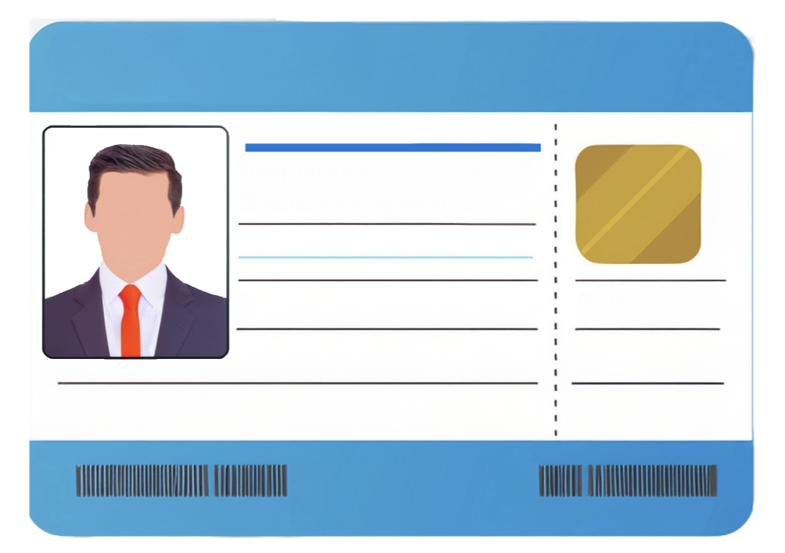

Lost or Damaged License
If your license is lost or destroyed, report it to the Florida Highway Safety and Motor Vehicles (FLHSMV). Apply for a duplicate license through GoRenew.com or a DMV office, as stipulated in Florida Statute § 322.17.

Legal Consequences = Real-World Barriers
Losing your license can impact more than just transportation. It can affect:
- Employment opportunities,
- Insurance rates,
- Family obligations,
- And even your sense of independence.
If you've experienced any of these, don’t just blame the law — ask yourself:
"What habit or mindset got me here — and how can I change it?"

License Expiration and Renewal
Florida licenses are valid for 4-6 years. Per Florida Statute § 322.18, driving with an expired license is illegal.

Renewal Options

1. Mail-In Renewal
- Available for U.S. citizens or immigrants for two consecutive license expirations.
- Renewal packet: Sent approximately 30 days before expiration.
- Fee: No additional charges.

2. Online Renewal
- Renew online at www.gorenew.com.
- Receive a renewal sticker (valid for 4–6 years) or a new digital license.

3. Telephone Renewal
- Call 1-866-467-3639 to renew.
- The new license or sticker will be mailed after processing.

Important
- Destroy old licenses after receiving new ones (Florida Statute § 322.212).
- Renew before expiration to avoid penalties.

Commitment Pledge
I pledge to treat my license as a reflection of my maturity and responsibility. I will obey traffic laws, keep my records clean, and recognize that following the law is not a burden — it’s a form of respect for others on the road.
✓ CLICK TO COMMIT

Classes of Licenses in Florida
Florida offers various driver’s license classifications depending on the type of vehicle operated and its purpose. Below is an organized breakdown of these license types and associated regulations:

1. Class E Operator’s License
- Purpose: For operating regular vehicles such as sedans, SUVs, and pickup trucks.
- Details:
  - Most common license type in Florida.
  - Required for all drivers operating personal motor vehicles on Florida roads.
For more details: FLHSMV Driver License Classes.

2. Motorcycle Endorsement
- Requirement: Mandatory for operating motorcycles, mopeds, or scooters.
  - Prohibition: Drivers under 16 cannot legally operate these vehicles, including bikes with electric helper motors (Florida Statute 316.003(2)).

To Obtain a Motorcycle Endorsement
- Hold a valid Class E driver’s license.
- Complete the Basic Rider Course through the Florida Rider Training Program.
- Pass written and on-cycle skills tests.
- Present the course completion certificate at the driver’s license office.
- Pay the endorsement fee.

Motorcycle-Only License
- Follows the same requirements as the motorcycle endorsement but excludes a four-wheel vehicle road test.
For more information: Motorcycle Rider License Information.

3. Commercial Driver Licenses (CDL)
Florida Statutes Section 322.53:
Required for operating large or specialized vehicles for commercial purposes. CDLs are categorized into three classes:
- Class A: For vehicles weighing more than 26,001 pounds towing loads exceeding 10,000 pounds.
- Class B: For vehicles weighing more than 26,001 pounds but not towing loads over 10,000 pounds.
- Class C: For vehicles transporting 16 or more passengers or carrying hazardous materials.
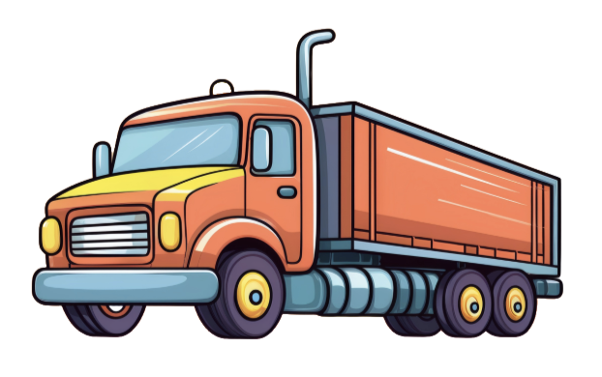

CDL Endorsements
Endorsements allow drivers to operate specialized commercial vehicles. Examples include:
- Hazardous Materials (H)
- Passenger (P)
- Tank Vehicle (N)
- Double/Triple Trailers (T)
- School Bus (S)
- Motorcycle (M)

CDL Safety Regulations
- Blood Alcohol Content (BAC) Limit: 0.04%
  - Violations (e.g., DUI, leaving an Crashscene) result in a 1-year disqualification for the first offense.
Penalty Chart for CDL Drivers
Offense | 2nd Conviction | 3rd or Subsequent Conviction
Speeding 15 mph over limit | 60 days | 120 days
Reckless driving | 60 days | 120 days
Improper lane changes | 60 days | 120 days
Following too closely | 60 days | 120 days
Fatal collision law violation | 60 days | 120 days
Driving without obtaining CDL | 60 days | 120 days
Source: Federal Motor Carrier Safety Administration, Section 383.51.

Key Considerations for All Licenses
- Maintaining Safety: Drivers must follow Florida’s road rules and obtain the appropriate license for their vehicle type.
- Penalties: Non-compliance can lead to license suspension, revocation, or fines.
- Continuous Education: License renewal and special endorsements often require additional courses or certifications to ensure up-to-date knowledge of road safety.

License Denial, Suspension, Revocation, and Reinstatement

License Denial
A driver's license in Florida can be denied for several reasons, including:
- Failing the vision, written, or driving tests.
- Unpaid fines or being a traffic offender.
- Failing to complete a driver's education course (for drivers under 18).
- Medical conditions that could impair driving ability.
- Inability to prove legal presence in the U.S.
For more details, see Florida Statutes Section 322.271.

License Revocation
License revocation is the termination of your driving privileges. You must apply for a new license after the revocation period ends. Common reasons for revocation include:
- DUI (Driving Under the Influence).
- Accumulating multiple driving offenses.
- Causing a serious collision.
- Minors caught possessing tobacco products.
Florida Statutes Section 322.26 outlines additional reasons for revocation.

Driving Without a License
- Florida Statute 322.03: Driving without a valid license can lead to fines, and a third or subsequent conviction carries a minimum jail sentence.

License Suspension
A suspension is a temporary loss of driving privileges. Reasons for suspension include:
- Theft or shoplifting.
- Providing false information on a license application.
- Allowing someone else to use your license.
- Court-ordered suspension.
- Refusing a DUI test (implied consent law).
- Misusing a restricted license.
- Accumulating points for traffic violations (see "Point System").
- Non-payment of child support or insurance lapses.
- Failing to stop for a school bus.
For a complete list, refer to Florida Statutes Section 322.27.

License Cancellation
Your license may be canceled if issued due to fraud or mistakes, such as falsifying information during the application process. Additionally, your license may be cancelled if you fail to complete the required school.

Driving During Suspension or Revocation
Driving while suspended or revoked leads to:
- Extending the suspension or revocation period.
- Additional fines and potential jail time.

License Reinstatement
After suspension or revocation, you may apply for a hardship license or have your license reinstated by:
- Completing a Driver Improvement or DUI course (if required).
- Paying reinstatement fees.
- Meeting any additional conditions set by the DMV.
A hardship license allows individuals with a suspended or revoked driver's license to drive under specific circumstances, typically for work, school, or medical needs.
Visit the Florida Highway Safety and Motor Vehicles (FLHSMV) website for more details.

Point System
Florida’s DMV point system assigns penalties for specific traffic violations, helping to identify risky drivers. Accumulating too many points can result in license suspension.

Point System Breakdown:
- Speeding 15 mph or less over the limit: 3 points.
- Speeding over 15 mph: 4 points.
- Reckless driving: 4 points.
- Leaving the scene of a crash: 6 points.
- Failing to stop for a school bus: 4 points.

Suspension Periods for Points Accumulation:
- 12 points in 12 months: 30-day suspension.
- 18 points in 18 months: 3-month suspension.
- 24 points in 36 months: 1-year suspension.
Good News: Drivers who meet requirements after a suspension may have 3 points deducted from their record.
For details, refer to Florida Statutes Section 322.27.

Mandatory Restrictions for Minors
For drivers under 18:
- Accumulating six or more points in 12 months limits driving to work-related activities for one year.
- Repeat offenses may lead to longer restrictions.
Additionally, restrictions include:
- First year: Driving limited to 6 a.m. to 11 p.m.
- Second year: Driving allowed 6 a.m. to midnight, unless accompanied by a licensed adult (21+) or driving to/from work.
Visit FLHSMV Teens for more information.

Suspension by a Judge
A judge may suspend your license for severe offenses, including:
- Hit and run.
- Reckless driving.
- Street racing.
- Unpaid fines.


Habitual Offender Revocation
Drivers may be labeled as habitual offenders and face license revocation for repeated violations, such as:
- Manslaughter.
- DUI offenses.
- Refusing a BAC test multiple times.
- Driving without a valid license.
Habitual offender guidelines are outlined in Florida Statutes Section 322.264.

Minors and "No Pass, No Drive"
Florida enforces a "No Pass, No Drive" rule for students under 18:
- Poor academic performance or excessive absences may result in license suspension.
- Regular school attendance is required to regain driving privileges.

Special Laws for Driving
- Zero tolerance for underage drinking: Drivers under 21 face license suspension for a BAC of 0.02 or higher.
- Implied consent law: Refusing a DUI test leads to automatic suspension.
- Open container law: Prohibits open alcohol containers in the vehicle, even for passengers.
For more legal information, visit the FLHSMV Website.
Learning an Effective System for Changing Troubling Driving Habits
As a student of this Advanced Driver Improvement course, your most important driver responsibility is to reflect and create a system to change problematic driving behavior. To change your driving habits, it’s essential to understand the emotions, attitudes, and personality traits that influence your decisions on the road. Your thoughts, feelings, and underlying personality traits can significantly affect how you approach driving situations. By becoming more aware of these influences, you can learn to take control of your actions and shift your driving behavior in a positive direction.
Here’s a structured approach to changing your driving habits based on emotional and psychological awareness:
1. Understanding the Influence of Emotions on Driving Habits
Emotions and Their Impact on Driving
Road Rage: Emotional stress, frustration, or anger can cause aggressive driving behaviors, such as speeding, tailgating, or reckless lane changes.
Impatience: When you're running late or under pressure, impatience can lead to speeding, running lights, or ignoring signs.
Fear: Anxiety or fear of driving in certain situations (e.g., heavy traffic, night driving, or unfamiliar roads) can lead to hesitation, erratic driving, or avoiding safe driving practices like signaling.
Strategy to Manage Emotions on the Road
Recognize Triggers: Identify what triggers negative emotions while driving. Is it heavy traffic, rude drivers, or feeling late? Knowing your triggers helps you anticipate emotional responses.
Practice Breathing Techniques: Deep breathing exercises can help calm your nerves and reduce feelings of anger or frustration. Take deep breaths when you feel overwhelmed.
Pause and Reflect: If you feel emotions like anger or frustration building up, take a moment to reflect and choose a better response (e.g., slowing down or giving space instead of speeding up or cutting others off).
2. Attitudes Toward Driving and How They Affect Habits
Attitudes Toward Risk
Your attitude toward risk can shape your driving behavior:
Optimistic Attitude: If you believe that "nothing will happen to me," you may be more inclined to take risks, like speeding or texting while driving.
Defensive Attitude: A cautious, proactive mindset can help you anticipate potential hazards and avoid taking unnecessary risks.
Strategy to Shift Your Attitude
Adopt a Defensive Driving Mindset: Commit to driving as if you are always at risk of a crash. Be prepared to react to other drivers’ actions and road conditions. Don’t rely on other drivers to keep you and your passengers safe. Not every driver will be as aware or courteous as you, and it’s important to recognize that the behavior of other drivers is not always predictable. When you are driving, only proceed when you know it’s safe, and continuously scan for hazards.
Evaluate Risks Realistically: Instead of thinking "I’ll be fine," ask yourself if the risk you’re taking is truly worth it (e.g., speeding to save a few minutes). When you speed, you significantly increase both the likelihood and physical impact of a collision, on your vehicle and others surrounding. Realizing the consequences can shift your perspective.
3. Personality Traits and Their Role in Driving Behavior
How Personality Influences Driving
Certain personality traits, such as impulsiveness, aggressiveness, or perfectionism, can lead to driving habits that put you and others at risk:
Aggressive Drivers: People with a high need for dominance or control may exhibit aggressive driving, such as tailgating or cutting off others.
Perfectionist Drivers: Those with perfectionist tendencies might become overly cautious or rigid in their driving, causing hesitation or delays in decision-making.
Impulsive Drivers: Drivers who act without thinking may make quick, unsafe decisions like speeding or changing lanes without signaling.
Strategy to Adjust Driving Based on Personality
Self-Reflection: Reflect on how your personality may affect your driving. Are you quick to anger? Do you feel the need to be in control at all times? Understanding your tendencies will help you change your behavior.
Set Clear Driving Goals: Set goals to adjust behaviors that align with your personality. For instance, if you tend to speed, make a goal to stay within the speed limit for a week.
Practice Patience: If you're prone to impatience, work on staying calm during situations like traffic jams or long waits at lights. Developing patience improves your driving habits and helps you stay in control.

4. Creating a System for Self-Improvement
To effectively change your driving habits, develop a system that includes awareness, reflection, and action:
Step 1: Increase Awareness of Your Emotional and Psychological States
Pay attention to how you feel before and during your driving. Are you stressed, rushed, or calm?
Recognizing when emotions, attitudes, or personality traits are affecting your driving is the first step to making changes.

Step 2: Identify Specific Problem Behaviors
Are there patterns in your driving? Do you speed when you’re running late or tailgate when frustrated? Write down specific habits that need attention.

Step 3: Set Achievable Goals
Set clear, realistic goals based on your problem behaviors. For example, you might aim to reduce aggressive driving or avoid distractions.

Step 4: Implement Strategies
Use strategies like mindful driving (focus on the present moment), practice relaxation techniques when feeling stressed, and commit to defensive driving when you feel frustrated.

Step 5: Track Your Progress
Keep track of your driving behavior and how often you meet your goals. If you experience setbacks, don’t be discouraged—continue focusing on improvement.

5. Understanding the Importance of Self-Compassion
Changing ingrained habits takes time, and it’s important to be patient with yourself. Self-compassion helps you stay motivated even if you experience setbacks. Understand that mistakes are a part of the learning process and that driving behavior can improve with continuous effort.
Strategy for Self-Compassion:
When you make a mistake, acknowledge it without judgment, learn from it, and focus on what you can do better next time. Avoid harsh self-criticism—it can cause frustration and hinder progress.

Conclusion: Creating Lasting Change
By becoming more aware of your emotions, attitudes, and personality traits, you can identify how they influence your driving and take steps to modify these behaviors. The key is to stay patient and committed to the process. Developing positive driving habits will not only improve your safety on the road but also give you a sense of empowerment and control over your actions. With the right strategies in place, you can develop the desire and ability to change your driving habits for the better.

