Chapter 10: Freeway Driving, Legal Knowledge, & Common Courtesy

Freeway Driving
Driving on a freeway typically involves higher speeds and heavier traffic, which can increase the risks of collisions. Remaining alert, exercising good judgment, and maintaining proper timing are essential, especially at speeds over 50 mph. Follow these guidelines for safe freeway navigation:

Getting on the Freeway
- Be Prepared: Before entering the freeway, observe your surroundings, follow speed limits, and identify merging points.
- Merge Safely: Use acceleration lanes to match freeway speeds, ensuring a safe gap between your vehicle and others.
- Keep Distance: Maintain a 4-second gap from the vehicle in front to allow room for sudden stops or adjustments.
- No Acceleration Lane? Wait for a significant gap before entering traffic and smoothly reach freeway speeds. (FS 316.081)

Timed Entrance Signals
- How They Work: Some freeway on-ramps feature timed signals to regulate entry. These may apply to single or multiple lanes and sometimes exclude carpool lanes, which are marked with a diamond symbol.
- Merge Courteously: When merging, take turns with vehicles in adjacent lanes, even during off-peak hours when signals may not operate.
- Double Merger Lanes: Follow staggered signal timing to ensure a safe and orderly entry.

Scenario: Lane Merging on the Freeway
You are entering the freeway from an on-ramp. Previously, you may have merged without checking your blind spots or adjusting your speed to match the flow of traffic.
Desired Behavioral Change: Defensive driving and predictive awareness.
CARD – Click To See New Behavior
Accelerate to the appropriate speed in the acceleration lane and check your blind spots before merging. Use your turn signal to indicate your intentions and ensure that you are merging safely.
Consider this advice when you encounter these traffic scenarios:
Acceleration Lane: Marks the transition between the ramp and freeway. Adjust your speed to match the flow of traffic.
Lane Merge Signs: Indicate where lanes are merging and remind drivers to yield.
Why It’s Important: Merging unsafely can cause collisions, especially at high speeds on freeways. By being aware of your surroundings and yielding when necessary, you reduce the risk of collision.
While on the Freeway
Maintain safe, steady speeds and space cushions. Vehicles going at higher speeds use the leftmost lanes, slow moving vehicles or merging/exiting vehicles use the right lane.

Leaving the Freeway
- Plan Ahead: Know your exit and position yourself in the correct lane well in advance. Avoid sudden lane changes. (FS 316.089)
- Exit Safely: Use deceleration lanes to slow down without affecting rear traffic. Exit only at marked ramps, not across medians or unauthorized areas.
- Missed Exit? If you miss your exit, take the next one instead of making unsafe maneuvers.

Scenario: Handling Traffic Signals on Freeways
You approach an on-ramp or off-ramp on a freeway and must adjust your speed according to the traffic signals.
Desired Behavioral Change: Adaptation to freeway conditions and appropriate speed control.
CARD – Click To See New Behavior
On on-ramps, accelerate to match the freeway’s speed. On off-ramps, begin slowing down well before the exit, ensuring you can exit safely without disturbing the flow of traffic.
Related Traffic Control Devices:
Ramp Metering Signals: These signals control the flow of traffic entering the freeway and prevent congestion.
Speed Limit Signs: Indicate safe speeds for both entry and exit lanes.
Why It’s Important: Not adjusting your speed properly on ramps can result in collisions, especially when merging onto or exiting freeways.

Sharp Curves on Exit Ramps
Be cautious on curved ramps, as exiting too quickly can cause a loss of control. Reduce speed appropriately and maintain focus to safely navigate these areas.
By following these best practices and adhering to traffic laws, you can minimize risks and ensure smoother, safer freeway driving.

Carpool Lanes
Carpool lanes, marked with a diamond symbol and "CARPOOL LANE" or “HOV” on the pavement, are designated for vehicles with at least two (sometimes three) occupants. This encourages drivers and passengers to ride together, decreasing carbon emissions. Rules for carpool lanes in Florida:
- Observe signage for applicable days and hours.
- Enter and exit only at designated locations where the solid lines break.
- Do not cross the double parallel solid lines.
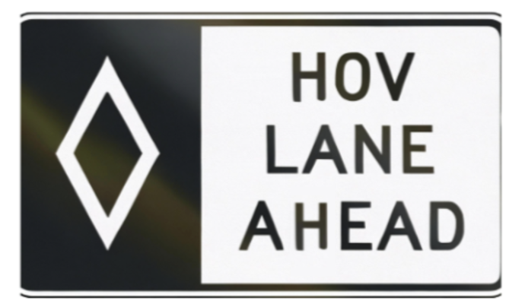

Interacting with Law Enforcement During a Traffic Stop
Traffic stops are high-stress moments. This section shows how applying emotional awareness and respect for procedure can prevent escalation and protect everyone involved. Being pulled over by law enforcement can be stressful, but understanding your rights and responsibilities can help the interaction proceed smoothly and safely. Below are guidelines and legal considerations to follow during a traffic stop in Florida.

What to Do When Pulled Over
- Pull Over Safely:
  - As soon as you see flashing lights or hear a siren, signal, and pull over to the nearest safe location.
  - Stop your vehicle as far to the right as possible and turn off your engine.
- Stay Calm and Visible:
  - Keep your hands on the steering wheel where the officer can see them.
  - At night, turn on your interior lights to improve visibility for the officer.
- Wait for Instructions:
  - Do not reach for your license, registration, or other documents until the officer requests them. Sudden movements could be misinterpreted as a threat.
- Follow Instructions Respectfully:
  - Comply with the officer's requests promptly and remain courteous.
  - If you need to reach for a document, inform the officer beforehand.
Have you ever gotten angry during a stop — and did it help or hurt your outcome?



Interacting with Law Enforcement: Calm is Your Power
Being pulled over is stressful — especially if you’re anxious, embarrassed, or frustrated. But your mindset in that moment can either de-escalate or inflame the situation.
Ask yourself:
- Do I tense up and act defensive?
- Do I let fear or anger speak for me?
- Am I focusing on blame — or staying calm and responsible?
The truth is: You can’t control why you’re being stopped — but you can always control how you respond. That attitude could be the difference between a warning and a citation, or between a smooth interaction and a lasting consequence.

Rights During a Traffic Stop
- Right to Remain Silent:
  - You have the right to remain silent. Politely inform the officer if you choose to exercise this right.
- Right to Refuse a Search:
  - Officers cannot search your vehicle without your consent unless they have probable cause, a search warrant, or specific circumstances like seeing contraband in plain view (Fourth Amendment).
- Right to Record the Interaction:
  - You have the right to record the traffic stop, provided you do not interfere with the officer's duties. Ensure your recording device is visible and not obstructing your movements.
- Right to Know the Reason for the Stop:
  - You can politely ask why you were pulled over. The officer is required to provide a reason, such as a traffic violation or a vehicle issue.

Scenario: “Why Am I Being Pulled Over?”
Situation:
Marcus is driving home from work, tired and irritable. He’s going 5 mph over the limit and changes lanes without signaling. Suddenly, he sees flashing lights in his mirror. His heart races. He mutters under his breath and slams his hand on the wheel. As the officer approaches, Marcus is visibly angry, refuses to make eye contact, and starts arguing before the officer says a word.
The officer notes Marcus’s attitude, asks him to step out, and ends up writing two citations — one for the moving violation and one for failure to obey instructions. Marcus leaves the stop more upset than before.

Reflective Questions:
- What part of Marcus’s emotional response made the situation worse?
- How did his tone, body language, and words escalate what could have been a minor stop?
- What could Marcus have done differently?

Emotional + Legal Insight:
Traffic stops often trigger strong emotions — fear, embarrassment, or anger — especially if a driver already feels targeted or stressed. But law enforcement is trained to look for signs of threat or resistance. When a driver responds with hostility or defensiveness, it can shift the entire tone of the stop.
By staying calm, polite, and cooperative, Marcus could have reduced tension, possibly avoided the second citation, and shown maturity — a quality law enforcement often responds to positively.

Commitment Pledge:
I pledge to manage my emotions during any traffic stop. I will stay calm, speak respectfully, and follow lawful instructions. I understand that my attitude can affect the outcome just as much as my driving behavior. My safety — and my driving record — depend on how I choose to respond.
✓ CLICK TO COMMIT

What You Are Required to Do
- Provide Identification:
  - Under Florida Statute 322.15, you must provide your driver’s license, vehicle registration, and proof of insurance upon request.
- Sign a Citation:
  - Signing a citation is not an admission of guilt but an acknowledgment that you received it. Refusing to sign may result in additional penalties.

Legal Protections and Limitations
- Consent and Searches:
  - If an officer requests to search your vehicle and you do not wish to consent, clearly state, "I do not consent to a search."
- Probable Cause:
  - Law enforcement may search your vehicle without your consent if they have probable cause, such as the smell of illegal substances or visible contraband.
- Refusal to Take a DUI Test:
  - Under Florida’s Implied Consent Law (FS 316.1932), refusing a blood, breath, or urine test when suspected of DUI will result in automatic license suspension (one year for the first refusal and 18 months for subsequent refusals).

Disputing a Traffic Violation
If you believe you were wrongfully cited:
- Stay Polite: Arguing at the scene will not void the citation.
- Document the Interaction: Record details like the officer's name, badge number, and the location of the stop.
- Challenge the Citation in Court: You have the right to contest the citation before a judge. Bring evidence such as photos, dashcam footage, or witness testimony.

What to Do If You Feel Unsafe
If you feel unsafe pulling over in a particular area:
- Signal and Slow Down: Activate your hazard lights and reduce your speed to indicate you acknowledge the officer.
- Drive to a Well-Lit Area: Proceed to the nearest well-lit, populated area before stopping.
- Call 911 to Confirm: If unsure whether the vehicle is an actual law enforcement officer, call 911 to verify their identity.

Complaints About Officer Misconduct
If you feel the officer acted inappropriately, follow these steps:
- Do Not Argue During the Stop: Stay calm and document the details of the interaction.
- File a Complaint: Contact the law enforcement agency involved and provide detailed information about the incident.
By understanding your rights and responsibilities during a traffic stop, you can navigate the situation calmly while protecting yourself and ensuring compliance with Florida laws.

Knowing the Rules of the Road
Driving is a multifaceted skill requiring knowledge and practice. Staying updated on traffic laws and taking traffic safety courses can help ensure compliance with existing and new laws. These rules are designed to promote safety and order on the road.

Communication on the Road
Effective communication with other drivers is essential for safe driving. Ways to communicate include:
- Turn signals: Indicate turns and lane changes.
- Horn: Use only to warn of danger.
- Body language: Use hand gestures or facial expressions when needed to clarify intentions.
Friendly and polite communication can prevent misunderstandings and create a safer road environment.

Yielding and Right of Way
Florida drivers must yield to:
- Pedestrians and bicyclists at crosswalks.
- Vehicles already in an intersection.
- Vehicles on the right at an all-way stop.
- Emergency vehicles and public transit buses.
Always prioritize safety. Whenever necessary, yield the right of way to protect the safety of all road users and avoid collisions.
Understanding and respecting right-of-way rules at T-intersections helps prevent crashes, reduce hesitation, and keep traffic flowing safely.
Under Florida Statutes 316, drivers are reminded that no one can "claim" or “have” the right of way. Safety should always take precedence over assertion.
When to Yield The Right of Way:
Even in a situation where another vehicle or road user would normally yield to your vehicle, yielding yourself is prudent in certain situations to avoid collisions. For example:
- Letting another vehicle go if it fails to stop at a stop sign.
- Yielding to a driver exhibiting erratic or unsafe behavior.
Key Tip: Always prioritize avoiding a crash over following typical right of way rules.
By following these guidelines and referring to Florida-specific statutes, drivers can navigate various road situations effectively while prioritizing safety.
Yielding at a T-Intersection in Florida
In Florida, when you approach a T-intersection, the vehicle on the road that ends must yield the right of way to all traffic on the through road. This applies even if there are no signs or signals posted.
That means if you're driving on the stem of the "T," you are required to wait for a safe gap before entering or crossing the through road—even if the other driver arrives at the same time.
However, it's also important to remember that right of way is something you yield, not take. If another driver hesitates or signals for you to proceed, use caution, eye contact, and clear judgment before moving forward. Defensive driving means being prepared for confusion, even when you’re following the rules.

Scenario: Yielding to Pedestrians at Crosswalks
You approach a crosswalk in a residential area and see a pedestrian waiting to cross the road.
Desired Behavioral Change: Respect for pedestrian safety and attentiveness.
CARD – Click To See New Behavior
Slow down as you approach the crosswalk, and be prepared to yield to pedestrians. Always stop completely and allow the pedestrian to cross safely.
Remember:
- Drivers making right turns must yield to pedestrians and bicyclists in the crosswalk they are turning into.
- Drivers making left turns must yield to oncoming traffic, including pedestrians and bicyclists crossing the road they are turning into.
Think of this behavioral change when you encounter a:
Pedestrian Crossing Sign: Indicates that drivers must yield to pedestrians.
Crosswalk: Demarcates areas where pedestrians are expected to cross. You must come to a stop before the white lines of the crosswalk.
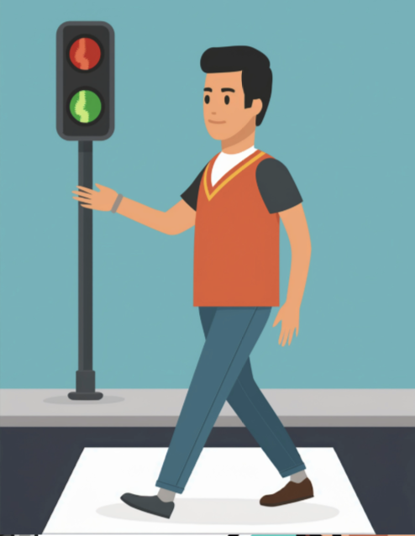
Unsafe or Reckless Pedestrian: Just like some drivers, pedestrians don’t always cross follow traffic rules. If a pedestrian decides to cross or enter the road at a place that is not designated for crossing, it is still your responsibility as a driver to ensure their safety by immediately slowing down, stopping, and allowing them to exit the road safely.
Why It’s Important: Not yielding to pedestrians can result in collisions and fines (Fla. Stat. § 316.130). By remaining alert and yielding, you protect vulnerable road users.

Courteous Driving
Your driving attitude significantly impacts road safety. Courteous driving involves more than just following laws—it’s about fostering positive interactions with others.
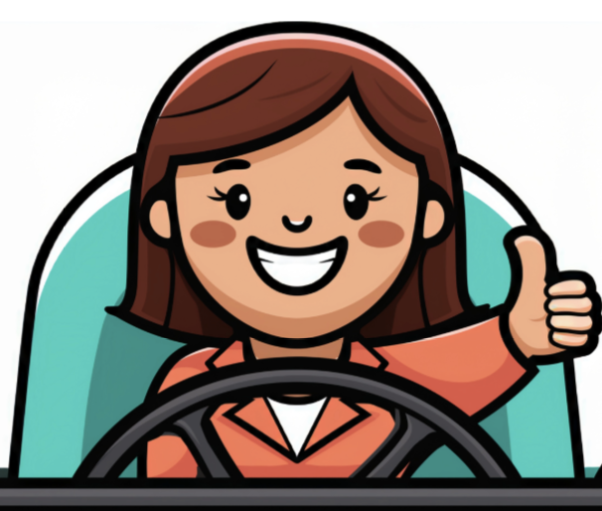
Best practices for courteous driving:
- Allow others to merge to maintain traffic flow.
- Give ample space to other vehicles.
- Drive slower in areas with high pedestrian or bicycle traffic.
- Make friendly eye contact and smile when appropriate.
- Signal intentions clearly to avoid confusion.
- Be patient and acknowledge kindness with a smile or wave.
- Use your horn judiciously, only to avoid collisions.
If other drivers act discourteously, remember to remain calm and give them space.
Identifying the Driving Habits That Have Caused Problems
Now that you have finished most of the material for this course, you should be able to recognize the driving habits or behaviors that cause problems for drivers, and understand which of these you need to correct in your own driving behavior. Unsafe driving habits can lead to a variety of serious issues, from accumulating points on your driving record to causing collisions and even criminal charges. In Florida, certain habits are more likely to result in penalties or legal trouble. Below is a refresher of common driving behaviors that often lead to problems for Florida drivers, possibly including you, such as violations, fines, and other consequences.
1. Speeding
What It Is: Exceeding the speed limit or driving too fast for road conditions.
Why It's a Problem: Speeding increases the likelihood of collisions, reduces your ability to react to sudden changes in traffic or road conditions, and can lead to hefty fines and points on your driving record (Fla. Stat. § 318).
Consequences: Accumulating points for speeding violations can lead to license suspension. Repeated speeding offenses can classify you as a habitual traffic offender (Fla. Stat. § 322.264), resulting in a license revocation.

2. Distracted Driving
What It Is: Using a cell phone, adjusting in-car entertainment or navigation systems, or engaging in other activities that take your attention away from the road.
Why It's a Problem: Distracted driving is one of the leading causes of collisions in Florida. It reduces your reaction time and increases the risk of collisions, particularly when driving in heavy traffic or bad weather conditions.
Consequences: Florida law prohibits texting while driving (Fla. Stat. § 316.305). Violating this law can result in fines and points on your driving record. Distracted driving collisions can also lead to serious personal injury or property damage.

3. Driving Under the Influence (DUI)
What It Is: Operating a vehicle with a blood alcohol concentration (BAC) over 0.08% or while impaired by drugs (Fla. Stat. § 316.193).
Why It's a Problem: DUI is one of the most severe offenses in Florida. It impairs your judgment, reaction times, and decision-making, leading to an increased risk of collisions.
Consequences: A DUI conviction can result in license suspension, fines, mandatory alcohol education classes, and jail time. A DUI also remains on your record, which can lead to higher insurance rates and possible employment consequences.

4. Failure to Yield or Stop
Disobeying traffic signals—such as failing to yield the right of way, running red lights, or ignoring stop signs—is a dangerous and illegal driving behavior that puts everyone on the road at risk. These violations are a leading cause of intersection crashes, often resulting in serious injuries or fatalities.
Failure to Yield can happen when drivers don't allow others their legal turn, whether it's at a yield sign, during a left turn, or when merging into traffic. This often leads to side-impact or pedestrian collisions.
Running Red Lights is one of the most common—and deadly—traffic offenses. According to national data, thousands of lives are lost each year because drivers ignore red signals.
Rolling Through or Ignoring Stop Signs may seem minor, but full stops are required by law. Failing to stop properly can lead to collisions with cross traffic, pedestrians, or cyclists.
These actions are not only unsafe—they can result in hefty fines, points on your license, higher insurance rates, and in some cases, criminal charges. Responsible drivers must always obey all traffic control devices, approach intersections with caution, and prioritize safety over speed.
What It Is: Not yielding the right of way at intersections or failing to stop at stop signs or red lights.
Why It's a Problem: Running a stop sign or light, or failing to yield the right of way, is a common cause of intersection collisions. It can cause serious injuries and damages to others.
Consequences: Violating Florida’s right-of-way laws (Fla. Stat. § 316.123) can result in traffic tickets, points, and increased insurance rates. In some cases, it can also lead to more severe penalties if collisions are involved.

5. Tailgating (Following Too Closely)
Following too closely, also known as tailgating, is a dangerous and aggressive driving behavior that significantly increases the risk of rear-end collisions. When you don’t leave enough space between your vehicle and the one in front of you, there’s little time to react if traffic suddenly slows or stops.
Florida law requires drivers to maintain a safe following distance based on speed, road conditions, and traffic flow. A good rule of thumb is the "three-second rule": pick a fixed object ahead, and make sure at least three seconds pass between when the car in front of you passes it and when you do. In bad weather or heavy traffic, increase that distance.
What It Is: Driving too closely behind another vehicle, not allowing enough space to stop in an emergency.
Why It's a Problem: Tailgating reduces your reaction time and increases the risk of a rear-end collision. It also is known to evoke unwanted emotional responses from other drivers. This is especially dangerous in heavy traffic or bad weather conditions.
Consequences: Tailgating can result in citations and points on your driving record. In the case of a collision, you could be held liable for damages or injuries.

6. Driving Without Insurance
What It Is: Operating a vehicle without the required minimum insurance coverage (Fla. Stat. § 324.022).
Why It's a Problem: Florida law requires all drivers to carry minimum auto insurance. Driving without it puts you at risk of financial and legal penalties, especially if you are involved in a crash.
Consequences: Driving without insurance can lead to license suspension, fines, and being required to purchase high-risk insurance at a much higher rate.

7. Reckless Driving
What It Is: Operating a vehicle with willful disregard for the safety of others, such as weaving in and out of traffic or excessive speeding.
Why It's a Problem: Reckless driving is a dangerous behavior that puts both the driver and others at risk. It is considered a criminal offense in Florida (Fla. Stat. § 316.192).
Consequences: Reckless driving can result in criminal charges, fines, points on your record, and potentially jail time for severe offenses. It also increases the likelihood of collisions.

8. Not Using Turn Signals
What It Is: Failing to signal when turning or changing lanes.
Why It's a Problem: Not using turn signals can confuse other drivers and lead to collisions. It’s a simple and effective way to communicate your intentions to other drivers and ensure road safety.
Consequences: Failing to signal is a violation of Florida traffic laws (Fla. Stat. § 316.155) and can lead to traffic tickets and points on your driving record.

9. Driving with Expired or Suspended Registration
What It Is: Operating a vehicle with an expired or suspended registration.
Why It's a Problem: Driving with an expired registration or suspended tags is illegal and could result in a traffic stop and penalties.
Consequences: If caught driving with expired or suspended registration, you may face fines, vehicle impoundment, or further license suspension.

10. Driving Without a Valid License
What It Is: Operating a vehicle without a valid driver’s license.
Why It's a Problem: Driving without a valid license is illegal in Florida and can lead to fines, criminal charges, and vehicle impoundment.
Consequences: If caught driving without a valid license, you may face increased fines, possible court appearances, and even jail time in some cases. If your license is expired or suspended, it’s essential to renew it or have the suspension lifted.

11. Driving While Drowsy
What It Is: Operating a vehicle when you are overly tired or fatigued.
Why It's a Problem: Fatigue impairs your reaction time, judgment, and decision-making ability, making it similar to driving under the influence of alcohol or drugs.
Consequences: Drowsy driving can lead to collisions, particularly on highways, and if caught, it could lead to fines or be used as evidence in a traffic collision lawsuit.

12. Driving in Unsafe Weather Conditions
What It Is: Driving too fast or without caution in adverse weather conditions, such as heavy rain, fog, or snow. If conditions make driving unsafe, you must avoid driving until the conditions have improved..
Why It's a Problem: Weather conditions in Florida, especially heavy rain, can reduce visibility and road traction. Drivers often underestimate the danger or fail to adjust their driving accordingly.
Consequences: Driving in unsafe weather conditions can result in collisions, fines, and points on your license. Failing to adjust speed appropriately can also lead to reckless driving charges.

13. Failure to Yield to Emergency Vehicles
What It Is: Not yielding the right of way when an emergency vehicle (ambulance, police car, fire truck, etc.) is approaching.
Why It's a Problem: Florida law requires drivers to yield the right of way to emergency vehicles with their lights and sirens on (Fla. Stat. § 316.126). Failing to do so can delay emergency response times and increase the risk of collisions.
Consequences: Failure to yield to emergency vehicles can result in fines, points, and possibly more severe penalties if it leads to an emergency vehicle being involved in a crash.
14. Improper Lane Changes
Improper lane changes occur when a driver changes lanes without signaling, doesn’t check blind spots, cuts off another vehicle, or weaves between lanes unpredictably. These behaviors are illegal and dangerous, especially at high speeds or in congested traffic.
Florida law requires drivers to:
- Use turn signals to indicate intent before changing lanes.
- Ensure the lane is clear and safe before moving over.
- Avoid lane changes within intersections or where prohibited by signs or road markings.
Improper lane changes can lead to side-swipe collisions, road rage incidents, and loss of vehicle control. They’re one of the top causes of highway crashes—and violations can result in citations, license points, and increased insurance premiums.
Always signal, check your mirrors and blind spots, and make smooth, legal lane changes to keep the road safe for everyone.
Conclusion
In Florida, several unsafe driving behaviors can create serious problems, including legal issues, collisions, financial strain, and even loss of driving privileges. These behaviors often lead to violations of Florida traffic laws, resulting in fines, points, suspension of your license, and higher insurance premiums. By recognizing these habits and understanding their consequences, you can make better choices behind the wheel and avoid further legal and financial problems.
If you want to learn more, Florida Department of Highway Safety and Motor Vehicles (DHSMV) provides resources on safe driving practices, Crash prevention, and defensive driving techniques. You can visit their website or refer to their publications for further information.

