SCRATCHCREST
Website Content Rewrite + Screenshot Mapping
A section-by-section content handoff based on the supplied homepage screenshot and reference sites.

How to Use This Document
Every section page pairs the exact corresponding crop from the current ScratchCrest homepage on the left with proposed replacement copy on the right. This lets you see immediately where each piece of content belongs.

Reference Sites
Lottery Display: https://lotterydisplay.com/
Texas Lottery: https://www.texaslottery.com/
The references were used for information architecture and topic coverage. The ScratchCrest copy is original.
Important: figures visible in the screenshot such as 30%, 1.2s and $135 should remain demo placeholders until ScratchCrest has verified evidence or approved case-study data.

01 — HERO / ABOVE THE FOLD
SCREENSHOT SECTION Screenshot section: “Sell up to 30% more scratch tickets.”
EXISTING WEBSITE  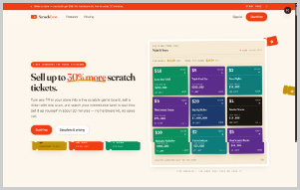 | REWRITTEN HEADLINE  Turn Your Scratch Ticket Wall Into a Smarter Sales Tool.  REWRITTEN COPY  ScratchCrest helps lottery retailers organize, promote, and monitor scratch ticket inventory from one clear digital workspace. Give customers better visibility, help staff make faster decisions, and keep your ticket wall working harder.  CTA BUTTONS  View the Live Board | See How It Works  CONTENT / DESIGN NOTE  Primary message: ScratchCrest is not just a screen. It is a smarter way to manage and present scratch ticket inventory.

02 — TRUST / VALUE STRIP
SCREENSHOT SECTION Screenshot section: short benefit labels directly below the hero.
EXISTING WEBSITE   | REWRITTEN HEADLINE  Built for Faster Decisions. Designed for Better Visibility.  REWRITTEN COPY  Live ticket information • Clear inventory visibility • Simple store management • Actionable sales insights  CONTENT / DESIGN NOTE  Keep this strip very short. It should communicate four benefits before the visitor starts scrolling.

03 — BUYER WALL / CORE PROBLEM
SCREENSHOT SECTION Screenshot section: “A busier wall is worth a number. Here’s the number.”
EXISTING WEBSITE   | REWRITTEN HEADLINE  A Busy Ticket Wall Should Give You More Than a Busy Counter.  REWRITTEN COPY  When dozens of scratch games compete for attention, it is easy to lose track of what is moving, what needs attention, and what customers are actually choosing. ScratchCrest turns that clutter into a clear, organized view so retailers can see the bigger picture at a glance.  CTA BUTTONS  See Your Inventory Clearly  CONTENT / DESIGN NOTE  This replaces the vague sales promise with a concrete retailer problem: visibility and decision-making.

04 — KEY METRICS / PROOF STRIP
SCREENSHOT SECTION Screenshot section: “30% / 1.2s / 100% / $0” metrics.
EXISTING WEBSITE   | REWRITTEN HEADLINE  The Numbers That Matter at the Counter.  REWRITTEN COPY  Use verified ScratchCrest metrics here once available. Recommended metric labels:  CTA BUTTONS  Sales lift | Average update time | Inventory visibility | Setup cost / starting cost  CONTENT / DESIGN NOTE  Do not publish the screenshot's numerical values until they are verified. This section works best as four compact proof points.

05 — SIX JOBS / FEATURE GRID
SCREENSHOT SECTION Screenshot section: “Six jobs your store does badly on paper.”
EXISTING WEBSITE  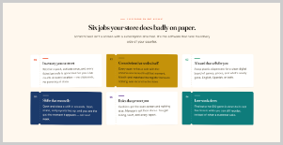 | REWRITTEN HEADLINE  Six Tasks ScratchCrest Makes Easier.  REWRITTEN COPY  1. Track what is available — Keep ticket information organized and easy to review.  2. See what is moving — Identify sales activity without digging through scattered records.  3. Keep displays current — Put relevant ticket information in front of customers.  4. Reduce manual work — Spend less time maintaining paper lists and manual updates.  5. Compare store activity — Understand performance across products or locations.  6. Act on better information — Turn everyday sales data into practical next steps.  CTA BUTTONS  Explore Features  CONTENT / DESIGN NOTE  This is the main feature section. Use six cards with short titles and one-sentence explanations.

06 — DISPLAY MODES / PRODUCT EXPERIENCE
SCREENSHOT SECTION Screenshot section: “Three display modes. One URL. Any TV in the store.”
EXISTING WEBSITE  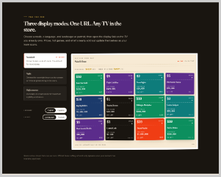 | REWRITTEN HEADLINE  One System. Multiple Displays. One Clear View.  REWRITTEN COPY  Run the ScratchCrest experience on the screens that fit your store. Highlight available tickets, surface important information, and give customers a cleaner way to browse what is on offer.  CTA BUTTONS  Explore Display Options | View a Sample Board  CONTENT / DESIGN NOTE  Avoid overpromising device compatibility unless technically confirmed. If the product supports any-TV/browser deployment, state that explicitly in final technical copy.

07 — SALE / SCAN FLOW
SCREENSHOT SECTION Screenshot section: “One scan. One second. Sale recorded.”
EXISTING WEBSITE  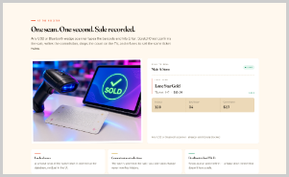 | REWRITTEN HEADLINE  From Ticket Selection to Sale Record — Without the Extra Steps.  REWRITTEN COPY  Keep the customer journey simple. Capture the relevant ticket activity, record the sale, and keep the information available for review. ScratchCrest is designed to make everyday tracking feel like part of the normal checkout flow.  CTA BUTTONS  See the Workflow  CONTENT / DESIGN NOTE  The screenshot strongly suggests a scan-to-record workflow. Keep the final wording aligned with the actual product implementation.

08 — LIVE ACTIVITY / TIMELINE
SCREENSHOT SECTION Screenshot section: “Live before the afternoon rush. Nothing gets missed on you.”
EXISTING WEBSITE  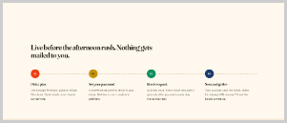 | REWRITTEN HEADLINE  Know What Is Happening Before the Rush Starts.  REWRITTEN COPY  ScratchCrest brings important ticket activity into one live view, helping your team stay aware of changes throughout the day. Check the board, spot what needs attention, and keep the store ready for the next customer.  CTA BUTTONS  See Live Activity  CONTENT / DESIGN NOTE  Use a 4-step timeline visually: Update → Review → Act → Record.

09 — COMPARISON / RETAILER CONTROL
SCREENSHOT SECTION Screenshot section: “They sell you a television. We run your counter.”
EXISTING WEBSITE  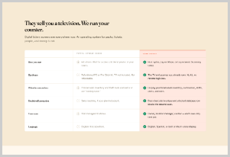 | REWRITTEN HEADLINE  More Than a Screen. A Smarter Retail Workflow.  REWRITTEN COPY  A display can show information. ScratchCrest is built to help you use it. Bring visibility, ticket activity, and store-level insights together so your team can spend less time checking and more time serving customers.  CONTENT / DESIGN NOTE  Recommended comparison rows: Display only / Live information / Sales tracking / Inventory visibility / Reporting / Store management.

10 — STORE PERFORMANCE / DASHBOARD
SCREENSHOT SECTION Screenshot section: dashboard showing sales, costs and a positive result.
EXISTING WEBSITE  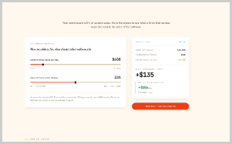 | REWRITTEN HEADLINE  Turn Daily Ticket Activity Into Useful Store Insight.  REWRITTEN COPY  See the information behind your scratch ticket sales in a format that is easy to understand. Review activity, identify patterns, and use real store data to make better inventory and merchandising decisions.  CTA BUTTONS  View a Sample Report  CONTENT / DESIGN NOTE  Use real dashboard screenshots here. Replace the '$135' and other sample figures with clearly labeled demo data or verified customer data.

11 — SOCIAL PROOF / RETAILER QUOTES
SCREENSHOT SECTION Screenshot section: “Retailers stopped guessing which games were actually selling.”
EXISTING WEBSITE  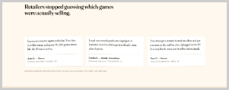 | REWRITTEN HEADLINE  Less Guesswork. More Visibility.  REWRITTEN COPY  Give retailers a place to share what changed after using ScratchCrest. Focus testimonials on measurable operational improvements such as easier tracking, faster decisions, clearer displays, and better visibility.  CTA BUTTONS  Read Retailer Stories  CONTENT / DESIGN NOTE  Use real testimonials with retailer name, store type, location, and date where permission is available. Do not invent testimonials.

12 — PRODUCT / USE-CASE GALLERY
SCREENSHOT SECTION Screenshot section: three visual cards/screenshots.
EXISTING WEBSITE   | REWRITTEN HEADLINE  See ScratchCrest in Action.  REWRITTEN COPY  Explore the different ways ScratchCrest can support the modern lottery counter — from customer-facing displays to store-level monitoring and performance views.  CTA BUTTONS  Explore the Platform  CONTENT / DESIGN NOTE  Use three visuals: Customer Display / Store Dashboard / Sales & Inventory View.

13 — FAQ
SCREENSHOT SECTION Screenshot section: “Straight answers before you pay.”
EXISTING WEBSITE  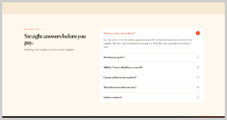 | REWRITTEN HEADLINE  Questions? Start Here.  REWRITTEN COPY  What is ScratchCrest?  ScratchCrest is a digital platform designed to help lottery retailers present, organize, and monitor scratch ticket activity.  How does ScratchCrest work?  It brings relevant ticket and store information into a clear digital experience for customers and staff.  Do I need special hardware?  Use the final answer only after confirming the supported hardware and setup requirements.  Can I manage more than one store?  If multi-store management is supported, explain how locations, users, and permissions are handled.  Can I see sales or inventory information?  If these features are part of the product, explain exactly which information is tracked and how reports are accessed.  How do I get started?  Start with a demo or setup consultation so the ScratchCrest team can understand your store and recommend the right configuration.  CTA BUTTONS  Get a Demo | Contact ScratchCrest  CONTENT / DESIGN NOTE  The FAQ should answer real buying questions. Replace conditional wording with verified product specifications before launch.

14 — FINAL CTA
SCREENSHOT SECTION Screenshot section: “Put a live board on the wall overnight.”
EXISTING WEBSITE  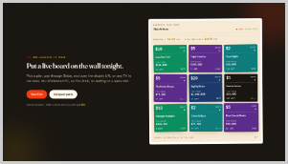 | REWRITTEN HEADLINE  Put a Smarter Scratch Ticket Experience on Your Wall.  REWRITTEN COPY  Give your customers a clearer view of what is available — and give your team better information to work with. Start with ScratchCrest and build a more organized, more visible lottery counter.  CTA BUTTONS  Book a Demo | See ScratchCrest in Action  CONTENT / DESIGN NOTE  Keep this CTA strong but factual. Avoid repeating the 30% claim unless it is supported by evidence.

15 — FOOTER
SCREENSHOT SECTION Screenshot section: dark footer with navigation.
EXISTING WEBSITE  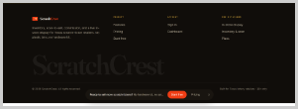 | REWRITTEN HEADLINE  ScratchCrest  Smarter visibility for scratch ticket retailers.  REWRITTEN COPY  Suggested footer navigation:  Product — Features — How It Works — Displays — Reporting — FAQ  Company — About — Contact — Support — Privacy — Terms  CTA: Book a Demo  CONTENT / DESIGN NOTE  Add the actual company address, email, phone number, legal links, social links, and support details once confirmed.

