Economic conditions and the changing scale and organisation of female sex work in Pakistan: a multi-period ecological study
1. Qazi Raza, MPH, Health Services Academy, NIH Complex, Park Road, Chak Shahzad, Islamabad, 44000, Pakistan [Corresponding Author]
- Email ID: qaziraza.rq@gmail.com
- ORCID: https://orcid.org/0000-0003-4303-3390
- SSRN Author ID: 12309708
2. Amna Khan, MPH, Health Services Academy, NIH Complex, Park Road, Chak Shahzad, Islamabad, 44000, Pakistan
- Email ID: amnaathar045@gmail.com
- ORCID: https://orcid.org/0009-0000-9152-3912
3. Maham Qazi, BS Public Health, Health Services Academy, NIH Complex, Park Road, Chak Shahzad, Islamabad, 44000, Pakistan
- Email ID: qazimaham.mq@gmail.com
- ORCID: https://orcid.org/0009-0002-1199-7240
Running title: Economic conditions and female sex work in Pakistan
Article type: Original research

Abstract

Objectives
To determine whether economic conditions were associated with the density, population size, growth, and organisation of mapped female sex work across Pakistan's complete published surveillance series.

Methods
We conducted a retrospective ecological study of 49 city-round observations from female sex work mapping and surveillance in 2006-07, 2011, 2014, and 2016-17. City outcomes were matched to district urban indicators and national economic conditions. The primary analysis correlated recent household economic deterioration with mapped density across 15 cities in 2011. Secondary analyses examined absolute population, work setting, common-city change, and 32 round-level economic-marker correlations using permutation or exact inference and false-discovery-rate adjustment.

Results
Recent deterioration was weakly inversely associated with density in 2011 (Spearman rho=-0.138; bootstrap 95% CI -0.597 to 0.372; permutation p=0.620), but positively associated with absolute mapped population (rho=0.657) and kothikhana share (rho=0.618). All-area deterioration and kothikhana share was the only association surviving adjustment across 54 cross-sectional tests (rho=0.771; q=0.041). During economic deterioration, the common ten-city mapped population increased 66.3%, while median home-based share rose 18.3 percentage points and street-based share fell 24.2 points. In continuous panels, annualised growth slowed from 9.65% to 5.30% in four cities and from 14.39% to 0.87% in six cities as conditions improved. None of 32 round-level macroeconomic correlations survived exact inference and multiplicity adjustment.

Conclusions
Pakistan's published series contains an economic signal, but density alone does not capture it. Deterioration coincided with rapid mapped-population growth and organisational change; improvement coincided with marked growth deceleration toward a plateau. The pattern is consistent with reduced net entry during recovery alongside barriers to exit, although individual transitions were not measured.

Key messages

What is already known on this topic
Economic need is a common reason for entering and continuing sex work, but Pakistani evidence has not previously linked repeated mapping estimates to contemporaneous economic conditions.

What this study adds
Across Pakistan's complete published surveillance series, worsening conditions coincided with faster mapped-population growth and organisational change, while improving conditions coincided with a pronounced slowdown toward a plateau; cross-sectional density was not the informative marker.

How this study might affect research, practice or policy
HIV programmes should monitor absolute population, growth, and work organisation alongside density and should adapt outreach when economic change shifts sex work into less visible or intermediary-linked settings.
Keywords: female sex workers; HIV surveillance; economic conditions; Pakistan; population size estimation

Introduction
Pakistan's HIV epidemic is expanding while diagnosis, treatment, and viral suppression remain limited. In 2024, an estimated 350,000 people were living with HIV and 48,000 acquired HIV, three times the estimated number of new infections in 2010. [1] National adult prevalence remains low, but surveillance shows a concentrated and geographically uneven epidemic; HIV prevalence among female sex workers was 2.2% in 2016-17, with substantially higher prevalence in some cities. [2] Pakistan's national strategy consequently treats key-population size estimates and city surveillance as essential for prevention planning. [3]
Female sex work in Pakistan includes street-, home-, brothel-, kothikhana-, and cellphone-mediated arrangements. [4] Population size, concentration, work setting, and client volume vary markedly between cities, and repeated surveillance has documented growth and organisational change. [5,6] Movement into homes or mediated networks can alter both economic exposure and the reach of HIV services.
Economic conditions may affect entry, continuation, demand, and work setting in different directions. In Lahore, 91% of surveyed participants cited financial need as a reason for entering sex work, 99% cited economic survival as a reason for continuing, and median duration in sex work was seven years. [7] During Zimbabwe's economic collapse, sexual-economic exchange became more private, informal, and commodity based, while loss of wages also reduced client demand; activity later increased with recovery. [8,9] Conversely, economic expansion in Zambian mining cities and stronger outside-employment incentives in Cambodia were associated with less transactional sex or sex work. [10,11]
These mechanisms imply that density, absolute population, organisation, and growth need not move together. Deterioration may increase economic pressure while reducing client spending; recovery may reduce new entry without rapidly reversing an accumulated population when exit is difficult. No previous study has combined Pakistan's complete published female sex work mapping series with matched local socioeconomic surveys and national economic indicators.
We examined whether economic conditions were associated with mapped female sex worker density, population size, growth, and organisation across Pakistani cities and surveillance rounds. The prespecified primary analysis tested whether recent household economic deterioration was positively associated with 2011 mapped density. Secondary analyses examined chronic deprivation, absolute population, work setting, network organisation, cross-round change, improved conditions, and national macroeconomic indicators.

Methods

Study design and data sources
We conducted a retrospective multi-period ecological study reported according to STROBE. [12] One observation represented one city in one surveillance round. The dataset contained 49 city-round observations: 12 in 2006-07, 15 in 2011, four in 2014, and 18 in 2016-17. Surveillance coverage and methods changed, so we analysed rounds separately and used common-city panels for longitudinal comparisons rather than pooling all observations.
Female sex work measures came from national surveillance Round II, Round IV, the 2014 Punjab survey, the 2015 mapping publication, and Round V. [2,13-16] The 2011 round was primary because it alone reported city-specific density per 1,000 adult men with broad coverage. Earlier rounds supplied population totals and work-setting counts; Round V supplied city totals but no comparable city density or typology table.
District socioeconomic indicators came from Pakistan Social and Living Standards Measurement Survey reports for 2006-07, 2010-11, and 2014-15. [17-19] The primary exposure was the urban percentage of households reporting that their economic situation was worse or much worse than one year earlier. Secondary 2011 measures were model-based urban poverty, female illiteracy, sanitation deprivation, and an equal-weight standardised chronic-deprivation index. [20] National GDP growth, inflation, per-capita income, and unemployment came from Pakistan Economic Surveys. [21-24]
Table 1. Surveillance rounds, available measures, and analytical use
Round | Cities | Available FSW measures | Economic pairing | Analytical use
2006-07 | 12 | Mapped total and typology | PSLM 2006-07; PES 2006-07 | Structural replication and common-city change
2011 | 15 | Mapped total, density, typology, and network structure | PSLM 2010-11; model-based poverty; PES 2010-11 | Primary cross-section and multi-marker analysis
2014 | 4 | Mapped total and typology in Punjab | PSLM 2014-15; PES 2014-15 | Regional structural replication and recovery comparison
2016-17 | 18 | Printed city totals only | PES 2016-17; local district exposure not forced | Context and common-city count comparison

Eligibility, matching, and outcomes
We included official or peer-reviewed sources with extractable city measures and a defensible geographic and temporal match. Cities entered an analysis only when both required variables were available. Missing values were not imputed, unavailable density or typology was not coded as zero, and adult-male denominators were not reconstructed for rounds without published density. Round V's 18 printed city estimates summed to 71,315 whereas its printed grand total was 64,829; we retained city rows for common-city comparisons but did not use the inconsistent grand total.
Cities were linked through an explicit geographic crosswalk to district urban strata and graded as close, composite, district proxy, or problematic. Sensitivity analyses restricted geographic quality and excluded megacities. Outcomes were mapped density, absolute mapped population, work-setting shares, and network measures. Cross-round analyses used identical-city panels and kept national indicators at their true round level.

Statistical analysis
The primary statistic was Spearman's correlation between 2011 urban household deterioration and mapped density. We calculated a two-sided 100,000-permutation p value and a 20,000-resample percentile bootstrap 95% confidence interval. Sensitivity analyses used Pearson correlation, alternative deprivation measures, leave-one-city-out estimates, geographic restrictions, log density, and ordinary least-squares models with HC3 robust standard errors. Linear, quadratic, and cubic models were compared by leave-one-city-out prediction error.
An exploratory atlas crossed six economic exposures with nine sex-work outcomes (54 correlations), with Benjamini-Hochberg adjustment. Separate analyses examined network structure, standardised two-exposure models, within-round typology associations, and city-level changes. Common-city panels compared combined totals and approximate annualised growth across deterioration and recovery. Thirty-two correlations paired four national indicators with eight round-level sex-work or survey markers; exact permutation inference and multiplicity adjustment preserved the true sample of three or four rounds.
Bias handling included within-round comparisons, explicit match grades, common-city panels, restricted samples, influence diagnostics, robust standard errors, permutation or exact inference, and multiplicity adjustment. Automated checks verified provenance, row uniqueness, expected city counts, positive totals, percentage ranges, typology reconciliation, and missingness. Analyses used Python, pandas, and NumPy; derived data and code are provided with the article.

Ethics
Only publicly available aggregate reports and de-identified secondary data were used. There was no participant recruitment, contact, intervention, or access to identifiable records; ethical approval and individual informed consent were not required.

Results

Primary and cross-sectional results
The 49 observations represented 12 cities and 49,037 mapped female sex workers in 2006-07; 15 cities and 89,178 in 2011; four Punjab cities and 44,160 in 2014; and 18 Round V city rows summing to 71,315. All 15 primary cities had complete density, mapped population, and socioeconomic exposures.
Recent deterioration was weakly inversely associated with 2011 density (rho=-0.138; bootstrap 95% CI -0.597 to 0.372; permutation p=0.620). Pearson correlation was -0.196. All leave-one-city-out estimates remained negative (-0.264 to -0.031), while geographic restrictions yielded small estimates in either direction. Robust linear, adjusted, and log-density models were weak and imprecise. Polynomial models did not improve out-of-sample prediction over a constant-only model.
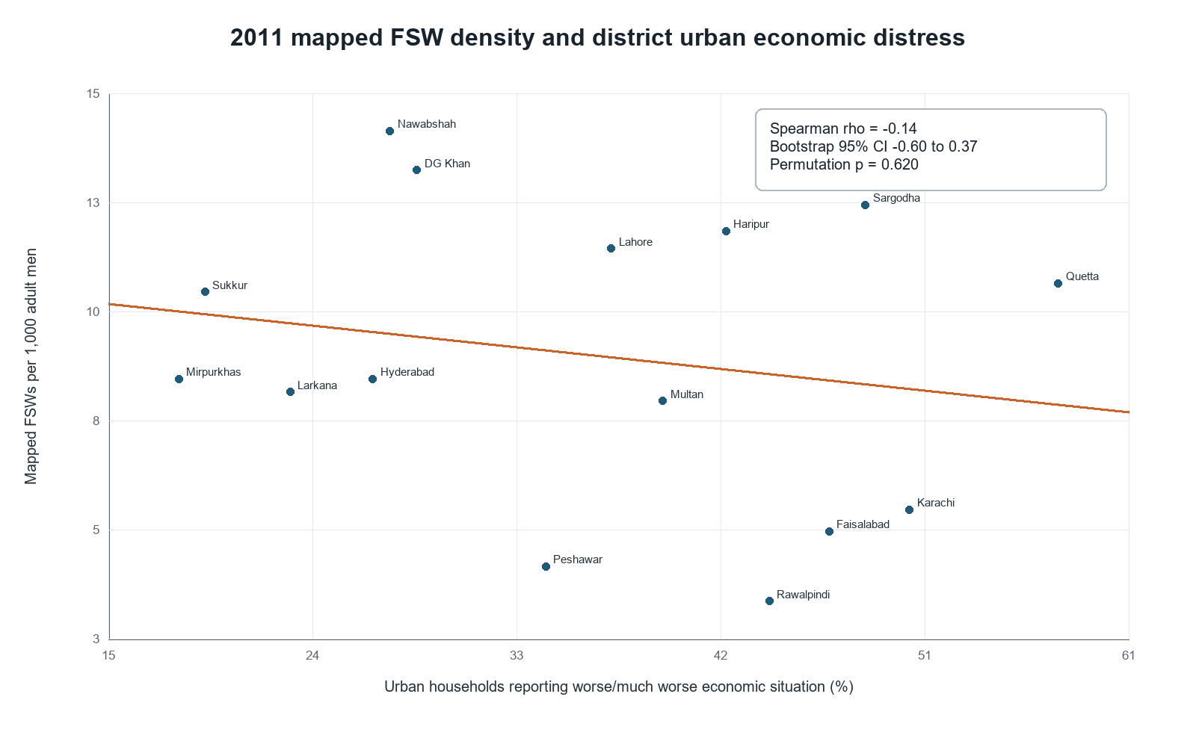
Figure 1. Recent urban economic deterioration and mapped female sex worker density across 15 Pakistani cities in 2011. The labelled scatterplot shows the weak inverse rank association and the broad dispersion of density at similar levels of deterioration.
Recent deterioration was positively associated with absolute mapped population (rho=0.657; raw p=0.0078; q=0.069) and kothikhana share (rho=0.618; raw p=0.014; q=0.069), and inversely associated with cellphone-based share (rho=-0.515; raw p=0.050; q=0.167). All-area deterioration and kothikhana share was the only association surviving correction across 54 tests (rho=0.771; q=0.041). Chronic deprivation showed the opposite scale pattern: it was inversely associated with mapped total (rho=-0.700; q=0.054) but weakly positively associated with density (rho=0.315). Network and two-exposure model estimates were directionally consistent but imprecise.

Deterioration, recovery, and organisation
Between 2006-07 and 2011, GDP growth fell from 7.0% to 2.4%, inflation rose from 7.9% to 14.0%, and median household deterioration increased 20.84 percentage points in ten common cities. Their combined mapped population increased from 47,062 to 78,241 (+66.25%; approximately 11.96% annually). Eight of ten cities increased. Median home-based share rose 18.32 percentage points, street-based share fell 24.16 points, and kothikhana share rose 6.99 points. City-level change correlations and within-round structural correlations were not stable, indicating a period pattern rather than a universal city ranking.
As national conditions improved, mapped totals did not immediately fall but growth slowed. Four common Punjab cities increased 16.77% from 2011 to 2014 (approximately 5.30% annually). Ten common cities increased only 3.36% through 2016-17 (0.60% annually); four increased, six decreased, and median city change was -1.94%. In strict continuous panels, annualised growth slowed from 9.65% to 5.30% in four cities and from 14.39% to 0.87% in six cities.
Table 2. Common-city mapped population and organisational change across economic periods
Comparison | Cities | Mapped total change | Annualised change | Median home change | Median street change | Sign-test p
2006-07 to 2011 | 10 | +66.25% | +11.96% | +18.32 pp | -24.16 pp | 0.109
2011 to 2014 | 4 | +16.77% | +5.30% | -26.10 pp | +17.11 pp | 0.125
2011 to 2016-17 | 10 | +3.36% | +0.60% | Not available | Not available | 0.754
Annualised changes use approximate intervals of 4.5, 3.0, and 5.5 years. pp, percentage points.
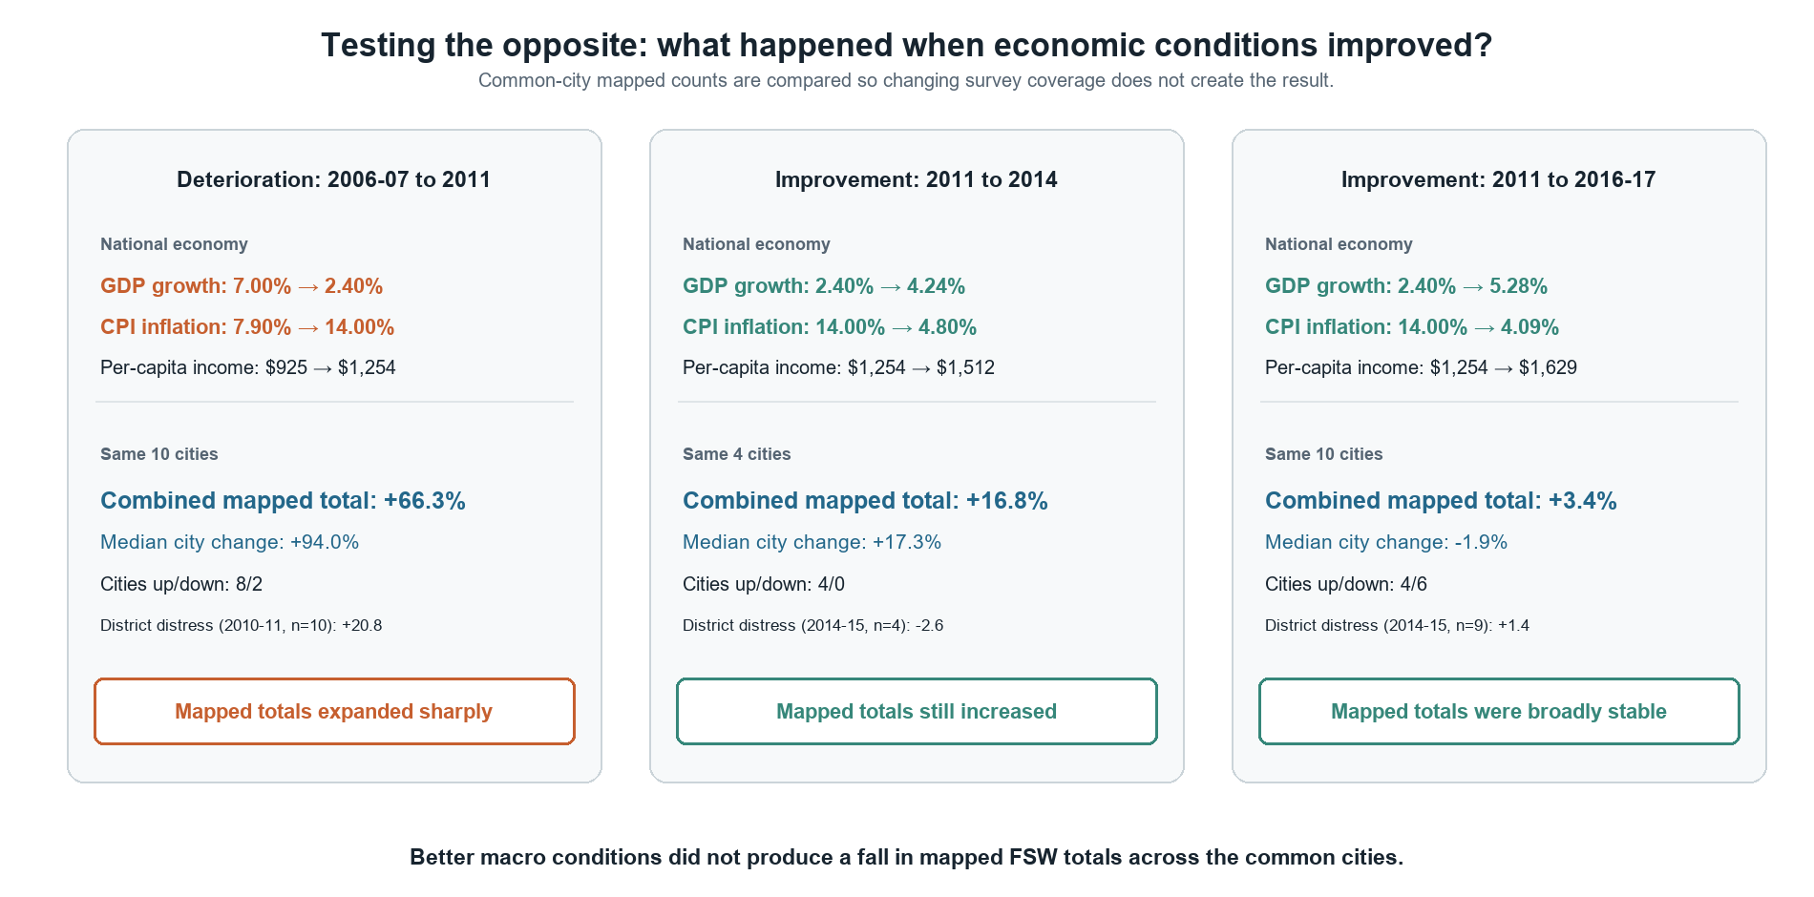
Figure 2. Common-city mapped population change during economic deterioration and recovery. The combined population expanded rapidly before 2011 and then grew more slowly, approaching a plateau through 2016-17.
Across the national round-level panel, GDP growth was inversely correlated with median city mapped count (rho=-0.600) and inflation was positively correlated (rho=0.400). None of 32 correlations was distinguishable with three or four rounds after exact inference and adjustment (minimum exact p=0.333; all q=1.000). These results provide directional context, not stable time-series estimates.

Discussion

Principal findings
Pakistan's complete published surveillance series contains an economic signal, but not the simple positive density relationship initially tested. Recent deterioration marked larger cities and larger mapped populations, while chronic deprivation marked smaller cities with somewhat higher density. The clearest longitudinal pattern was rapid mapped-population growth and organisational change during deterioration followed by pronounced growth deceleration toward a plateau during recovery.
Density is a ratio and cannot represent all dimensions of a changing market. It may remain stable when mapped population and the underlying city population grow together, while a smaller city can have high density but modest programme burden. The null density result, positive count and kothikhana associations, and common-panel growth contrast therefore answer different questions rather than contradicting one another.

Interpretation in relation to other evidence
The 66.3% common-city increase during deterioration is compatible with greater pressure on entry or return. Lahore evidence identifies financial need and survival as dominant reasons for entry and continuation. Economic shocks in Kenya and Malawi and historical recessions have likewise increased sexual-economic exchange or less formal sex-work supply. [25-27] These studies support a mechanism but do not establish why each additional person was mapped in Pakistan.
The Pakistani change was organisational as well as numerical: home-based work increased while street-based work declined. Zimbabwe provides the closest comparison, where economic collapse weakened some formal demand but dispersed exchange into private, informal, and commodity-based forms. Population estimates can also change with mapping reach and visibility, particularly for mobile or hidden work. [28] The observed Pakistani growth probably combines population dynamics with changes in organisation and ascertainment.
Recovery affected growth more clearly than the accumulated population. Longitudinal studies describe extended occupational duration, difficult exit, and re-entry after economic shocks. [29,30] Conversely, improved outside opportunities in Zambia and Cambodia reduced transactional sex or sex work. The Pakistani plateau is therefore consistent with lower net entry during recovery combined with barriers to exit, but entry and exit were not observed directly.
Demand can offset supply. During downturns, more women may need income while clients have less to spend; during recovery, entry pressure may ease while client demand returns. This helps explain unstable city rankings and why population, work setting, and density need not move in one direction.

Implications, strengths, and limitations
HIV programmes should monitor absolute mapped population, common-city growth, work setting, and network organisation alongside density. Movement from streets to homes or intermediary-linked settings may reduce contact with testing, condoms, pre-exposure prophylaxis, violence support, and treatment referral. Outreach should therefore be flexible across peer, phone, home, and network channels. Economic recovery should not be expected to reverse an accumulated population without credible voluntary livelihood, housing, and safety options.
This study used the complete published Pakistani surveillance series, retained each source's analytical grain, separated primary from exploratory inference, and tested sensitivity to geography, influential cities, functional form, and multiplicity. However, mapping estimates are programme estimates rather than censuses. Coverage, field intensity, definitions, mobility, network reach, and visibility changed between rounds. Surveillance cities were selected for programme priorities, city outcomes were paired with district measures, only 2011 reported comparable density, and the 2014 sample contained four Punjab cities. The primary interval was wide, only one of 54 cross-sectional associations survived adjustment, and none of 32 macro-marker correlations survived exact inference. Ecological associations cannot identify individual entry, exit, earnings, prices, or client demand.

Conclusion
Economic deterioration in Pakistan coincided with rapid growth and reorganisation of the mapped female sex worker population. Improved conditions coincided with sharp growth deceleration toward a plateau rather than immediate population decline. Density alone was not an informative economic marker; population growth, absolute programme burden, and organisation carried the clearer signal. Longitudinal surveillance should measure stable denominators, mapping intensity, entry and exit, earnings, client demand, mobility, and work setting so that the mechanisms underlying this relationship can be tested directly.

Declarations

Ethics approval and consent to participate
This study used only publicly available aggregate reports and de-identified secondary data, with no participant recruitment, contact, intervention, or access to identifiable records. Ethical approval and individual informed consent were not required.

Consent for publication
Not applicable.

Availability of data and materials
Derived analytical data, code, source manifests, statistical outputs, and validation reports are provided in the accompanying supplementary and reproducibility files and at https://github.com/QaziRaza/FSW. Underlying surveillance and socioeconomic reports remain available from their original publishers at the URLs in the source manifest.

Competing interests
The authors declare no competing interests.

Funding
This research received no specific grant from any funding agency in the public, commercial, or not-for-profit sectors.

Author contributions
QR conceived the study, developed the methodology, directed the analysis, interpreted the findings, and drafted the manuscript. AK contributed to data review, interpretation, and critical revision. MQ contributed to evidence synthesis, public-health interpretation, and critical revision. All authors read and approved the final manuscript.

Acknowledgements
None.

Generative artificial intelligence disclosure
OpenAI Codex was used to assist with reproducible code execution, evidence organisation, statistical verification, reference formatting, and language drafting. The authors reviewed and verified the analytical outputs, cited sources, interpretations, and final text and accept full responsibility for the submitted manuscript.

References
1. World Health Organization Regional Office for the Eastern Mediterranean. HIV infections rise in Pakistan; WHO and UNAIDS call to action [Internet]. Cairo: WHO EMRO; 2025 Dec 1 [cited 2026 Oct 3]. Available from: https://www.emro.who.int/pak/pakistan-news/hiv-infections-rise-in-pakistan-who-and-unaids-call-to-action.html
2. National AIDS Control Programme. Integrated Biological and Behavioral Surveillance in Pakistan: Round 5 [Internet]. Islamabad: National AIDS Control Programme; 2017 [cited 2026 Oct 3]. Available from: https://www.nacp.gov.pk/repository/howwework/pdf/IBBS%20Report%20Round%205.pdf
3. Government of Pakistan, Ministry of National Health Services, Regulations and Coordination. Pakistan AIDS Strategy IV 2021-2025 [Internet]. Islamabad: Government of Pakistan; 2021 [cited 2026 Oct 3]. Available from: https://extranet.who.int/cpcd/sites/default/files/public_file_repository/PAK_Pakistan_National-Strategic-Plan-HIV_2021-2025.pdf
4. Emmanuel F, Thompson LH, Athar U, Salim M, Sonia A, Akhtar N, et al. The organisation, operational dynamics and structure of female sex work in Pakistan. Sex Transm Infect. 2013;89 Suppl 2:ii29-33. doi:10.1136/sextrans-2013-051062.
5. Blanchard JF, Khan A, Bokhari A. Variations in the population size, distribution and client volume among female sex workers in seven cities of Pakistan. Sex Transm Infect. 2008;84 Suppl 2:ii24-27. doi:10.1136/sti.2008.033167.
6. Mishra S, Thompson LH, Sonia A, Khalid N, Emmanuel F, Blanchard JF. Sexual behaviour, structural vulnerabilities and HIV prevalence among female sex workers in Pakistan. Sex Transm Infect. 2013;89 Suppl 2:ii34-42. doi:10.1136/sextrans-2012-050776.
7. Khan MS, Unemo M, Zaman S, Lundborg CS. HIV, STI prevalence and risk behaviours among women selling sex in Lahore, Pakistan. BMC Infect Dis. 2011;11:119. doi:10.1186/1471-2334-11-119.
8. Elmes J, Skovdal M, Nhongo K, Ward H, Campbell C, Hallett TB, et al. A reconfiguration of the sex trade: how social and structural changes in eastern Zimbabwe left women involved in sex work and transactional sex more vulnerable. PLoS One. 2017;12(2):e0171916. doi:10.1371/journal.pone.0171916.
9. Steen R, Hontelez JAC, Mugurungi O, Mpofu A, Matthijsse SM, de Vlas SJ, et al. Economy, migrant labour and sex work: interplay of HIV epidemic drivers in Zimbabwe over three decades. AIDS. 2019;33(1):123-31. doi:10.1097/QAD.0000000000002066.
10. Wilson N. Economic booms and risky sexual behavior: evidence from Zambian copper mining cities. J Health Econ. 2012;31(6):797-812. doi:10.1016/j.jhealeco.2012.07.007.
11. Mahadeshwar R, Zhou A. Outside options and the supply of sex work [working paper on the Internet]. 2024 Nov 14 [cited 2026 Oct 3]. Available from: https://www.isid.ac.in/~acegd/acegd2024/papers/RuchiMahadeshwar.pdf
12. von Elm E, Altman DG, Egger M, Pocock SJ, Gotzsche PC, Vandenbroucke JP; STROBE Initiative. The Strengthening the Reporting of Observational Studies in Epidemiology statement: guidelines for reporting observational studies. Lancet. 2007;370(9596):1453-7. doi:10.1016/S0140-6736(07)61602-X.
13. National AIDS Control Programme. HIV second generation surveillance in Pakistan: national report round II [Internet]. Islamabad: National AIDS Control Programme; 2007 [cited 2026 Oct 3]. Available from: https://www.nacp.gov.pk/repository/howwework/pdf/SGS%20Round%202%20Report%202006-07.pdf
14. National AIDS Control Programme. HIV second generation surveillance in Pakistan: national report round IV [Internet]. Islamabad: National AIDS Control Programme; 2011 [cited 2026 Oct 3]. Available from: https://www.anf.gov.pk/library/report-round4-2011.pdf
15. Punjab AIDS Control Program. Integrated biological and behavioral surveillance in Punjab 2014 [Internet]. Lahore: Punjab AIDS Control Program; 2014 [cited 2026 Oct 3]. Available from: https://phkh.nhsrc.pk/sites/default/files/2021-01/IBBS%20Punjab%202014.pdf
16. National AIDS Control Programme. Mapping of key populations in Pakistan 2015 [Internet]. Islamabad: National AIDS Control Programme; 2015 [cited 2026 Oct 3]. Available from: https://medbox.org/document/mapping-of-key-populations-in-pakistan-2015
17. Pakistan Bureau of Statistics. Pakistan Social and Living Standards Measurement Survey 2006-07: district level report [Internet]. Islamabad: Pakistan Bureau of Statistics; 2008 [cited 2026 Oct 3]. Available from: https://www.pbs.gov.pk/sites/default/files/pslm/publications/pslm2006_07/pslm2006_07.pdf
18. Pakistan Bureau of Statistics. Pakistan Social and Living Standards Measurement Survey 2010-11: district level report [Internet]. Islamabad: Pakistan Bureau of Statistics; 2012 [cited 2026 Oct 3]. Available from: https://www.pbs.gov.pk/sites/default/files/pslm/publications/pslm2010_11/pslm2010_11.pdf
19. Pakistan Bureau of Statistics. Pakistan Social and Living Standards Measurement Survey 2014-15: national, provincial and district report [Internet]. Islamabad: Pakistan Bureau of Statistics; 2016 [cited 2026 Oct 3]. Available from: https://www.pbs.gov.pk/sites/default/files/pslm/publications/pslm2014_15/pslm_2014-15_national-provincial-district_report.pdf
20. Jamal H. Estimating sub-national poverty and inequality in Pakistan. Karachi: Social Policy and Development Centre; 2013. Research Report No. 85.
21. Government of Pakistan, Finance Division. Pakistan Economic Survey 2006-07: overview [Internet]. Islamabad: Ministry of Finance; 2007 [cited 2026 Oct 3]. Available from: https://www.finance.gov.pk/survey_0607.html
22. Government of Pakistan, Finance Division. Pakistan Economic Survey 2010-11: overview [Internet]. Islamabad: Ministry of Finance; 2011 [cited 2026 Oct 3]. Available from: https://www.finance.gov.pk/survey_1011.html
23. Government of Pakistan, Finance Division. Pakistan Economic Survey 2014-15: overview [Internet]. Islamabad: Ministry of Finance; 2015 [cited 2026 Oct 3]. Available from: https://www.finance.gov.pk/survey_1415.html
24. Government of Pakistan, Finance Division. Pakistan Economic Survey 2016-17: overview [Internet]. Islamabad: Ministry of Finance; 2017 [cited 2026 Oct 3]. Available from: https://www.finance.gov.pk/survey_1617.html
25. Robinson J, Yeh E. Transactional sex as a response to risk in western Kenya. Am Econ J Appl Econ. 2011;3(1):35-64. doi:10.1257/app.3.1.35.
26. Treibich C, Bell E, Lepine A, Blanc E. From a drought to HIV: an analysis of the effect of droughts on transactional sex and sexually transmitted infections in Malawi. SSM Popul Health. 2022;19:101221. doi:10.1016/j.ssmph.2022.101221.
27. Goehring G. Fallen women: recessions and the supply of sex work. J Public Econ. 2025;247:105405. doi:10.1016/j.jpubeco.2025.105405.
28. Fearon E, Chabata ST, Magutshwa S, et al. Estimating the population size of female sex workers in Zimbabwe: comparison of estimates obtained using different methods in twenty sites and development of a national-level estimate. J Acquir Immune Defic Syndr. 2020;85(1):30-8. doi:10.1097/QAI.0000000000002393.
29. Manopaiboon C, Bunnell RE, Kilmarx PH, Chaikummao S, Limpakarnjanarat K, Supawitkul S, et al. Leaving sex work: barriers, facilitating factors and consequences for female sex workers in northern Thailand. AIDS Care. 2003;15(1):39-52. doi:10.1080/012021000039743.
30. Ward H, Day S. What happens to women who sell sex? Report of a unique occupational cohort. Sex Transm Infect. 2006;82(5):413-7. doi:10.1136/sti.2006.020982.

