Six Stack – a Card Game

Problem definition

To implement a Card game which uses Stacks as its primary data structures. The game is to contain six stacks of six cards each, a turn pile and a discard pile (both of these will be Stacks). The idea is to remove cards of the top of the six stacks onto the discard pile so that the card you are moving has an ‘adjacent’ face value, irrespective of suite. This can be simply done by popping off the six stacks and pushing the popped card onto the discard pile.

Classes

Card class
Needs attributes to store the Value, suite, and colour. I also decided it would be a good idea to store code definitions for the suites, colours and named values (e.g. king). Methods needed would be the obvious gets and set for the attributes, but also some comparison methods for the values, suites and colours. Will implement Listable so it can be stored in a List.

Pack class
Contains a list of Cards and methods for creating standard or user defined decks, adding / removing cards and shuffling the deck (requires java.util.Random). I also supplied a method for dealing a card and using a pointer to show which card is next to deal. The shuffle() method chose random indexes from the List of cards , removed that Card and added it to the front of a new List (called shuffledList). As the removeAt(int theIindex) method replaces the removed card with the last card in the array, all the Cards were kept at the front of the array and all I had to do was decrement the uppermost value of the Random number generator. Once all the cards have been randomly moved into shuffledList, List allcards is made equal to shuffledList. This means that allCards now point to a shuffled List of Cards.

SixStack Class

This is the top level class which starts the game, sets up all the data structures needed and contains the algorithms to play the game and define the rules. It contains an array of six Stacks each with a capacity of six Objects. There is also another two stacks for the turnover pile and the discard pile. The main methods in this class are dealGame() and doUserMove(int stackNum). dealGame calls the dealCard() method from pack and, using a nested for-loop, put all the cards in the array of small stacks and the turnover pile. DoUserMove(int) takes in a value representing the stack that the user has chosen to play from. It then calls methods to test that the move is valid and, if the move is valid, pops from the appropriate stack pushing the card onto the discard pile.
I had only planed to use this class to keep the methods for playing and use separate user-interface classes to get user input and display the results on the screen. As it turned out, I ended up starting to implement a text based user-interface in this method as I was running out of time for coding the project.

The displayLayout() method was used for this text display. For the small selection stacks it printed a number at the start of the line, “XXX” for each hidden Card in the Stack and called the toString() method on the top Card (called by using peek() in stack). The Number at the start of the line is the number to type to select the respective Stack. Unfortunately I hadn’t got round to coding the methods for user-input but the output worked well.
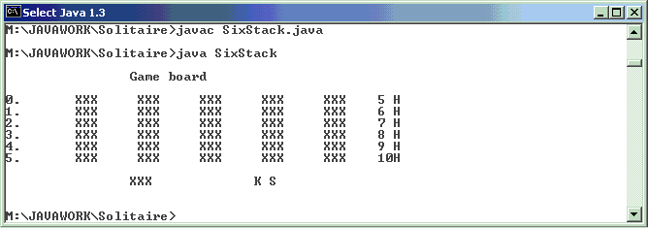

Testing.

Most of my testing was done while I was coding, especially with the SixStack class as writing a test harness would be the same as writing the code. As methods were coded and working, I activated them within “main” and “newGame” methods of class “SixStack”

Conclusion

Although I am happy with the Completeness of the first few classes I spent a long time creating them and not concentrating on the time constraints ahead of me. I am disappointed that I was unable to finish The interfaces so that the game was working. I felt that the challenge in this project was not implementing the Stacks (which is what the project was set out to do) but in making us think about the logic behind the game and how to implement it. Shuffling was a particularly complex puzzle and so was dealing the cards in the appropriate way. I also felt that planning for all eventualities in the game was a lot more complex than I originally thought.
If I was to do this again I would defiantly put a lot more planning and scheduling into it.

