**程序体系机构框图：**

客户信息管理系统

数据备份

删除客户

修改客户信息

添加客户

客户查询

系统管理员

**用例图：**

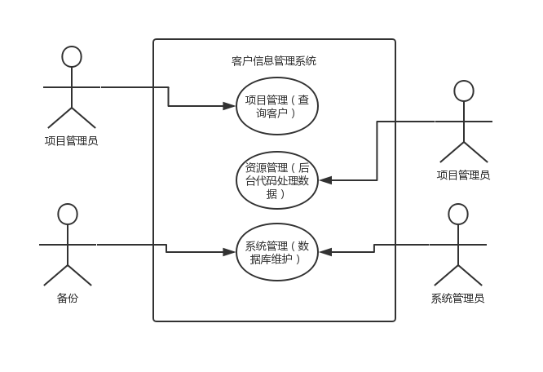**泳道图**：

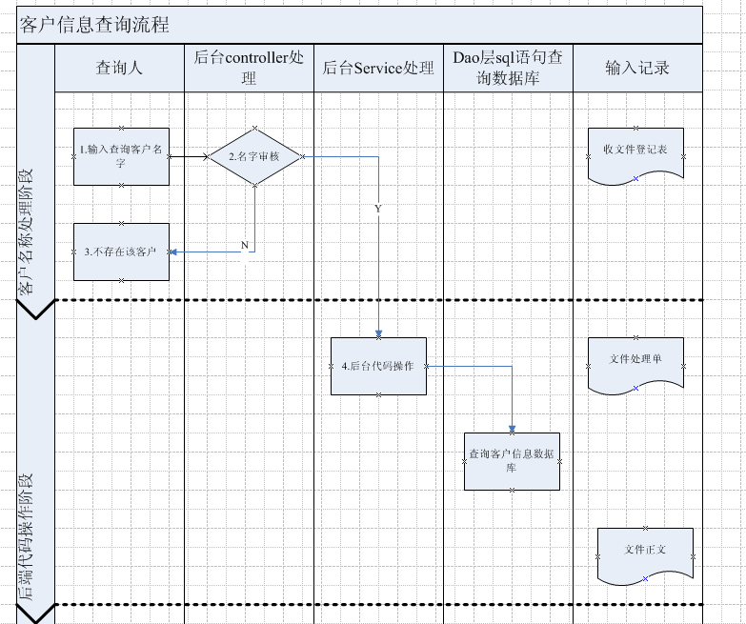

**时序图：**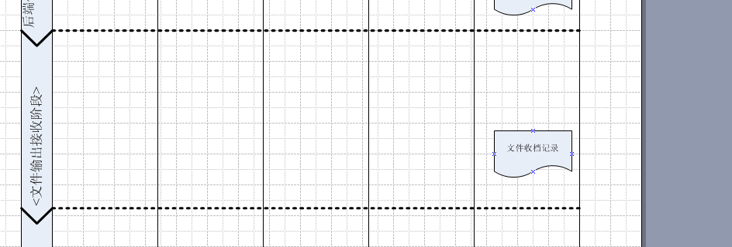  
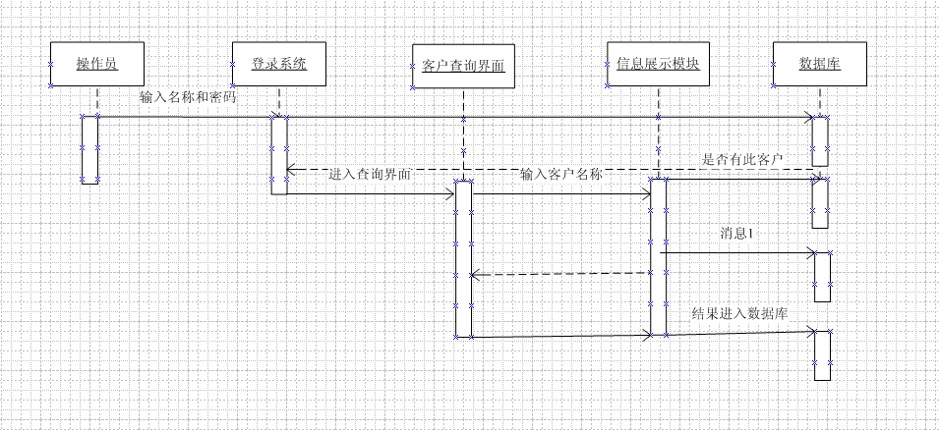

**类图：**

|  |
| --- |
| Client |
| +id int  +name varchar  +sex varchar  +phone varchar  +email varchar  +note varchar  -areaId varchar |
| Get()  Set()  Tostring() |

|  |
| --- |
| Area |
| +id int  +name varchar  +detailadress varchar |
| Get()  Set()  Tostring() |

**类图转换为代码：**

**public** **class** ClientEntity {

**private** Integer id;

**private** String name;

**private** String sex;

**private** String phone;

**private** String email;

**private** String note;

**private** Integer areaId;

**private** AreaEntity area;

**public** AreaEntity getArea() {

**return** area;

}

**public** **void** setArea(AreaEntity area) {

**this**.area = area;

}

**public** ClientEntity(Integer id, String name, String sex, String phone, String email, String note,

Integer areaId){

**super**();

**this**.id = id;

**this**.name = name;

**this**.sex = sex;

**this**.phone = phone;

**this**.email = email;

**this**.note = note;

**this**.areaId = areaId;

}

**public** ClientEntity() {

**super**();

}

**public** Integer getId() {

**return** id;

}

**public** **void** setId(Integer id) {

**this**.id = id;

}

**public** String getName() {

**return** name;

}

**public** **void** setName(String name) {

**this**.name = name;

}

**public** String getSex() {

**return** sex;

}

**public** **void** setSex(String sex) {

**this**.sex = sex;

}

**public** String getPhone() {

**return** phone;

}

**public** **void** setPhone(String phone) {

**this**.phone = phone;

}

**public** String getEmail() {

**return** email;

}

**public** **void** setEmail(String email) {

**this**.email = email;

}

**public** String getNote() {

**return** note;

}

**public** **void** setNote(String note) {

**this**.note = note;

}

**public** Integer getAreaId() {

**return** areaId;

}

**public** **void** setAreaId(Integer areaId) {

**this**.areaId = areaId;

}

@Override

**public** String toString() {

**return** "ClientEntity [id=" + id + ", name=" + name + ", sex=" + sex + ", phone=" + phone + ", email="

+ email + ", note=" + note + ", areaId=" + areaId + "]";

}

}

**public** **class** AreaEntity {

**private** Integer id;

**private** String name;

**private** String detailaddress;

**public** AreaEntity(Integer id, String name, String detailaddress) {

**super**();

**this**.id = id;

**this**.name = name;

**this**.detailaddress = detailaddress;

}

**public** AreaEntity() {

**super**();

}

**public** Integer getId() {

**return** id;

}

**public** **void** setId(Integer id) {

**this**.id = id;

}

**public** String getName() {

**return** name;

}

**public** **void** setName(String name) {

**this**.name = name;

}

**public** String getDetailaddress() {

**return** detailaddress;

}

**public** **void** setDetailaddress(String detailaddress) {

**this**.detailaddress = detailaddress;

}

@Override

**public** String toString() {

**return** "CompanyEntity [id=" + id + ", name=" + name + ", detailaddress=" + detailaddress + "]";

}

}