01 · LESSON
DNA, chromosomes and genes
9A Genetics and evolution · Lesson 4 of 7
Date ______________________ Class __________
Today I can 今天我能
☐ I can outline how the structure of DNA was discovered and say what each scientist did.
☐ I can describe how DNA, chromosomes, genes and genetic information are linked, and give the number of chromosomes in body cells and gametes.
What happens today
1 Do Now: the secret of life
2 Learn: Discovering the structure of DNA · Who did what · From cell to gene · and more
3 Core tasks
4 Challenge, then the exit ticket
Student Book pages 12 to 13 · Workbook pages 8 to 9
What I learned today (one or two sentences) 今天我学到了：

02 · KEY VOCABULARY
Key Vocabulary
Term | 中文 | Definition
DNA | DNA（脱氧核糖核酸） | the very long molecule that stores genetic information
double helix | 双螺旋 | the shape of a DNA molecule: two strands twisted into a spiral
chromosome | 染色体 | a structure in the nucleus made of one long DNA molecule
gene | 基因 | a section of DNA that carries the instructions for one characteristic
genetic information | 遗传信息 | the instructions for inherited characteristics
nucleus | 细胞核 | the part of a cell that contains the chromosomes
sex chromosomes | 性染色体 | the pair of chromosomes that decides sex: XX (female) or XY (male)
gamete | 配子 | a sex cell (sperm or egg) with 23 chromosomes
zygote | 受精卵 | the fertilised egg cell, with 46 chromosomes
X-ray | X射线 | a type of radiation used to make images, including of molecules
model | 模型 | a simpler representation of something that scientists test against evidence
Command words 指令词: Draw 画出 · Explain 解释 · Give 给出 · Give a reason 给出理由 · Match 连线（配对） · Number 编号（排序） · State 说明（写出） · Suggest 提出（建议） · Use 使用（运用）
03 · QUICK REVIEW
Quick Review
the secret of life
28 February 1953, Cambridge. Two men interrupt people eating lunch: 'We have discovered the secret of life!'
1 What do you think they had discovered?

2 Where in a cell is genetic information stored?

3 Guess: how many chromosomes are in one human body cell?

04 · CORE
Core 1 of 4
Everyone does these. Answer on the card or under it. 人人都做，答案写在卡片上或下面。
1 Match each scientist to one thing they did to help discover the structure of DNA. Draw a line.
Francis Crick |  | took very clear X-ray photos of DNA and said the first model was wrong
Rosalind Franklin |  | tested the model and made corrections to it over several years
James Watson |  | saw from a photo that DNA was a spiral and helped build the model
Maurice Wilkins |  | helped to build the double helix model in 1953

2 Answer each question by writing a number.
a) The number of DNA molecules in one chromosome.

b) The number of Y chromosomes in a body cell from a male.

05 · CORE
Core 2 of 4
Everyone does these. Answer on the card or under it. 人人都做，答案写在卡片上或下面。
2 continued
c) The number of copies of each gene in a body cell from a female.

d) The number of chromosomes in a human gamete.

e) The number of chromosomes in a zygote.

3 Number these items in order of size. Give the biggest a 1 and the smallest a 4.
____ cell ____ chromosome ____ gene ____ nucleus
06 · CORE
Core 3 of 4
Everyone does these. Answer on the card or under it. 人人都做，答案写在卡片上或下面。
4 The photo shows the chromosomes from one human body cell, sorted into pairs.
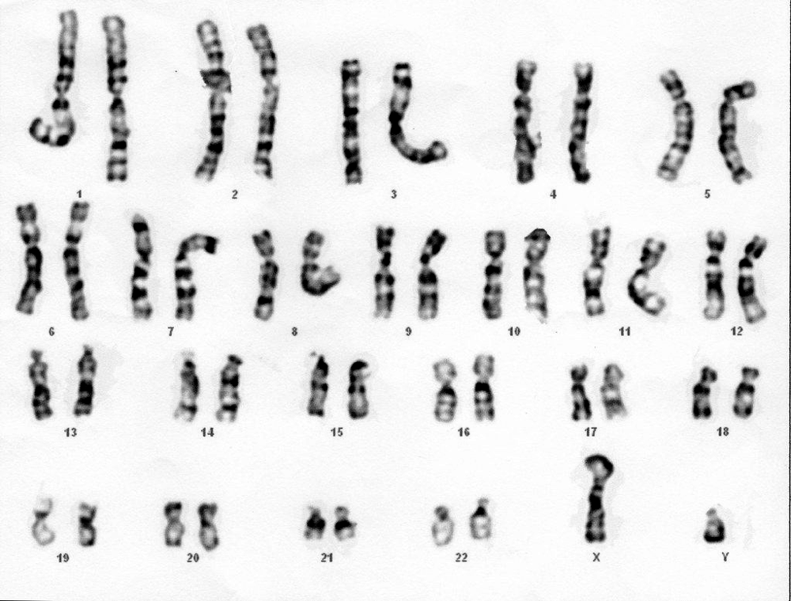
Image: Can H., CC BY 2.0, via Wikimedia Commons
a) State whether the cell is from a male or a female. Give a reason.

07 · CORE
Core 4 of 4
Everyone does these. Answer on the card or under it. 人人都做，答案写在卡片上或下面。
4 continued
b) How many pairs of chromosomes does the cell contain?

08 · CHALLENGE
Challenge 1 of 2
When Core is finished. Full sentences. 完成基础题后做；请写完整句子。
C1 Draw a labelled diagram to show how DNA, chromosomes, genes, genetic information and the nucleus are linked. Use arrows or nested shapes.
Draw here. 画在这里。

09 · CHALLENGE
Challenge 2 of 2
When Core is finished. Full sentences. 完成基础题后做；请写完整句子。
C2 Watson and Crick used data from other scientists to build their model.
a) Suggest how they were able to find other scientists' data in 1953.

b) Explain why scientists publish their work in journals such as Nature, and why it mattered that Franklin and Wilkins published in the same edition.

10 · EXIT TICKET
Exit Ticket
Hand this card in at the end of the lesson.
Name ______________________________
1 Where in a cell is DNA found?

2 How many chromosomes are there in a human body cell, and in a human gamete?

3 What is a gene?

Today I can: Goal 1 ☐ Goal 2 ☐

