01 · LESSON
Gas exchange in leaves
9B Plant growth · Lesson 3 of 7
Date ______________________ Class __________
Today I can 今天我能
☐ I can describe how stomata and guard cells control gas exchange in a leaf.
☐ I can explain how temperature and concentration difference affect diffusion, and why a plant loses more water on a hot day.
What happens today
1 Do Now: a leaf under the microscope
2 Learn: Stomata and guard cells · Diffusion · Gas exchange in a leaf · and more
3 Practical: Looking at stomata
4 Challenge, then the exit ticket
Student Book pages 25 · Workbook pages 18
What I learned today (one or two sentences) 今天我学到了：

02 · KEY VOCABULARY
Key Vocabulary
Term | 中文 | Definition
stomata | 气孔 | tiny holes in a leaf that let gases in and out (one is a stoma)
guard cell | 保卫细胞 | one of the pair of cells that opens and closes a stoma
diffusion | 扩散 | the overall movement of particles from where they are more concentrated to where they are less concentrated
concentration | 浓度 | how many particles of a substance there are in a certain space
gas exchange | 气体交换 | the swapping of gases between a leaf and the air
water vapour | 水蒸气 | water in the form of a gas
evaporation | 蒸发 | a liquid turning into a gas
wilt | 枯萎 | to droop because the cells have too little water
epidermis | 表皮 | the outer layer of cells of a leaf
Command words 指令词: Complete 完成（填写） · Draw 画出 · Estimate 估算 · Explain 解释 · Give 给出 · Give a reason 给出理由 · Label 标注 · Name 说出名称 · State 说明（写出） · Suggest 提出（建议） · Tick 打勾 · Use 使用（运用）
03 · QUICK REVIEW
Quick Review
a leaf under the microscope
1 What is this hole in the leaf surface called?

2 Name two gases that pass through it.

3 Predict when the hole is shut: day or night?

04 · CORE
Core 1 of 4
Everyone does these. Answer on the card or under it. 人人都做，答案写在卡片上或下面。
1 The diagram shows a stoma in the lower epidermis of a leaf at two different times of day.
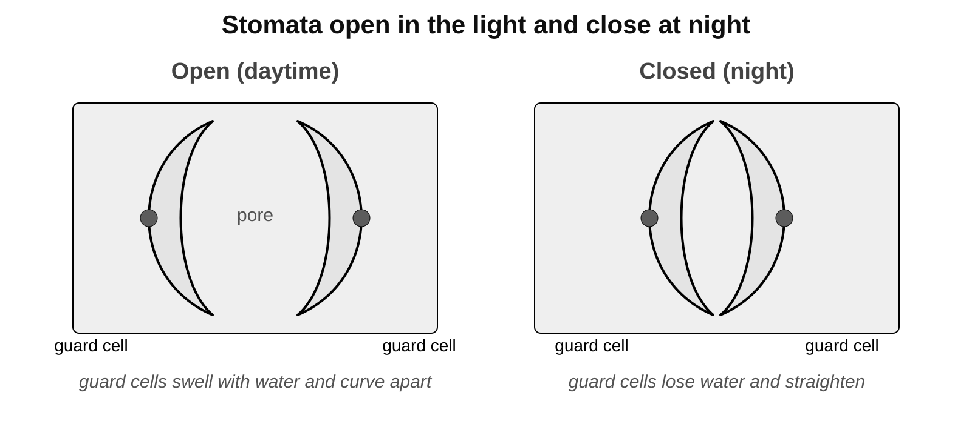
a) State the function of the guard cells.

05 · CORE
Core 2 of 4
Everyone does these. Answer on the card or under it. 人人都做，答案写在卡片上或下面。
1 continued
b) Name two gases that are exchanged between the leaf and the air through stomata.

c) Which diagram shows a stoma at night? Give a reason for your answer.

2 Complete the sentences. Use the word bank: concentration, fall, photosynthesis, rapidly, respiration, rise, slowly.
In bright light, __________ takes up carbon dioxide from the air inside the leaf.
This causes the __________ of carbon dioxide inside the leaf to __________.
So carbon dioxide diffuses more __________ into the leaf from the air.
06 · CORE
Core 3 of 4
Everyone does these. Answer on the card or under it. 人人都做，答案写在卡片上或下面。
3 Tick one box in each row to show whether the statement is true or false.
Statement about diffusion | True | False
Particles move from where they are less concentrated to where they are more concentrated.
Diffusion is faster at higher temperatures.
A bigger difference in concentration makes diffusion faster.
Once particles are evenly spread they stop moving.
Leaves are thin so gases do not have to diffuse far.

4 Practical: stomata on the lower surface of a leaf.
a) Draw one stoma with its two guard cells. Label the guard cells and the pore.
Draw here. 画在这里。

07 · CORE
Core 4 of 4
Everyone does these. Answer on the card or under it. 人人都做，答案写在卡片上或下面。
4 continued
b) Record the number of stomata you can see in the field of view.
Count 1 | Count 2 | Count 3 | Mean

08 · CHALLENGE
Challenge
When Core is finished. Full sentences. 完成基础题后做；请写完整句子。
C1 Most leaves have far more stomata on their lower surface than on their upper surface. Suggest two reasons why this helps the plant.

C2 A student counted a mean of 32 stomata in a field of view with an area of 0.5 mm². The lower surface of the leaf had an area of 40 cm² (4000 mm²). Estimate the number of stomata on the lower surface of the leaf. Show your working.

09 · EXIT TICKET
Exit Ticket
Hand this card in at the end of the lesson.
Name ______________________________
1 What is the job of the guard cells?

2 Name two gases that are exchanged between a leaf and the air through its stomata.

3 Explain why a leaf loses more water on a hot day than on a cool day.

Today I can: Goal 1 ☐ Goal 2 ☐

