9A Lesson 2  Inherited variation  Year 9 Science · 9A Genetics and evolution · Student Book pages 8 to 9  Name ________________ Class ______ Date ________  Today I can:  ☐ I can give examples of inherited variation and explain how sexual reproduction causes it.  ☐ I can sort inherited variation into continuous and discontinuous, and recognise a normal distribution. | Key words 关键词  Command words 指令词  Complete 完成（填写） · Describe 描述 · Explain 解释 · Give 给出 · Give a reason 给出理由 · Name 说出名称 · Suggest 提出（建议） · Tick 打勾 · Use 使用（运用）
  inherited variation | 遗传变异
  offspring | 后代
  genetic information | 遗传信息
  gene | 基因
  nucleus | 细胞核
  gamete | 配子
  fertilisation | 受精
  zygote | 受精卵
  continuous variation | 连续变异
  discontinuous variation | 不连续变异
  normal distribution | 正态分布

● Core Everyone does this section.
1. Complete the sentences using words from the box. Use each word once.
Word box: characteristics fertilisation fuse genetic inherited offspring parents zygote
The nucleus of a cell contains the __________ information that controls __________ characteristics.
When two gametes __________ (join together) during __________, they produce a __________ (fertilised egg cell).
The fertilised egg cell contains genetic information from both __________, so it has instructions for inherited
__________ from both parents. The __________ will have some characteristics of each parent.
2. Tick one box in each row to show what causes the variation: genes, the environment, or both.

Characteristic | Genes | Environment | Both
being able to speak more than one language
length of hair
human height
natural eye colour
blood group
a scar

3. Class survey. Record the class totals in the table.
a) Complete the table using the class results.

Characteristic | Group | Number of students
tongue rolling | can roll
 | cannot roll
ear lobes | attached
 | free (hanging)

b) Is tongue rolling continuous or discontinuous variation? Give a reason.

●● Stretch When Core is finished.
S1. The bar chart shows the blood groups of people in Saudi Arabia.
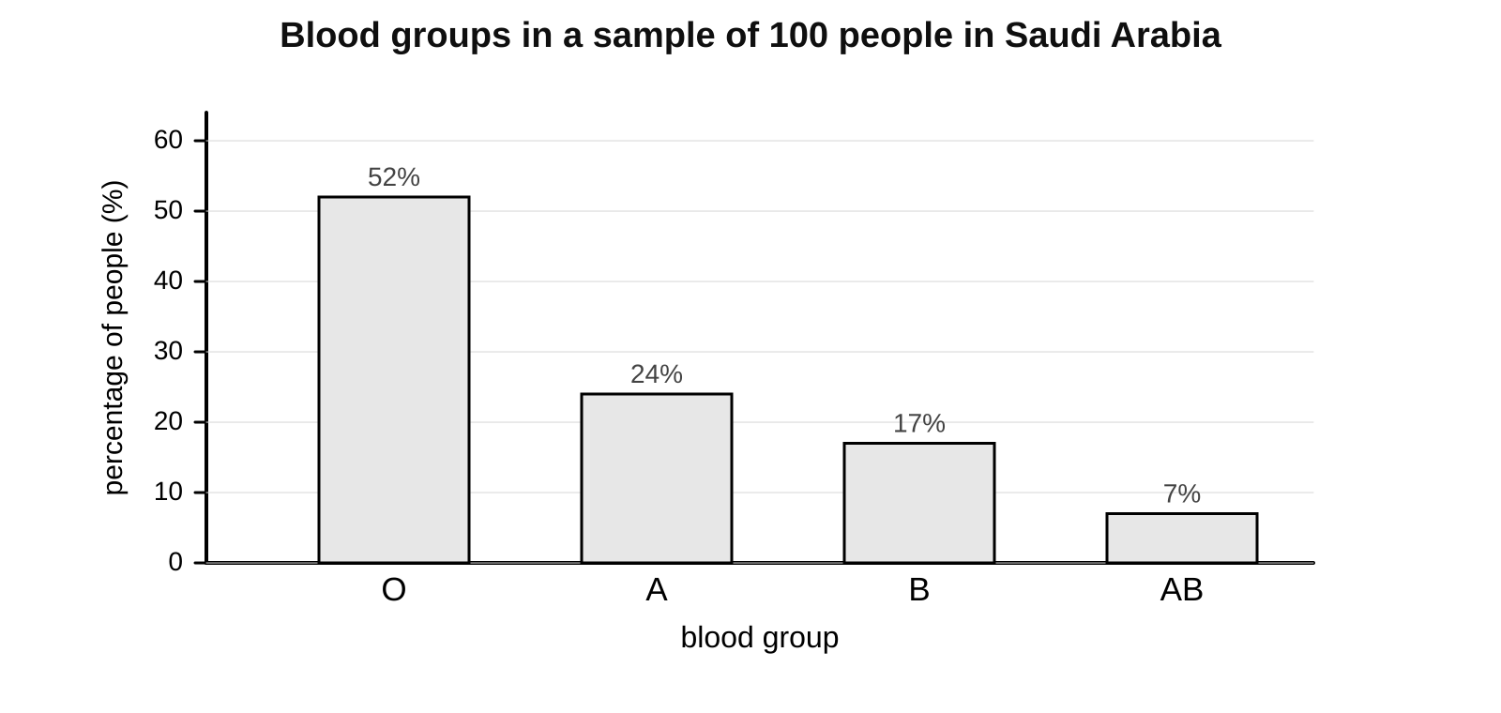
a) What percentage of people have blood group A?

b) In a group of 300 people from Saudi Arabia, how many would you expect to have blood group AB? Show your working.

c) Tick the boxes that describe this type of variation.
☐ continuous
☐ discontinuous
☐ environmental
☐ inherited
S2. Explain why foot length is an example of continuous variation but shoe size is discontinuous.

S3. Explain why brothers and sisters do not look exactly the same, even though they have the same parents.

●●● Challenge Explain in full sentences.
C1. Suggest a variation in tomatoes that is caused by both genetic information and environmental factors. Explain your reasoning.

C2. The chart shows the heights of 200 Year 9 students.
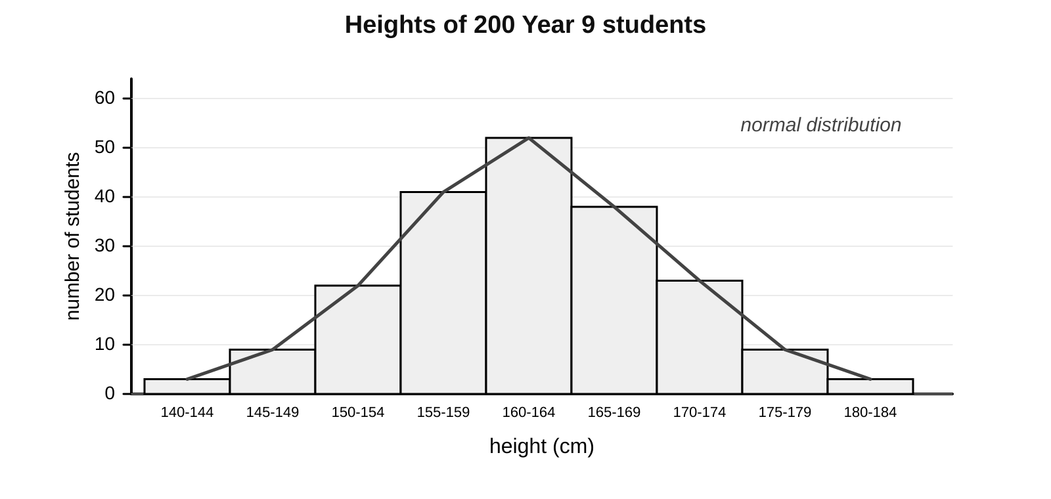
a) Describe the shape of the chart and name this type of distribution.

b) Explain why height gives this shape but blood group cannot.

c) Suggest one other characteristic that you would expect to show a normal distribution.

My thinking (any language 可用中文)
Identical twins have exactly the same genetic information. Suggest how two identical twins could still look a little different from each other.

Word bank inherited variation 遗传变异 · offspring 后代 · genetic information 遗传信息 · gene 基因 · nucleus 细胞核 · gamete 配子 · fertilisation 受精 · zygote 受精卵 · continuous variation 连续变异 · discontinuous variation 不连续变异
✂ - - - - - - - - - - - - - - - - - - - - - - - - - - - - - - - - - - - - - - - - - - - - - - - - - - - - - - - - - - - - - - - cut here
Exit ticket 9A Lesson 2: Inherited variation Name ____________________
1. Where in a cell is genetic information stored?

2. Name the cell formed when two gametes fuse.

3. Blood group: is it continuous or discontinuous, and inherited or environmental?

Today I can: Goal 1 ☐ Goal 2 ☐

