9A Lesson 4  DNA, chromosomes and genes  Year 9 Science · 9A Genetics and evolution · Student Book pages 12 to 13  Name ________________ Class ______ Date ________  Today I can:  ☐ I can outline how the structure of DNA was discovered and say what each scientist did.  ☐ I can describe how DNA, chromosomes, genes and genetic information are linked, and give the number of chromosomes in body cells and gametes. | Key words 关键词  Command words 指令词  Draw 画出 · Explain 解释 · Give 给出 · Give a reason 给出理由 · Match 连线（配对） · Number 编号（排序） · Plot 绘制（数据点） · State 说明（写出） · Suggest 提出（建议） · Use 使用（运用）
  DNA | DNA（脱氧核糖核酸）
  double helix | 双螺旋
  chromosome | 染色体
  gene | 基因
  genetic information | 遗传信息
  nucleus | 细胞核
  sex chromosomes | 性染色体
  gamete | 配子
  zygote | 受精卵
  X-ray | X射线
  model | 模型

● Core Everyone does this section.
1. Match each scientist to one thing they did to help discover the structure of DNA. Draw a line.
Francis Crick |  | took very clear X-ray photos of DNA and said the first model was wrong
Rosalind Franklin |  | tested the model and made corrections to it over several years
James Watson |  | saw from a photo that DNA was a spiral and helped build the model
Maurice Wilkins |  | helped to build the double helix model in 1953

2. Answer each question by writing a number.
a) The number of DNA molecules in one chromosome.

b) The number of Y chromosomes in a body cell from a male.

c) The number of copies of each gene in a body cell from a female.

d) The number of chromosomes in a human gamete.

e) The number of chromosomes in a zygote.

3. Number these items in order of size. Give the biggest a 1 and the smallest a 4.
____ cell ____ chromosome ____ gene ____ nucleus
4. The photo shows the chromosomes from one human body cell, sorted into pairs.
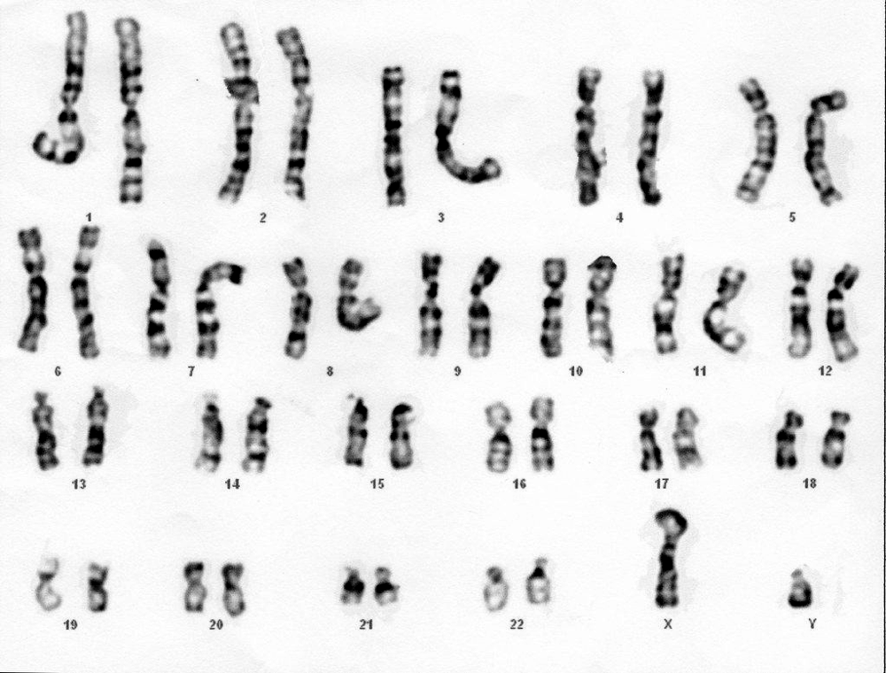
Image: Can H., CC BY 2.0, via Wikimedia Commons
a) State whether the cell is from a male or a female. Give a reason.

b) How many pairs of chromosomes does the cell contain?

●● Stretch When Core is finished.
S1. The table shows the number of chromosomes in the body cells of some animals.
a) Plot the data on the grid as a bar chart. Put the animals in a logical order and label both axes.

Animal | lion | elephant | chicken | rabbit | horse
Number of chromosomes | 38 | 56 | 78 | 44 | 64


b) Give the reason why the number of chromosomes in each species is an even number.

c) A student says: 'This data shows that birds have more chromosomes in their cells than mammals.' Explain whether this is a good conclusion.

S2. Explain why a body cell contains two copies of each gene, but a gamete contains only one copy.

●●● Challenge Explain in full sentences.
C1. Draw a labelled diagram to show how DNA, chromosomes, genes, genetic information and the nucleus are linked. Use arrows or nested shapes.

C2. Watson and Crick used data from other scientists to build their model.
a) Suggest how they were able to find other scientists' data in 1953.

b) Explain why scientists publish their work in journals such as Nature, and why it mattered that Franklin and Wilkins published in the same edition.

My thinking (any language 可用中文)
Franklin's X-ray photo was shown to Watson without her permission. Was that fair? What rules should scientists follow when sharing data today?

Word bank DNA DNA（脱氧核糖核酸） · double helix 双螺旋 · chromosome 染色体 · gene 基因 · genetic information 遗传信息 · nucleus 细胞核 · sex chromosomes 性染色体 · gamete 配子 · zygote 受精卵 · X-ray X射线
✂ - - - - - - - - - - - - - - - - - - - - - - - - - - - - - - - - - - - - - - - - - - - - - - - - - - - - - - - - - - - - - - - cut here
Exit ticket 9A Lesson 4: DNA, chromosomes and genes Name ____________________
1. Where in a cell is DNA found?

2. How many chromosomes are there in a human body cell, and in a human gamete?

3. What is a gene?

Today I can: Goal 1 ☐ Goal 2 ☐

