9B Lesson 1  Reactions in plants  Year 9 Science · 9B Plant growth · Student Book pages 21 to 23  Name ____________________ Class ______ Date ________  Today I can:  ☐ I can write the word and symbol equations for photosynthesis and aerobic respiration, and say where and when each happens in a plant.  ☐ I can explain how limiting factors slow photosynthesis and why roots need oxygen. | Key words  photosynthesis the process plants use to make glucose from carbon dioxide and water, using light  aerobic respiration the reaction in every living cell that releases energy from glucose using oxygen  chlorophyll the green substance that captures energy from light  chloroplast the part of a plant cell where photosynthesis happens  glucose the sugar made in photosynthesis  reactant a substance used up in a chemical reaction  product a substance made in a chemical reaction  limiting factor a variable that slows down the rate of photosynthesis  phloem tubes made of living cells that carry sugar solution around a plant  yield the amount of useful product a farmer gets from a crop

● Core Everyone does this section.
1. Complete the word equations. Use the word bank.
Photosynthesis: ____________ + water makes ____________ + oxygen
Aerobic respiration: glucose + ____________ makes carbon dioxide + ____________ (+ energy released)
2. Tick one box in each row to show whether the statement is about photosynthesis or aerobic respiration.

Statement | Photosynthesis | Respiration
happens only when there is light
happens all the time, day and night
takes in carbon dioxide
releases energy from glucose
happens in chloroplasts
happens in every living cell

3. Match each key word to its meaning. Draw a line.
chlorophyll |  | tubes of living cells that carry sugar solution around the plant
chloroplast |  | the sugar made in photosynthesis
limiting factor |  | the green substance that captures energy from light
phloem |  | a variable that slows down the rate of photosynthesis
glucose |  | the part of a plant cell where photosynthesis happens

4. Van Helmont grew a willow tree in a pot of dry soil for five years. He added only rainwater. The table shows his results.

 | At the start | After five years
mass of dry soil (kg) | 90.72 | 90.66
mass of tree (kg) | 2.27 | 76.74

a) Calculate the change in the mass of the soil.

b) Calculate the change in the mass of the tree.

c) Aristotle thought that roots sucked up soil for the plant to eat. Explain how these results show that Aristotle was wrong.

●● Stretch When Core is finished.
S1. The graph shows the concentrations of two gases dissolved in the water around pondweed over 18 hours.
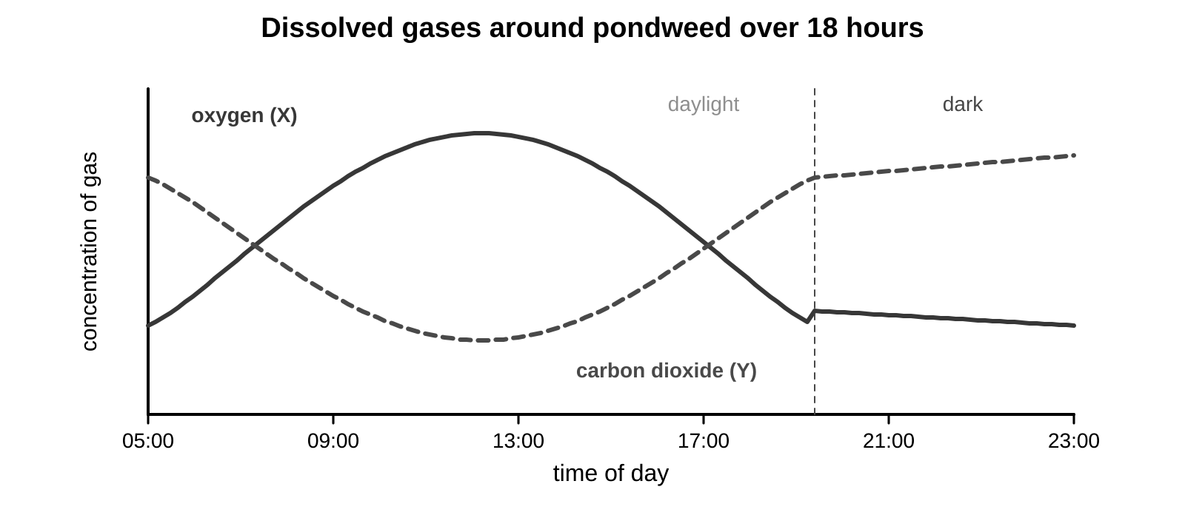
a) Which line shows oxygen, X or Y? Give a reason.

b) Explain why line X falls after it gets dark.

S2. A student counts the oxygen bubbles from pondweed. Explain how three different limiting factors could stop the number of bubbles increasing.

S3. Root cells cannot photosynthesise. Explain where root cells get the glucose and the oxygen they need, and why flooding a field can kill crops.

●●● Challenge Explain in full sentences.
C1. Draw a flow chart to show how energy from the Sun becomes stored in a plant. Use the words light, chlorophyll, chloroplast and glucose.

C2. After his experiment, van Helmont concluded that all the extra mass of the tree came from the water he added. Evaluate this conclusion. Use the word equation for photosynthesis in your answer.

My thinking (any language)
Plants give out oxygen. Do they also take in oxygen? If so, when, and why?

Word bank carbon dioxide · glucose · oxygen · water · photosynthesis · aerobic respiration · chlorophyll · chloroplast · limiting factor · phloem
✂ - - - - - - - - - - - - - - - - - - - - - - - - - - - - - - - - - - - - - - - - - - - - - - - - - - - - - - - - - - - - - - - cut here
Exit ticket 9B Lesson 1: Reactions in plants Name ____________________
1. Write the word equation for photosynthesis.

2. Where in a plant cell does photosynthesis happen?

3. Why do plants in a field only photosynthesise during the day?

Today I can: Goal 1 ☐ Goal 2 ☐

