9B Lesson 3  Gas exchange in leaves  Year 9 Science · 9B Plant growth · Student Book pages 25  Name ________________ Class ______ Date ________  Today I can:  ☐ I can describe how stomata and guard cells control gas exchange in a leaf.  ☐ I can explain how temperature and concentration difference affect diffusion, and why a plant loses more water on a hot day. | Key words 关键词  Command words 指令词  Choose 选择 · Complete 完成（填写） · Draw 画出 · Estimate 估算 · Explain 解释 · Give 给出 · Give a reason 给出理由 · Label 标注 · Name 说出名称 · State 说明（写出） · Suggest 提出（建议） · Tick 打勾 · Use 使用（运用）
  stomata | 气孔
  guard cell | 保卫细胞
  diffusion | 扩散
  concentration | 浓度
  gas exchange | 气体交换
  water vapour | 水蒸气
  evaporation | 蒸发
  wilt | 枯萎
  epidermis | 表皮

● Core Everyone does this section.
1. The diagram shows a stoma in the lower epidermis of a leaf at two different times of day.
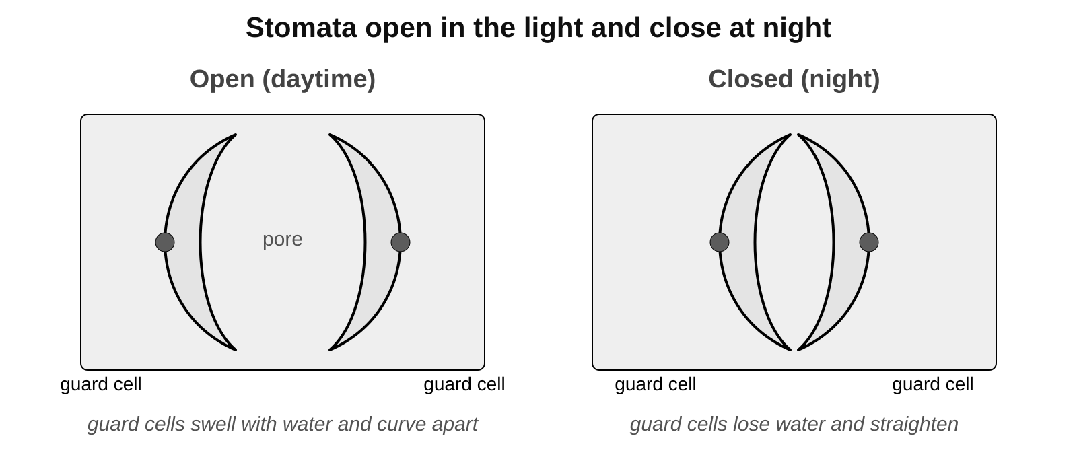
a) State the function of the guard cells.

b) Name two gases that are exchanged between the leaf and the air through stomata.

c) Which diagram shows a stoma at night? Give a reason for your answer.

2. Complete the sentences. Use the word bank: concentration, fall, photosynthesis, rapidly, respiration, rise, slowly.
In bright light, ____________ takes up carbon dioxide from the air inside the leaf.
This causes the ____________ of carbon dioxide inside the leaf to ____________.
So carbon dioxide diffuses more ____________ into the leaf from the air.
3. Tick one box in each row to show whether the statement is true or false.

Statement about diffusion | True | False
Particles move from where they are less concentrated to where they are more concentrated.
Diffusion is faster at higher temperatures.
A bigger difference in concentration makes diffusion faster.
Once particles are evenly spread they stop moving.
Leaves are thin so gases do not have to diffuse far.

4. Practical: stomata on the lower surface of a leaf.
a) Draw one stoma with its two guard cells. Label the guard cells and the pore.

b) Record the number of stomata you can see in the field of view.

Count 1 | Count 2 | Count 3 | Mean

●● Stretch When Core is finished.
S1. Explain why stomata are open in the light but closed at night. Give one advantage of each.

S2. Two identical pot plants had the same amount of light and water. The one kept in a hot room wilted. Choose the correct word in each pair to complete the explanation.
When temperatures are higher, the speed of particles decreases / increases.
This causes the rate of evaporation inside the leaf to decrease / increase, and the rate of diffusion of water vapour out of the leaf to decrease / increase.
This results in a decrease / an increase in the amount of water in the leaf. If this is not replaced by more / less water coming up from the roots, the plant wilts.
S3. Explain why oxygen diffuses out of a leaf more quickly on a windy day than on a still day. (Hint: think about the concentration of oxygen in the air just outside the leaf.)

●●● Challenge Explain in full sentences.
C1. Most leaves have far more stomata on their lower surface than on their upper surface. Suggest two reasons why this helps the plant.

C2. A student counted a mean of 32 stomata in a field of view with an area of 0.5 mm². The lower surface of the leaf had an area of 40 cm² (4000 mm²). Estimate the number of stomata on the lower surface of the leaf. Show your working.

My thinking (any language 可用中文)
Cactus plants open their stomata at night and keep them shut during the day. Suggest why this helps a cactus, and what problem it could cause.

Word bank stomata 气孔 · guard cell 保卫细胞 · diffusion 扩散 · concentration 浓度 · gas exchange 气体交换 · water vapour 水蒸气 · evaporation 蒸发 · wilt 枯萎 · carbon dioxide · oxygen
✂ - - - - - - - - - - - - - - - - - - - - - - - - - - - - - - - - - - - - - - - - - - - - - - - - - - - - - - - - - - - - - - - cut here
Exit ticket 9B Lesson 3: Gas exchange in leaves Name ____________________
1. What is the job of the guard cells?

2. Name two gases that are exchanged between a leaf and the air through its stomata.

3. Explain why a leaf loses more water on a hot day than on a cool day.

Today I can: Goal 1 ☐ Goal 2 ☐

