9B Lesson 6  Farming problems and the carbon cycle  Year 9 Science · 9B Plant growth · Student Book pages 32 to 33  Name ____________________ Class ______ Date ________  Today I can:  ☐ I can explain how fertilisers, pesticides and clearing land can harm wild organisms, including eutrophication and bioaccumulation.  ☐ I can use the carbon cycle to explain how farming and burning fuels change the carbon dioxide in the air, and suggest ways to farm more sustainably. | Key words  habitat the place where an organism lives  eutrophication a very rich supply of nutrients in water, which leads to fast plant growth and then death of fish  algae simple plant-like organisms that photosynthesise in water  decomposer a microorganism that breaks down dead material, using oxygen  persistent does not break down in the environment  bioaccumulation the build-up of a substance in organisms along a food chain  food web a diagram of linked food chains showing what eats what  biodiversity the number of different species in an area  carbon cycle the processes that move carbon between the air, living things and the Earth  combustion burning, which releases carbon dioxide  global warming the rise in the Earth's average temperature  sustainable development making the things we need without destroying habitats for the future

● Core Everyone does this section.
1. Number the statements 1 to 6 to show how using fertiliser can lead to the death of fish. The first and last have been done for you.

Order | Statement
1 | Nutrients from the fertiliser dissolve in soil water.
 | Decomposers break down the dead plants, using oxygen from the water.
 | Extra nutrients in the water cause rapid growth of algae and water plants.
 | Soil water with extra nutrients leaks into a nearby stream or river.
 | Algae and water plants at the surface block the light, so deeper plants die.
6 | Fish die because there is too little oxygen in the water.

2. The diagram shows a food web from a hedge next to a wheat field.
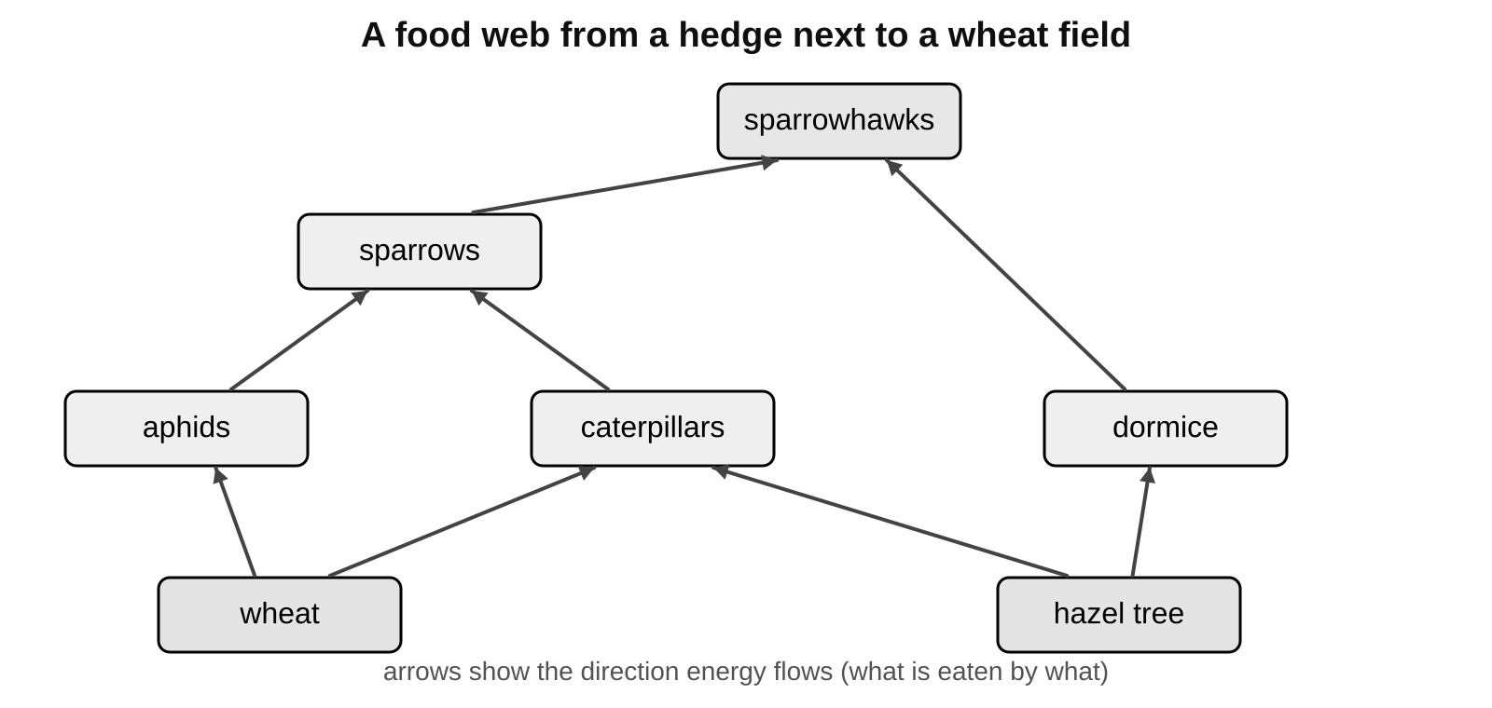
a) Name one producer in this food web.

b) Name two animals that eat caterpillars.

c) The farmer sprays the wheat with a general insecticide, which kills all insects. Tick one box in each row to show what happens to each population.

Population | Increases | Decreases | No change
aphids
caterpillars
sparrows
sparrowhawks

3. Match each process in the carbon cycle to what it does. Draw a line.
photosynthesis |  | releases carbon dioxide when fuels or wood burn
respiration |  | passes carbon compounds from plants to animals
combustion |  | removes carbon dioxide from the air
decomposers feeding |  | releases carbon dioxide from dead plants and animals
animals feeding |  | releases carbon dioxide from living cells, day and night

●● Stretch When Core is finished.
S1. Explain why an increase in bacteria in a lake can reduce the population of fish.

S2. Explain why extra nitrates in a lake make algae and water plants grow quickly. (Hint: think about what plants use nitrates for.)

S3. Explain two different ways in which cutting down a forest can increase the carbon dioxide concentration in the air.

●●● Challenge Explain in full sentences.
C1. In 19th century Ireland, most people survived by growing and eating one variety of potato, called the lumper. Between 1845 and 1852 more than a million people starved. Suggest why, using the words variety, disease and biodiversity.

C2. A persistent insecticide was sprayed on crops next to a river for many years. Years later, fish-eating birds at the top of the river food chain were found to contain large amounts of the insecticide.
a) Explain how the insecticide reached the birds and why they contained so much of it.

b) In 2014 the EU banned some neonicotinoid insecticides on rapeseed, which flowers, but not on wheat. Suggest why.

My thinking (any language)
Limestone is mainly calcium carbonate. To make cement, limestone is heated to make calcium oxide and carbon dioxide gas, using fuel for the heating. Explain two ways cement production adds carbon dioxide to the air.

Word bank eutrophication · algae · decomposer · oxygen · persistent · bioaccumulation · food web · biodiversity · habitat · photosynthesis · respiration · combustion
✂ - - - - - - - - - - - - - - - - - - - - - - - - - - - - - - - - - - - - - - - - - - - - - - - - - - - - - - - - - - - - - - - cut here
Exit ticket 9B Lesson 6: Farming problems and the carbon cycle Name ____________________
1. What does eutrophication mean?

2. Name two processes that release carbon dioxide into the air.

3. Why is it risky to plant one variety of crop over a very large area?

Today I can: Goal 1 ☐ Goal 2 ☐

