Year 9 Science Test 1 Core paper
Variation and inheritance · Adaptation, extinction and natural selection · Cells and the microscope · States of matter · Atoms and the periodic table
Name | Class | Date | Score / 40

Instructions · Time: 40 minutes · Total: 40 marks
• You have 40 minutes. Answer all the questions in Section A (30 marks), then try Section B (10 marks).
• Write your answers in the spaces on this paper. If you need more space, use the back of the page and write the question number.
• The marks for each part are shown in brackets, for example [2]. There are 40 marks in total.
• Read each question carefully. Use the science key words in your answers.

Key words 关键词
abiotic factor | 非生物因素 | biotic factor | 生物因素 | environmental variation | 环境变异
continuous variation | 连续变异 | discontinuous variation | 不连续变异 | species | 物种
inherited | 遗传的 | nucleus | 细胞核 | gamete | 配子
fertilisation | 受精 | zygote | 受精卵 | adaptation | 适应性特征
nature reserve | 自然保护区 | breeding programme | 繁育计划 | gene bank | 基因库
natural selection | 自然选择 | evolution | 进化 | generation | 世代
camouflage | 伪装 | cell wall | 细胞壁 | chloroplast | 叶绿体
vacuole | 液泡 | cell membrane | 细胞膜 | magnification | 放大倍数
eyepiece lens | 目镜 | objective lens | 物镜 | solid | 固体
liquid | 液体 | gas | 气体 | melting | 熔化
evaporating | 蒸发 | condensing | 液化 | proton | 质子
neutron | 中子 | electron | 电子 | atomic number | 原子序数
mass number | 质量数 | electron configuration | 电子排布 | group | 族
period | 周期
Command words 指令词: Calculate 计算 · Complete 完成（填写） · Draw 画出 · Explain 解释 · Tick 打勾 · Use 使用（运用） · Write 写出

Section A: Core 30 marks
Answer all the questions. 30 marks.
1 Environmental variation (4 marks)
(a) Put one tick in each row to show whether the factor is abiotic (non-living) or biotic (living). [2]
Factor | Abiotic | Biotic
temperature
predation (being hunted)
amount of light
infectious disease

(b) Put one tick in each row to show whether the variation is continuous or discontinuous. [2]
Characteristic | Continuous | Discontinuous
height
blood group
hand span
tongue rolling (can or cannot)

2 Inherited variation (4 marks)
(a) Complete the sentences using words from the box. Use each word once. One word is not needed. [4]
nucleus gametes fertilisation zygote environment
Genetic information is stored in the ______________________ of a cell.
A sperm cell and an egg cell are both ______________________.
They join together at ______________________.
The new cell that is made is called a ______________________.
3 Adaptation and extinction (4 marks)
(a) What is an adaptation? [1]

(b) Draw one line from each way of protecting a species to how it works. [3]
nature reserve |  | endangered animals are bred in captivity to increase their numbers
breeding programme |  | seeds, gametes or cells are stored at a low temperature
gene bank |  | an area where the habitat and the species living in it are protected

4 Natural selection and evolution (4 marks)
(a) What causes inherited variation? Tick one box. [1]
☐ the food an organism eats
☐ genes passed on from parents
☐ the weather
☐ exercise
(b) In the 1800s, black peppered moths became more common near Manchester. The sentences below explain why, but they are in the wrong order. Write 1, 2, 3 and 4 in the boxes to put them in the correct order. [2]
Order | Sentence
 | Birds spotted and ate more pale moths than black moths.
 | A few moths had genes that made them black.
 | Each generation had more black moths than the one before.
 | Soot from factories made the tree trunks black.

(c) What is evolution? [1]

5 Cells and the microscope (5 marks)
(a) The diagram shows a plant cell. Write the name of each labelled part. [4]
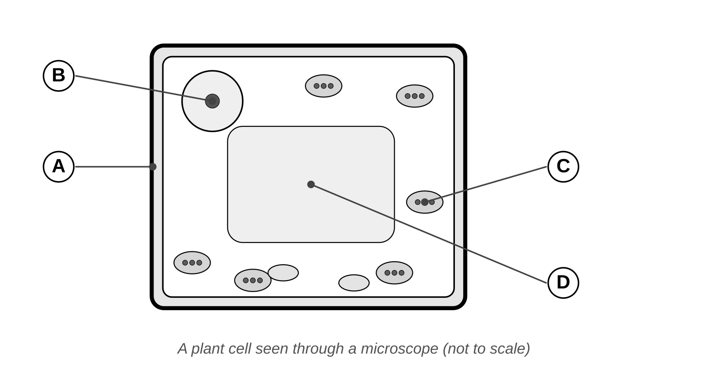
A _______________________________
B _______________________________
C _______________________________
D _______________________________
(b) A microscope has a x10 eyepiece lens and a x4 objective lens. Calculate the total magnification. [1]
Total magnification = x ______________
6 States of matter (4 marks)
(a) The diagrams show the particles in a solid, a liquid and a gas. Write solid, liquid or gas for each diagram. [2]
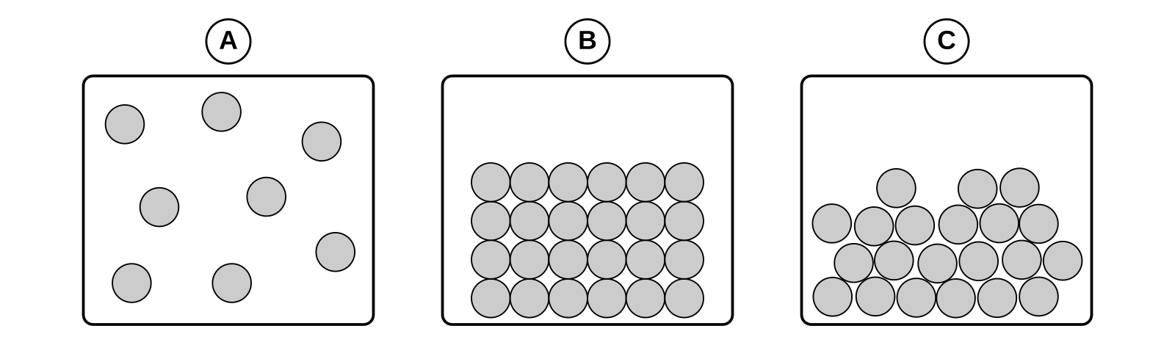
A _______________________________
B _______________________________
C _______________________________
(b) Complete the table using words from the box. One word is not needed. [2]
melting condensing evaporating
Change of state | Name of the change
solid to liquid
liquid to gas

7 Atoms and the periodic table (5 marks)
(a) Complete the table about the three particles in an atom. The first row has been done for you. [2]
Particle | Relative charge | Where it is found
proton | +1 | in the nucleus
neutron
electron

(b) A sodium atom has atomic number 11 and mass number 23. [2]
(i) How many protons does the atom have?
protons = ____________
(ii) How many neutrons does the atom have?
neutrons = ____________
(c) A sodium atom has 11 electrons. Complete its electron configuration. [1]
2, 8, ______
Section B: Stretch and Challenge 10 marks
Try these when you have finished Section A. 10 marks. Stretch questions need a longer explanation. The Challenge question links ideas together.
8 Natural selection in the Salton Sea STRETCH (3 marks)
(a) The Salton Sea in California has become saltier and saltier since 1905. Most fish species died out, but tilapia still live there and can cope with very salty water. Explain how natural selection made the tilapia able to live in very salty water. [3]

9 The size of a cell STRETCH (3 marks)
(a) A microscope has a x10 eyepiece lens. A student uses the x40 objective lens and draws a cell that is 20 mm wide in the drawing. [3]
(i) Calculate the total magnification.
Total magnification = x ____________
(ii) Calculate the actual width of the cell in millimetres. Show your working.

10 Groups and periods CHALLENGE (4 marks)
(a) Fluorine (atomic number 9) and chlorine (atomic number 17) are both in group 7 of the periodic table and react in similar ways. [4]
(i) Write the electron configuration of a fluorine atom and of a chlorine atom.
fluorine ____________________ chlorine ____________________
(ii) Use your answer to explain why fluorine and chlorine react in similar ways.

(iii) Potassium has atomic number 19. Explain why potassium is in period 4.

END OF TEST

