Year 9 Science Revision Guide 1
Variation and inheritance · Adaptation, extinction and natural selection · Cells and the microscope · States of matter · Atoms and the periodic table
Name ____________________________________ Class ______________
How to use this guide
• Read one section at a time. Cover the Key ideas and say them out loud, or write them from memory, then check.
• Learn the key words: cover the meaning, say it, check. The Chinese column is there to help you understand, but answer in English.
• Do the Test yourself questions in your exercise book without looking back. Mark them with the answers at the back. Questions marked Stretch and Challenge are harder: try them once the others are secure.
• Tick the checklist on this page only when you can answer the questions without help. Come back to anything you got wrong.

Revision checklist: tick each line when you can do it without help
Topic | I can ... | Done
1 Environmental variation | I can describe abiotic and biotic factors and give examples of environmental variation.  I can tell continuous variation from discontinuous variation, and explain why environmental variation can make classification difficult. | ☐  ☐
2 Inherited variation | I can give examples of inherited variation and explain how sexual reproduction causes it.  I can sort inherited variation into continuous and discontinuous, and recognise a normal distribution. | ☐  ☐
3 Genes, adaptation and extinction | I can explain how changes in abiotic and biotic factors can make a species endangered or extinct, using the idea of adaptations.  I can describe ways of preserving biodiversity: nature reserves, breeding programmes and gene banks. | ☐  ☐
4 Natural selection and evolution | I can explain how natural selection works on inherited variation when the environment changes, using the peppered moth and the Salton Sea tilapia.  I can describe the theory of evolution by natural selection and explain how natural selection can produce a new species. | ☐  ☐
5 Cells and the microscope | I can label an animal cell and a plant cell and give the job of each part.  I can set up and focus a microscope, make a slide, and draw and label cells correctly.  I can calculate total magnification and the actual size of a cell. | ☐  ☐  ☐
6 States of matter | I can describe how the particles are arranged and how they move in solids, liquids and gases, and use this to explain their properties.  I can name the changes of state and say what happens to the particles when a substance is heated or cooled. | ☐  ☐
7 Atoms and the periodic table | I can describe the structure of an atom and use the atomic number and mass number.  I can write the electron configuration of the first 20 elements.  I can explain how the periodic table is arranged in groups and periods. | ☐  ☐  ☐

Contents
1 Environmental variation Exploring Science 9A, Lesson 1 (Student Book pages 5 to 7)
2 Inherited variation Exploring Science 9A, Lesson 2 (Student Book pages 8 to 9)
3 Genes, adaptation and extinction Exploring Science 9A, Lesson 6 (Student Book pages 16 to 17)
4 Natural selection and evolution Exploring Science 9A, Lesson 7 (Student Book pages 18 to 20)
5 Cells and the microscope Revisits earlier work on cells, microscopes and scientific drawing
6 States of matter Revisits earlier work on solids, liquids and gases and the particle model
7 Atoms, atomic mass and the periodic table Revisits earlier work on atoms, elements and the periodic table
Answers
1 Environmental variation
Exploring Science 9A, Lesson 1 (Student Book pages 5 to 7)
Key ideas
• An organism's surroundings are its environment. Environmental factors can change an organism.
• Abiotic factors are the non-living (physical) parts of the environment: temperature, light, water, mineral salts in the soil, wind.
• Biotic factors are caused by other organisms: competition for food or light, predation (being hunted), infectious disease.
• A characteristic is a feature of an organism. Variation is the differences between the characteristics of organisms. Even a small difference is variation.
• Environmental variation is caused by the surroundings: a scar, a hairstyle, a suntan, a tree bent by the wind, a pale plant grown in the dark. It is not passed on to offspring.
• Continuous variation can take any value between two points: height, mass, hand span, leaf length. Put the measurements into groups; the bars of the chart touch; the shape is often a bell.
• Discontinuous variation has only a limited set of values: blood group (A, B, AB or O), scar or no scar, number of petals. Count how many in each group; the bars have gaps.
• Classification is sorting organisms into groups. The smallest group is the species: organisms that can breed together to produce offspring that can also breed.
• Environmental variation can make classification difficult. Bones found on Flores Island in 2003 came from adults just over 1 m tall. Were they our species with a poor diet (too little iodine), or a different, extinct species?
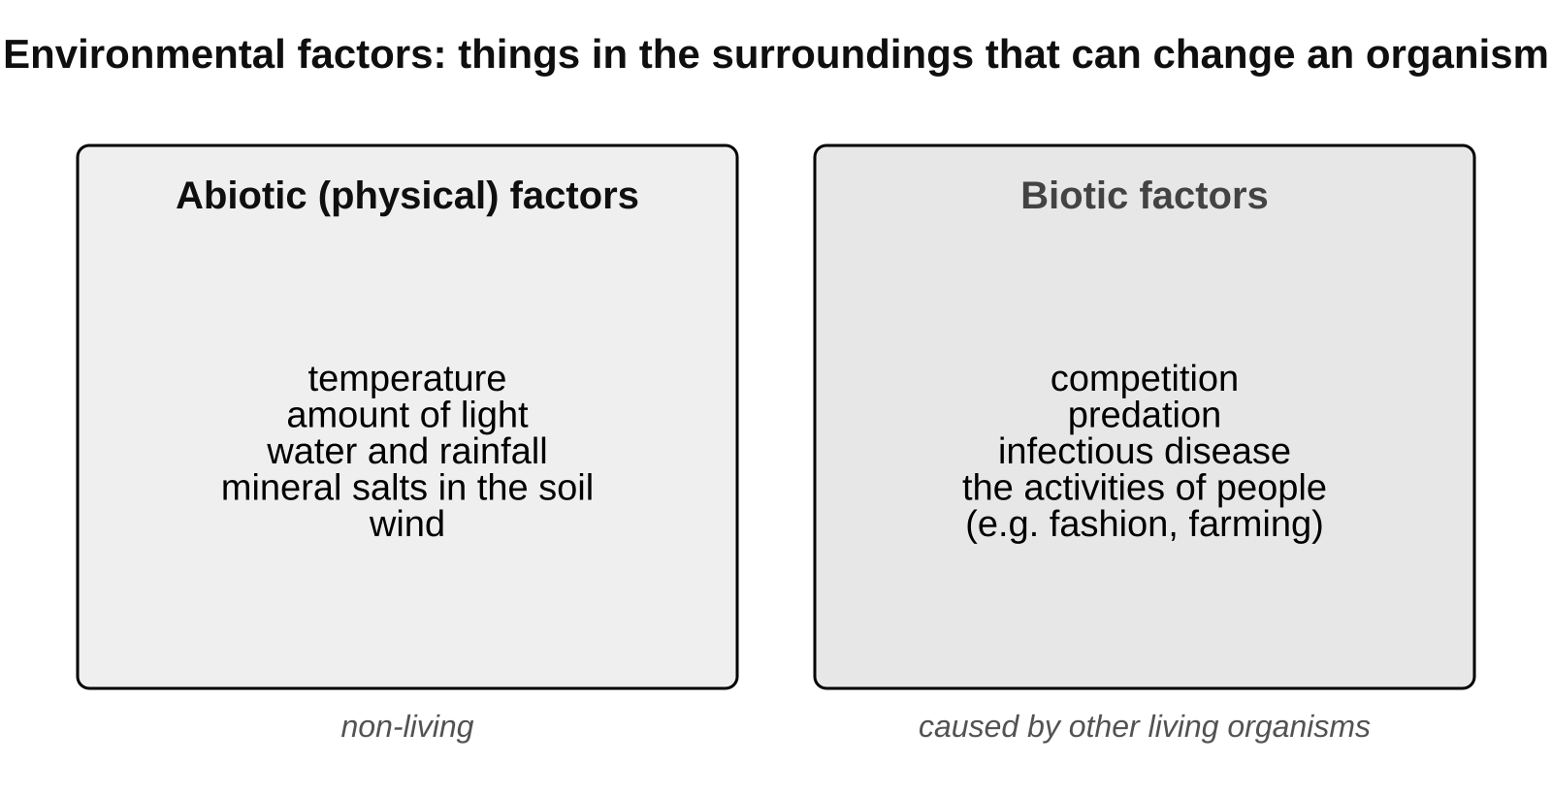
Abiotic factors are non-living; biotic factors come from other living things.
Abiotic or biotic? Examples for a pond
Abiotic (non-living) factors | Biotic (living) factors
water temperature | predation: herons eating fish
amount of light reaching the water | competition between plants for light
oxygen dissolved in the water | infectious disease spreading between fish
mineral salts in the mud | plants shading other plants

Continuous or discontinuous?
 | Continuous variation | Discontinuous variation
Values | any value between two points | a limited set of values
Examples | height, mass, foot length, pumpkin size | blood group, tongue rolling, number of petals
Recording | measure, then put the values into groups | count how many in each group
Chart | bar chart with the bars touching; often a bell shape | bar chart with gaps between the bars

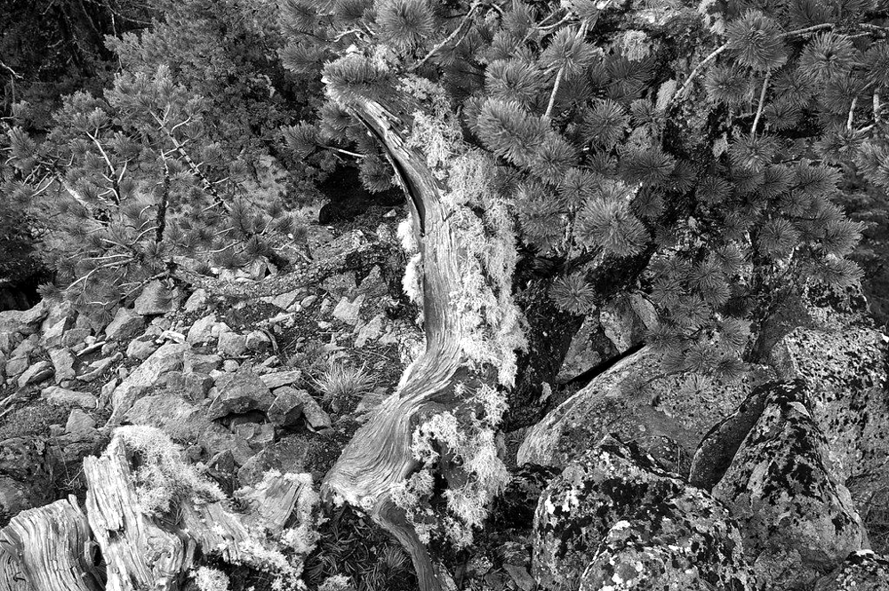
A tree bent and stunted by the wind: environmental variation. Its seeds would grow straight in a sheltered place. Image: brewbooks, CC BY-SA 2.0, via Flickr
Remember To decide if variation is continuous, ask: could the value be anything in between? Hand span could be 18.5 cm, 18.6 cm or 18.65 cm, so it is continuous. Blood group cannot be 'between A and B', so it is discontinuous.

Common mistakes
✗ 'Variation' only means big differences. ✓ Any difference in a characteristic, however small, is variation.
✗ All variation can be passed on. ✓ Environmental variation (a scar, a wind-bent tree) is not inherited.
✗ 'Continuous' means 'keeps happening'. ✓ In science it means the measurement can take any value in a range.

Key words
Term | Meaning
species | a group of organisms that can breed together to produce offspring that can also breed
extinct | a species with no living members left
environment | the surroundings of an organism
abiotic factor | a physical (non-living) part of the environment, e.g. temperature
biotic factor | the activities of other organisms, e.g. predation, disease
characteristic | a feature of an organism
variation | the differences between the characteristics of organisms
environmental variation | variation caused by an organism's environment
continuous variation | variation that can have any value between two points
discontinuous variation | variation with only a limited set of possible values
classification | sorting organisms into groups

Test yourself
Answer in your exercise book without looking back, then check your answers at the back of this guide. Stretch and Challenge questions are harder: try them once the others are secure.
1. Give one abiotic factor and one biotic factor that affect a plant growing in a field. [2]
2. A tree growing on a windy cliff is short and bent. Is this environmental or inherited variation? Explain your answer. [2]
3. Sort these into continuous and discontinuous variation: shoe size, hand span, blood group, mass, tongue rolling, leaf length. [3]
4. What is a species? [2]
5. Explain why environmental variation can make it hard to decide whether two organisms belong to the same species. [2]
6. Students measured the heights of 50 bean plants. What type of chart should they draw, and should the bars touch? Give a reason. [2]
7. STRETCH Pumpkins grown from the seeds of one giant pumpkin varied in mass from 2 kg to 40 kg. Suggest two environmental factors that could explain this variation, and explain why the plants' genes alone cannot explain it. [3]
8. CHALLENGE On a seashore, plants are 10 cm tall with pink flowers. On a nearby island the same kind of plant is over 50 cm tall with dark purple flowers. Seeds from both places were grown in the same laboratory conditions and all the plants grew to look the same. Explain what this shows about the cause of the variation, and why variation like this makes classification difficult. [4]
Total: 20 marks
2 Inherited variation
Exploring Science 9A, Lesson 2 (Student Book pages 8 to 9)
Key ideas
• Offspring get a mixture of characteristics from their parents. We say they inherit them. Examples of inherited variation: natural eye colour, a dimpled chin, blood group, attached ear lobes.
• Genetic information is the set of instructions for inherited characteristics. It is stored in genes, in the nucleus of every cell. A gene is a section of DNA that carries the instructions for one characteristic.
• In sexual reproduction a male gamete (a sperm cell, or a pollen cell in plants) and a female gamete (an egg cell) fuse at fertilisation to make a zygote. The zygote has genetic information from both parents.
• Every gamete carries a slightly different mixture of its parent's genetic information. That is why brothers and sisters are not identical (only identical twins, who grew from the same zygote, share all their genes).
• Inherited variation can be discontinuous (blood group, dimpled chin, tongue rolling: usually caused by genes only) or continuous (height, hand span, skin colour: caused by genes and the environment).
• Some characteristics depend on both. Tall parents usually have tall children, but only if the children eat well. Skin colour is inherited but also changes with sunlight.
• Grouped continuous data usually give a bell-shaped chart called a normal distribution: most values are near the middle and very large or very small values are rare.
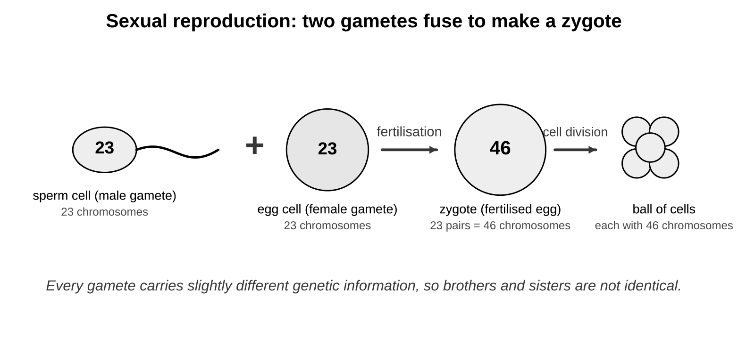
Two different gametes fuse at fertilisation, so each zygote gets its own mixture of the parents' genetic information.
Genes, environment, or both?
Characteristic | Caused by | Type of variation
natural eye colour | genes | discontinuous
blood group | genes | discontinuous
a scar | environment | discontinuous
the language you speak | environment | discontinuous
height | genes and environment (diet) | continuous
skin colour | genes and environment (sunlight) | continuous

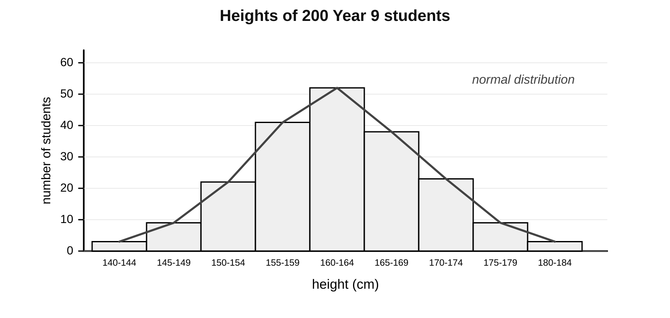
Heights of 200 students: grouped continuous data, bars touching, a bell shape. This is a normal distribution.
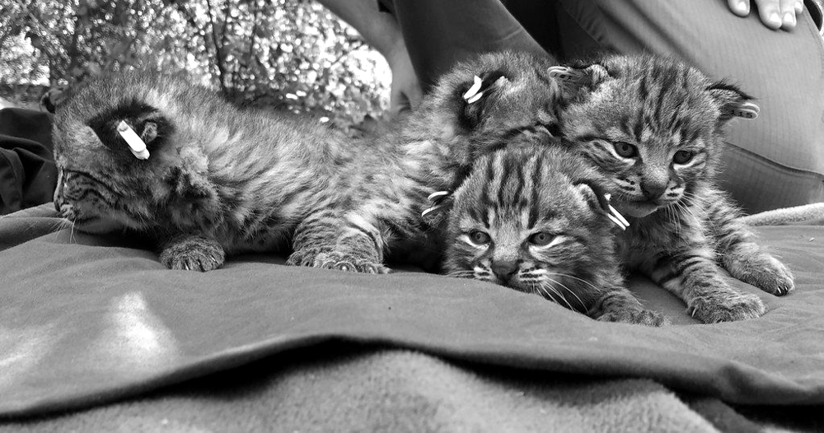
Kittens in one litter inherit coat colour from both parents, but each gets a different mixture, so they are not identical. Image: Santa Monica Mountains National Recreation Area, Public domain, via Flickr
Remember Both gametes carry genetic information, so offspring have some characteristics of each parent. Only characteristics controlled by genes are passed on: a scar or a learned language is not.

Common mistakes
✗ Offspring inherit everything from one parent (often the mother). ✓ Both gametes carry genetic information.
✗ Features caused by lifestyle can be inherited. ✓ A scar, a hairstyle or a learned skill is not passed on.
✗ Continuous variation is caused by genes only. ✓ Height and skin colour are inherited but are also affected by diet and sunlight.

Key words
Term | Meaning
inherited variation | differences in characteristics that are passed on from parents to offspring
offspring | the young produced by parents
genetic information | the instructions for inherited characteristics, stored in the nucleus
gene | a section of DNA that carries the instructions for one characteristic
nucleus | the part of a cell that contains the genetic information
gamete | a sex cell (a sperm cell or an egg cell)
fertilisation | when a male gamete and a female gamete fuse (join together)
zygote | the fertilised egg cell
normal distribution | the bell shape you get when grouped continuous data are plotted

Test yourself
Answer in your exercise book without looking back, then check your answers at the back of this guide. Stretch and Challenge questions are harder: try them once the others are secure.
1. Where in a cell is genetic information stored? [1]
2. Name the two human gametes and the cell that is formed when they fuse. [3]
3. Explain why brothers and sisters are not identical. [2]
4. Two tall parents have a child who is shorter than both of them. Explain how this is possible. [3]
5. Blood group: is it continuous or discontinuous, and inherited or environmental? [2]
6. Describe the shape of a chart showing the heights of 200 students, and name this shape. [2]
7. STRETCH Identical twins grow from one zygote that splits in two. Explain why identical twins always have the same blood group but can have different heights. [3]
8. CHALLENGE Explain why height shows continuous variation with a normal distribution, while blood group shows discontinuous variation. Use the words genes and environment. [4]
Total: 20 marks
3 Genes, adaptation and extinction
Exploring Science 9A, Lesson 6 (Student Book pages 16 to 17)
Key ideas
• An adaptation is a characteristic that helps an organism survive in its habitat. Adaptations are caused by genes. A sand cat has sand-coloured fur (camouflage) and furry feet for hot sand.
• If the ecosystem changes, a species may no longer be well adapted to the new conditions. Its numbers fall: it becomes endangered, and it may become extinct.
• Changes in abiotic factors: rainfall, temperature, light. Changes in biotic factors: new competitors, disease, predators, and human activities such as hunting, clearing habitats and using poisons.
• An organism cannot choose to change its genes. Only the individuals that already have helpful characteristics survive and reproduce.
• Competition is when organisms need the same limited resource: food, water, light, space or mates. Red squirrels are a native species in the UK. Grey squirrels, brought from the USA in the 1870s, store more body fat, can digest unripe acorns (so they eat them first) and carry squirrel pox, which kills reds. Reds still do well in conifer forests, where their lighter bodies suit the thin branches.
• Biodiversity is the number of different species in an area or on Earth. Extinctions upset ecosystems and food webs, and we lose species we could use for food or medicines.
• Preserving biodiversity: banning hunting of certain animals, setting up nature reserves (protecting the habitat), running breeding programmes (breeding endangered species in captivity, then releasing them), and storing seeds, gametes or cells cold in gene banks so a species can be grown again.
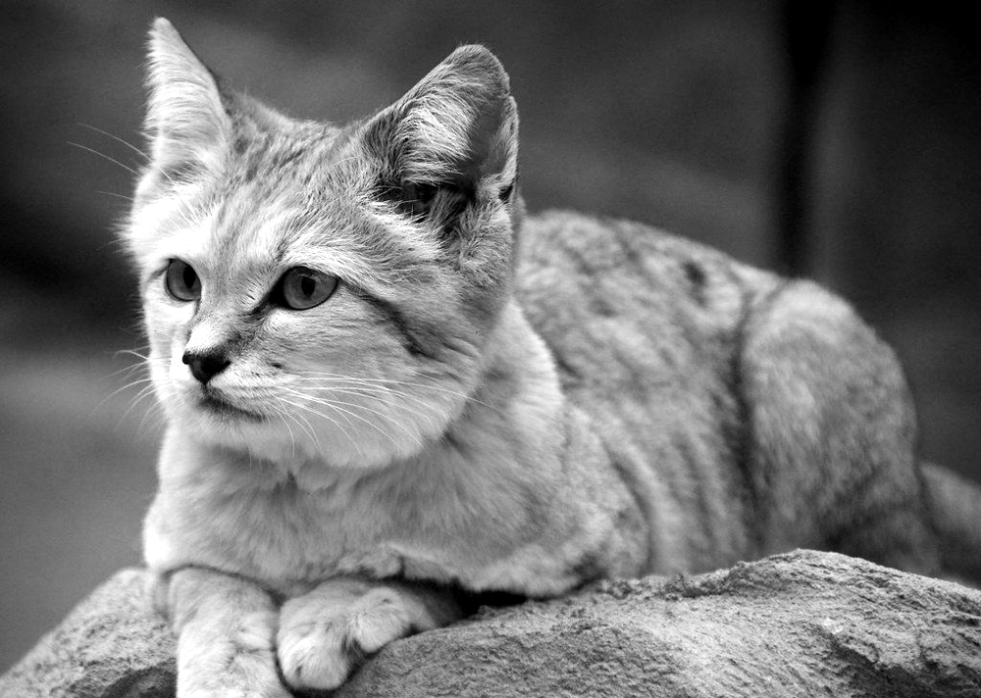
A sand cat: fur that matches the sand and furry feet are adaptations to a hot desert. Image: charlieishere@btinternet.com, CC BY 2.0, via Flickr
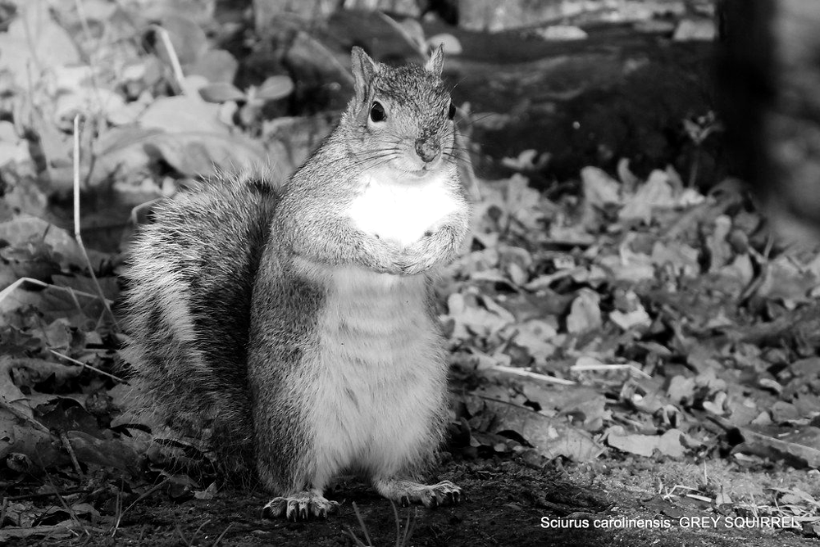
The grey squirrel out-competes the red squirrel for food and carries squirrel pox. Image: pete. #hwcp, CC BY 2.0, via Flickr
Ways of preserving biodiversity
Method | How it works | Limitation
hunting ban | stops people killing the animals, so numbers can recover | needs enforcing; does not protect the habitat
nature reserve | protects the habitat, so the species keeps its food and shelter | takes land; animals may move outside it
breeding programme | endangered animals or plants are bred in captivity to increase numbers, then released | slow and expensive; released animals need a suitable habitat
gene bank | seeds, gametes or cells are stored at low temperature so the species can be produced again | cannot replace a lost habitat; stored genes are not a living population

Remember A good explanation of an extinction says: what changed (the abiotic or biotic factor), why the species was no longer well adapted, and what happened to its numbers.

Common mistakes
✗ Animals compete only by fighting. ✓ Most competition is for food, water, space, light or mates; the grey squirrel wins by eating the acorns first.
✗ Organisms choose to adapt when the environment changes. ✓ Adaptations come from genes, and an individual cannot change its genes.
✗ Conservation only happens in big wild places. ✓ Gene banks, zoos and small local reserves also preserve biodiversity.

Key words
Term | Meaning
adaptation | a characteristic that helps an organism survive in its habitat
endangered | a species in danger of becoming extinct
extinct | a species with no living members left
competition | when organisms need the same limited resource, e.g. food or light
native species | a species that is naturally found in a part of the world
biodiversity | the number of different species in an area or on Earth
nature reserve | an area where habitats and species are protected
breeding programme | breeding endangered animals or plants in captivity to increase their numbers
gene bank | a store of seeds, gametes or cells kept cold so a species can be grown again

Test yourself
Answer in your exercise book without looking back, then check your answers at the back of this guide. Stretch and Challenge questions are harder: try them once the others are secure.
1. What is an adaptation? Give one adaptation of a sand cat. [2]
2. What does it mean if a species is endangered? [1]
3. Give two reasons why grey squirrels have replaced red squirrels in most of the UK. [2]
4. Polar bears hunt seals from the sea ice. The ice is melting earlier each year. Predict the effect on the polar bear population and explain your reasoning. [3]
5. Explain how a gene bank helps to preserve biodiversity, and give one thing a gene bank cannot do. [2]
6. Why can losing one species affect other species? [2]
7. STRETCH Red squirrels still do well in conifer forests even where grey squirrels live nearby. Explain why, using the idea of being better adapted. [3]
8. CHALLENGE Haast's eagle in New Zealand hunted the moa, a giant flightless bird. When people arrived about 700 years ago they hunted the moa to extinction. Explain why the eagle also became extinct, and why a gene bank could not have saved it. [4]
Total: 19 marks
4 Natural selection and evolution
Exploring Science 9A, Lesson 7 (Student Book pages 18 to 20)
Key ideas
• Natural selection: organisms that are better adapted to their environment are more likely to survive, reproduce and pass on their genes. It works on inherited variation that is already in the population.
• The four steps: (1) there is inherited variation; (2) the environment changes, or a resource runs short; (3) the better adapted individuals survive and reproduce more; (4) the next generation has more of the helpful variation. Repeated over many generations, the whole population changes.
• Peppered moths: most are pale and speckled; a few have genes that make them black. In the 1800s soot from factories blackened the trees near Manchester. Birds spotted and ate more pale moths, so more black moths survived and reproduced. By 1895, 98% of the moths there were black. The moths did not change colour: the black ones were already there, and more of them survived.
• Salton Sea tilapia: the sea got saltier and saltier after 1905 and most fish died out. By chance some tilapia had genes that helped them cope with salt. More of them survived and reproduced, so each generation coped better. Today all the Salton Sea tilapia live in very salty water.
• Evolution is a change over time in the characteristics of organisms. Over very many generations natural selection can produce a new species, for example when two populations are separated and different variations are selected in each, until they can no longer breed together.
• Charles Darwin and Alfred Russel Wallace had the hypothesis that natural selection causes evolution. It has been tested many times, with a great deal of evidence, so it is now the theory of evolution by natural selection. Many scientists think some dinosaurs evolved into birds over millions of years.
• Changes made during an organism's life are not inherited. A wading bird that stretches its legs does not pass on longer legs (Lamarck's idea, not accepted). Birds with genes for longer legs got more fish, survived and reproduced, so long legs became common (Darwin's explanation).
• Cloning makes a new organism with exactly the same genetic information as another. DNA survives in frozen mammoth remains, so a mammoth might one day be cloned; dinosaur DNA has not survived for millions of years, so a dinosaur cannot be.
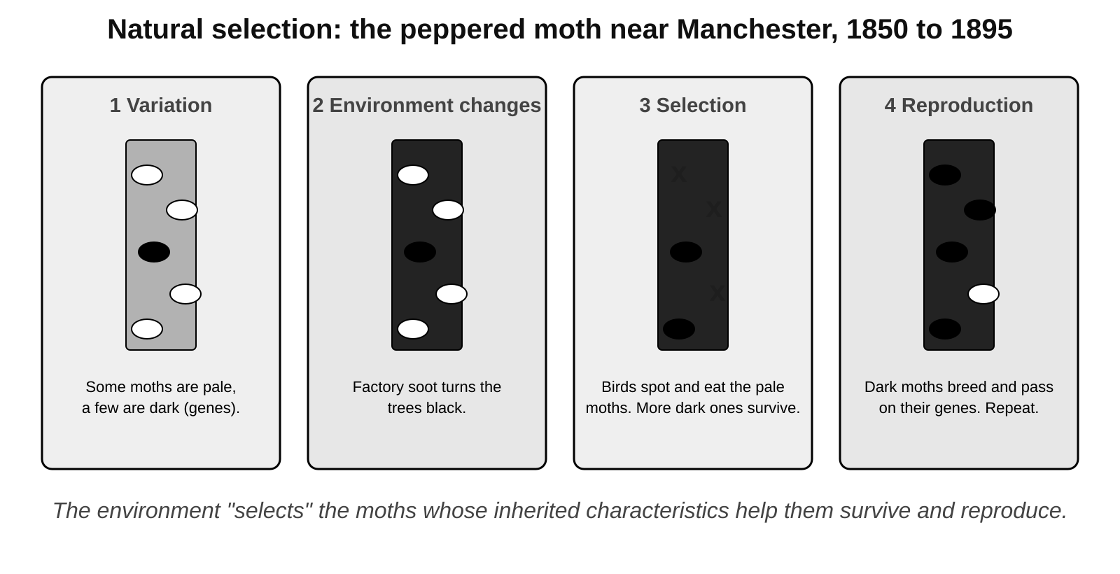
Natural selection in the peppered moth: the environment selects the inherited variation that survives and is passed on.
The four steps of natural selection, with the peppered moth
Step | What happens | Peppered moth example
1 Variation | individuals differ because of their genes | a few moths have genes that make them black
2 Change | the environment changes, or a resource runs short | soot from factories makes the trees black
3 Selection | the better adapted survive and reproduce; the others are eaten or die | birds eat more pale moths; more black moths survive and breed
4 Next generation | offspring inherit the helpful genes, so the variation becomes more common | each generation has more black moths; 98% by 1895

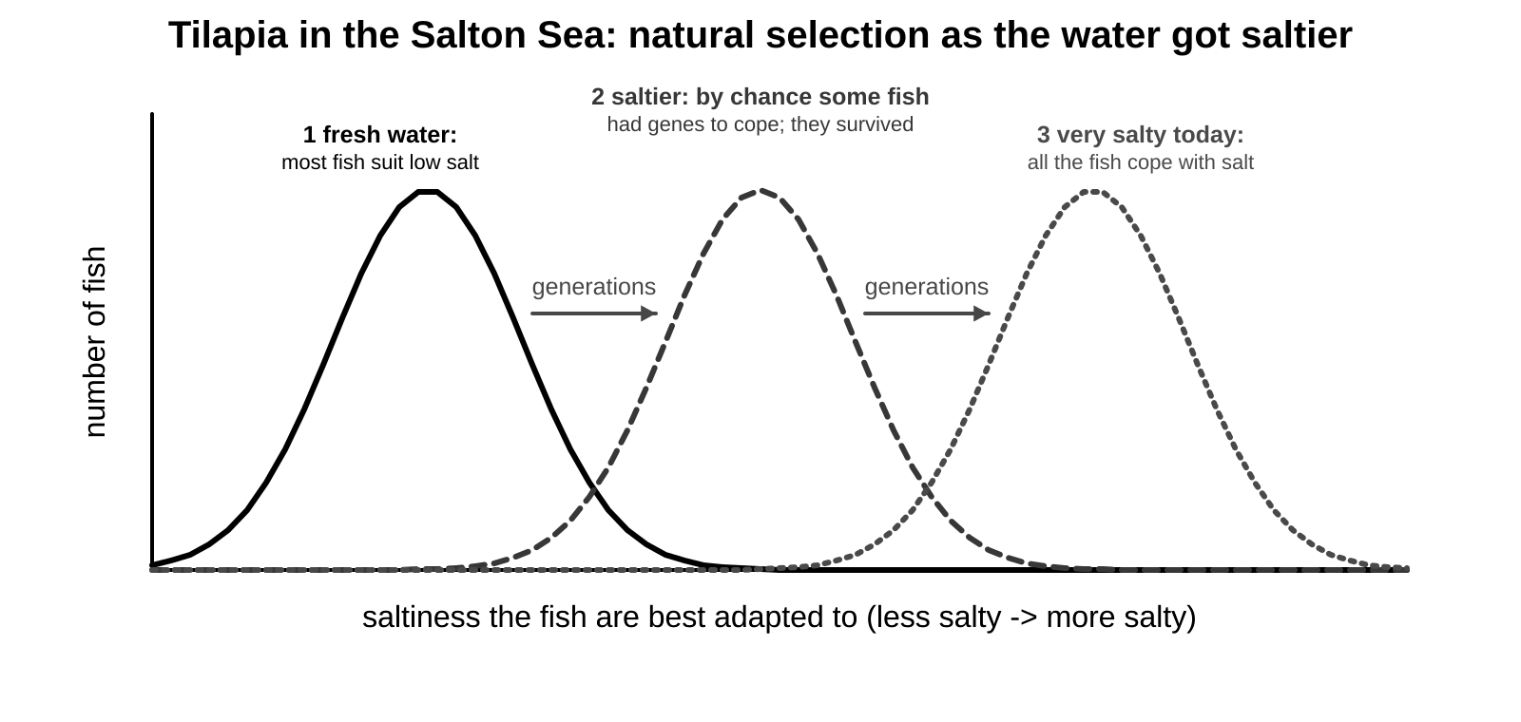
The Salton Sea tilapia: as the water got saltier, generation by generation, the fish that could cope with salt became the whole population.
Lamarck or Darwin? Why wading birds have long legs
Lamarck would say (not accepted) | Darwin would say
Birds stretched their legs to reach fish in deeper water. | Birds varied in leg length because of their genes.
The stretched legs were passed on to their offspring. | When fish were scarce, longer-legged birds waded deeper and got more fish.
Over time the legs got longer and longer. | More of them survived and reproduced, passing on the genes for long legs.
Problem: a change made during life is not inherited. | Each generation had more long-legged birds.

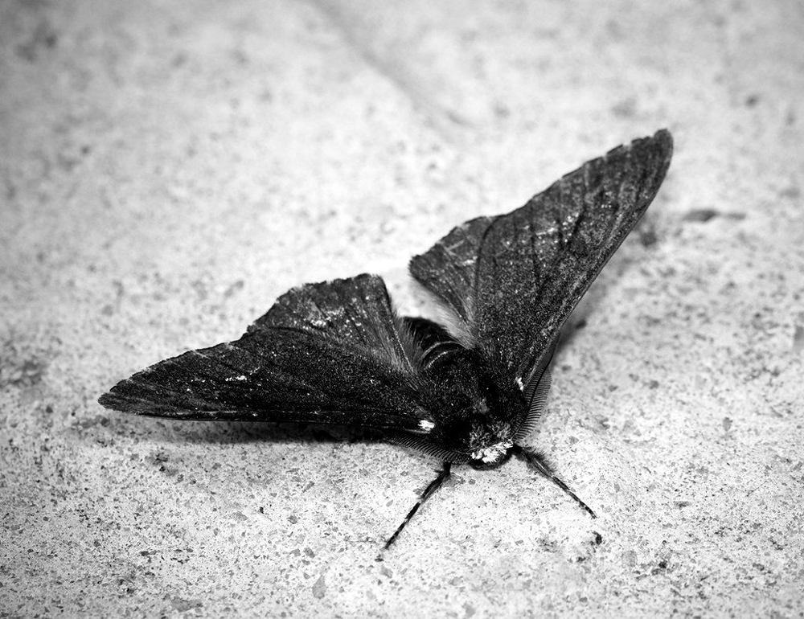
A pale peppered moth on a lichen-covered tree: well camouflaged where the air is clean. Image: Bennyboymothman, CC BY 2.0, via Flickr
Remember Never write 'the moths changed colour to survive'. Write 'more of the moths that were already dark survived and reproduced, so the next generation had more dark moths'. Natural selection changes a population over generations, not an individual.

Common mistakes
✗ Organisms change themselves to suit the environment. ✓ Changes made during a lifetime are not inherited; natural selection only works on inherited variation that is already in the population.
✗ 'Only a theory' means evolution is a guess. ✓ In science a theory is an explanation that has been tested many times and is supported by a great deal of evidence.
✗ Natural selection always makes a species 'better'. ✓ It makes a population better adapted to its current environment; if the environment changes again, different variations are selected (pale moths increased again once the air was cleaner).

Key words
Term | Meaning
natural selection | organisms better adapted to their environment are more likely to survive, reproduce and pass on their genes
evolution | a change over time in the characteristics of organisms, sometimes making a new species
inherited variation | differences between individuals caused by genes, passed on to offspring
gene | a section of DNA that carries the instructions for one characteristic
reproduce | to produce offspring
generation | all the offspring born at about the same time; parents, children and grandchildren are three generations
hypothesis | an idea, based on observations, that can be tested
theory | an explanation that has been tested many times and is accepted by scientists
species | a group of organisms that can breed together to produce offspring that can also breed
camouflage | colours or patterns that make an organism hard to see
cloning | making a new organism with exactly the same genetic information as another

Test yourself
Answer in your exercise book without looking back, then check your answers at the back of this guide. Stretch and Challenge questions are harder: try them once the others are secure.
1. What is natural selection? [2]
2. State what causes inherited variation. [1]
3. Explain why black peppered moths became more common near Manchester in the 1800s. [3]
4. What is the difference between a hypothesis and a theory? [2]
5. Since the 1960s the air near Manchester has become cleaner and the trees are pale again. Predict what has happened to the numbers of pale and black moths, and explain why. [2]
6. What is evolution? [1]
7. STRETCH A student says that wading birds have long legs because they stretched their legs to reach fish and passed the longer legs on to their chicks. Explain what is wrong with this idea, and give the natural selection explanation. [4]
8. CHALLENGE Explain how natural selection can produce a new species when two populations of one species become separated, for example on two islands. [4]
Total: 19 marks
5 Cells and the microscope
Revisits earlier work on cells, microscopes and scientific drawing
Key ideas
• All living things are made of cells. Cells are too small to see without a microscope, which magnifies them (makes them look bigger).
• Parts found in both animal and plant cells: the nucleus (controls the cell and holds the genetic information), the cytoplasm (a jelly where chemical reactions happen), the cell membrane (controls what goes in and out) and mitochondria (where respiration releases energy).
• Parts found only in plant cells: the cell wall (made of cellulose; supports the cell and gives it shape), chloroplasts (contain chlorophyll, which traps light for photosynthesis) and a large vacuole (full of cell sap; keeps the cell firm).
• A light microscope has an eyepiece lens (usually x10) and objective lenses (x4, x10, x40) on a turning nosepiece. The stage holds the slide; light comes from below; the coarse and fine focus knobs move the stage to make the image sharp.
• Total magnification = eyepiece magnification x objective magnification. With a x10 eyepiece and a x40 objective the image is x400.
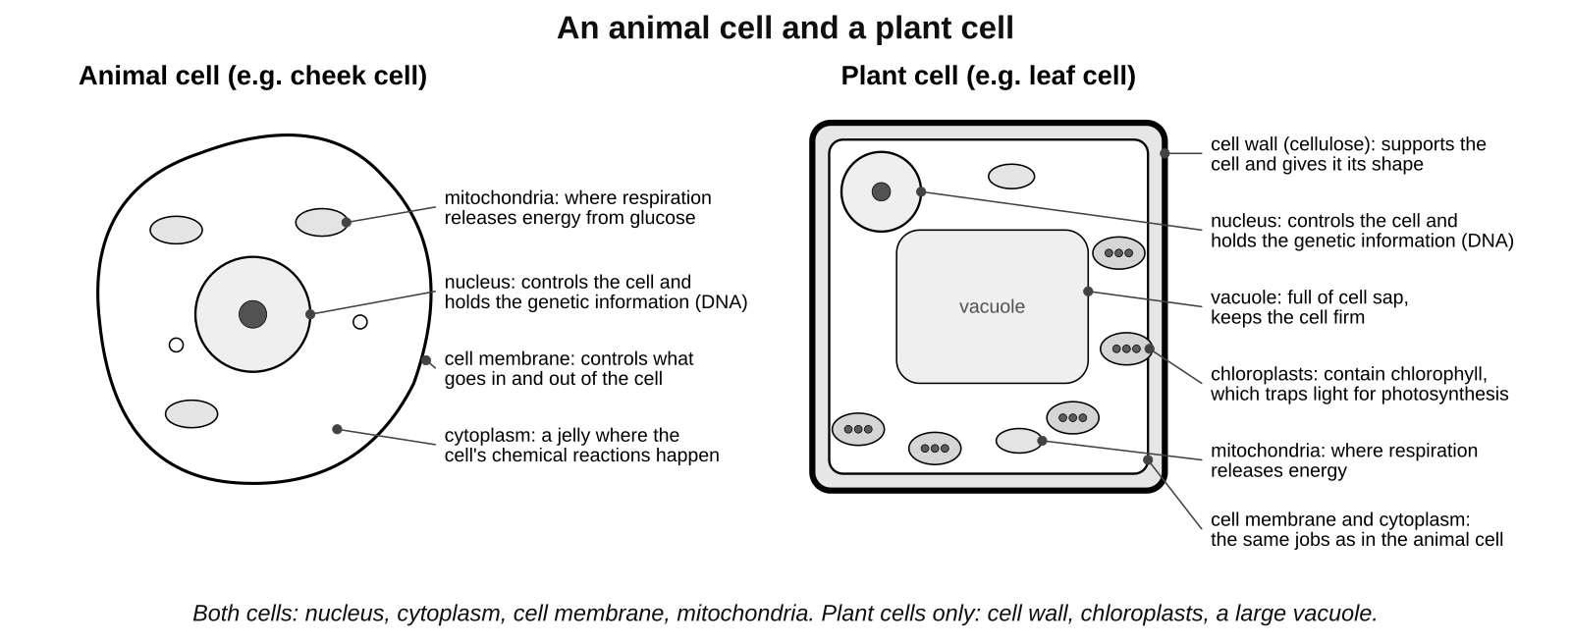
An animal cell and a plant cell. Learn the parts and the job of each.
Cell parts and their jobs
Part | Job | Animal cell | Plant cell
nucleus | controls the cell; contains the genetic information (DNA) | yes | yes
cytoplasm | jelly where the chemical reactions of the cell happen | yes | yes
cell membrane | controls what goes into and out of the cell | yes | yes
mitochondria | where aerobic respiration releases energy from glucose | yes | yes
cell wall | made of cellulose; supports the cell and gives it its shape | no | yes
chloroplasts | contain chlorophyll; trap light energy for photosynthesis | no | yes
vacuole | a bag of cell sap; keeps the cell firm and stores substances | no | yes (large)

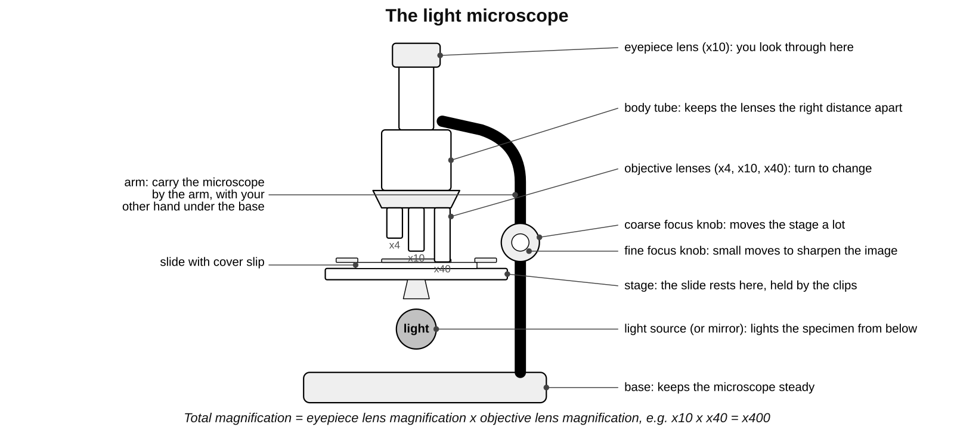
The parts of a light microscope and what each one does.
How to set up and use a microscope
1. Carry the microscope with one hand on the arm and the other under the base. Put it on a flat bench, away from the edge.
2. Turn the nosepiece so the lowest-power objective lens (x4) clicks into place.
3. Put the slide on the stage with the specimen over the hole, and hold it with the clips. Switch on the light (or angle the mirror towards the light).
4. Looking from the side (not through the eyepiece), turn the coarse focus knob to bring the objective lens close to the slide, without touching it.
5. Look through the eyepiece. Turn the coarse focus knob slowly to move the lens away from the slide until the specimen comes into view.
6. Turn the fine focus knob to make the image sharp.
7. To see more detail, turn the nosepiece to a higher-power objective (x10, then x40) and refocus with the fine focus knob only. Never use the coarse focus on high power: the lens can hit and break the slide.
8. Work out the total magnification: eyepiece x objective. Write it next to your drawing.
How to make a slide (onion skin or cheek cells)
1. Put a drop of water (or stain) in the middle of a clean slide.
2. Peel a thin layer of onion skin (one cell thick) with forceps and lay it flat in the drop. For cheek cells, gently scrape the inside of your cheek with a clean cotton bud and smear it on the slide.
3. Add a drop of stain so the parts show up: iodine solution for onion cells (it stains the nucleus brown), methylene blue for cheek cells.
4. Lower a cover slip onto the drop at an angle, using a mounted needle, so that no air bubbles are trapped.
5. Blot any extra liquid from around the cover slip with paper towel. Handle slides and cover slips by the edges; put broken glass in the sharps bin.
Rules for drawing and labelling cells
1. Use a sharp HB pencil and plain paper. Make the drawing large: at least half the space available.
2. Draw only what you see, usually two or three cells, with smooth, clear, single outlines. No sketchy lines, no shading, no colouring.
3. Keep the proportions right: a nucleus that is one fifth of the cell's width in the eyepiece should be one fifth of the cell's width in your drawing.
4. Label the parts with straight lines drawn with a ruler. The lines must not cross each other, and each line must end exactly on the part it labels. Write the labels horizontally.
5. Give the drawing a title that says what it is, the stain used and the total magnification, for example 'Onion skin cells, iodine stain, x100'.
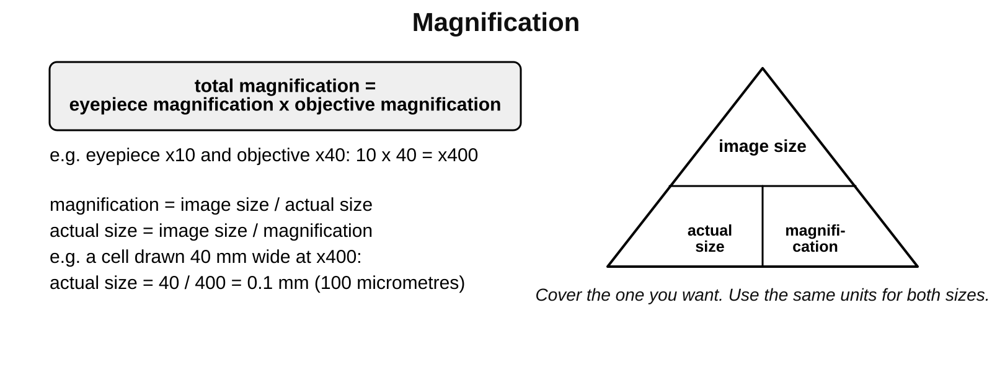
Magnification calculations. Use the same units for the image size and the actual size.
Worked example: how big is the cell really?
A student uses a x10 eyepiece and a x40 objective. Total magnification = 10 x 40 = x400.
In the drawing a cell is 40 mm wide. Actual size = image size / magnification = 40 / 400 = 0.1 mm.
0.1 mm = 100 micrometres (there are 1000 micrometres in 1 mm).

Common mistakes
✗ All cells have a cell wall. ✓ Only plant cells (and some other organisms such as bacteria and fungi) have one; animal cells do not.
✗ Chloroplasts are found in every plant cell. ✓ Root cells are underground, get no light and have no chloroplasts.
✗ Focus with the coarse knob on high power. ✓ On x40 use the fine focus only, or the lens can smash the slide.
✗ Shading and colouring make a better drawing. ✓ Scientific drawings use clear single lines and labels, no shading.

Key words
Term | Meaning
cell | the basic unit that all living things are made of
nucleus | controls the cell and contains the genetic information
cytoplasm | the jelly inside a cell where chemical reactions happen
cell membrane | the thin layer around a cell that controls what goes in and out
mitochondria | the parts of a cell where respiration releases energy
cell wall | the tough outer layer of a plant cell, made of cellulose, that supports it
chloroplast | the part of a plant cell that contains chlorophyll and carries out photosynthesis
vacuole | a space in a plant cell filled with cell sap that keeps the cell firm
microscope | an instrument that magnifies very small objects
magnification | how many times bigger the image is than the real object
eyepiece lens | the lens you look through at the top of the microscope
objective lens | the lens just above the specimen; usually x4, x10 or x40
stage | the flat part of the microscope that the slide rests on
focus | to make the image sharp by moving the lens and specimen closer or further apart
specimen | the object being looked at under the microscope
slide | the strip of glass that the specimen is put on
cover slip | the thin square of glass placed over the specimen
stain | a dye that colours parts of a cell so they can be seen

Test yourself
Answer in your exercise book without looking back, then check your answers at the back of this guide. Stretch and Challenge questions are harder: try them once the others are secure.
1. Name three parts found in both animal cells and plant cells. [3]
2. Name three parts found only in plant cells and give the job of each. [3]
3. Describe how to focus a microscope on a slide, starting on low power. [4]
4. Give three rules for a good scientific drawing of cells. [3]
5. A microscope has a x10 eyepiece and a x40 objective lens. What is the total magnification? [1]
6. A cell is drawn 30 mm wide at a magnification of x100. What is its actual width in mm? [2]
7. Why is the cover slip lowered onto the slide at an angle? [1]
8. STRETCH A student looks at onion cells with a total magnification of x40 and counts 20 cells across the field of view. She changes to a total magnification of x400. Predict how many cells she will see across the field of view, and explain your answer. [3]
9. CHALLENGE Root hair cells are plant cells that have no chloroplasts and have a long, thin extension. Explain both of these features. [4]
Total: 24 marks
6 States of matter
Revisits earlier work on solids, liquids and gases and the particle model
Key ideas
• Everything is made of tiny particles. The three states of matter are solid, liquid and gas. The particle model explains their properties by how the particles are arranged and how they move.
• Solid: the particles are close together in a regular pattern, held by strong forces. They vibrate about fixed positions. A solid has a fixed shape and a fixed volume, and it cannot be compressed (squashed).
• Liquid: the particles are close together but not in a regular pattern, and they slide past each other. A liquid can flow and takes the shape of its container. It has a fixed volume and cannot be compressed.
• Gas: the particles are far apart and move quickly in all directions. A gas spreads out to fill its container, has no fixed shape or volume, and can be compressed because there is space between its particles.
• Changes of state: heating gives the particles more energy, so they move faster. Melting is solid to liquid. Evaporating or boiling is liquid to gas. Cooling takes energy away: condensing is gas to liquid and freezing is liquid to solid.
• The melting point is the temperature at which a solid melts. The boiling point is the temperature at which a liquid boils. Pure water melts at 0 °C and boils at 100 °C.
• Evaporation happens at the surface of a liquid at any temperature. Boiling happens all through the liquid, with bubbles, at the boiling point.
• In a change of state the particles themselves do not change and none are lost. Only their arrangement and movement change, so the mass stays the same: 10 g of ice melts to make 10 g of water.
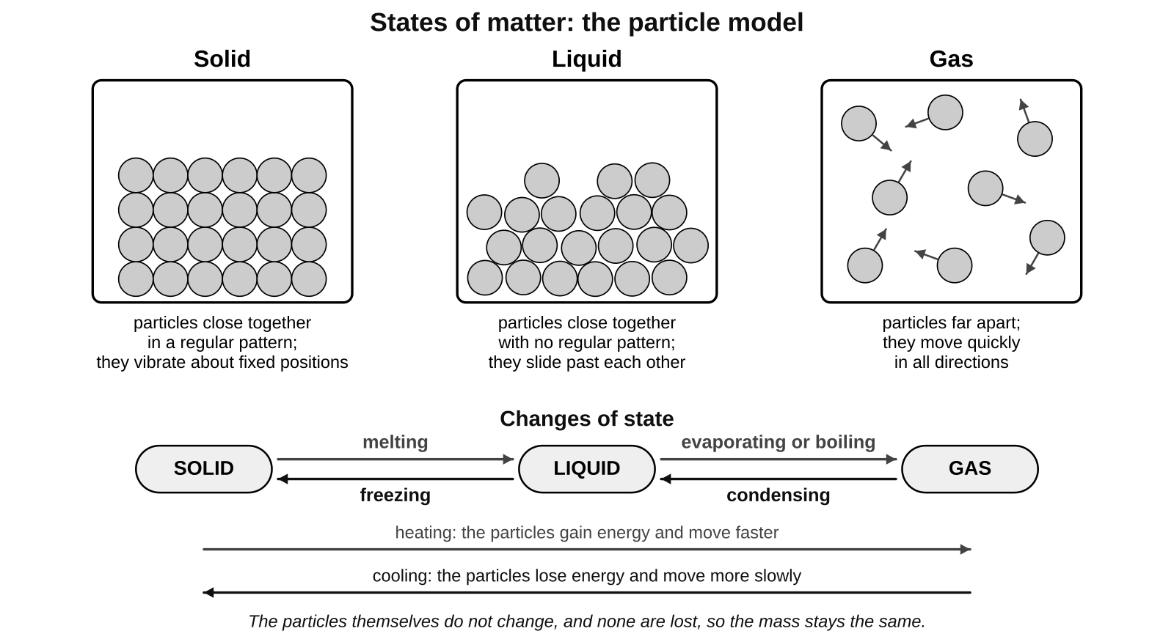
The particle model of a solid, a liquid and a gas, and the names of the changes of state.
Solids, liquids and gases compared
 | Solid | Liquid | Gas
Arrangement of particles | close together, regular pattern | close together, no pattern | far apart, no pattern
Movement of particles | vibrate about fixed positions | slide past each other | move quickly in all directions
Shape | fixed | takes the shape of its container | fills its container
Volume | fixed | fixed | not fixed
Can it be compressed? | no | no | yes
Can it flow? | no | yes | yes

The changes of state
Change | Name | Heating or cooling?
solid to liquid | melting | heating
liquid to gas | evaporating or boiling | heating
gas to liquid | condensing | cooling
liquid to solid | freezing | cooling

Remember Describe a state by two things: how the particles are arranged and how they move. When a substance is heated, its particles move faster; they do not get bigger, hotter or softer.

Common mistakes
✗ The particles in a solid do not move. ✓ They vibrate about fixed positions.
✗ The particles in a liquid are far apart. ✓ They are still touching each other; they are just not in a regular pattern, which is why a liquid cannot be compressed.
✗ Particles melt, expand or get hot. ✓ The particles stay the same; only their movement and arrangement change.
✗ The bubbles in boiling water are air. ✓ They are water in the gas state (steam).

Key words
Term | Meaning
state of matter | one of the three forms a substance can be in: solid, liquid or gas
particle | one of the tiny pieces that all substances are made of
particle model | the idea that the arrangement and movement of particles explain how solids, liquids and gases behave
solid | a state with a fixed shape and volume; particles close together in a regular pattern
liquid | a state that flows and has a fixed volume; particles close together with no pattern
gas | a state that fills its container; particles far apart and moving quickly
vibrate | to move backwards and forwards about a fixed position
compress | to squash something into a smaller volume
flow | to move from place to place, as liquids and gases do
melting | changing from a solid to a liquid
freezing | changing from a liquid to a solid
evaporating | changing from a liquid to a gas at the surface of the liquid
boiling | changing from a liquid to a gas all through the liquid, at the boiling point
condensing | changing from a gas to a liquid
melting point | the temperature at which a solid melts; 0 °C for pure water
boiling point | the temperature at which a liquid boils; 100 °C for pure water

Test yourself
Answer in your exercise book without looking back, then check your answers at the back of this guide. Stretch and Challenge questions are harder: try them once the others are secure.
1. Name the three states of matter. [1]
2. Describe how the particles are arranged and how they move in a solid. [2]
3. Explain why a gas can be compressed but a liquid cannot. [2]
4. Name the change of state when (a) a solid becomes a liquid, (b) a gas becomes a liquid. [2]
5. What are the melting point and the boiling point of pure water? [2]
6. 20 g of ice melts. What is the mass of the water that is formed? Explain your answer. [2]
7. STRETCH A puddle dries up on a cool day when the temperature is 15 °C, far below the boiling point of water. Use the idea of particles to explain how this happens. [3]
8. CHALLENGE A solid iron bar gets slightly longer when it is heated, but its mass does not change. Use the particle model to explain both facts. [4]
Total: 18 marks
7 Atoms, atomic mass and the periodic table
Revisits earlier work on atoms, elements and the periodic table
Key ideas
• Everything is made of atoms. An element is a substance made of only one type of atom. There are about 100 elements, each with a symbol of one or two letters, the first a capital: C for carbon, Cl for chlorine, Na for sodium.
• An atom has a tiny central nucleus made of protons (charge +1) and neutrons (no charge). Electrons (charge -1) move around the nucleus in electron shells. Protons and neutrons each have a relative mass of 1; an electron's mass is almost nothing, so nearly all the mass of an atom is in its nucleus.
• Atoms are neutral: the number of electrons equals the number of protons.
• The atomic number is the number of protons in an atom. Every element has its own atomic number. The mass number is the number of protons plus neutrons. So: neutrons = mass number minus atomic number.
• The relative atomic mass (the larger number in the periodic table square) is the average mass of an element's atoms compared with carbon. For most elements it is close to a whole number. Chlorine's is 35.5 because chlorine atoms come in two kinds, with 18 or 20 neutrons (isotopes: atoms of the same element with different numbers of neutrons), and 35.5 is the average.
• Electron configuration: electrons fill the shells from the inside. The first shell holds up to 2 electrons, the second up to 8 and the third up to 8 (for the first 20 elements). Write the numbers in each shell separated by commas: sodium (11 electrons) is 2,8,1.
• The periodic table lists the elements in order of atomic number. A row is a period: all its elements have the same number of shells. A column is a group: all its elements have the same number of electrons in the outer shell, so they react in similar ways. Group 0 elements have a full outer shell.
• Metals are on the left and in the middle (most elements); non-metals are on the right. Group 1 is the alkali metals (very reactive), group 7 the halogens (reactive non-metals) and group 0 the noble gases (unreactive).
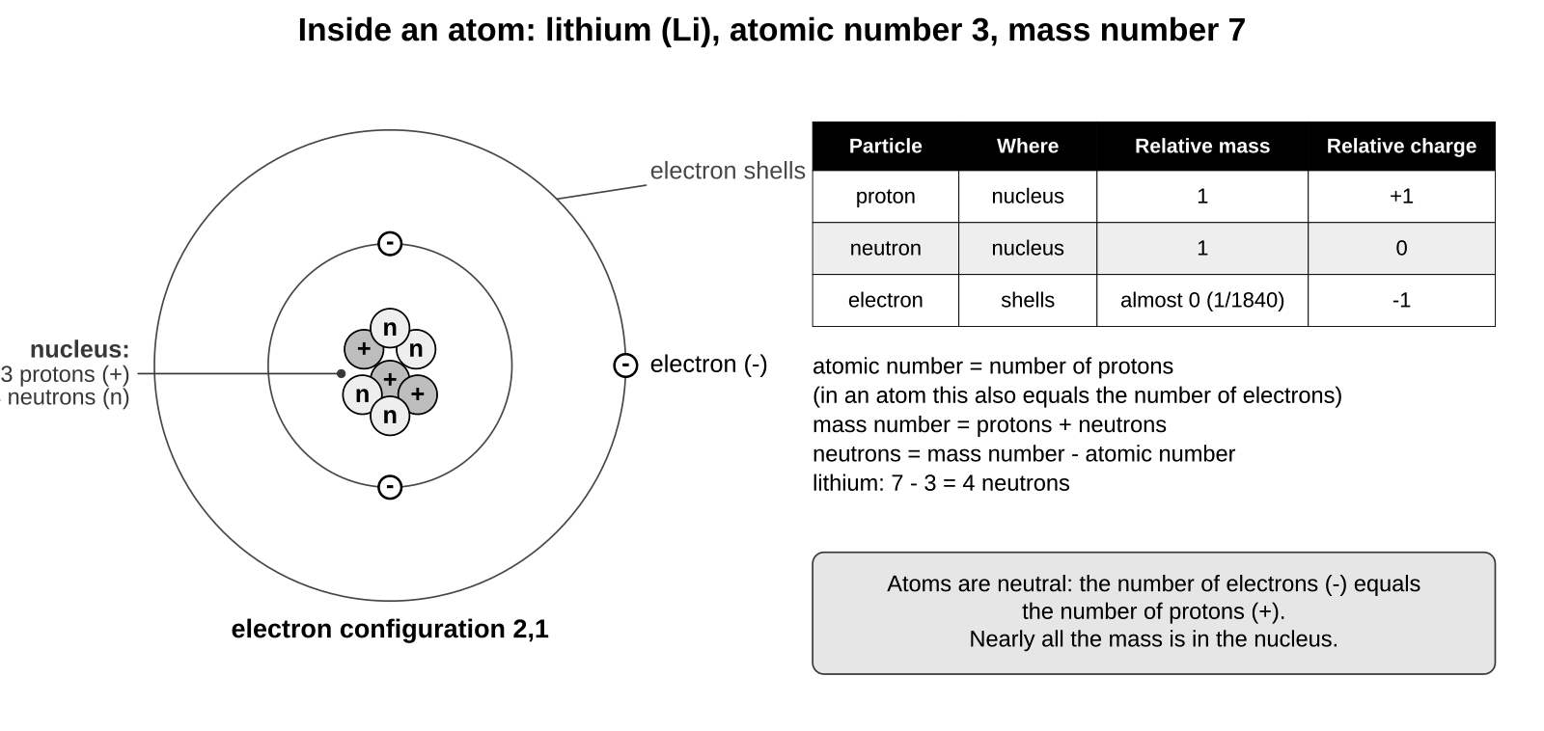
A lithium atom: 3 protons and 4 neutrons in the nucleus, 3 electrons in two shells (2,1).
The three particles in an atom
Particle | Where it is | Relative mass | Relative charge
proton | in the nucleus | 1 | +1
neutron | in the nucleus | 1 | 0
electron | in shells around the nucleus | almost 0 (about 1/1840) | -1

Worked example 1: using the atomic number and mass number
Sodium: atomic number 11, mass number 23.
Protons = atomic number = 11. Electrons = protons = 11 (the atom is neutral).
Neutrons = mass number - atomic number = 23 - 11 = 12.

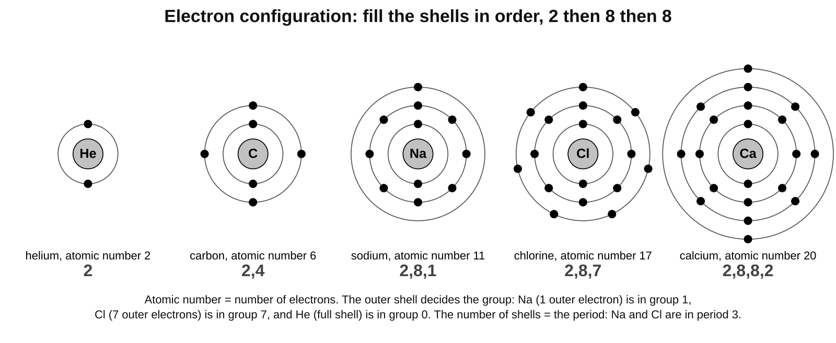
Fill the shells in order: 2, then 8, then 8. The outer shell tells you the group; the number of shells tells you the period.
Worked example 2: electron configuration
Oxygen, atomic number 8: 8 electrons. First shell 2, second shell 6. Configuration 2,6. Period 2 (two shells), group 6 (six outer electrons).
Magnesium, atomic number 12: 2,8,2. Period 3, group 2.
Potassium, atomic number 19: 2,8,8,1. Period 4, group 1.
Argon, atomic number 18: 2,8,8. Full outer shell, so it is in group 0 and is unreactive.

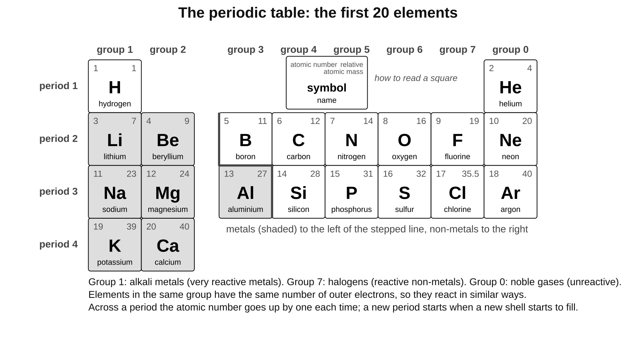
The first 20 elements. Metals are shaded; the stepped line separates metals from non-metals.
What the numbers in a periodic table square tell you
Number | What it means | Example: chlorine
atomic number (smaller) | number of protons, and the element's position in the table | 17: 17 protons, 17 electrons
relative atomic mass (larger) | average mass of the atoms compared with carbon | 35.5
group (column) | number of outer electrons | group 7: 7 outer electrons
period (row) | number of electron shells | period 3: 3 shells, so 2,8,7

Remember Atomic number = protons = electrons. Mass number = protons + neutrons. Shells fill 2, 8, 8. Group = outer electrons; period = number of shells.

Common mistakes
✗ The atomic number is the number of neutrons. ✓ It is the number of protons. Neutrons = mass number minus atomic number.
✗ Mass number and relative atomic mass are the same thing. ✓ The mass number belongs to one atom; the relative atomic mass is an average for the element, which is why chlorine's is 35.5.
✗ Electrons have the same mass as protons. ✓ An electron's mass is about 1/1840 of a proton's; almost all the mass is in the nucleus.
✗ The third shell always holds 18. ✓ For the first 20 elements, fill it to 8 and start the fourth shell (potassium is 2,8,8,1).

Key words
Term | Meaning
atom | the smallest particle of an element
element | a substance made of only one type of atom
symbol | the one or two letters that stand for an element, e.g. Na
nucleus (of an atom) | the tiny centre of an atom, made of protons and neutrons
proton | a particle in the nucleus with a charge of +1 and a relative mass of 1
neutron | a particle in the nucleus with no charge and a relative mass of 1
electron | a particle with a charge of -1 and almost no mass, found in shells around the nucleus
electron shell | a level around the nucleus where electrons are found; the first holds 2, the next 8
electron configuration | the number of electrons in each shell, e.g. 2,8,1
atomic number | the number of protons in an atom
mass number | the number of protons plus neutrons in an atom
relative atomic mass | the average mass of the atoms of an element compared with carbon
isotope | atoms of the same element with different numbers of neutrons
periodic table | the table of all the elements in order of atomic number
group | a column of the periodic table; elements with the same number of outer electrons
period | a row of the periodic table; elements with the same number of shells
metal | an element on the left of the periodic table; usually shiny and conducts electricity
non-metal | an element on the right of the periodic table
alkali metal | a very reactive metal in group 1, e.g. sodium
halogen | a reactive non-metal in group 7, e.g. chlorine
noble gas | an unreactive gas in group 0, e.g. argon

Test yourself
Answer in your exercise book without looking back, then check your answers at the back of this guide. Stretch and Challenge questions are harder: try them once the others are secure.
1. Name the three particles in an atom. Give the charge of each and say where it is found. [3]
2. Magnesium has atomic number 12 and mass number 24. How many protons, neutrons and electrons does a magnesium atom have? [3]
3. Write the electron configuration of (a) nitrogen, atomic number 7, (b) aluminium, atomic number 13, (c) potassium, atomic number 19. [3]
4. Fluorine has the electron configuration 2,7. Which group and which period is it in? Why does fluorine react in a similar way to chlorine? [3]
5. What is the relative atomic mass of chlorine, and why is it not a whole number? [2]
6. What is the name of the group 0 elements? Give one property they share and explain it. [2]
7. Use the periodic table. Name the element with atomic number 16, write its electron configuration, and say whether it is a metal or a non-metal. [3]
8. STRETCH Potassium (atomic number 19) reacts in a similar way to sodium (atomic number 11). Write the electron configuration of each atom and use them to explain the similarity. [3]
9. CHALLENGE Chlorine has two isotopes: chlorine-35 atoms have 18 neutrons and chlorine-37 atoms have 20 neutrons. Explain why both are atoms of chlorine, and why the relative atomic mass of chlorine is 35.5 rather than 36. [4]
Total: 26 marks
Answers
Give yourself the marks in brackets. Where a question says "explain", you need the reason as well as the fact.
1 Environmental variation
1. Abiotic: any one of temperature, light, water (rainfall), mineral salts, wind. Biotic: any one of competition from other plants, being eaten by animals (grazing or insects), disease.
2. Environmental variation (1). It was caused by the wind, a factor in the environment, not by the tree's genes, so its seeds would grow straight in a sheltered place (1).
3. Continuous: hand span, mass, leaf length. Discontinuous: shoe size, blood group, tongue rolling. (1 mark for each correct pair.)
4. A group of organisms that can breed together (1) to produce offspring that can also breed (1).
5. Two organisms of the same species can look different because of their environment, for example diet or wind (1), so you cannot tell from their appearance alone whether the difference is inherited or environmental (1).
6. A bar chart of grouped heights (a histogram) with the bars touching (1), because height is continuous variation and the groups run on from each other with no gaps (1).
7. STRETCH Any two of: amount of water, light, temperature, mineral salts in the soil, space or competition (1 each, max 2). The seeds came from the same parent, so the plants have similar genes; such a large difference must come from their different surroundings (1).
8. CHALLENGE The differences in height and colour were caused by the environment, not by genes (1), because when the environment was the same the differences disappeared (1). The plants are probably the same species (1). Organisms of one species can look different in different places, so appearance alone cannot tell you whether two organisms belong to the same species (1).
2 Inherited variation
1. In the nucleus (in the genes, which are sections of DNA).
2. Sperm cell (1), egg cell (1); they fuse to form a zygote (1).
3. Each gamete carries a different mixture of the parent's genetic information (1), so each zygote, and each child, gets a different combination of genes from the two parents (1).
4. The child inherited genetic information from both parents, but each gamete carries only a mixture of a parent's genes (1), so the child may not have inherited the genes for being tall (1). Height is also affected by the environment, for example diet, so poor food can make a child shorter (1).
5. Discontinuous (1) and inherited (1).
6. A bell shape: most students near the middle height, with few very short or very tall (1). It is a normal distribution (1).
7. STRETCH Identical twins have exactly the same genetic information because they came from one zygote (1). Blood group is controlled by genes only, so it must be the same (1). Height is affected by genes and by the environment, such as diet and exercise, so it can differ (1).
8. CHALLENGE Blood group is controlled by genes alone, with only a few possible versions, so there are only four groups and nothing in between (1). Height is controlled by many genes working together (1) and is also affected by the environment, such as diet (1), so it can take any value in a range; most people are near the middle and extremes are rare, giving the bell shape (1).
3 Genes, adaptation and extinction
1. A characteristic that helps an organism survive in its habitat (1). Sand-coloured fur for camouflage, or furry feet for walking on hot sand (1).
2. It is in danger of becoming extinct (its numbers are very low or falling fast).
3. Any two of: greys store more fat so more survive the winter; greys can digest unripe acorns and eat them before the reds; greys carry squirrel pox, which kills reds but not greys.
4. The population will fall (1). The changing abiotic factor is temperature (the ice melting earlier) (1). Polar bears are adapted to hunting from ice; with less ice they cannot catch enough seals, so fewer survive and reproduce (1).
5. It stores seeds, gametes or cells at low temperature so a species can be grown or bred again if it becomes extinct in the wild (1). It cannot replace a lost habitat, or keep a living population in the wild (1).
6. Species are linked in food webs (1); if one is lost, its predators lose food and the organisms it ate may increase, so the whole ecosystem changes (1).
7. STRETCH Red squirrels are lighter, so they can feed on the thin, flexible branches of conifers (1), and they eat the small conifer seeds (1). In that habitat they are the better adapted species, so they get enough food to survive and reproduce, while the heavier greys do less well (1).
8. CHALLENGE The eagle was adapted to hunting large prey and the moa was its main food, a biotic factor (1). When the moa died out the eagle had too little food, so fewer survived and reproduced until none were left (1). A gene bank only stores genetic material (seeds, gametes or cells) (1); it cannot replace the moa or the habitat the eagle needed, so an eagle bred from stored genes still could not survive in the wild (1).
4 Natural selection and evolution
1. Organisms that are better adapted to their environment are more likely to survive and reproduce (1) and pass on their genes to the next generation (1).
2. Genes (genetic information passed on from parents; a different mixture in each gamete).
3. A few moths already had genes that made them black (1). Soot blackened the trees, so birds spotted and ate more pale moths than black ones (1). More black moths survived and reproduced, passing on their genes, so each generation had more black moths (1).
4. A hypothesis is an idea based on observations that can be tested (1). A theory is an explanation that has been tested many times and is supported by a lot of evidence (1).
5. Pale moths have increased and black moths have decreased (1), because pale moths are now better camouflaged, so birds eat more black moths and more pale moths survive and reproduce (1).
6. A change over time in the characteristics of organisms (which can produce a new species).
7. STRETCH A change made during an animal's life, such as stretching, is not inherited; only genes are passed on (1). Birds varied in leg length because of their genes (1). When fish were scarce, longer-legged birds waded deeper, got more food and were more likely to survive and reproduce (1). They passed on the genes for long legs, so each generation had more long-legged birds (1).
8. CHALLENGE The two islands have different environments, such as food, predators or climate (1), so different inherited variations are selected in each population (1). Over many generations the populations become more and more different (1). Eventually they are so different that they can no longer breed together to produce offspring that can breed, so they are two species (1).
5 Cells and the microscope
1. Any three of: nucleus, cytoplasm, cell membrane, mitochondria.
2. Cell wall: supports the cell and gives it shape. Chloroplasts: contain chlorophyll and trap light for photosynthesis. Vacuole: holds cell sap and keeps the cell firm. (1 mark for each part with its job.)
3. Select the lowest-power objective (x4) (1). Looking from the side, use the coarse focus to bring the lens close to the slide without touching it (1). Look through the eyepiece and turn the coarse focus to move the lens away until the specimen appears (1). Use the fine focus to sharpen the image; on higher power use the fine focus only (1).
4. Any three of: sharp pencil; large drawing; clear single outlines with no shading or colouring; draw only what you see; label lines drawn with a ruler, not crossing, ending on the part; a title with the specimen, stain and magnification.
5. 10 x 40 = x400.
6. Actual size = image size / magnification = 30 / 100 (1) = 0.3 mm (1).
7. So that air bubbles are not trapped under it (bubbles would get in the way of the specimen).
8. STRETCH About 2 cells (1). The magnification is 10 times greater, so each cell looks 10 times wider (1) and the field of view covers only one tenth as much of the slide (1).
9. CHALLENGE Root hair cells are underground where there is no light (1), so chloroplasts, which trap light for photosynthesis, would be useless (1). The long, thin extension gives the cell a large surface area (1), so it can absorb water and mineral salts from the soil faster (1).
6 States of matter
1. Solid, liquid and gas (all three for the mark).
2. They are close together in a regular pattern (1) and they vibrate about fixed positions (1).
3. In a gas the particles are far apart, so there is space for them to be pushed closer together (1). In a liquid the particles are already touching, so there is no space to push them closer (1).
4. (a) melting (1). (b) condensing (1).
5. Melting point 0 °C (1); boiling point 100 °C (1).
6. 20 g (1). No particles are lost or gained when a substance changes state; only their arrangement and movement change (1).
7. STRETCH The water evaporates (1). Some particles at the surface have enough energy to escape from the liquid and move away into the air as a gas (1). Evaporation happens at any temperature, not only at the boiling point; it is just slower when it is cool (1).
8. CHALLENGE Heating gives the particles more energy, so they vibrate more (1) and take up slightly more space, moving a little further apart, so the bar gets longer (1). The particles themselves do not get bigger (1). No particles are added or lost, so the mass stays the same (1).
7 Atoms, atomic mass and the periodic table
1. Proton: +1, in the nucleus (1). Neutron: 0, in the nucleus (1). Electron: -1, in shells around the nucleus (1).
2. 12 protons (1), 24 - 12 = 12 neutrons (1), 12 electrons (1).
3. (a) 2,5 (1). (b) 2,8,3 (1). (c) 2,8,8,1 (1).
4. Group 7 (1), period 2 (1). Both have 7 electrons in the outer shell, and the outer electrons decide how an element reacts (1).
5. 35.5 (1). Chlorine has two isotopes (atoms with 18 or 20 neutrons), and 35.5 is the average mass of a chlorine atom (1).
6. The noble gases (1). They are unreactive because their outer shell is full (1).
7. Sulfur (1), 2,8,6 (1), a non-metal (1).
8. STRETCH Sodium 2,8,1 (1); potassium 2,8,8,1 (1). Both have one electron in the outer shell, and the outer electrons decide how an element reacts, so both are in group 1 and react in similar ways (1).
9. CHALLENGE Both have 17 protons, and the number of protons (the atomic number) decides which element an atom is (1); they differ only in neutrons (1). The relative atomic mass is an average of all the atoms (1); there are about three chlorine-35 atoms for every chlorine-37 atom, so the average is nearer 35 than 37 (1).

