01 · LESSON
Farming problems and the carbon cycle
9B Plant growth · Lesson 6 of 7
Date ______________________ Class __________
Today I can 今天我能
☐ I can explain how fertilisers, pesticides and clearing land can harm wild organisms, including eutrophication and bioaccumulation.
☐ I can use the carbon cycle to explain how farming and burning fuels change the carbon dioxide in the air, and suggest ways to farm more sustainably.
What happens today
1 Do Now: the dead fish
2 Learn: Eutrophication · Pesticide problems · and more
3 Core tasks
4 Challenge, then the exit ticket
Student Book pages 32 to 33 · Workbook pages 23 to 24
What I learned today (one or two sentences) 今天我学到了：

02 · KEY VOCABULARY
Key Vocabulary
Term | 中文 | Definition
habitat | 栖息地 | the place where an organism lives
eutrophication | 富营养化 | a very rich supply of nutrients in water, which leads to fast plant growth and then death of fish
algae | 藻类 | simple plant-like organisms that photosynthesise in water
decomposer | 分解者 | a microorganism that breaks down dead material, using oxygen
persistent | 持久性的 | does not break down in the environment
bioaccumulation | 生物富集 | the build-up of a substance in organisms along a food chain
food web | 食物网 | a diagram of linked food chains showing what eats what
biodiversity | 生物多样性 | the number of different species in an area
carbon cycle | 碳循环 | the processes that move carbon between the air, living things and the Earth
combustion | 燃烧 | burning, which releases carbon dioxide
global warming | 全球变暖 | the rise in the Earth's average temperature
sustainable development | 可持续发展 | making the things we need without destroying habitats for the future
Command words 指令词: Draw 画出 · Explain 解释 · Match 连线（配对） · Name 说出名称 · Number 编号（排序） · Suggest 提出（建议） · Tick 打勾
03 · QUICK REVIEW
Quick Review
the dead fish
1 What do fish need from the water for respiration?

2 Name one farm chemical that rain can wash into a river or lake.

3 Suggest how these fish died.

04 · CORE
Core 1 of 4
Everyone does these. Answer on the card or under it. 人人都做，答案写在卡片上或下面。
1 Number the statements 1 to 6 to show how using fertiliser can lead to the death of fish. The first and last have been done for you.
Order | Statement
1 | Nutrients from the fertiliser dissolve in soil water.
 | Decomposers break down the dead plants, using oxygen from the water.
 | Extra nutrients in the water cause rapid growth of algae and water plants.
 | Soil water with extra nutrients leaks into a nearby stream or river.
 | Algae and water plants at the surface block the light, so deeper plants die.
6 | Fish die because there is too little oxygen in the water.

05 · CORE
Core 2 of 4
Everyone does these. Answer on the card or under it. 人人都做，答案写在卡片上或下面。
2 The diagram shows a food web from a hedge next to a wheat field.
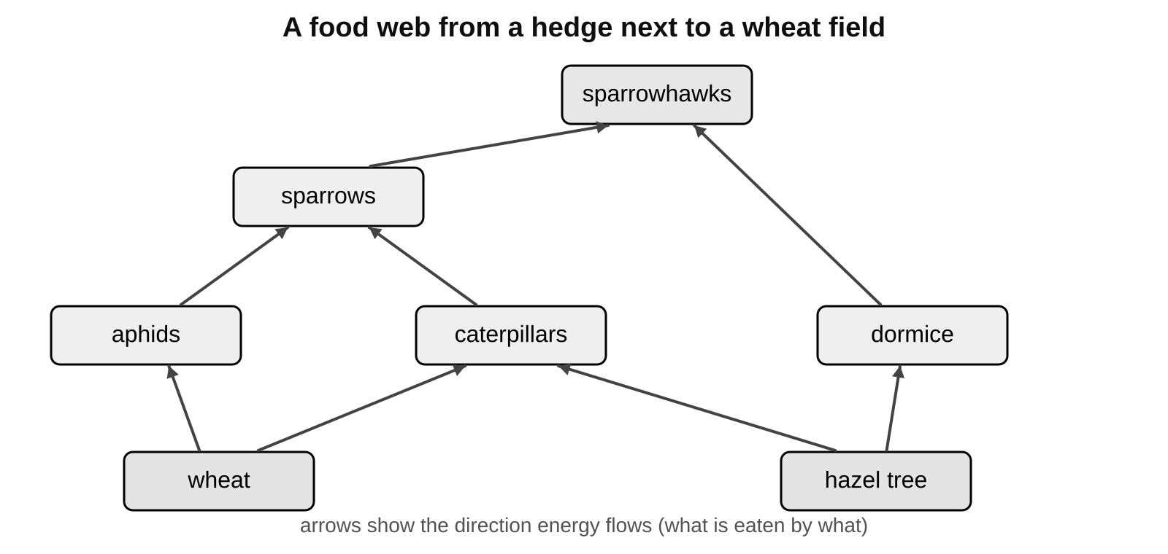
a) Name one producer in this food web.

06 · CORE
Core 3 of 4
Everyone does these. Answer on the card or under it. 人人都做，答案写在卡片上或下面。
2 continued
b) Name two animals that eat caterpillars.

c) The farmer sprays the wheat with a general insecticide, which kills all insects. Tick one box in each row to show what happens to each population.
Population | Increases | Decreases | No change
aphids
caterpillars
sparrows
sparrowhawks

07 · CORE
Core 4 of 4
Everyone does these. Answer on the card or under it. 人人都做，答案写在卡片上或下面。
3 Match each process in the carbon cycle to what it does. Draw a line.
photosynthesis |  | releases carbon dioxide when fuels or wood burn
respiration |  | passes carbon compounds from plants to animals
combustion |  | removes carbon dioxide from the air
decomposers feeding |  | releases carbon dioxide from dead plants and animals
animals feeding |  | releases carbon dioxide from living cells, day and night

08 · CHALLENGE
Challenge 1 of 2
When Core is finished. Full sentences. 完成基础题后做；请写完整句子。
C1 In 19th century Ireland, most people survived by growing and eating one variety of potato, called the lumper. Between 1845 and 1852 more than a million people starved. Suggest why, using the words variety, disease and biodiversity.

09 · CHALLENGE
Challenge 2 of 2
When Core is finished. Full sentences. 完成基础题后做；请写完整句子。
C2 A persistent insecticide was sprayed on crops next to a river for many years. Years later, fish-eating birds at the top of the river food chain were found to contain large amounts of the insecticide.
a) Explain how the insecticide reached the birds and why they contained so much of it.

b) In 2014 the EU banned some neonicotinoid insecticides on rapeseed, which flowers, but not on wheat. Suggest why.

10 · EXIT TICKET
Exit Ticket
Hand this card in at the end of the lesson.
Name ______________________________
1 What does eutrophication mean?

2 Name two processes that release carbon dioxide into the air.

3 Why is it risky to plant one variety of crop over a very large area?

Today I can: Goal 1 ☐ Goal 2 ☐

