Year 9 Science Test 1 Core paper
Variation and inheritance · Adaptation and extinction · Cells and the microscope · Atoms and the periodic table
Name | Class | Date | Score / 40

Instructions · Time: 40 minutes · Total: 40 marks
• You have 40 minutes. Answer all the questions.
• Write your answers in the spaces on this paper. If you need more space, use the back of the page and write the question number.
• The marks for each part are shown in brackets, for example [2]. There are 40 marks in total.
• Read each question carefully. Use the science key words in your answers.

1 Environmental variation (8 marks)
(a) Put one tick in each row to show whether the factor is abiotic (non-living) or biotic (living). [2]
Factor | Abiotic | Biotic
temperature
predation (being hunted)
amount of light
infectious disease

(b) A scar is caused by a cut. Complete the sentence. [1]
A scar is an example of ______________________ variation.
(c) Put one tick in each row to show whether the variation is continuous or discontinuous. [2]
Characteristic | Continuous | Discontinuous
height
blood group
hand span
tongue rolling (can or cannot)

(d) Some students measured the length of 40 leaves and drew a bar chart of their results. Should the bars touch each other? Tick one box and give a reason. [2]
☐ Yes, the bars should touch.
☐ No, there should be gaps between the bars.

(e) What is a species? [1]

2 Inherited variation (8 marks)
(a) Complete the sentences using words from the box. Use each word once. One word is not needed. [4]
nucleus gametes fertilisation zygote environment

Genetic information is stored in the ______________________ of a cell.
A sperm cell and an egg cell are both ______________________.
They join together at ______________________.
The new cell that is made is called a ______________________.
(b) Tick the two characteristics that are inherited. [2]
☐ natural eye colour
☐ a scar
☐ blood group
☐ being able to speak Chinese
(c) Brothers and sisters have the same parents, but they are not identical. Explain why. [2]

3 Adaptation and extinction (8 marks)
(a) What is an adaptation? [1]

(b) A sand cat lives in the desert. Its fur is the same colour as the sand. Explain how this helps the sand cat to survive. [2]

(c) Grey squirrels were brought to the UK from the USA. Red squirrels are now rare in most of the UK. Give two reasons why grey squirrels have replaced red squirrels. [2]

(d) Draw one line from each way of protecting a species to how it works. [3]
nature reserve |  | endangered animals are bred in captivity to increase their numbers
breeding programme |  | seeds, gametes or cells are stored at a low temperature
gene bank |  | an area where the habitat and the species living in it are protected

4 Cells and the microscope (8 marks)
(a) The diagram shows a plant cell. Write the name of each labelled part. [4]
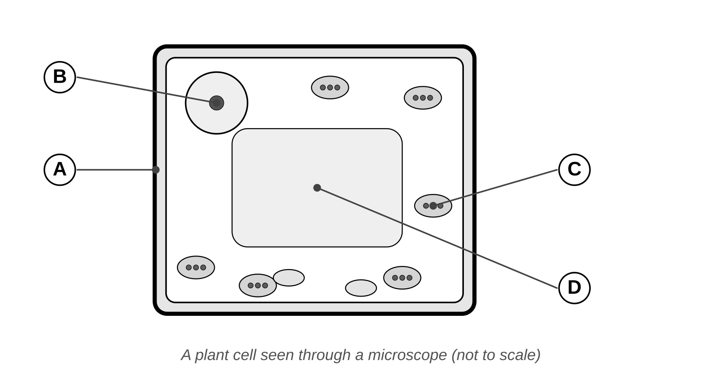
A _______________________________
B _______________________________
C _______________________________
D _______________________________
(b) Which part of a cell controls what goes into and out of the cell? Tick one box. [1]
☐ cell wall
☐ cell membrane
☐ cytoplasm
☐ nucleus
(c) A microscope has a x10 eyepiece lens and a x4 objective lens. Calculate the total magnification. [1]
Total magnification = x ______________
(d) Give two rules for a good scientific drawing of cells. [2]

5 Atoms and the periodic table (8 marks)
(a) Complete the table about the three particles in an atom. The first row has been done for you. [4]
Particle | Relative charge | Where it is found
proton | +1 | in the nucleus
neutron
electron

(b) A sodium atom has atomic number 11 and mass number 23. [2]
(i) How many protons does the atom have?
protons = ____________
(ii) How many neutrons does the atom have?
neutrons = ____________
(c) A sodium atom has 11 electrons. Complete its electron configuration. [1]
2, 8, ______
(d) A magnesium atom has atomic number 12. Write its electron configuration. [1]
______ , ______ , ______
END OF TEST

