9A Lesson 4  DNA, chromosomes and genes  Year 9 Science · 9A Genetics and evolution · Student Book pages 12 to 13  Name ____________________ Class ______ Date ________  Today I can:  ☐ I can outline how the structure of DNA was discovered and say what each scientist did.  ☐ I can describe how DNA, chromosomes, genes and genetic information are linked, and give the number of chromosomes in body cells and gametes. | Key words  DNA the very long molecule that stores genetic information  double helix the shape of a DNA molecule: two strands twisted into a spiral  chromosome a structure in the nucleus made of one long DNA molecule  gene a section of DNA that carries the instructions for one characteristic  genetic information the instructions for inherited characteristics  nucleus the part of a cell that contains the chromosomes  sex chromosomes the pair of chromosomes that decides sex: XX (female) or XY (male)  gamete a sex cell (sperm or egg) with 23 chromosomes  zygote the fertilised egg cell, with 46 chromosomes  X-ray a type of radiation used to make images, including of molecules  model a simpler representation of something that scientists test against evidence

● Core Everyone does this section.
1. Match each scientist to one thing they did to help discover the structure of DNA. Draw a line.
Francis Crick |  | took very clear X-ray photos of DNA and said the first model was wrong
Rosalind Franklin |  | tested the model and made corrections to it over several years
James Watson |  | saw from a photo that DNA was a spiral and helped build the model
Maurice Wilkins |  | helped to build the double helix model in 1953

2. Answer each question by writing a number.
a) The number of DNA molecules in one chromosome.

b) The number of Y chromosomes in a body cell from a male.

c) The number of copies of each gene in a body cell from a female.

d) The number of chromosomes in a human gamete.

e) The number of chromosomes in a zygote.

3. Number these items in order of size. Give the biggest a 1 and the smallest a 4.
____ cell ____ chromosome ____ gene ____ nucleus
4. The photo shows the chromosomes from one human body cell, sorted into pairs.
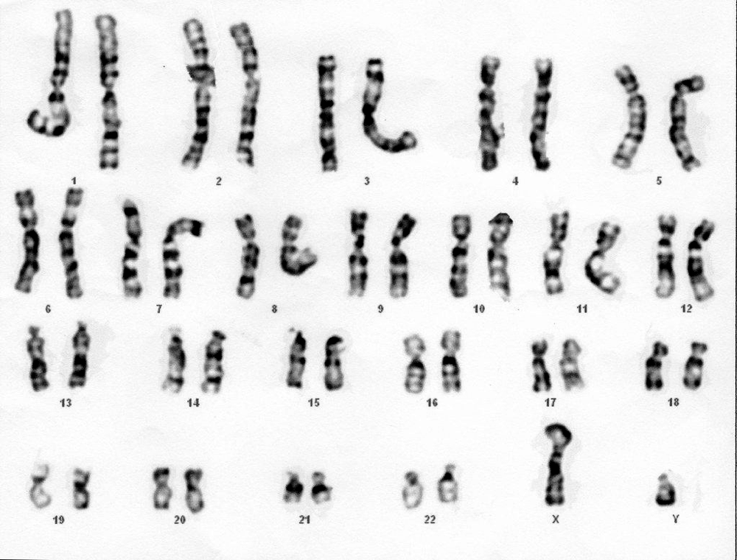
Image: Can H., CC BY 2.0, via Wikimedia Commons
a) State whether the cell is from a male or a female. Give a reason.

b) How many pairs of chromosomes does the cell contain?

●● Stretch When Core is finished.
S1. The table shows the number of chromosomes in the body cells of some animals.
a) Plot the data on the grid as a bar chart. Put the animals in a logical order and label both axes.

Animal | lion | elephant | chicken | rabbit | horse
Number of chromosomes | 38 | 56 | 78 | 44 | 64

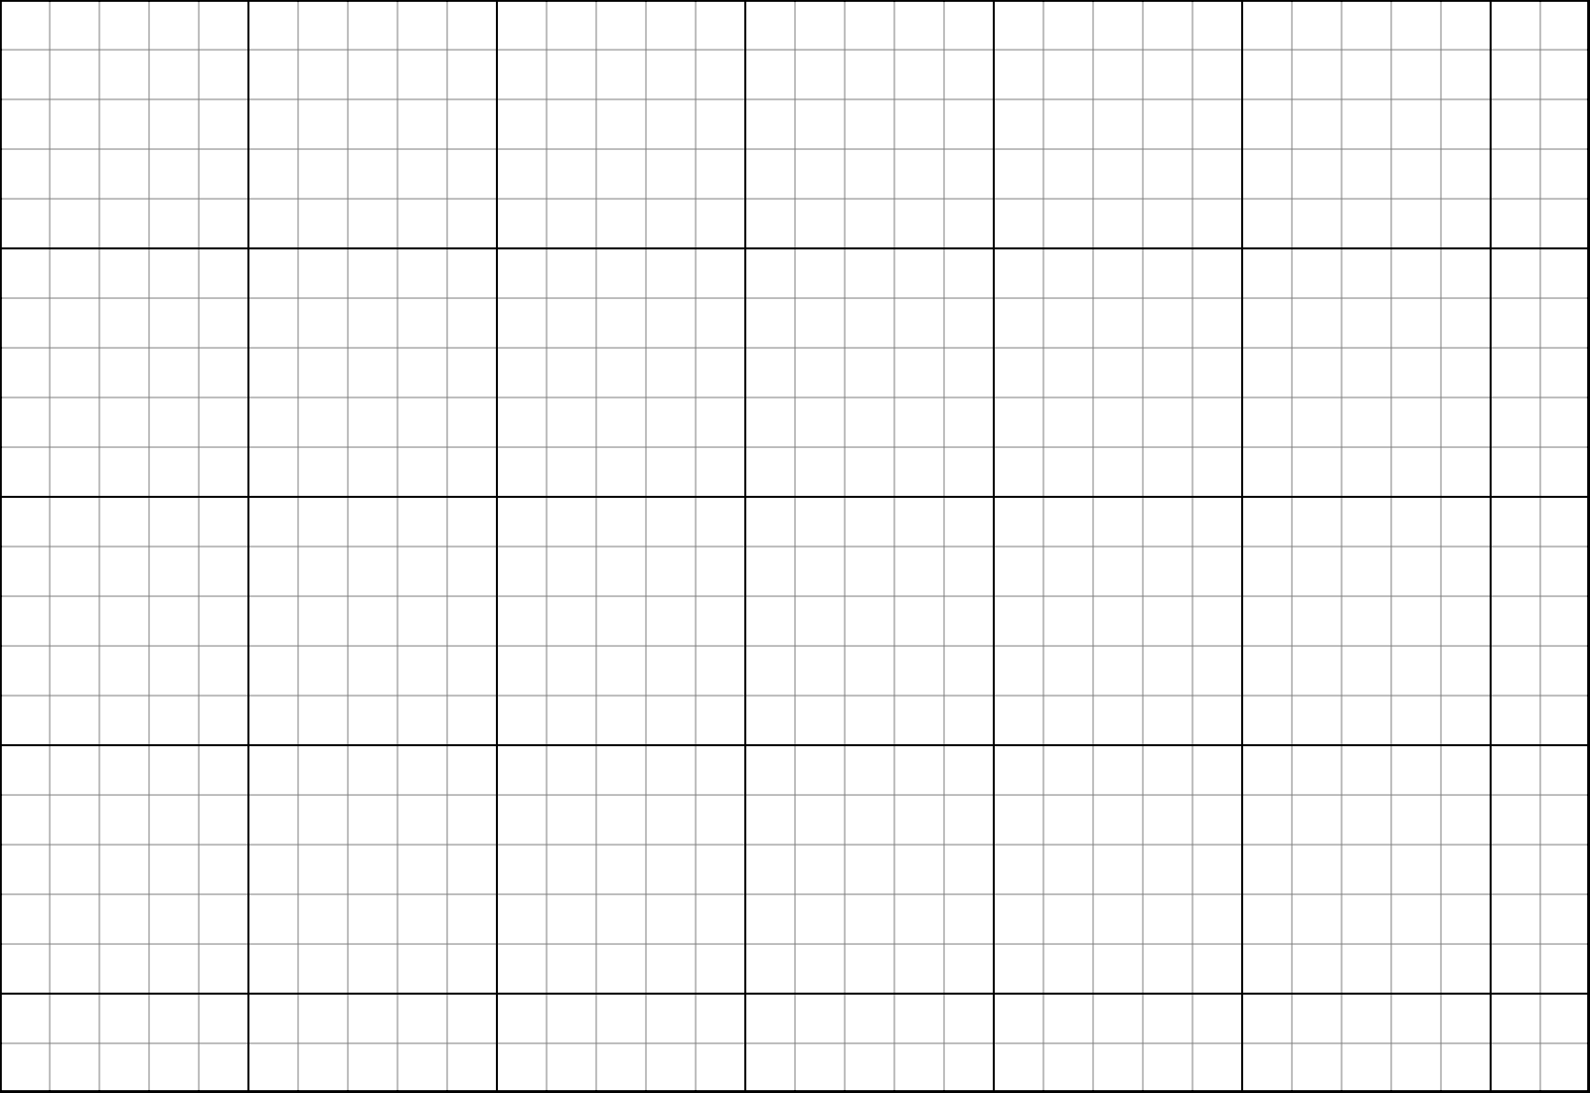
b) Give the reason why the number of chromosomes in each species is an even number.

c) A student says: 'This data shows that birds have more chromosomes in their cells than mammals.' Explain whether this is a good conclusion.

S2. Explain why a body cell contains two copies of each gene, but a gamete contains only one copy.

●●● Challenge Explain in full sentences.
C1. Draw a labelled diagram to show how DNA, chromosomes, genes, genetic information and the nucleus are linked. Use arrows or nested shapes.

C2. Watson and Crick used data from other scientists to build their model.
a) Suggest how they were able to find other scientists' data in 1953.

b) Explain why scientists publish their work in journals such as Nature, and why it mattered that Franklin and Wilkins published in the same edition.

My thinking (any language)
Franklin's X-ray photo was shown to Watson without her permission. Was that fair? What rules should scientists follow when sharing data today?

Word bank DNA · double helix · chromosome · gene · genetic information · nucleus · sex chromosomes · gamete · zygote · X-ray
✂ - - - - - - - - - - - - - - - - - - - - - - - - - - - - - - - - - - - - - - - - - - - - - - - - - - - - - - - - - - - - - - - cut here
Exit ticket 9A Lesson 4: DNA, chromosomes and genes Name ____________________
1. Where in a cell is DNA found?

2. How many chromosomes are there in a human body cell, and in a human gamete?

3. What is a gene?

Today I can: Goal 1 ☐ Goal 2 ☐

