9B Lesson 6  Farming problems and the carbon cycle  Year 9 Science · 9B Plant growth · Student Book pages 32 to 33  Name ________________ Class ______ Date ________  Today I can:  ☐ I can explain how fertilisers, pesticides and clearing land can harm wild organisms, including eutrophication and bioaccumulation.  ☐ I can use the carbon cycle to explain how farming and burning fuels change the carbon dioxide in the air, and suggest ways to farm more sustainably. | Key words 关键词  Command words 指令词  Draw 画出 · Explain 解释 · Match 连线（配对） · Name 说出名称 · Number 编号（排序） · Suggest 提出（建议） · Tick 打勾
  habitat | 栖息地
  eutrophication | 富营养化
  algae | 藻类
  decomposer | 分解者
  persistent | 持久性的
  bioaccumulation | 生物富集
  food web | 食物网
  biodiversity | 生物多样性
  carbon cycle | 碳循环
  combustion | 燃烧
  global warming | 全球变暖
  sustainable development | 可持续发展

● Core Everyone does this section.
1. Number the statements 1 to 6 to show how using fertiliser can lead to the death of fish. The first and last have been done for you.

Order | Statement
1 | Nutrients from the fertiliser dissolve in soil water.
 | Decomposers break down the dead plants, using oxygen from the water.
 | Extra nutrients in the water cause rapid growth of algae and water plants.
 | Soil water with extra nutrients leaks into a nearby stream or river.
 | Algae and water plants at the surface block the light, so deeper plants die.
6 | Fish die because there is too little oxygen in the water.

2. The diagram shows a food web from a hedge next to a wheat field.
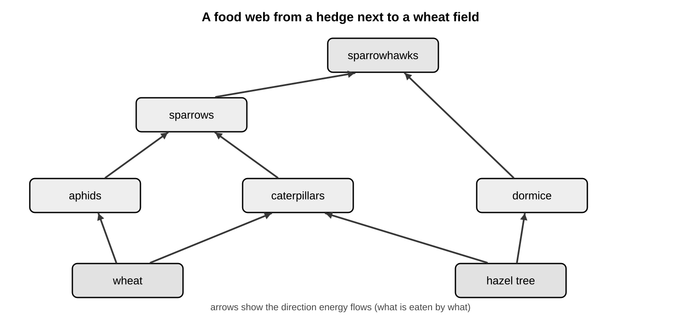
a) Name one producer in this food web.

b) Name two animals that eat caterpillars.

c) The farmer sprays the wheat with a general insecticide, which kills all insects. Tick one box in each row to show what happens to each population.

Population | Increases | Decreases | No change
aphids
caterpillars
sparrows
sparrowhawks

3. Match each process in the carbon cycle to what it does. Draw a line.
photosynthesis |  | releases carbon dioxide when fuels or wood burn
respiration |  | passes carbon compounds from plants to animals
combustion |  | removes carbon dioxide from the air
decomposers feeding |  | releases carbon dioxide from dead plants and animals
animals feeding |  | releases carbon dioxide from living cells, day and night

●● Stretch When Core is finished.
S1. Explain why an increase in bacteria in a lake can reduce the population of fish.

S2. Explain why extra nitrates in a lake make algae and water plants grow quickly. (Hint: think about what plants use nitrates for.)

S3. Explain two different ways in which cutting down a forest can increase the carbon dioxide concentration in the air.

●●● Challenge Explain in full sentences.
C1. In 19th century Ireland, most people survived by growing and eating one variety of potato, called the lumper. Between 1845 and 1852 more than a million people starved. Suggest why, using the words variety, disease and biodiversity.

C2. A persistent insecticide was sprayed on crops next to a river for many years. Years later, fish-eating birds at the top of the river food chain were found to contain large amounts of the insecticide.
a) Explain how the insecticide reached the birds and why they contained so much of it.

b) In 2014 the EU banned some neonicotinoid insecticides on rapeseed, which flowers, but not on wheat. Suggest why.

My thinking (any language 可用中文)
Limestone is mainly calcium carbonate. To make cement, limestone is heated to make calcium oxide and carbon dioxide gas, using fuel for the heating. Explain two ways cement production adds carbon dioxide to the air.

Word bank eutrophication 富营养化 · algae 藻类 · decomposer 分解者 · oxygen · persistent 持久性的 · bioaccumulation 生物富集 · food web 食物网 · biodiversity 生物多样性 · habitat 栖息地 · photosynthesis · respiration · combustion 燃烧
✂ - - - - - - - - - - - - - - - - - - - - - - - - - - - - - - - - - - - - - - - - - - - - - - - - - - - - - - - - - - - - - - - cut here
Exit ticket 9B Lesson 6: Farming problems and the carbon cycle Name ____________________
1. What does eutrophication mean?

2. Name two processes that release carbon dioxide into the air.

3. Why is it risky to plant one variety of crop over a very large area?

Today I can: Goal 1 ☐ Goal 2 ☐

