01 · LESSON
Inherited variation
9A Genetics and evolution · Lesson 2 of 7
Date ______________________ Class __________
Today I can
☐ I can give examples of inherited variation and explain how sexual reproduction causes it.
☐ I can sort inherited variation into continuous and discontinuous, and recognise a normal distribution.
What happens today
1 Do Now: a litter of kittens
2 Learn: Inherited variation · Where inherited variation comes from · and more
3 Core tasks
4 Challenge, then the exit ticket
Student Book pages 8 to 9 · Workbook pages 5 to 6
What I learned today (one or two sentences)

02 · KEY VOCABULARY
Key Vocabulary
Term | Definition
inherited variation | differences in characteristics that are passed on from parents to offspring
offspring | the young produced by parents
genetic information | the instructions for inherited characteristics, stored in the nucleus
gene | a section of DNA that carries the instructions for one characteristic
nucleus | the part of a cell that contains the genetic information
gamete | a sex cell (a sperm cell or an egg cell)
fertilisation | when a male gamete and a female gamete fuse (join together)
zygote | the fertilised egg cell
continuous variation | variation that can have any value between two points
discontinuous variation | variation with only a limited set of possible values
normal distribution | the bell shape you get when grouped continuous data are plotted

03 · QUICK REVIEW
Quick Review
a litter of kittens
1 Give two ways these kittens vary from each other.

2 Which of these differences did they inherit from their parents?

3 From last lesson: is a scar inherited or environmental variation?

04 · CORE
Core 1 of 3
Everyone does these. Answer on the card or under it.
1 Complete the sentences using words from the box. Use each word once.
Word box: characteristics fertilisation fuse genetic inherited offspring parents zygote
The nucleus of a cell contains the __________ information that controls __________ characteristics.
When two gametes __________ (join together) during __________, they produce a __________ (fertilised egg cell).
The fertilised egg cell contains genetic information from both __________, so it has instructions for inherited
__________ from both parents. The __________ will have some characteristics of each parent.
05 · CORE
Core 2 of 3
Everyone does these. Answer on the card or under it.
2 Tick one box in each row to show what causes the variation: genes, the environment, or both.
Characteristic | Genes | Environment | Both
being able to speak more than one language
length of hair
human height
natural eye colour
blood group
a scar

06 · CORE
Core 3 of 3
Everyone does these. Answer on the card or under it.
3 Class survey. Record the class totals in the table.
a) Complete the table using the class results.
Characteristic | Group | Number of students
tongue rolling | can roll
 | cannot roll
ear lobes | attached
 | free (hanging)

b) Is tongue rolling continuous or discontinuous variation? Give a reason.

07 · CHALLENGE
Challenge 1 of 3
When Core is finished. Full sentences.
C1 Suggest a variation in tomatoes that is caused by both genetic information and environmental factors. Explain your reasoning.

08 · CHALLENGE
Challenge 2 of 3
When Core is finished. Full sentences.
C2 The chart shows the heights of 200 Year 9 students.
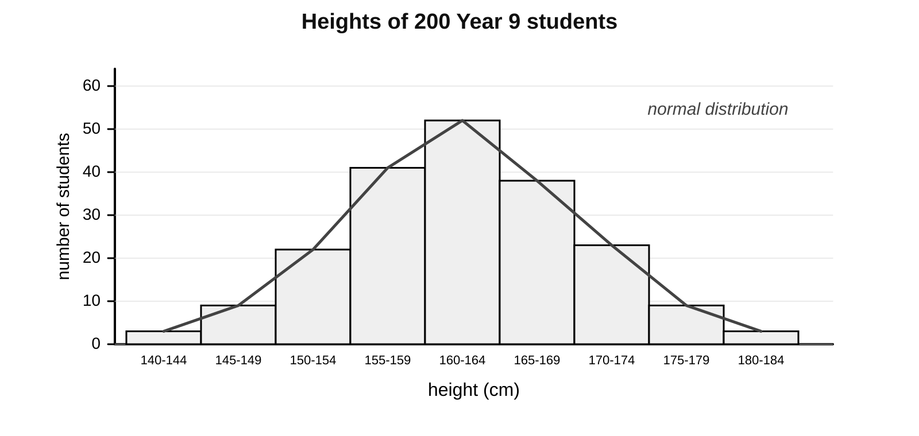
a) Describe the shape of the chart and name this type of distribution.

09 · CHALLENGE
Challenge 3 of 3
When Core is finished. Full sentences.
C2 continued
b) Explain why height gives this shape but blood group cannot.

c) Suggest one other characteristic that you would expect to show a normal distribution.

10 · EXIT TICKET
Exit Ticket
Hand this card in at the end of the lesson.
Name ______________________________
1 Where in a cell is genetic information stored?

2 Name the cell formed when two gametes fuse.

3 Blood group: is it continuous or discontinuous, and inherited or environmental?

Today I can: Goal 1 ☐ Goal 2 ☐

