01 · LESSON
Inherited variation
9A Genetics and evolution · Lesson 2 of 7
Date ______________________ Class __________
Today I can 今天我能
☐ I can give examples of inherited variation and explain how sexual reproduction causes it.
☐ I can sort inherited variation into continuous and discontinuous, and recognise a normal distribution.
What happens today
1 Do Now: a litter of kittens
2 Learn: Inherited variation · Where inherited variation comes from · and more
3 Core tasks
4 Challenge, then the exit ticket
Student Book pages 8 to 9 · Workbook pages 5 to 6
What I learned today (one or two sentences) 今天我学到了：

02 · KEY VOCABULARY
Key Vocabulary
Term | 中文 | Definition
inherited variation | 遗传变异 | differences in characteristics that are passed on from parents to offspring
offspring | 后代 | the young produced by parents
genetic information | 遗传信息 | the instructions for inherited characteristics, stored in the nucleus
gene | 基因 | a section of DNA that carries the instructions for one characteristic
nucleus | 细胞核 | the part of a cell that contains the genetic information
gamete | 配子 | a sex cell (a sperm cell or an egg cell)
fertilisation | 受精 | when a male gamete and a female gamete fuse (join together)
zygote | 受精卵 | the fertilised egg cell
continuous variation | 连续变异 | variation that can have any value between two points
discontinuous variation | 不连续变异 | variation with only a limited set of possible values
normal distribution | 正态分布 | the bell shape you get when grouped continuous data are plotted
Command words 指令词: Complete 完成（填写） · Describe 描述 · Explain 解释 · Give 给出 · Give a reason 给出理由 · Name 说出名称 · Suggest 提出（建议） · Tick 打勾 · Use 使用（运用）
03 · QUICK REVIEW
Quick Review
a litter of kittens
1 Give two ways these kittens vary from each other.

2 Which of these differences did they inherit from their parents?

3 From last lesson: is a scar inherited or environmental variation?

04 · CORE
Core 1 of 3
Everyone does these. Answer on the card or under it. 人人都做，答案写在卡片上或下面。
1 Complete the sentences using words from the box. Use each word once.
Word box: characteristics fertilisation fuse genetic inherited offspring parents zygote
The nucleus of a cell contains the __________ information that controls __________ characteristics.
When two gametes __________ (join together) during __________, they produce a __________ (fertilised egg cell).
The fertilised egg cell contains genetic information from both __________, so it has instructions for inherited
__________ from both parents. The __________ will have some characteristics of each parent.
05 · CORE
Core 2 of 3
Everyone does these. Answer on the card or under it. 人人都做，答案写在卡片上或下面。
2 Tick one box in each row to show what causes the variation: genes, the environment, or both.
Characteristic | Genes | Environment | Both
being able to speak more than one language
length of hair
human height
natural eye colour
blood group
a scar

06 · CORE
Core 3 of 3
Everyone does these. Answer on the card or under it. 人人都做，答案写在卡片上或下面。
3 Class survey. Record the class totals in the table.
a) Complete the table using the class results.
Characteristic | Group | Number of students
tongue rolling | can roll
 | cannot roll
ear lobes | attached
 | free (hanging)

b) Is tongue rolling continuous or discontinuous variation? Give a reason.

07 · CHALLENGE
Challenge 1 of 3
When Core is finished. Full sentences. 完成基础题后做；请写完整句子。
C1 Suggest a variation in tomatoes that is caused by both genetic information and environmental factors. Explain your reasoning.

08 · CHALLENGE
Challenge 2 of 3
When Core is finished. Full sentences. 完成基础题后做；请写完整句子。
C2 The chart shows the heights of 200 Year 9 students.
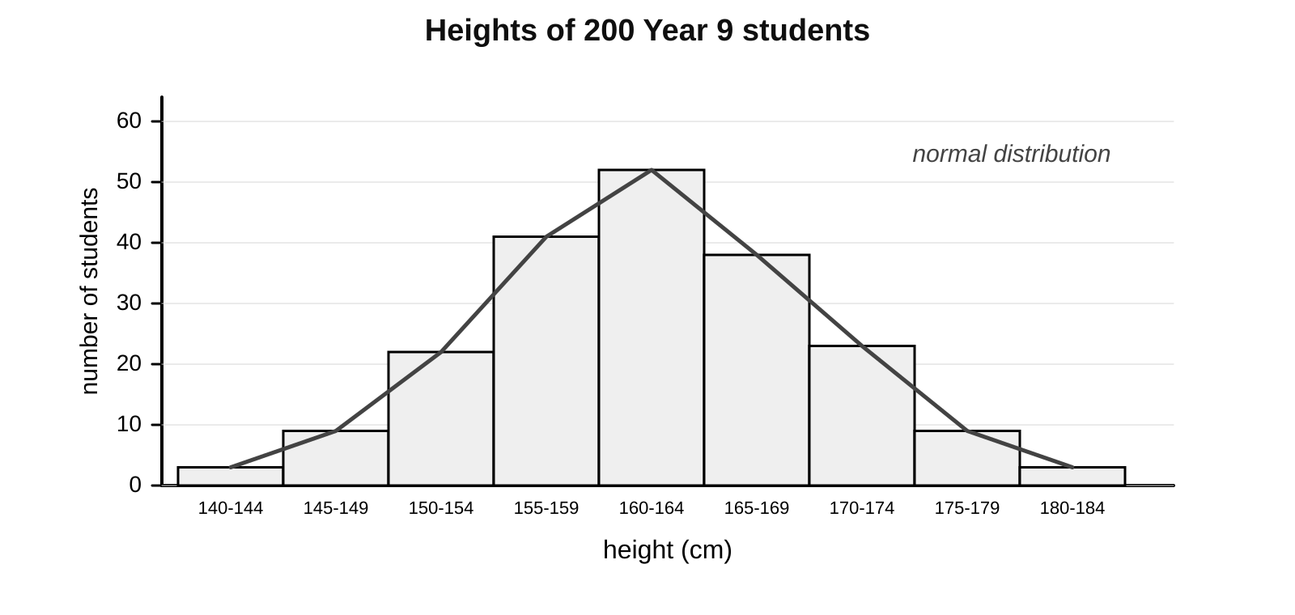
a) Describe the shape of the chart and name this type of distribution.

09 · CHALLENGE
Challenge 3 of 3
When Core is finished. Full sentences. 完成基础题后做；请写完整句子。
C2 continued
b) Explain why height gives this shape but blood group cannot.

c) Suggest one other characteristic that you would expect to show a normal distribution.

10 · EXIT TICKET
Exit Ticket
Hand this card in at the end of the lesson.
Name ______________________________
1 Where in a cell is genetic information stored?

2 Name the cell formed when two gametes fuse.

3 Blood group: is it continuous or discontinuous, and inherited or environmental?

Today I can: Goal 1 ☐ Goal 2 ☐

