**Process: Update Target Hosted Service with Data From Excel Sheet for Today’s Records**

**Date: 7-27-2018**

**Author: Esri NGSE (**[**anieto@esri.com**](mailto:anieto@esri.com)**)**

**Installation Requirements:**

1. ArcGIS API for Python (1.4 or higher)
2. Jupyter Notebooks (From ArcGIS Pro or Anaconda distribution)
3. Microsoft Excel
4. ArcGIS Maps for Office

**Set-up Requirements:**

1. The user needs a published hosted service on ArcGIS Online (or ArcGIS Enterprise) with edit permissions. The service should follow the schema established when publishing the “Master” sheet from the provided excel (Baseline_Book.xlsx) using ArcGIS Maps for Office.
2. Zipped folder from <https://esri.box.com/s/k1fqlnb2gxab05hl0vct9am7z8vqth15> downloaded locally and unzipped.
3. The Excel that is used as the input data should have a new set of records corresponding to today’s date for the process to actually perform updates. These records should be reflected in the “Master” sheet.

**To run from notebook:**

1. Open the “*2_ops_LoadExcelRecordsWithGeoToLayer.ipynb”* file using a Jupyter Notebook session.
   * The recommended way to do this is to open a CMD prompt, change directory (CD) to the unzipped folder location, and start the session by entering “Jupyter Notebook” + <Enter> on the prompt.
2. A few parameters need to be set by the user:

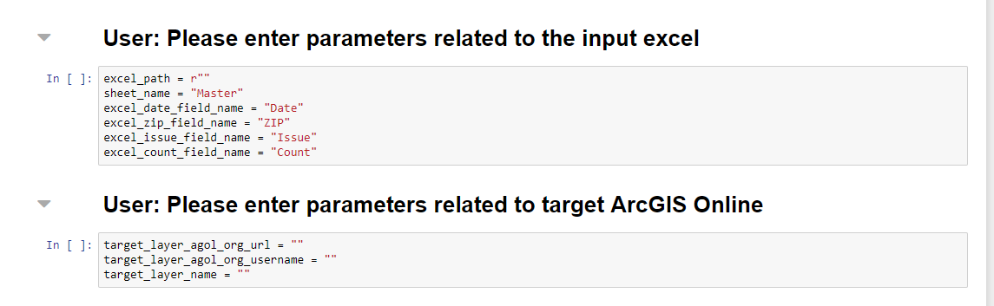

* Example of filled in parameters:

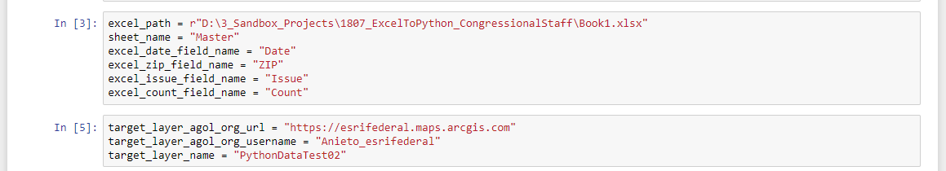

1. Run the notebook by selecting “Cell” > “Run All”:

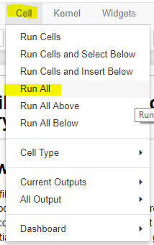

1. Once completed, the last cell should provide brief messaging regarding how many features were added to the target service.

A python file is also included to allow the user to set up a Windows scheduled task to run each day.

**To run this script on an automated routine:**

1. Open the *2_ops_LoadExcelRecordsWithGeoToLayer.py* file using a text editor, and enter the parameter values (in the same manner as seen in the notebook step above). Save and close the text editor.
2. Run the python file by double clicking the file to test the updates occur.
3. If successful, set up a windows scheduled task to call the python file. Help for this can be found here:

<http://desktop.arcgis.com/en/arcmap/10.3/analyze/executing-tools/scheduling-a-python-script-to-run-at-prescribed-times.htm>