网页说明：苦于在网上找不到table-最好是英文的网站，所以，按照韬韬TA群上说的自己写了三个有表格的网页，然后加入那行神秘代码测试。全部成功。如下：
网页一：
table-test1测试截图如下：
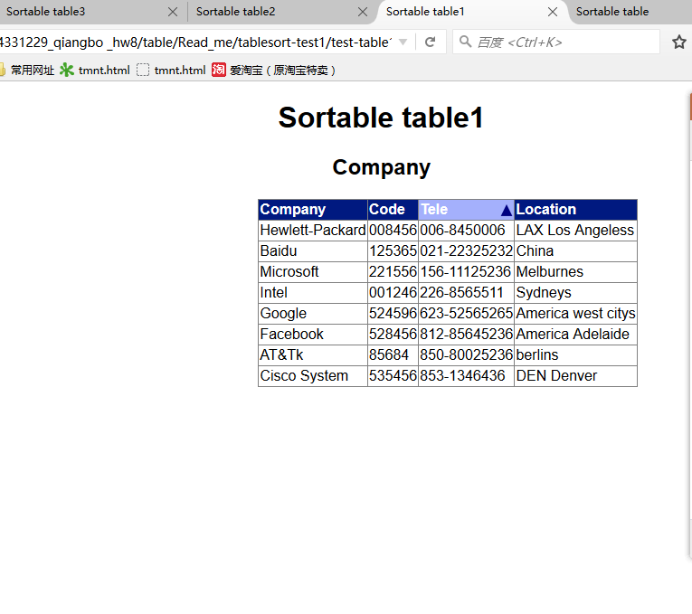
网页二：
table-test2测试截图如下：
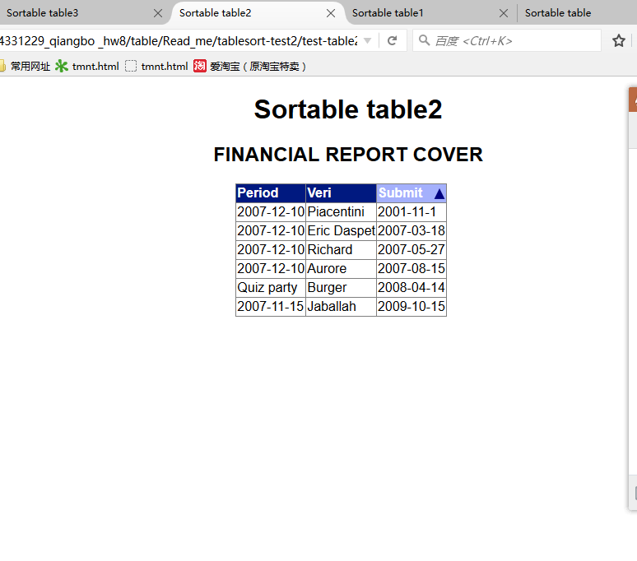
网页三：
table-test3测试截图如下：
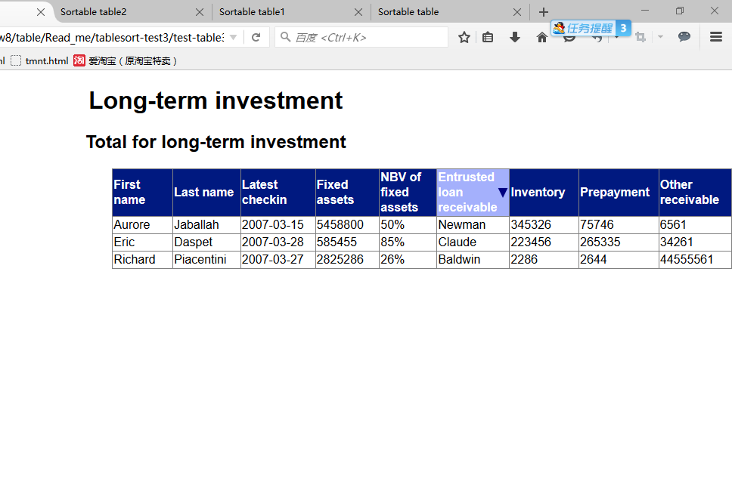
神秘代码如下：
$(document).ready(function() {module = (function(){var loop = 1;init_function();var if_diff = 0;function init_function(){var tableobjs=$('table');var n = 0;_.times(tableobjs.length, function() {n_table(n++);});}function n_table(n) {var tableobjs=$('table');var nHead = tableobjs[n].rows[0];
var col = 0;_.times(nHead.cells.length, function() {click_func(nHead, col, n);col++;});}function click_func(nHead, col, n) {nHead.cells[col].onclick = function(){loop = (-1) * loop;if (if_diff == col) { // 0_colupdownchange(col,n);} else {if_diff = col; //loop = -1;updownchange(col,n);}Sort_table(col, n);}}function updownchange(col, n) {var tableobjs1=$('table');var temp = tableobjs1[n].rows[0];if (loop == -1) {temp.cells[col].setAttribute('class', 'thcss1');other_cells(col,n);} else if (loop == 1){temp.cells[col].setAttribute('class', 'thcss2');other_cells(col,n);}}function other_cells(col,n) {var tableobjs2=$('table');var temp2 = tableobjs2[n].rows[0];var ss = 0;_.times(temp2.cells.length, function () {if (ss != col) temp2.cells[ss].setAttribute('class', 'th');ss++;});}function Sort_table(col,n) var all_tables =$('table');var this_table = all_tables[n];var table_word = this_table.tBodies[0];var old_word = table_word.rows;var new_word = new Array();var i = 0;_.times(old_word.length,function(){new_word[i] = old_word[i]; i++;});if (table_word.sortCol == col) {new_word.reverse();}else{new_word.sort(comp(col));}show_table(new_word,table_word,col);}function show_table(new_word,table_word,col) {var show_new_word = document.createDocumentFragment();var i = 0;_.times(new_word.length,function(){show_new_word.appendChild(new_word[i]); i++;});table_word.appendChild(show_new_word);table_word.sortCol = col;}function comp(col) {return function compare(first, second) {firstValue = String(first.cells[col].innerHTML);secondValue String(second.cells[col].innerHTML);if (firstValue < secondValue) {return -1;} else if (firstValue > secondValue) {return 1;} else {return 0;}};}})();})

