**ROS I/O Package**

Getting Started Guide

**R2014a**



**Revision History**

December 2013 New for Version 0.1.6.0 (Release 2013b)

January 2014 Updated for Version 0.1.6.1 (Release 2013b)

March 2014 Updated for Version 0.1.6.2 (Release 2014a)

Table of Contents

Introduction 4

Product Description 4

System Requirements 4

Installation and Configuration 5

Software Installation 5

Installed Files and Folders 10

Uninstallation 11

Updating rosjava Distribution 12

Importing Custom Messages 12

Tutorials 13

Creating a Publisher and a Subscriber 13

Reassigning Message Listener Tasks of a Subscriber 14

Creating a Custom Message Listener 16

Setting Up Shutdown Tasks of a Node 17

Class Reference 19

*rosmatlab.roscore* 19

*rosmatlab.node* 20

*rosmatlab.publisher* 24

*rosmatlab.subscriber* 25

*rosmatlab.message* 27

Useful Links 28

# Introduction

## Product Description

ROS I/O Package is a MATLAB® extension that provides the capability to interact with Robot Operating System (ROS) from MATLAB. ROS is basically a set of libraries and tools that helps software developers create robot applications. Licensed under an open source, BSD license, ROS provides hardware abstraction, device drivers, libraries, visualizers, message-passing, package management, and others. For more information, see [*http://wiki.ros.org*](http://wiki.ros.org/). Due to its flexibility, ROS is very popular among software developers in robotics. On the other hand, MATLAB and Simulink® are commonly used when it comes to prototyping algorithms and designs. The ability for MATLAB to interface with ROS is therefore very useful for users who want to verify their new algorithms prototyped in MATLAB along with existing software running on ROS. ROS I/O Package allows users to interact with robots and simulators that run on ROS from MATLAB directly without having to reimplement their publisher and/or subscriber nodes in Python®, C++, or Java®.

By extending the rosjava API, ROS I/O Package provides a set of new API for creating ROS nodes in MATLAB that operate and communicate based on ROS publisher/subscriber mechanism. ROS I/O Package has the following key features:

* Enable creation and removal of new nodes from MATLAB.
* Enable creation and removal of publishers from MATLAB.
* Enable creation and removal of subscribers from MATLAB.
* Enable creation of ROS messages in MATLAB.
* Enable publishers to publish MATLAB data to their advertised topics.
* Enable subscribers’ message listeners to execute arbitrary user defined MATLAB functions when applicable messages are received.
* Enable launching of ROS masters on the local host from MATLAB if none is available for connection externally.
* Support 32-bit and 64-bit Windows®.
* Support 64-bit Linux®, including Ubuntu®.
* Support 64-bit Mac OS X.

## System Requirements

* Operating system: Windows (32-bit and 64-bit), Linux (64-bit only), or Mac OS X (64-bit only).
* MATLAB R2014a, R2013b, R2013a, or R2012b.
* Access to ROS Hydro and Gazebo is recommended for running more examples on [*http://www.mathworks.com/ros*](http://www.mathworks.com/ros).

**Note:**

* Even though this guide is written specifically for MATLAB R2014a, you may use it with any of the supported releases. However, make sure you use the installer that matches the MATLAB release when installing ROS I/O Package.
* While ROS I/O Package is only tested against ROS Hydro, it is expected to work with other ROS releases as well. However, keep in mind that incompatibilities can exist if you apply messages that have mismatched signatures across releases.

# Installation and Configuration

## Software Installation

* To install ROS I/O Package on MATLAB R2014a win32, run the installer   
  *ROSIOPackage-R2014a_v0.1.6.2_win32-Install.exe*.
* To install ROS I/O Package on MATLAB R2014a win64, run the installer   
  *ROSIOPackage-R2014a_v0.1.6.2_win64-Install.exe*.
* To install ROS I/O Package on MATLAB R2014a glnxa64, run the installer   
  *ROSIOPackage-R2014a_v0.1.6.2_glnxa64-Install*.
* To install ROS I/O Package on MATLAB R2014a maci64, run the installer   
  *ROSIOPackage-R2014a_v0.1.6.2_maci64-Install*.
* You will be asked to select a destination folder for the PSP when running the installer. Select the root folder of your MATLAB installation as the destination folder. If necessary, you can use the MATLAB command *matlabroot* to determine the root folder where MATLAB is installed.
* Note that if ROS I/O Package is already installed, you must first uninstall it by running the uninstaller *ROSIOPackage-R2014a_v0.1.6.2_XXXXX-Uninstall*. You can find the uninstaller at *matlabroot\uninstall* (e.g., *C:\Program Files\MATLAB\R2014a\uninstall*). See the uninstallation instructions below.

**ATTENTION UBUNTU USERS!**

The following preparation steps are necessary in order to successfully launch the installer in Ubuntu:

* + Install the ia32-libs package by running *sudo apt-get install ia32-libs*, if it is not already installed. Otherwise, the installer will not launch.
  + Enable the execute permission of the installer file by enabling the *Allow executing file as program* option in the *Permissions* tab of the file’s Properties dialog.

Here are the instructions to run the installer:

1. Double-click *ROSIOPackage-R2014a_v0.1.6.2_XXXXX-Install* to launch the installer.
2. Click *Yes* when the Install ROS IO Package dialog appears.

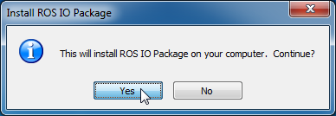

1. When the *Welcome to the InstallJammer Wizard for ROS IO Package* screen appears in the ROS IO Package Setup dialog, click *Next >* to start the installation process.

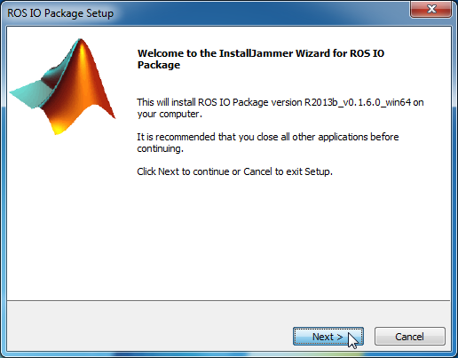

1. When the *License Agreement* screen appears in the ROS IO Package Setup dialog, read and then accept the license agreement by clicking *Next >*.

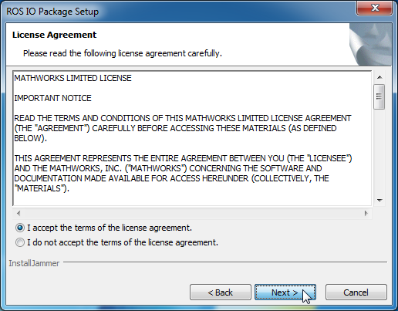

1. When the *Choose Destination Location* screen appears, click *Browse* to select a destination folder. This must be the root folder of your MATLAB installation.

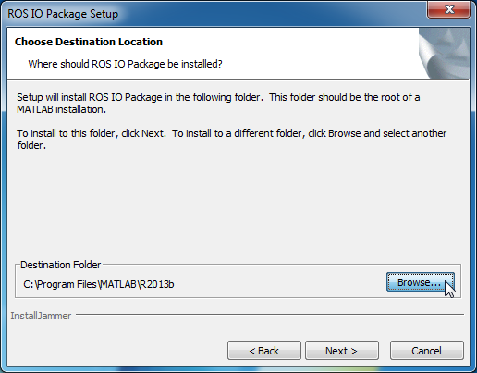

1. Click *Next >* after selecting a destination folder.

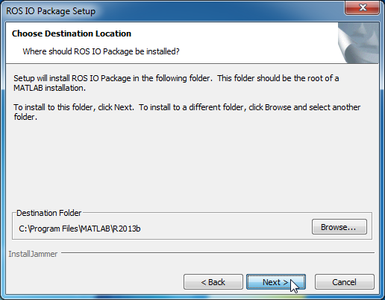

1. When the *Verifying MATLAB Directory* screen appears, click *Next >* to start the release verification step.

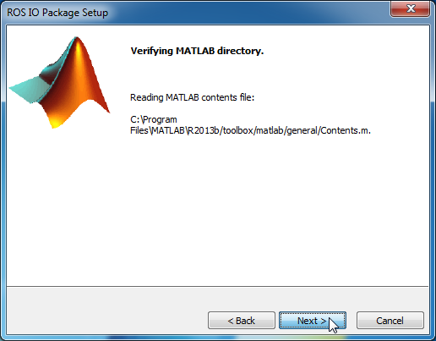

1. The verification result is displayed in the *Verifying MATLAB Release* screen. If the selected MATLAB release matches the targeted release, click *Next >*. Otherwise, you have to return to the *Choose Destination Location* screen to re-select the targeted release.

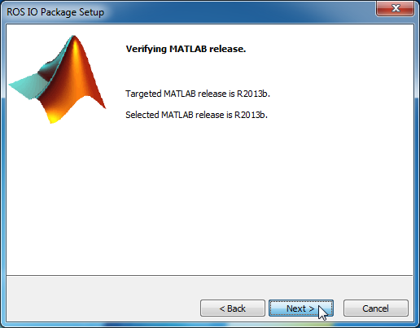

1. When the *Start Copying Files* screen appears, click *Next >* to start file extraction.

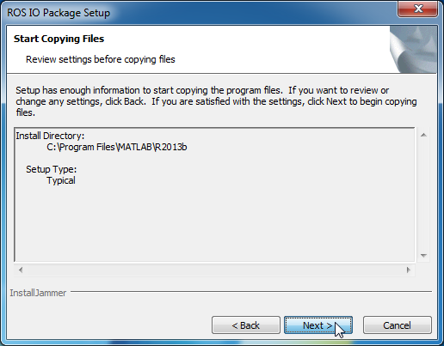

1. The *Installing* screen appears after all files are successfully copied. Click *Next >* to start the configuration process. The configuration process sets up the path so that ROS I/O Package is available for use when you launch MATLAB next time. Because this step automatically launches MATLAB to perform path addition, it may take a few minutes before the next screen appears.

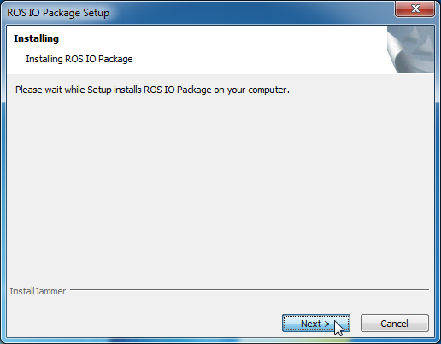

1. When the *Adding ROS IO Package to the MATLAB Path* screen appears, click *Next >*.

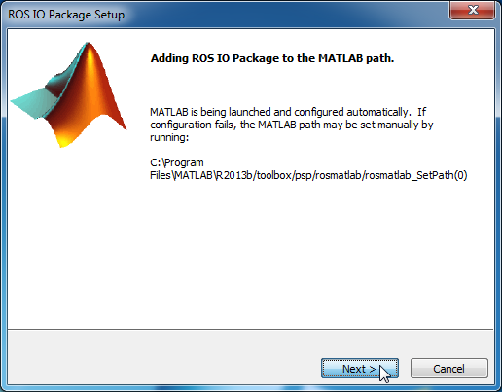

1. If the installation is successful, you will be brought to the *InstallJammer Wizard Complete* screen. Click *Finish* to close the installer.

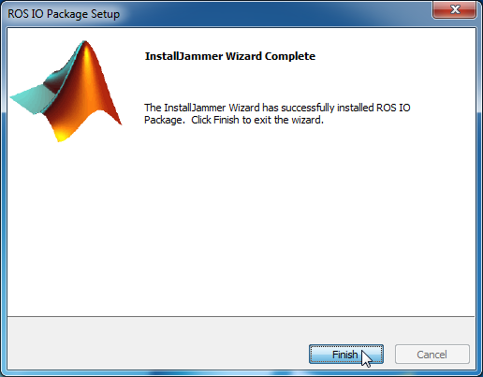

1. On Windows, the Program Compatibility Assistant may appear after the installation. You can simply click *This program installed correctly* to dismiss the dialog.

## Installed Files and Folders

When using ROS I/O Package, you might find it helpful to know the location of related files and folders as explained below:

* ROS I/O Package uses folders and files located in *matlabroot\toolbox\psp\rosmatlab*. This folder contains the new API that is made available under a package named rosmatlab. It also contains utilities for managing all related MATLAB and Java class paths.
* All applicable Java archive files that are distributed through the [maven artifact repository for rosjava dependencies and builds](https://github.com/rosjava/rosjava_mvn_repo) are placed in *matlabroot\toolbox\psp\rosmatlab\jars*. Note that ROS I/O Package 0.1.6.2 complements rosjava_core 0.1.6 (*rosjava-0.1.6.jar*). Its compatibility with other versions of rosjava_core is unknown.
* The folder *matlabroot\toolbox\psp\rosmatlab\examples* contains files used for demonstrating the ROS I/O Package API. These examples contain instructions for creating publisher and subscriber nodes in MATLAB.

## Uninstallation

**FOR WINDOWS AND LINUX USERS:**

An uninstaller named *ROSIOPackage-R2014a_v0.1.6.2_XXXXXUniInstall* is automatically created and placed in *matlabroot\uninstall* upon a successful installation. Here are the instructions to remove ROS I/O Package from MATLAB using the uninstaller:

1. Double-click *ROSIOPackage-R2014a_v0.1.6.2_XXXXX-Uninstall* to launch the uninstaller.
2. Click *Yes* when the Uninstall ROS IO Package dialog appears.

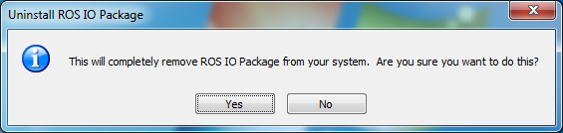

1. When the *Removing ROS IO Package from the MATLAB Path* screen appears in the ROS IO Package Setup dialog, click *Next >* to start the uninstallation process.

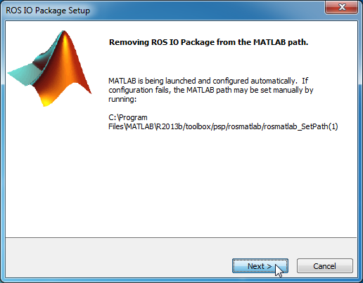

1. If the uninstallation is successful, you will be brought to the *Uninstall Complete* screen. Click *Finish* to close the uninstaller.

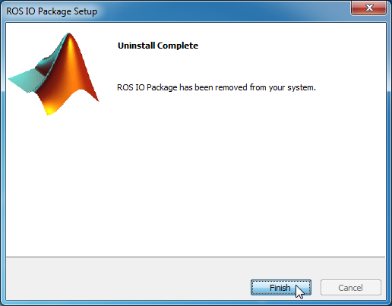

1. On Windows, the Program Compatibility Assistant may appear after the uninstallation. You can simply click *This program installed correctly* to dismiss the dialog.

**FOR MAC USERS:**

There is no uninstaller available for Mac. Use the following instructions to remove ROS I/O Package from MATLAB:

1. In MATLAB, run *rosmatlab_SetPath(1)* to revert changes to the Java class path and remove ROS I/O Package from the MATLAB path.
2. Exit MATLAB.
3. You can now safely delete all contents in *matlabroot\toolbox\psp\rosmatlab*.

## Updating rosjava Distribution

You can update or add new JAR files under the rosjava distribution if necessary. To do this,

1. Download the applicable JAR files from the [maven artifact repository for rosjava dependencies and builds](https://github.com/rosjava/rosjava_mvn_repo).
2. Copy the downloaded JAR files to *matlabroot\toolbox\psp\rosmatlab\jars*.
3. Remove JAR files that you want to replace from *matlabroot\toolbox\psp\rosmatlab\jars*.
4. Run the utility *rosmatlab_AddClassPath* to update the Java class path.
5. Restart MATLAB in order for the changes to take effect.

Keep in mind that when you replace existing JAR files in ROS I/O Package, the risk of incompatibility exists.

## Importing Custom Messages

If you have custom messages that are generated using rosjava based on the instructions given at <http://wiki.ros.org/rosjava/Tutorials/hydro/Unofficial%20Messages>, you can import them for use with ROS I/O Package. To do this,

1. Copy the rosjava generated JAR files to *matlabroot\toolbox\psp\rosmatlab\jars*.
2. Run the utility *rosmatlab_AddClassPath* to update the Java class path.
3. Restart MATLAB in order for the changes to take effect.

# Tutorials

## Creating a Publisher and a Subscriber

|  |
| --- |
| **Note:**  Commands used in the following example can be found in *matlabroot\toolbox\psp\ rosmatlab\examples\rosmatlab_basic.m*. |

The following example explains the basic instructions for creating publishers and subscribers. In the example, we create a node with a publisher and a subscriber that exchange *std_msgs/String* messages.

Every ROS node must connect to a master. Assuming that there is no external master available for connection, we have to first launch a master on the local host before proceeding with creating a new node. Use the following command to launch a ROS master on port *11311* on the local host:

|  |
| --- |
| roscore = rosmatlab.roscore(11311); |

To see the URI of the master, enter *roscore.RosMasterUri*. An attempt to launch another master on the same port will result in an error. Note that you must assign the returned object to a handle variable in order to keep it in memory. Otherwise, the object is automatically assigned to *ans*, and the object will be destroyed if *ans* is reassigned.

With a master available for connection, we are now ready to create a new node. Use the following command to create a new node named */NODE* and connect it to the master we just launched:

|  |
| --- |
| node = rosmatlab.node('NODE', roscore.RosMasterUri); |

To see the URI of the node, enter *node.Node.getUri()*. Notice that the IP address of the local host has been used to construct the URI. Also, notice that both *node.Publishers* and *node.Subscribers* are empty in the new node.

Next, we will create a publisher and a subscriber that exchange messages of type *std_msgs/String* via a topic named */TOPIC*. First, use the following command to add a publisher to the new node:

|  |
| --- |
| publisher = rosmatlab.publisher('TOPIC', 'std_msgs/String', node); |

Then, use the following command to add a subscriber to the new node:

|  |
| --- |
| subscriber = rosmatlab.subscriber('TOPIC', 'std_msgs/String', 1, node); |

Notice how the above command sets the buffer limit of the subscriber to *1*. Given the queue size of one, if the message listener processes new messages slower than they are received, the existing message that is yet to be processed will be removed from the buffer if a new message is received. If a subscriber is expecting messages that are published repeatedly, we recommend setting the buffer limit to at least a quarter of the highest frequency at which messages are received. Such a setting minimizes chances of experiencing dropped messages. For example, to receive messages at *100 Hz*, consider using a buffer limit of *25*. Note that this setting is particularly crucial if you are running on Windows.

In order for the subscriber to be useful, we need to bind at least one function to its standard message listener. This function executes when a valid message is published to the subscribed topic. It serves the purpose of carrying out message-driven tasks. Use the following command to set execution of a pair of functions named *function1* and *function2* whenever a valid message is published to */TOPIC*:

|  |
| --- |
| subscriber.setOnNewMessageListeners({@function1, @function2}); |

The definitions of both *function1* and *function2* are given in the code snippet below:

|  |
| --- |
| function function1(message)  disp(char(message.getData()));  end  function function2(message)  disp(sprintf('Message received: %s',datestr(now)));  end |

Note that each function expects the received message as its sole argument. Also, notice how *function1* reads the *data* field of the *std_msgs/String* message using the *getData* method of the message object.

Now, let us create a new message for use by the publisher. Use the following command to first create a *std_msgs/String* message:

|  |
| --- |
| msg = rosmatlab.message('std_msgs/String', node); |

Then use the following command to set the *data* field of the *std_msgs/String* message:

|  |
| --- |
| msg.setData(sprintf('Message created: %s', datestr(now))); |

Notice how the above command writes the *data* field of the *std_msgs/String* message using the *setData* method of the message object.

Once a message is populated with useful data, it is ready to be published. Use the following command to publish the message we just constructed:

|  |
| --- |
| publisher.publish(msg); |

You should see outputs similar to the following depending on the current date and time:

|  |
| --- |
| Message created: dd-mmm-yyyy HH:MM:SS  Message received: dd-mmm-yyyy HH:MM:SS |

## Reassigning Message Listener Tasks of a Subscriber

|  |
| --- |
| **Note:**  Commands used in the following example can be found in *matlabroot\toolbox\psp\ rosmatlab\examples\rosmatlab_basic.m*. |

The following example explains the basic instructions for reassigning and withdrawing the functions that you want execute when a valid message is published to the subscribed topic.

You can reassign tasks carried out by the standard message listener by simply binding a new set of functions using the *setOnNewMessageListener* method of the subscriber. The following command replaces *function1* and *function2* that were previously set with *function3*.

|  |
| --- |
| subscriber.setOnNewMessageListeners({@function3}); |

The definition of *function3*, which basically combines the tasks performed by both *function 1* and *function2* into a single function, is given in the code snippet below:

|  |
| --- |
| function function3(message)  disp([char(message.getData()), sprintf('\n Message received: %s', datestr(now))]);  end |

To test the new binding, use the following commands to update and publish the message iteratively:

|  |
| --- |
| for i = 1:10  msg.setData(sprintf('Iteration %d:\n Message created: %s', i, datestr(now)));  publisher.publish(msg);  pause(1);  end |

You can suspend the subscriber without removing it from the node by unbinding all functions from the standard message listener. To do that, use the following command:

|  |
| --- |
| subscriber.setOnNewMessageListeners([]); |

Without any binding, using the following commands to update and publish the message produces no effect:

|  |
| --- |
| msg.setData(sprintf('Message created: %s', datestr(now)));  publisher.publish(msg); |

If you want to remove a publisher or a subscriber from a node, you must use the *removePublisher* or *removeSubscriber* method of the node, respectively. Use the following command to remove the subscriber we previously created from the node:

|  |
| --- |
| node.removeSubscriber(subscriber); |

Verify that *node.Subscribers* is now empty. Notice that the variable *subscriber* in the workspace has been automatically deleted when you remove the subscriber from the node. Likewise, if you remove the publisher we previously created from the node, the variable *publisher* in the workspace will be automatically deleted as well.

Finally, to clean up, use the following command to delete the variable *roscore*:

|  |
| --- |
| clear('roscore'); |

This command triggers a call to the destructor of the *rosmatlab.roscore* object. The destructor first shuts down the master, and then destroys the object. In the process of doing so, the destructor searches for *rosmatlab.node* objects that are connected to the master for deletion. Notice that the above command not only deletes the variable *roscore* in the workspace, it also deletes the variables *node*, *publisher*, and *subscriber* if they still exist in the workspace.

## Creating a Custom Message Listener

|  |
| --- |
| **Note:**  Commands used in the following example can be found in *matlabroot\toolbox\psp\ rosmatlab\examples\rosmatlab_extra.m*. |

The following example demonstrates the use of alternative API for creating publishers, subscribers, and messages. It also explains how you can add a custom message listener to carry out user defined tasks when a valid message is published to the subscribed topic. This is useful when the function that performs the tasks expects arguments other than the message itself. In the example, we create a node with a publisher and a subscriber that exchange *geometry_msgs/Point* messages.

Similar to the previous example, we must first launch a master on the local host before proceeding with creating a new node. Use the following command to launch a ROS master on the local host.

|  |
| --- |
| roscore = rosmatlab.roscore(); |

Enter *roscore.RosMasterUri* to return the URI of the master. Notice that the master is launched on port *11311* by default since the *port* argument is omitted.

Next, we proceed with creating a new node. Use the following command to create a new node named */NODE* and connect it to the master we just launched:

|  |
| --- |
| node = rosmatlab.node('NODE', [], [], 'rosIP', '127.0.0.1'); |

Enter *node.Node.getUri()* to return the URI of the node. Notice that the above command uses the loopback interface to construct the node’s URI instead of using the host’s IP address. Also, notice that both *host* and *port* arguments are omitted in the command. This assumes the master is running on port *11311* on *localhost*.

With a new node, we can now create a publisher and a subscriber that exchange messages of type *geometry_msgs/Point* via a topic named */POINT*. Use the following commands to first add a publisher, and then a subscriber to the new node:

|  |
| --- |
| publisher = node.addPublisher('POINT', 'geometry_msgs/Point');  subscriber = node.addSubscriber('POINT', 'geometry_msgs/Point', 10); |

Notice how the above command sets the buffer limit of the subscriber to *10*. If the message listener processes new messages slower than they are received, existing messages that are yet to be processed will be removed from the buffer when more than 10 new messages are queued.

Instead of binding a function to the subscriber’s standard message listener, let us add a custom message listener to implement user defined tasks that execute when a valid message is published to the subscribed topic. Use the following command to add a custom message listener and set execution of a function named *custom_function* whenever a valid message is published to */POINT*:

|  |
| --- |
| subscriber.addCustomMessageListener({@custom_function, node.Node}); |

Notice how *custom_function* is set with a supplementary argument *node.Node* in the above command. We need to inspect the definition of *custom_function* in order to explain the syntax.

The definition of *custom_function* is given in the code snippet below:

|  |
| --- |
| function custom_function(handle, event, node)  message = event.JavaEvent.getSource;  magnitude = norm([message.getX(), message.getY(), message.getZ()]);  point = ['[', num2str(message.getX()), ',', num2str(message.getY()), ',', ...  num2str(message.getZ()), ']'];  node.getLog().info(['Distance of ', point, ' from the origin is ', num2str(magnitude), '.']);  end |

Note that the function expects a *node* object as a supplementary argument in addition to the standard arguments *handle* and *event*. Also, notice how *custom_function* extracts the received message from the *event* argument.

Now, let us create a new message for use by the publisher. Use the following command to first create a *geometry_msgs/Point* message:

|  |
| --- |
| msg = node.newMessage('geometry_msgs/Point'); |

Then use the following command to set the *x*, *y*, and *z* fields of the *geometry_msgs/Point* message for publishing iteratively.

|  |
| --- |
| for i = 1:10  msg.setX(rand(1))  msg.setY(rand(1))  msg.setZ(rand(1))  publisher.publish(msg);  pause(0.1);  end |

## Setting Up Shutdown Tasks of a Node

|  |
| --- |
| **Note:**  Commands used in the following example can be found in *matlabroot\toolbox\psp\ rosmatlab\examples\rosmatlab_extra.m*. |

Every node has a default node listener. You can bind user defined functions to a node’s default listener to perform clean up tasks when the node shuts down. Use the following command to set execution of a function named *preShutdownTask* when the node has started to shut down:

|  |
| --- |
| node.setOnShutdownListener(@preShutdownTask); |

Likewise, use the following command to set execution of a function named *postShutdownTask* when the node has shut down:

|  |
| --- |
| node.setOnShutdownCompleteListener(@postShutdownTask); |

The definitions of both *preShutdownTask* and *postShutdownTask* are given in the code snippet below:

|  |
| --- |
| function preShutdownTask(handle, event)  node = event.JavaEvent.getSource;  disp(['Node ', char(node.getName()), ' running on ', char(node.getUri()), ...  ' is shutting down.'])  end  function postShutdownTask(handle, event)  node = event.JavaEvent.getSource;  disp(['Node ', char(node.getName()), ' running on ', char(node.getUri()), ...  ' has shut down.'])  end |

To verify that the binding of *preShutdownTask* and *postShutdownTask* with the default node listener performs correctly, use the following command to shut down the node:

|  |
| --- |
| node.Node.shutdown(); |

You should see outputs similar to the following depending on the port where the node runs:

|  |
| --- |
| Node /NODE running on http://127.0.0.1:XXXXX/ is shutting down.  Node /NODE running on http://127.0.0.1:XXXXX/ has shut down. |

Finally, to completely destroy the node, use the following command to delete the variable *node*:

|  |
| --- |
| clear('node'); |

This command triggers a call to the destructor of the *rosmatlab.node* object. The destructor first shuts down the node, and then destroys the object. In the process of doing so, the destructor searches for *rosmatlab.publisher* and *rosmatlab.subscriber* objects that are attached to the node for deletion. Notice that the above command not only deletes the variable *node* in the workspace, it also deletes the variables *publisher* and *subscriber* if they still exist in the workspace.

# Class Reference

ROS I/O Package contains the following classes for constructing ROS masters, nodes, publishers, subscribers, and messages:

* *rosmatlab.roscore*
* *rosmatlab.node*
* *rosmatlab.publisher*
* *rosmatlab.subscriber*
* *rosmatlab.message*

Note that these classes are defined under a package named *rosmatlab*.

## *rosmatlab.roscore*

|  |  |
| --- | --- |
| **Property Summary** | |
| ***RosMaster*** (read only) | Master as returned by rosjava. ([*org.ros.RosCore*](http://rosjava.github.io/rosjava_core/hydro/javadoc/org/ros/RosCore.html)) |
| ***RosMasterUri*** (read only) | URI where the master is running on. (*char* array) |

|  |
| --- |
| **Constructor Summary** |
| Syntax:  *roscore = rosmatlab.****roscore****(port)*  Description:  Launch a ROS Master on the specified *port* on the local host. This constructor automatically starts the master once it is instantiated. The input argument *port* must be a *double*. If *port* is omitted, *11311* is the default.  Example:  *roscore = rosmatlab.roscore(11311)*  *roscore = rosmatlab.roscore()* |

|  |
| --- |
| **Method Summary** |
| Syntax:  *roscore.****start*** *()*  Description:  Start the master. Because the constructor automatically starts the master, use this method only if you want to restart the master after it has been shut down by the *roscore.shutdown ()* method.  Example:  *roscore.start()* |
| Syntax:  *roscore.****shutdown*** *()*  Description:  Shut down the master. Use this method only if you want to shut down the master without destroying it.  Example:  *roscore.shutdown ()* |
| Syntax:  *roscore.****delete****()*  Description:  Destructor. Note that this method automatically deletes all *rosmatlab.node* objects that run on the master in the caller workspace. This method is automatically called when all references to the object are deleted.  Example:  *roscore.delete()* |

## *rosmatlab.node*

|  |  |
| --- | --- |
| **Property Summary** | |
| ***Node*** (read only) | Default node as returned by rosjava. ([*org.ros.internal.node.DefaultNode*](http://rosjava.github.io/rosjava_core/hydro/javadoc/org/ros/internal/node/DefaultNode.html)) |
| ***NodeName*** (read only) | Name of the node. (*char* array) |
| ***OnShutdownListener*** (read only) | Listener binding the MATLAB function that executes when the node has started to shut down. (*handle.listener*) |
| ***OnShutdownCompleteListener*** (read only) | Listener binding the MATLAB function that executes when the node has shut down. (*handle.listener*) |
| ***Publishers*** (read only) | Publishers that are attached to the node. (*cell* array of *rosmatlab.publisher*) |
| ***Subscribers*** (read only) | Subscribers that are attached to the node. (*cell* array of *rosmatlab.publisher*) |

|  |
| --- |
| **Constructor Summary** |
| Syntax:  *node = rosmatlab.****node****(name, host, port)*  Description:  Launch a node with the specified *name* on the master that is running on http://*host*:*port*. The input arguments *name* and *host* must each be a *char* array. The input argument *port* must be a *double*. Note that *host* must be either the name or IP address of the host where the master you want to connect to is running on. If *host* is omitted, *localhost* is the default. If *port* is omitted, *11311* is the default. Every ROS node is assigned with a URI. This URI is not the same as the URI of its master. The URI of a new node is always constructed using one of the following in the order of precedence:   * Environment variable ROS_HOSTNAME * Environment variable ROS_IP * IP address of the local host   Example:  *node = rosmatlab.node('NODE', '123.33.22.234', 11311)*  *node = rosmatlab.node('NODE', 'HOSTNAME', 11311)*  *node = rosmatlab.node('NODE', 'HOSTNAME', [])*  *node = rosmatlab.node('NODE', [], 11311)*  *node = rosmatlab.node('NODE')* |
| Syntax:  *node = rosmatlab.****node****(name, uri)*  Description:  Launch a node with the specified *name* on the master that is running on *uri*. The input arguments *name* and *uri* must each be a *char* array (string). Note that *uri* must be the URI of the host where the master you want to connect to is running on. If *uri* is omitted, the environment variable *ROS_MASTER_URI* is used if it exists. Otherwise, *http://localhost:11311* is the default. Every ROS node is assigned with a URI. This URI is not the same as the URI of its master. The URI of a new node is always constructed using one of the following in the order of precedence:   * Environment variable ROS_HOSTNAME * Environment variable ROS_IP * IP address of the local host   Example:  *node = rosmatlab.node('NODE', 'http://123.33.22.234:11311')*  *node = rosmatlab.node('NODE', 'http://HOSTNAME:11311')*  *node = rosmatlab.node('NODE', 'http://localhost:11311')* |
| Syntax:  *node = rosmatlab.****node****(name, host, port, option, value)*  Description:  Launch a node with the specified *name* on the master that is running on http://*host*:*port* with any combination of the following options:   * *safeMode* - Use this option to enable parsing of connection errors to the master. Its value must be either *true* or *false*. The option is useful when the status of the master is not known. Note that this option incurs a delay of at least 20 seconds in order to detect the connection status. Without the option, you may experience error information that is logged to the MATLAB command window after every unsuccessful attempt to connect to the master. * *onShutdown* - Use this option to bind a user defined function that executes when the node has started to shut down. Its value must be a handle to a function with a signature of *functionName(handle, event)*. This option is useful for executing tasks upon a call to *node.Node.shutdown()*. * *onShutdownComplete* - Use this option to attach a user defined function that executes when the node has shut down. Its value must be a handle to a function with a signature of *functionName(handle, event)*. This option is useful for executing tasks upon a return of *node.Node.shutdown()*. * *rosIP* - Use this option to overwrite the IP address that is automatically determined for the local host. Its value must be a string in dotted decimal notation. When a node is created, the IP address for the local host is used to construct its URI for robustness reason. This option is useful for specifying the correct IP address when the local host is assigned with multiple IP addresses. You can also use this option to apply the loopback interface (127.0.0.1) for better performance if the node only communicates with other nodes on the local host.   Every ROS node is assigned with a URI. This URI is not the same as the URI of its master. The URI of a new node is always constructed using one of the following in the order of precedence:   * Value of the *rosIP* option * Environment variable ROS_HOSTNAME * Environment variable ROS_IP * IP address of the local host   Example:  The following command creates a node that connects to a master running on http://*HOSTNAME*:*11311* with the *safeMode* option enabled:  *node = rosmatlab.node('NODE', 'HOSTNAME', 11311,'safeMode', true)*  The following command creates a node that connects to a master running on http://*HOSTNAME*:*11311* using the loopback interface:  *node = rosmatlab.node('NODE', 'HOSTNAME', 11311, 'rosIP', '127.0.0.1')*  The following command creates a node that connects to a master running on http://*localhost*:*11311* with a setup to execute *preShutdown* and *postShutdown* functions when the node is shut down:  *node = rosmatlab.node('NODE', [], [], 'onShutdown', @preShutdown, ... 'onShutdownComplete', @postShutdown)* |

|  |
| --- |
| **Method Summary** |
| Syntax:  *publisher = node.****addPublisher****(topic, type)*  Description:  Create a new publisher of the specified *topic* and attach it to the node for sending messages of the given *type*. The input arguments *topic* and *type* must each be a *char* array. Note that *type* must be the name of a valid message type that implements *org.ros.internal.message.Message*. You can also use the constructor of *rosmatlab.publisher* to create a publisher as an alternative. See the documentation of *rosmatlab.publisher* for details on publishing messages.  Example:  *publisher = node.addPublisher('/TOPIC', 'std_msgs/String')* |
| Syntax:  *subscriber = node.****addSubscriber****(topic, type, limit)*  Description:  Create a new subscriber to the specified *topic* and attach it to the node for receiving messages of the given *type*; with a buffer that can queue new messages up to the specified *limit*. The input arguments *topic* and *type* must each be a *char* array. The input argument *limit* must be a *double*. Note that *type* must be the name of a valid message type that implements *org.ros.internal.message.Message*. If a message listener of the subscriber processes new messages slower than they are received, older messages in the queue are removed from the buffer when the buffer limit is exceeded. If the subscriber is expecting messages that are published repeatedly at high frequencies, increase the buffer limit to minimize chances of experiencing dropped messages. You can also use the constructor of *rosmatlab.subscriber* to create a subscriber as an alternative. See the documentation of *rosmatlab.subscriber* for details on receiving messages.  Example:  *subscriber = node.addSubscriber('/TOPIC', 'std_msgs/String', 1)* |
| Syntax:  *node.****newMessage****(type)*  Description:  Create a new message of the given *type*. The input argument *type* must be a *char* array. Note that *type* must be the name of a valid message type that implements *org.ros.internal.message.Message*. You can also use the constructor of *rosmatlab.message* to create a message as an alternative.  Example:  *message = node.newMessage('std_msgs/String')* |
| Syntax:  *node.****removePublisher****(publisher)*  Description:  Remove the given *publisher* from the node. The input argument *publisher* must be a *rosmatlab.publisher* object that is attached to the node. Note that this method automatically deletes the corresponding *rosmatlab.publisher* object in the caller workspace.  Example:  *node.removePublisher(publisher)* |
| Syntax:  *node.****removeSubscriber****(subscriber)*  Description:  Remove the given *subscriber* from the node. The input argument *subscriber* must be a *rosmatlab.subscriber* object that is attached to the node. Note that this method automatically deletes the corresponding *rosmatlab.subscriber* object in the caller workspace.  Example:  *node.removeSubscriber(subscriber)* |
| Syntax:  *node.****setOnShutdownListener****(function)*  Description:  Set the given *function* to carry out user defined tasks when the node has started to shut down. The input argument *function* must be a handle to a function with a signature of *functionName(handle, event)*. Note that this method is used for binding a user defined function that executes at the start of the shutdown process.  Example:  *node.setOnShutdownListener(@preShutdown)* |
| Syntax:  *node.****setOnShutdownCompleteListener****(function)*  Description:  Set the given *function* to carry out user defined tasks when the node has shut down. The input argument *function* must be a handle to a function with a signature of *functionName(handle, event)*. Note that this method is used for binding a user defined function that executes at the end of the shutdown process.  Example:  *node.setOnShutdownCompleteListener(@postShutdown)* |
| Syntax:  *node.****delete*** *()*  Description:  Destructor. Note that this method automatically deletes all *rosmatlab.publisher* and *rosmatlab.subscriber* objects that are attached to the node in the caller workspace. This method is automatically called when all references to the object are deleted.  Example:  *node.delete()* |

## *rosmatlab.publisher*

|  |  |
| --- | --- |
| **Property Summary** | |
| ***Publisher*** (read only) | Default publisher as returned by rosjava. ([*org.ros.internal.node.topic.DefaultPublisher*](http://rosjava.github.io/rosjava_core/hydro/javadoc/org/ros/internal/node/topic/DefaultPublisher.html)) |
| ***TopicMessageType*** (read only) | Type of message to be sent to the advertised topic. (*char* array) |
| ***TopicName*** (read only) | Name of the advertised topic. (*char* array) |

|  |
| --- |
| **Constructor Summary** |
| Syntax:  *publisher = rosmatlab.****publisher****(topic, type, node)*  Description:  Create a new publisher of the specified *topic* and attach it to *node* for sending messages of the given *type*. The input arguments *topic* and *type* must each be a *char* array. The input argument *node* must be a *rosmatlab.node* object. Note that *type* must be the name of a valid message type that implements *org.ros.internal.message.Message*. You can also use the *addPublisher* method of *rosmatlab.node* to create a publisher as an alternative.  Example:  *publisher = rosmatlab.publisher ('/TOPIC', 'std_msgs/String', node)* |

|  |
| --- |
| **Method Summary** |
| Syntax:  *publisher.****publish****(message)*  Description:  Publish the given *message* to the advertised topic. The input argument *message* must be a message object that implements *org.ros.internal.message.Message*. Note that the type of *message* must match the expected topic message type.  Example:  *publisher.publish(message)* |
| Syntax:  *publisher.****delete*** *()*  Description:  Destructor. This method is automatically called when all references to the object are deleted.  Example:  *publisher.delete()* |

## *rosmatlab.subscriber*

|  |  |
| --- | --- |
| **Property Summary** | |
| ***Subscriber*** (read only) | Default subscriber as returned by rosjava. ([*org.ros.internal.node.topic.DefaultSubscriber*](http://rosjava.github.io/rosjava_core/hydro/javadoc/org/ros/internal/node/topic/DefaultSubscriber.html)) |
| ***BufferLimit*** (read only) | The maximum number of messages to queue. (*int32*) |
| ***TopicMessageType*** (read only) | Type of message to be received from the subscribed topic. (*char* array) |
| ***TopicName*** (read only) | Name of the subscribed topic. (*char* array) |
| ***OnNewMessageListeners*** (read/write) | Listeners binding the MATLAB functions that execute when messages are received via the subscribed topics. (*cell* array of *handle.listener*) |

|  |
| --- |
| **Constructor Summary** |
| Syntax:  *subscriber = rosmatlab.****subscriber****(topic, type, limit, node)*  Description:  Create a new subscriber to the specified *topic* and attach it to *node* for receiving messages of the given *type*, with a buffer that can queue new messages up to the specified *limit*. The input arguments *topic* and *type* must each be a *char* array. The input argument *limit* must be a *double*. The input argument *node* must be a *rosmatlab.node* object. Note that *type* must be the name of a valid message type that implements *org.ros.internal.message.Message*. If a message listener of the subscriber processes new messages slower than they are received, older messages in the queue are removed from the buffer when the buffer limit is exceeded. If the subscriber is expecting messages that are published repeatedly at high frequencies, increase the buffer limit to minimize chances of experiencing dropped messages. You can also use the *addSubscriber* method of *rosmatlab.node* to create a subscriber as an alternative.  Example:  *subscriber = rosmatlab.subscriber ('/TOPIC', 'std_msgs/String', 1, node)* |

|  |
| --- |
| **Method Summary** |
| Syntax:  *subscriber.****addCustomMessageListener****(function)*  Description:  Set the given *function* that operates on an arbitrary number of arguments to carry out user defined tasks when a valid message is published to the subscribed topic. The input argument *function* must be a *cell* array in which the first entry is a function handle while the remaining entries are additional function arguments. Note that the function that is associated with this handle must have a signature of *functionName(handle, event, arguments)*.  Example:  *subscriber.addCustomMessageListener({@custom_function, extra_argument})* |
| Syntax:  *subscriber.****setOnNewMessageListeners****(functions)*  Description:  Set the given *functions* that operate on a received message to carry out user defined tasks when a valid message is published to the subscribed topic. The input argument *functions* must be a *cell* array of function handles. Note that each function that is associated with these handles must have a signature of *functionName(message)*.  Example:  *subscriber.setOnNewMessageListeners({@function1, @ function2})* |
| Syntax:  *subscriber.****delete*** *()*  Description:  Destructor. This method is automatically called when all references to the object are deleted.  Example:  *subscriber.delete()* |

## *rosmatlab.message*

|  |
| --- |
| **Constructor Summary** |
| Syntax:  *rosmatlab.****message****(type, node)*  Description:  Create a new message of the given *type* using a message factory of *node*. The input argument *type* must be a *char* array. The input argument *node* must be a *rosmatlab.node* object. Note that *type* must be the name of a valid message type that implements *org.ros.internal.message.Message*. You can also use the *newMessage* method of *rosmatlab.node* to create a message as an alternative.  Example:  *message = rosmatlab.message('std_msgs/String', node)*  Remarks:  In order to use a specific type of message, you must have exposure to its message definition. This information is available by inspecting either the msg file or documentation of the message. You can use [*http://wiki.ros.org*](http://wiki.ros.org) to lookup documentation for standard ROS messages. For example, documentation for the *std_msgs* package can be found at [*http://wiki.ros.org/std_msgs*](http://wiki.ros.org/std_msgs). Note that rosjava automatically generates a pair of *get* and *set* methods for every field in each message definition. For example, *std_msgs/String* contains a field named *data*. Upon creating a message object of type *std_msgs/String*, you can read and write its *data* field using its *getData* and *setData* methods, respectively. |

# Useful Links

* [*http://wiki.ros.org*](http://wiki.ros.org/) is the wiki page for ROS documentation. Use this site to access installation and user instructions for ROS.
* [*http://wiki.ros.org/rosjava*](http://wiki.ros.org/rosjava) is the wiki page for rosjava documentation. Use this site to access installation and user instructions for rosjava.
* [*http://rosjava.github.io/rosjava_core/hydro/index.html*](http://rosjava.github.io/rosjava_core/hydro/index.html) is the link to the documentation for rosjava_core.
* [*http://rosjava.github.io/rosjava_core/hydro/javadoc/index.html*](http://rosjava.github.io/rosjava_core/hydro/javadoc/index.html) is the link to the generated API documentation for rosjava_core. Use this site to access the summary of each class/interface in every package under rosjava_core.
* [*https://github.com/rosjava/rosjava_mvn_repo*](https://github.com/rosjava/rosjava_mvn_repo) is the maven artifact repository for rosjava dependencies and builds. Use this site to download the latest rosjava distribution.
* [*http://wiki.ros.org/turtlebot_simulator?distro=hydro*](http://wiki.ros.org/turtlebot_simulator?distro=hydro) is the wiki page for the Turtlebot Simulator. Use this site to access installation and user instructions for the *turtlebot_simulator* package.