2017年计算机组成原理与汇编语言期末试题答案及评分标准——B卷

一、填空题（本大题共15空，每空2分，共30分）
1. B D A C
2. Lui $a0,0x1234 Ori $a0,0x5678 （$a0可为任意寄存器）
3. 81 41 1.98
4. -2047
- slt $s1,$s2,$s3
6. A D B C
7. 1000010110（或534）， 00010110（或22）

二、简答题（本大题共4小题，每小题5分，共20分）。
1. CPI 每条指令的时钟周期数 (一个1分)
P2最好
P1执行的指令数是P1 (instructions/sec) = 3 × 10⁹/1.5 = 2.0× 10⁹
P1执行的指令数是P1 (instructions/sec) = 2.5×10⁹/1.0 = 2.5 × 10⁹
P1执行的指令数是P1 (instructions/sec) = 4 × 10⁹/2.5 = 1.6 × 10⁹

2. 1）不能，可能1位或3位错（2分）
- 奇偶校验只能发现错，不能找到哪位错。（1分）
- 不能，可能2位错或者正确。（2分）

3. 20ten = 10100two = 1.0100_{two} • 2⁴
Sign = 1,
Significand = .0100
Single exponent = 4 + 127 = 131
单精度值：1 1000 011 010 0000 0000 0000 0000 0000 （每步1分）

4. 四个每个1分，其它描述1分
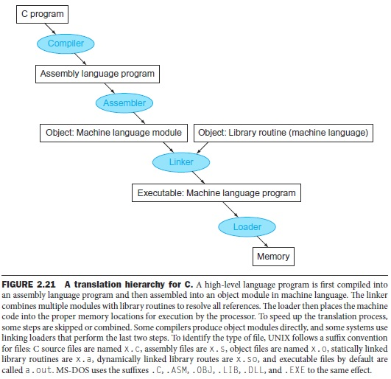

三、应用题（本大题共2小题，每小题10分，共20分）
1、add $t0, $zero, $zero # initialize running sum $t0 = 0
loop: beq $a1, $zero, finish # finished when $a1 is 0
add $t0, $t0, $a0 # compute running sum of $a0
sub $a1, $a1, 1 # compute this $a1 times
j loop # jump to loop
finish: add $v0, $t0, $zero # t0送给v0并return v0
程序功能是计算a*b
(每行1分，说出功能4分)

2. （每行2分）
十进制字地址 | 二进制字地址（30位） | TAG（26位） | INDEX | 命中
6 | 0...0 0000 0110 | 0...0 0000 | 0110 | 否
214 | 0...0 1101 0110 | 0...0 1101 | 0110 | 否
175 | 0...0 1010 1111 | 0...0 1010 | 1111 | 否
214 | 0...0 1101 0110 | 0...0 1101 | 0110 | 是
6 | 0...0 0000 0110 | 0...0 0000 | 0110 | 否

四、数据通路分析与设计题（本大题共2小题，每小题15分，共30分）。提示：按照各小题要求做相应分析或设计，若分析或设计正确则给分，若分析或设计完全错误则无分，若分析或设计不准确或不全面，则酌情扣分。
1. 1）. RegWrite = 1:Sw and beq should not write results to the register file.sw(beq) will overwrite a random register with either the store address (branch target) or random data from the memory data read port.
2）. ALUop1 = 1:lw and sw will not work correctly.lw and sw will perform a
random operation depending on the least significant bits of the address field
instead of addition operation necessary for address calculation.
3）. Branch = 1: Instructions other than branches ( beq) will not work correctly if the ALU Zero signal is raised. An R-format instruction that produces zero output will branch to a random address determined by its least significant 16 bits.
4）. MemRead = 1: All instructions will work correctly. (Data memory is always
read, but memory data is never written to the register file except in the case of lw.)
5）. MemWrite = 1: Only sw will work correctly. The rest of instructions will
store their results in the data memory, while they should not（每个3分）

2. (1) 单周期时钟长度取决于最慢的那条指令，效率太低。
多周期虽然增加了寄存器等，但可分时复用，同时多条指令运行，
而且每条指令执行周期不是固定为最慢的那条指令的周期。（4分）
(2) lw $t0,4($t1) 第二个周期（译码寄存器读周期）（每个信号0.5分）。
PCWrite = 0不写PC
MemWrite = 0不写内存
MemRead = 0 不读内存
IRWrite = 0不写IR
RegWrite = 0不写寄存器
ALUSrcB = 11（3）选择符号位扩展后的立即数
ALUSrcA = 0 选择PC
ALUOp = 00 SW指令

(3) 可以不增加电路和控制信号（2分）。4个周期（1分）原因（每个1分）
A.取指周期都一样。。。
B.译码后不需要读取寄存器，立即数会符号位扩展成32位， ALUSrcB = 10，
C.ALU上做移位运算，左移16位，低位补16个0
D.将ALUOUT的结果写入寄存器$s1.
We use the same datapath, so the immediate field shift will be done inside
the ALU.

1.Instruction fetch step: This is the same (IR <= Memory[PC]; PC <= PC + 4)
2. Instruction decode step: We don't really need to read any register in this stage if we know that the instruction in hand is a lui, but we will not know this before the end of this cycle. It is tempting to read the immediate field into the ALU to start shifting next cycle, but we don't yet know what the instruction is. So we have to perform the same way as the standard machine does.A <= 0 ($r0); B <= $rt; ALUOut <= PC + (sign-extend(immediate field));
3. Execution: Only now we know that we have a lui. We have to use the ALU to shift left the low-order 16 bits of input 2 of the multiplexor. (The sign extension is useless, and sign bits will be flushed out during the shift process.) ALUOut <= {IR[15-0],16(0)}
4. Instruction completion: Reg[IR[20-16]] = ALUOut.The first two cycles are identical to the FSM of Figure 5.38. By the end of the second cycle the FSM will recognize the opcode. We add the Op='lui', a new transition condition from state 1 to a new state 10. In this state we perform the left shifting of the immediate field: ALUSrcA = x, ALUSrcB = 10, ALUOp = 11 (assume this means left shift of ALUSrcB). State 10 corresponds to cycle 3. Cycle 4
will be translated into a new state 11, in which RegDst = 0, RegWrite, MemtoReg
= 0. State 11 will make the transition back to state 0 after completion.
As shown above the instruction execution takes 4 cycles.

