


上机实验报告

课程名称： | 操作系统
实验题目： | 文件操作的模拟实验
专业班级： | 计算机1902班
学 号： | 1906410229
姓 名： | 蔡艺洵
日 期： | 2021年12月1日

【实验目的】
- 了解文件系统的原理；
- 用高级语言编写和调试一个简单的文件系统，模拟文件管理的工作过程。从而对各种文件操作命令的实质内容和执行过程有比较深入的了解。

【实验准备】
1．文件的逻辑结构
  - 顺序文件
  - 索引文件
  - 索引顺序文件
  - 直接文件和哈希文件
2．外存分配方式
  - 连续分配
  - 链接分配
  - 索引分配

【实验内容】
- 实验要求
要求设计一个 n个用户的文件系统，每次用户可保存m个文件，用户在一次运行中只能打开一个文件，对文件必须设置保护措施，且至少有Create、delete、open、close、read、write等命令。
- 实验题目
  - 设计一个10个用户的文件系统，每次用户可保存10个文件，一次运行用户可以打开5个文件。
  - 程序采用二级文件目录（即设置主目录[MFD]）和用户文件目录（UED）。另外，为打开文件设置了运行文件目录（AFD）。
  - 为了便于实现，对文件的读写作了简化，在执行读写命令时，只需改读写指针，并不进行实际的读写操作。
- 算法与框图

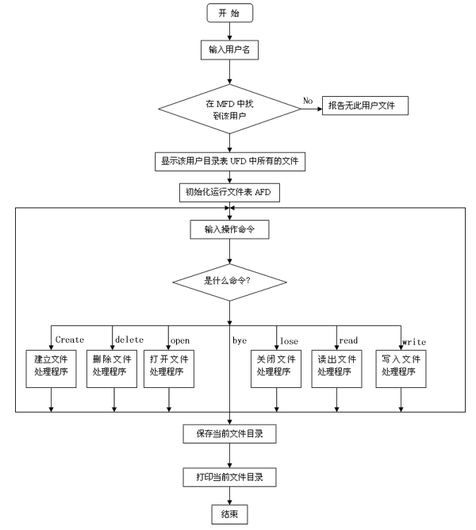
因系统小，文件目录的检索使用了简单的线性搜索。文件保护简单使用了三位保护码：允许读写执行、对应位为 1，对应位为0，则表示不允许读写、执行。程序中使用的主要设计结构如下：主文件目录和用户文件目录（ MFD、UFD）打开文件目录（ AFD）（即运行文件目录）。

  M D F
  用户名
  文件目录指针
  用户名
  文件目录指针
  U F D
  文件名
  保护码
  文件长度
  文件名
  A F D
  打开文件名
  打开保护码
  读写指针

【源程序代码】
#define _CRT_SECURE_NO_WARNINGS
#include<iostream>
#include<string>
#include<conio.h>
using namespace std;
struct TYPE_UFD
{
string File_Name;
bool Read;
bool Write;
bool Execute;
int Length_File;
};
struct TYPE_MFD
{
string User_Name;
TYPE_UFD *Pointer;
};
struct TYPE_AFD
{
int File_ID;
bool Read;
bool Write;
bool Execute;
int Pointer;
};
class TYPE_FILE_SYSTEM
{
public:
void Initial(void);
void Start(void);

private:
int _Number_Users;
int _Number_Files;
int _MaxNumber_Open_Files;
TYPE_MFD *_MFD;
TYPE_UFD *_UFD;
TYPE_AFD *_AFD;
};
void TYPE_FILE_SYSTEM::Initial(void)
{
_Number_Users = 10;
_Number_Files = 10;
_MaxNumber_Open_Files = 5;
_UFD = new TYPE_UFD[_Number_Users*_Number_Files]; _MFD = new TYPE_MFD[_Number_Users];
int i = 0;
for (i = 0; i < _Number_Users; i++)
{
_MFD[i].Pointer = &(_UFD[i*_Number_Files]);
}
_AFD = new TYPE_AFD[_MaxNumber_Open_Files];
_MFD[0].User_Name = "caiyixun";
_UFD[0].File_Name = "caiyixun1.txt";

_UFD[0].Length_File = 10;
_UFD[0].Read = true;
_UFD[0].Write = false;
_UFD[0].Execute = true;
_UFD[1].File_Name = "caiyixun2.txt";
_UFD[1].Length_File = 20;
_UFD[1].Read = true;
_UFD[1].Write = false;
_UFD[1].Execute = false;
for (i = 2; i < _Number_Files; i++)
{
_UFD[i].File_Name = "";
_UFD[i].Length_File = -1;
_UFD[i].Read = false;
_UFD[i].Write = false;
_UFD[i].Execute = false;
}}
void TYPE_FILE_SYSTEM::Start(void)
{
int User_ID;
int i, temp_int;
string temp;
char choice;
int Number_Open_Files;
string User_Name;
string Command;
TYPE_UFD *UFD;
do
{
do
{
cout << "User name:";
cin >> User_Name;
for (User_ID = 0; User_ID < _Number_Users; User_ID++) {
if (_MFD[User_ID].User_Name == User_Name)
break;
}
if (User_ID == _Number_Users)
cout << "Bad user name , please try again ." << endl;
}
while (User_ID == _Number_Users);
cout << "Ok , welcome to login , " << User_Name << " !" << endl; UFD = _MFD[User_ID].Pointer;
for (i = 0; i < _MaxNumber_Open_Files; i++)
{
_AFD[i].File_ID = -1;
}
Number_Open_Files = 0;
do
{
cout << "C:\\" << User_Name << ">";
cin >> Command;
if (Command == "dir")
{
cout << endl;
cout << "Files of user " << User_Name << endl;
cout << "\t" << "State\t" << "Length\t" << "File name" << endl;
for (i = 0; i < _Number_Files; i++){
if (UFD[i].Length_File != -1){
cout << "\t";
if (UFD[i].Read == true)
cout << "R";
else

cout << "-";
if (UFD[i].Write == true)
cout << "W";
else
cout << "-";
if (UFD[i].Execute == true)
cout << "E";
else
cout << "-";
cout << "\t";
cout << UFD[i].Length_File;
cout << "\t";
cout << UFD[i].File_Name << endl;
}}
cout << endl;
}
else if (Command == "diropen")
{
cout << endl;
cout << "Opening Files of user " << User_Name << endl; cout << "\t" << "State\t" << "Open File name" << endl; for (i = 0; i < _MaxNumber_Open_Files; i++){
if (_AFD[i].File_ID != -1)
{
cout << "\t";
if (_AFD[i].Read == true)
cout << "R";
else
cout << "-";
if (_AFD[i].Write == true)
cout << "W";

else
cout << "-";
if (_AFD[i].Execute == true)
cout << "E";
else
cout << "-";
cout << "\t";
cout << UFD[_AFD[i].File_ID].File_Name << endl;
}}
cout << endl;
}
else if (Command == "create"){
for (i = 0; i < _Number_Files; i++)
if (UFD[i].Length_File == -1)
break;
if (i == _Number_Files)
cout << "Error: you have already had " <<
_Number_Files << " files ." << endl;
else {
cout << "Please enter the information of the new file:" << endl;
cout << "File name : ";
cin >> temp;
UFD[i].File_Name = temp;
cout << "Read (y/n):";
do
{
choice = _getch();
}
while (choice != 'y' && choice != 'n');
if (choice == 'y')
UFD[i].Read = true;

else
UFD[i].Read = false;
cout << endl;
cout << "Write (y/n):";
do
{
choice = _getch();
}
while (choice != 'y' && choice != 'n');
if (choice == 'y')
UFD[i].Write = true;
else
UFD[i].Write = false;
cout << endl;
cout << "Execute (y/n):";
do
{
choice = _getch();
}
while (choice != 'y' && choice != 'n');
if (choice == 'y')
UFD[i].Execute = true;
else
UFD[i].Execute = false;
cout << endl;
cout << "Length :";
cin >> temp_int;
if (temp_int > 0)
UFD[i].Length_File = temp_int;
cout << "Ok , the new file " << UFD[i].File_Name << " is created!" << endl;}}

else if (Command == "delete")
{
cout << "Please enter the file name :";
cin >> temp;
for (i = 0; i < _Number_Files; i++)
if ((UFD[i].Length_File != -1) && (UFD[i].File_Name == temp))
break;
if (i == _Number_Files)
cout << "Bad file name , please try again ." << endl; else{
UFD[i].Length_File = -1;
cout << "Ok , the file " << UFD[i].File_Name << " is deleted ." << endl;}
}
else if (Command == "open")
{
if (Number_Open_Files == _MaxNumber_Open_Files)
cout << "Error: you have already opened " << Number_Open_Files << " files." << endl;
else
{
cout << "Please enter the file name :";
cin >> temp;
for (i = 0; i < _Number_Files; i++)
if ((UFD[i].Length_File != -1) && (UFD[i].File_Name == temp))
break;
if (i == _Number_Files)
cout << "Bad file name , please try again ." << endl;
else
{
Number_Open_Files++;
for (temp_int = 0;

temp_int < _MaxNumber_Open_Files; temp_int++)
if (_AFD[temp_int].File_ID == -1)
break;
_AFD[temp_int].File_ID = i;
_AFD[temp_int].Pointer = 0;
cout << "Please configure the open mode :" << endl;
if (UFD[i].Read == true)
{
cout << "Read (y/n):";
do
{
choice = _getch();
}
while (choice != 'y' && choice != 'n');
if (choice == 'y')
_AFD[temp_int].Read = true;
else
_AFD[temp_int].Read = false;
cout << endl;
}
else
_AFD[temp_int].Read = false;
if (UFD[i].Write == true){
cout << "Write (y/n):";
do
{
choice = _getch();
}
while (choice != 'y' && choice != 'n');
if (choice == 'y')
_AFD[temp_int].Write = true;

else
_AFD[temp_int].Write = false;
cout << endl;
}
else
_AFD[temp_int].Write = false;
if (UFD[i].Execute == true)
{
cout << "Execute (y/n):";
do
{
choice = _getch();
}
while (choice != 'y' && choice != 'n');
if (choice == 'y')
_AFD[temp_int].Execute = true;
else
_AFD[temp_int].Execute = false;
cout << endl;
}
else
_AFD[temp_int].Execute;
cout << "Ok , the file " << temp << " is open ." << endl;
}}}
else if (Command == "logout")
{
cout << "Ok , see you later , " << User_Name << " !" << endl;
break;
}
else if (Command == "close")
{
cout << "Please enter the file name :";
cin >> temp;
for (i = 0; i < _Number_Files; i++)
if ((UFD[i].Length_File != -1) && (UFD[i].File_Name == temp))
break;
if (i == _Number_Files)
cout << "Bad file name , please try again ." << endl; else
{
for (temp_int = 0; temp_int < _MaxNumber_Open_Files; temp_int++)
if (_AFD[temp_int].File_ID == i)
break;
if (temp_int == _MaxNumber_Open_Files)
cout << "The file " << temp << " isn't open ." << endl;
else
{
_AFD[temp_int].File_ID = -1;
Number_Open_Files--;
cout << "Ok , the file " << temp << " is closed ." << endl;
}}}
else if (Command == "read")
{
cout << "Please enter the file name :";
cin >> temp;
for (i = 0; i < _Number_Files; i++)
if ((UFD[i].Length_File != -1) && (UFD[i].File_Name == temp))
break;
if (i == _Number_Files)
cout << "Bad file name , please try again ." << endl; else
{
for (temp_int = 0; temp_int < _MaxNumber_Open_Files; temp_int++)
if (_AFD[temp_int].File_ID == i)
break;
if (temp_int == _MaxNumber_Open_Files)
cout << "The file " << temp << " isn't open ." << endl;
else
{
if (_AFD[temp_int].Read == true)
cout << "Ok , read the file " << temp << " successfully." << endl;
else
cout << "Error: the open mode of the file doesn't allow you to read it ." << endl;
}}}
else if (Command == "write")
{
cout << "Please enter the file name :";
cin >> temp;
for (i = 0; i < _Number_Files; i++)
if ((UFD[i].Length_File != -1) && (UFD[i].File_Name == temp))
break;
if (i == _Number_Files)
cout << "Bad file name , please try again ." << endl; else
{
for (temp_int = 0; temp_int < _MaxNumber_Open_Files; temp_int++)
if (_AFD[temp_int].File_ID == i)
break;
if (temp_int == _MaxNumber_Open_Files)
cout << "The file " << temp << " isn't open ." << endl;
else
{
if (_AFD[temp_int].Write == true)
cout << "Ok , write the file " << temp << " successfully." << endl;
else
cout << "Error: the open mode of the file doesn't allow you to write it ." << endl;}}}
else if (Command == "shutdown")
{
cout << "Loging out........" << endl;
cout << "Ok , see you later , " << User_Name << " !" << endl;
cout << "The power of the computer is shutting down.........." << endl;
break;}
else
{
cout << "Bad commands , please try again ." << endl;
}}
while (Command != "logout" && Command != "shutdown");}
while (Command != "shutdown");}
void main(){
TYPE_FILE_SYSTEM FS;
FS.Initial();
FS.Start();
}
运行结果：
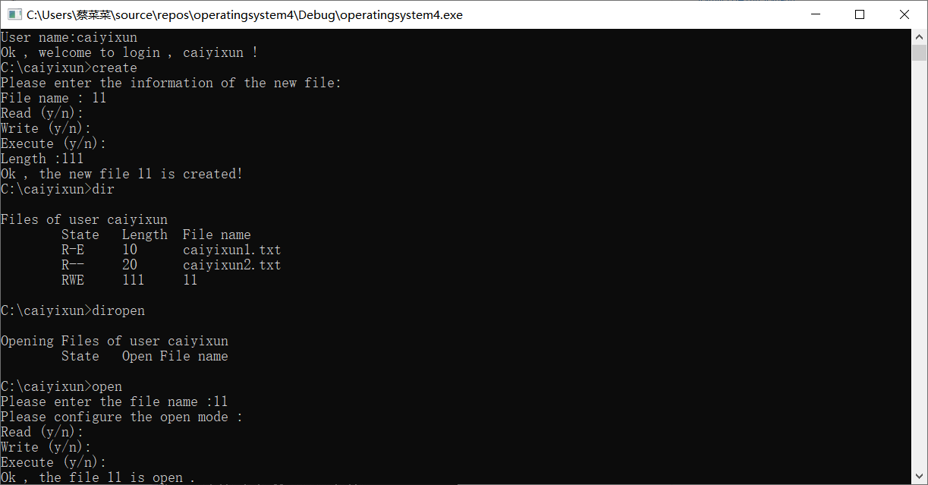
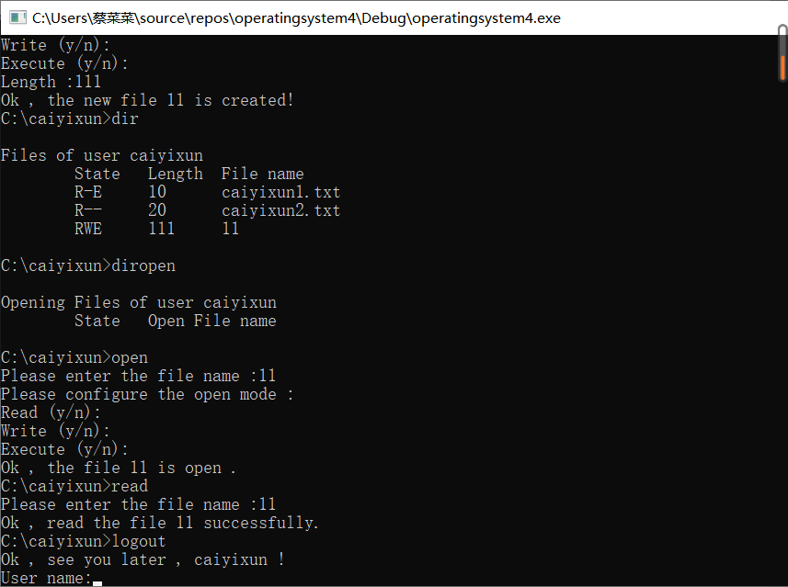
【实验体会】
通过这次的上机实验使我认识到要将操作系统这门计算机专业的课学好不仅仅是要把书上的基本知识学好而且还要不断进行实践，将所学的跟实践操作结合起来才能更好地巩固所学，才能提高自己实践能力.通过这次的设计使我认识到只停留在表面理解问题是很难使问题得到很好的解决的，实践能力与理论知识同样重要。可以说此课程设计的理论难度并不大，但是若要深入发掘其中的东西，并且实际去编程实现，就遇到了相当大的难度。因为与之涉及的很多方面并没有学过，需要自己去自学和实践检验。
【思考题】
- 什么是逻辑文件，什么是物理文件，它们有什么区别？
逻辑文件是从用户出发所观察到的文件组织形式，是用户可以直接处理的数据及其结构，它独立于文件的物理特性。物理文件，为文件的存储结构，是指文件在外存上的存储组织形式。与存储性能，所采用的外存分配方式有关。

