


上机实验报告

课程名称： | 操作系统
实验题目： | 文件操作的模拟实验
专业班级： | 计算机2101班
学 号： | 2104230414
日 期： | 2024.05.15

【实验目的】
- 了解文件系统的原理；
- 用高级语言编写和调试一个简单的文件系统，模拟文件管理的工作过程。从而对各种文件操作命令的实质内容和执行过程有比较深入的了解。

【实验准备】
文件的逻辑结构
  - 顺序文件
  - 索引文件
  - 索引顺序文件
  - 直接文件和哈希文件
2．外存分配方式
  - 连续分配
  - 链接分配
  - 索引分配

【实验内容】
- 实验要求
要求设计一个 n个用户的文件系统，每次用户可保存m个文件，用户在一次运行中只能打开一个文件，对文件必须设置保护措施，且至少有Create、delete、open、close、read、write等命令。
- 实验题目
  - 设计一个10个用户的文件系统，每次用户可保存10个文件，一次运行用户可以打开5个文件。
  - 程序采用二级文件目录（即设置主目录[MFD]）和用户文件目录（UED）。另外，为打开文件设置了运行文件目录（AFD）。
  - 为了便于实现，对文件的读写作了简化，在执行读写命令时，只需改读写指针，并不进行实际的读写操作。
- 算法与框图

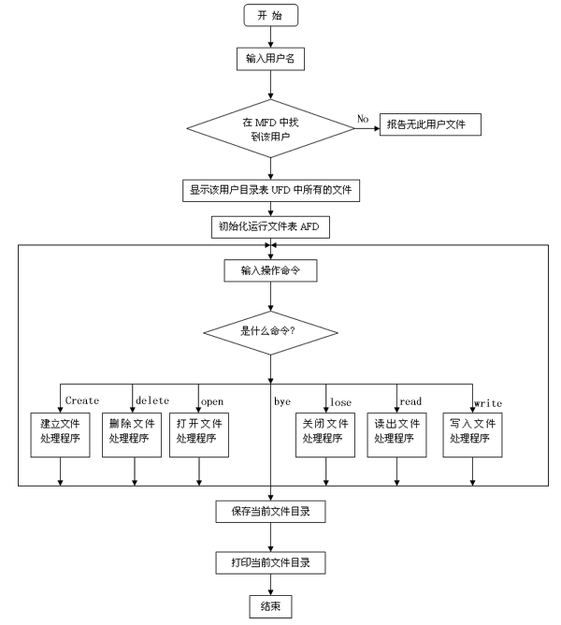
因系统小，文件目录的检索使用了简单的线性搜索。文件保护简单使用了三位保护码：允许读写执行、对应位为 1，对应位为0，则表示不允许读写、执行。程序中使用的主要设计结构如下：主文件目录和用户文件目录（ MFD、UFD）打开文件目录（ AFD）（即运行文件目录）。

  M D F
  用户名
  文件目录指针
  用户名
  文件目录指针
  U F D
  文件名
  保护码
  文件长度
  文件名
  A F D
  打开文件名
  打开保护码
  读写指针

【源程序代码】
#include<iostream>
#include<string>
#include<conio.h>
using namespace std;
struct TYPE_UFD
{
string File_Name;
bool Read;
bool Write;
bool Execute;
int Length_File;
};
struct TYPE_MFD
{
string User_Name;
TYPE_UFD* Pointer;
};
struct TYPE_AFD
{
int File_ID;
bool Read;
bool Write;
bool Execute;
int Pointer;
};
class TYPE_FILE_SYSTEM
{
public:
void Initial(void);
void Start(void);
private:
int _Number_Users;
int _Number_Files;
int _MaxNumber_Open_Files;
TYPE_MFD* _MFD;
TYPE_UFD* _UFD;
TYPE_AFD* _AFD;
};
void TYPE_FILE_SYSTEM::Initial(void)
{
_Number_Users = 10;
_Number_Files = 10;
_MaxNumber_Open_Files = 5;
_UFD = new TYPE_UFD[_Number_Users * _Number_Files]; _MFD = new TYPE_MFD[_Number_Users];
int i = 0;
for (i = 0; i < _Number_Users; i++)
{
_MFD[i].Pointer = &(_UFD[i * _Number_Files]);
}
_AFD = new TYPE_AFD[_MaxNumber_Open_Files];
_MFD[0].User_Name = "qc";
_UFD[0].File_Name = "test1.txt";
_UFD[0].Length_File = 10;
_UFD[0].Read = true;
_UFD[0].Write = false;
_UFD[0].Execute = true;
_UFD[1].File_Name = "test2.txt";
_UFD[1].Length_File = 20;
_UFD[1].Read = true;
_UFD[1].Write = false;
_UFD[1].Execute = false;
for (i = 2; i < _Number_Files; i++)
{
_UFD[i].File_Name = "";
_UFD[i].Length_File = -1;
_UFD[i].Read = false;
_UFD[i].Write = false;
_UFD[i].Execute = false;
}
}
void TYPE_FILE_SYSTEM::Start(void)
{
int User_ID;
int i, temp_int;
string temp;
char choice;
int Number_Open_Files;
string User_Name;
string Command;
TYPE_UFD* UFD;
do
{
do
{
cout << "User name:";
cin >> User_Name;
for (User_ID = 0; User_ID < _Number_Users; User_ID++) {
if (_MFD[User_ID].User_Name == User_Name)
break;
}
if (User_ID == _Number_Users)
cout << "Bad user name , please try again ." << endl;
} while (User_ID == _Number_Users);
cout << "欢迎" << User_Name << "登录文件系统 !" << endl; UFD = _MFD[User_ID].Pointer;
for (i = 0; i < _MaxNumber_Open_Files; i++)
{
_AFD[i].File_ID = -1;
}
Number_Open_Files = 0;
do
{
cout << "C:\\" << User_Name << ">";
cin >> Command;
if (Command == "dir")
{
cout << endl;
cout << "Files of user " << User_Name << endl;
cout << "\t" << "State\t" << "Length\t" << "File name" << endl;
for (i = 0; i < _Number_Files; i++) {
if (UFD[i].Length_File != -1) {
cout << "\t";
if (UFD[i].Read == true)
cout << "R";
else
cout << "-";
if (UFD[i].Write == true)
cout << "W";
else
cout << "-";
if (UFD[i].Execute == true)
cout << "E";
else
cout << "-";
cout << "\t";
cout << UFD[i].Length_File;
cout << "\t";
cout << UFD[i].File_Name << endl;
}
}
cout << endl;
}
else if (Command == "diropen")
{
cout << endl;
cout << "Opening Files of user " << User_Name << endl; cout << "\t" << "State\t" << "Open File name" << endl; for (i = 0; i < _MaxNumber_Open_Files; i++) {
if (_AFD[i].File_ID != -1)
{
cout << "\t";
if (_AFD[i].Read == true)
cout << "R";
else
cout << "-";
if (_AFD[i].Write == true)
cout << "W";
else
cout << "-";
if (_AFD[i].Execute == true)
cout << "E";
else
cout << "-";
cout << "\t";
cout << UFD[_AFD[i].File_ID].File_Name << endl;
}
}
cout << endl;
}
else if (Command == "create") {
for (i = 0; i < _Number_Files; i++)
if (UFD[i].Length_File == -1)
break;
if (i == _Number_Files)
cout << "Error: you have already had " <<
_Number_Files << " files ." << endl;
else {
cout << "请输入新文件信息:" << endl;
cout << "文件名 : ";
cin >> temp;
UFD[i].File_Name = temp;
cout << "Read (y/n):";
do
{
choice = _getch();
} while (choice != 'y' && choice != 'n');
if (choice == 'y')
UFD[i].Read = true;
else
UFD[i].Read = false;
cout << endl;
cout << "Write (y/n):";
do
{
choice = _getch();
} while (choice != 'y' && choice != 'n');
if (choice == 'y')
UFD[i].Write = true;
else
UFD[i].Write = false;
cout << endl;
cout << "Execute (y/n):";
do
{
choice = _getch();
} while (choice != 'y' && choice != 'n');
if (choice == 'y')
UFD[i].Execute = true;
else
UFD[i].Execute = false;
cout << endl;
cout << "Length :";
cin >> temp_int;
if (temp_int > 0)
UFD[i].Length_File = temp_int;
cout << "Ok , the new file " << UFD[i].File_Name << " is created!" << endl;
}
}
else if (Command == "delete")
{
cout << "Please enter the file name :";
cin >> temp;
for (i = 0; i < _Number_Files; i++)
if ((UFD[i].Length_File != -1) && (UFD[i].File_Name == temp))
break;
if (i == _Number_Files)
cout << "Bad file name , please try again ." << endl; else {
UFD[i].Length_File = -1;
cout << "Ok , the file " << UFD[i].File_Name << " is deleted ." << endl;
}
}
else if (Command == "open")
{
if (Number_Open_Files == _MaxNumber_Open_Files)
cout << "Error: you have already opened " << Number_Open_Files << " files." << endl;
else
{
cout << "Please enter the file name :";
cin >> temp;
for (i = 0; i < _Number_Files; i++)
if ((UFD[i].Length_File != -1) && (UFD[i].File_Name == temp))
break;
if (i == _Number_Files)
cout << "Bad file name , please try again ." << endl;
else
{
Number_Open_Files++;
for (temp_int = 0;
temp_int < _MaxNumber_Open_Files; temp_int++)
if (_AFD[temp_int].File_ID == -1)
break;
_AFD[temp_int].File_ID = i;
_AFD[temp_int].Pointer = 0;
cout << "Please configure the open mode :" << endl;
if (UFD[i].Read == true)
{
cout << "Read (y/n):";
do
{
choice = _getch();
} while (choice != 'y' && choice != 'n');
if (choice == 'y')
_AFD[temp_int].Read = true;
else
_AFD[temp_int].Read = false;
cout << endl;
}
else
_AFD[temp_int].Read = false;
if (UFD[i].Write == true) {
cout << "Write (y/n):";
do
{
choice = _getch();
} while (choice != 'y' && choice != 'n');
if (choice == 'y')
_AFD[temp_int].Write = true;
else
_AFD[temp_int].Write = false;
cout << endl;
}
else
_AFD[temp_int].Write = false;
if (UFD[i].Execute == true)
{
cout << "Execute (y/n):";
do
{
choice = _getch();
} while (choice != 'y' && choice != 'n');
if (choice == 'y')
_AFD[temp_int].Execute = true;
else
_AFD[temp_int].Execute = false;
cout << endl;
}
else
_AFD[temp_int].Execute;
cout << "Ok , the file " << temp << " is open ." << endl;
}
}
}
else if (Command == "logout")
{
cout << "Ok , see you later , " << User_Name << " !" << endl;
break;
}
else if (Command == "close")
{
cout << "Please enter the file name :";
cin >> temp;
for (i = 0; i < _Number_Files; i++)
if ((UFD[i].Length_File != -1) && (UFD[i].File_Name == temp))
break;
if (i == _Number_Files)
cout << "Bad file name , please try again ." << endl; else
{
for (temp_int = 0; temp_int < _MaxNumber_Open_Files; temp_int++)
if (_AFD[temp_int].File_ID == i)
break;
if (temp_int == _MaxNumber_Open_Files)
cout << "The file " << temp << " isn't open ." << endl;
else
{
_AFD[temp_int].File_ID = -1;
Number_Open_Files--;
cout << "Ok , the file " << temp << " is closed ." << endl;
}
}
}
else if (Command == "read")
{
cout << "Please enter the file name :";
cin >> temp;
for (i = 0; i < _Number_Files; i++)
if ((UFD[i].Length_File != -1) && (UFD[i].File_Name == temp))
break;
if (i == _Number_Files)
cout << "Bad file name , please try again ." << endl; else
{
for (temp_int = 0; temp_int < _MaxNumber_Open_Files; temp_int++)
if (_AFD[temp_int].File_ID == i)
break;
if (temp_int == _MaxNumber_Open_Files)
cout << "The file " << temp << " isn't open ." << endl;
else
{
if (_AFD[temp_int].Read == true)
cout << "Ok , read the file " << temp << " successfully." << endl;
else
cout << "Error: the open mode of the file doesn't allow you to read it ." << endl;
}
}
}
else if (Command == "write")
{
cout << "Please enter the file name :";
cin >> temp;
for (i = 0; i < _Number_Files; i++)
if ((UFD[i].Length_File != -1) && (UFD[i].File_Name == temp))
break;
if (i == _Number_Files)
cout << "Bad file name , please try again ." << endl; else
{
for (temp_int = 0; temp_int < _MaxNumber_Open_Files; temp_int++)
if (_AFD[temp_int].File_ID == i)
break;
if (temp_int == _MaxNumber_Open_Files)
cout << "The file " << temp << " isn't open ." << endl;
else
{
if (_AFD[temp_int].Write == true)
cout << "Ok , write the file " << temp << " successfully." << endl;
else
cout << "Error: the open mode of the file doesn't allow you to write it ." << endl;
}
}
}
else if (Command == "shutdown")
{
cout << "Loging out........" << endl;
cout << "Ok , see you later , " << User_Name << " !" << endl;
cout << "The power of the computer is shutting down.........." << endl;
break;
}
else
{
cout << "Bad commands , please try again ." << endl;
}
} while (Command != "logout" && Command != "shutdown");
} while (Command != "shutdown");
}
int main() {
TYPE_FILE_SYSTEM FS;
FS.Initial();
FS.Start();
return 0;
}
运行结果截图：
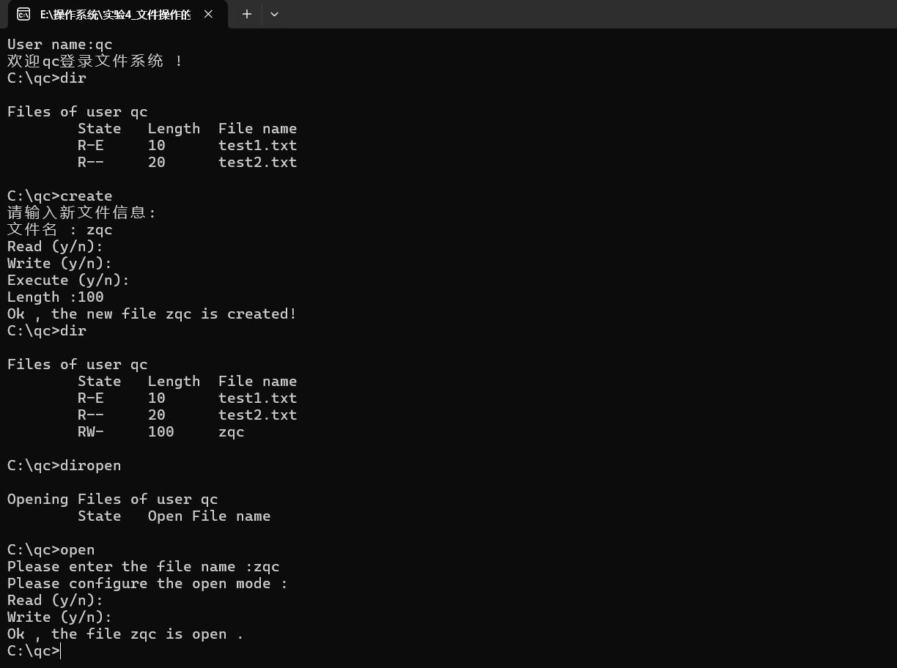
【实验体会】
这是操作系统的最后一次上机实验，我认为，文件系统的管理才是让我们普通用户感受操作系统最核心的部分，那种在控制台，一条条输入指定来调用相应的功能，完成文件的创建、读写、删除等操作，有点类似与Linux的命令行窗口。如果以后能有几乎开发一个自己的操作系统，那肯定会很有成就感。

【思考题】
什么是逻辑文件，什么是物理文件，它们有什么区别？
逻辑文件是用户视角下的文件，它表示了文件的组织方式和逻辑结构，比如记录的顺序和字段的格式。用户通过文件名和目录结构来访问逻辑文件，而无需关心文件在磁盘上的具体布局。
物理文件则是指文件在实际存储介质上的存储形式，涉及文件在磁盘上的具体位置、存储空间分配和访问方法等细节。物理文件通常由操作系统和文件系统管理，对用户透明。
简而言之，逻辑文件关注文件的内容和结构，而物理文件关注文件在存储设备上的实际表示，两者在视图角度、存储表示、管理方式和访问方式等方面存在区别。

