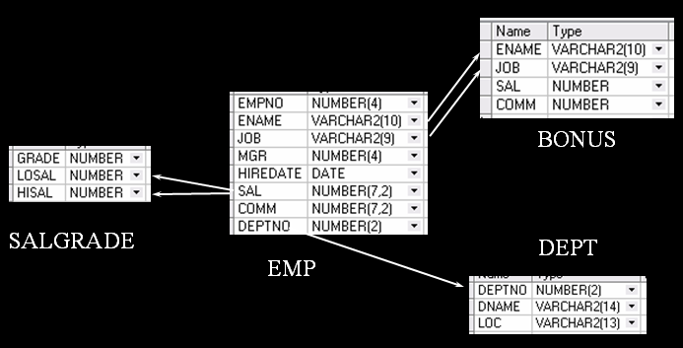

1．列出与“SCOTT”从事相同工作的所有员工。
SELECT * FROM EMP WHERE JOB=(SELECT JOB FROM EMP WHERE ENAME='SCOTT') AND ENAME!='SCOTT'
2．列出薪金等于部门30中员工的薪金的所有员工的姓名和薪金。
SELECT ENAME,SAL FROM EMP WHERE SAL IN (SELECT DISTINCT(SAL) FROM EMP WHERE DEPTNO='30')
3．列出薪金高于在部门30工作的所有员工的薪金的员工姓名和薪金。
SELECT ENAME,SAL FROM EMP WHERE SAL > (SELECT MAX(SAL) FROM EMP WHERE DEPTNO='30')
4．列出在每个部门工作的员工数量、平均工资和平均服务期限。
SELECT DNAME,COUNT(DNAME)AS 部门人数,AVG(SAL) AS 平均工资，AVG(SYSDATE-HIREDATE) as 平均服务时间 FROM EMP,DEPT WHERE EMP.DEPTNO=DEPT.DEPTNO GROUP BY DNAME
5．列出所有员工的姓名、部门名称和工资。
SELECT ENAME,DNAME,SAL FROM EMP,DEPT WHERE EMP.DEPTNO=DEPT.DEPTNO
6．列出所有部门的详细信息和部门人数。
SELECT a.DEPTNO,a.DNAME,a.LOC,b."部门人数" FROM DEPT a,(SELECT DNAME,COUNT(ENAME) AS 部门人数 FROM DEPT LEFT JOIN EMP ON EMP.DEPTNO=DEPT.DEPTNO GROUP BY DNAME) b WHERE a.DNAME=b.DNAME
7．列出各种工作的最低工资。
SELECT JOB,MIN(SAL) FROM EMP GROUP BY JOB
8．列出各个部门的MANAGER（经理）的最低薪金。
SELECT DEPTNO,MIN(SAL) AS 部门经理最低工资 FROM (SELECT ENAME,SAL,DEPTNO FROM EMP WHERE EMPNO IN (SELECT MGR FROM EMP)) GROUP BY DEPTNO
- 列出所有员工的年工资,按年薪从低到高排序。
SELECT ENAME,SAL*12 AS 年薪 FROM EMP ORDER BY SAL

